Jadd Cheng

UT Boot Camp Data

Excel Homework

July 27, 2019

<https://github.com/jlcatx512/excelhomework>

1. **Given the provided data, what are three conclusions we can draw about Kickstarter campaigns?**

The first conclusion is that there is a strong correlation between a project’s category and its funding success rate.

Projects related to the performing arts -- **film & video, music and theater** -- appear to have much higher success rates than other categories.

The success rates of these three categories -- film & video (**58%**), music (**77%**), theater (**60%**) – all surpassed the dataset’s overall average success rate of **53%**.

Meanwhile, categories like **journalism (0%) and food (17%)** were highly unlikely to have successful outcomes.

The second conclusion is related to the first. Sub-categories within categories had dramatically different success rates.

For example, within film & video, **television** projects had a 100% success rate while **animation** and **drama** had 100% failure rates.

In the music category, **pop** and **rock** projects both had 100% success rates. Whereas **jazz** had a 100% failure rate.

This is important because it suggests one cannot just pick a category with a high success rate. One must also choose a sub-category wisely.

A third conclusion is that the average donation is relatively small. In the U.S., which made up the bulk of this dataset’s projects, **342,758** backers donated an average amount of **$96.56** to raise **$31,910,402.96** to projects with successful outcomes.

1. **What are some limitations of this dataset?**

A major limitation of this dataset is that it is a tiny sample of the whole dataset of **300,000** projects launched on Kickstarter.

This dataset only records the results for **4,114** projects, which is only **1.33%** of the greater whole.

Of the **$2 billion** said to have been raised on Kickstarter, this dataset only represents **$46,173,741.66** of that total, or about **2.31%**.

Another indication that this dataset might not be representative is that the overall average success rate of projects listed in it is **53%**.

Meanwhile, it was mentioned in the background section that “**only a third** [of all Kickstarter projects] have made it through the funding process with a positive outcome.”

The dataset also seems to skew heavily to the U.S. as indicated by the fact that **74%** of the total campaigns are based there.

1. **What are some other possible tables and/or graphs that we could create?**

I found it useful to create a table and chart to visualize how the projects were distributed geographically. This simple pie chart showed that the U.S. represented an overwhelming majority of total campaigns launched on Kickstarter’s platform at **74%**. Great Britain was a distant second at **15%**.

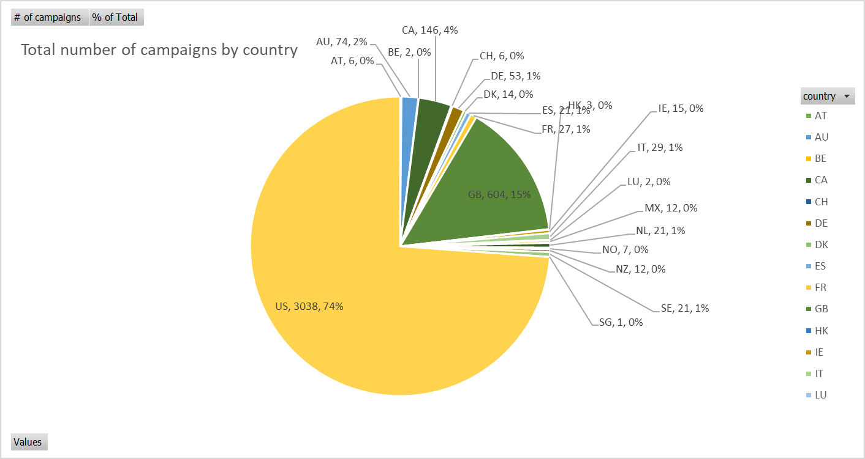

I made another table and chart to visualize that the U.S. also represented a similar percentage of the total amount raised on Kickstarter at **78%** of all funds pledged, though not necessarily to successful campaigns.

I also found it useful to make a simple PivotTable to summarize the average amount pledged broken down by the outcome of the campaign.

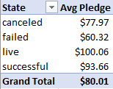

And finally, another useful PivotTable was to summarize the success rate expressed in percentages, broken down by categories and sub-categories.

