Installation and Initial set-up of
Resilient Smart Garden System

Table of Contents

List of Materials..............................................................................................x

Initial setup and Wiring for MCP3008............................................................x

Necessary software installations......................................................................x

Android OS Application setup........................................................................x

Pump preferences setup...................................................................................x

Powering the Smart Garden.............................................................................x

Appendix of links............................................................................................x

Additional information on electrical components...........................................x

List of Materials

Electronic Hardware-
Raspberry Pi B+
BB400 Solderless Plug-in BreadBoard
Phantom YoYo High Sensitivity Moisture Sensor
Electric Solenoid Valve 1/2” DC 12V normally closed inlet flow switch
12VDC 1A Regulated Switching Power Supply
MCP3008 8-channel 10-bit ADC with SPI Interface
OctagonStar DHT11 Digital Humidity/Temperature Sensor
Adafruit Power Relay FeatherWing
USB Mouse/Keyboard
Micro SD card with at least 4GB of memory
Micro USB power supply @ 5v 1.2A (minimum)
Cables/Connectors-
Raspberry Pi breakout board with pin numbering
GPIO Ribbon Cable for Raspberry Pi (40 pin)
Male to Male jumper wires (x)
Female to Male jumper wires (x)
12-10 AWG 10/Clam Female disconnect insulated (2)
Standard wire connectors (2)
½ Vinyl tubing (required Length) (2)
Female to Female PVC ½” to ½” (2)
Barbed Male 90* Elbow ½” (2)
Low voltage copper wire (required Length)
HDMI Cable
Ethernet Cable

Software-
MCP 3008 Library
DHT 11/22 library
Rasbian linux OS for Raspberry PI
Smart Garden Setup Python File
Putty SSH and Telnet client for Windows
Android IOS for data archiving, and visualization (optional)
Win32DiskImager utility

Initial setup and Wiring for MCP3008
MCP3008
The MCP3008 is a 8-channel 10-bit analog to digital converter (ADC). This ADC will allow the analog soil moisture sensor to send data to the Raspberry Pi. The MCP3008 connects to the Raspberry Pi using a SPI serial connection. There are two methods to use the MCP3008 with a Raspberry PI, a software SPI and a hardware SPI. This guide will use a software configuration. Place the MCP3008 on the breadboard so the chip resides on each side of the board, the half circle indicates the orientation with CH0 pin and VDD on the top left and right respectively. Place the chip below the breakout board.
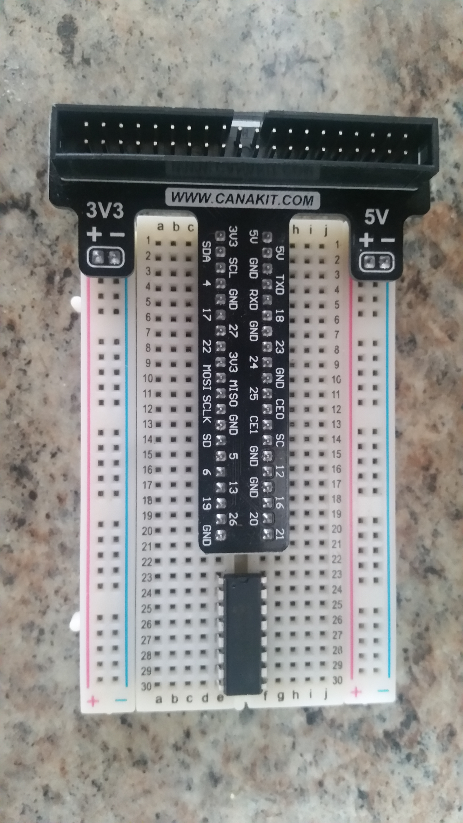
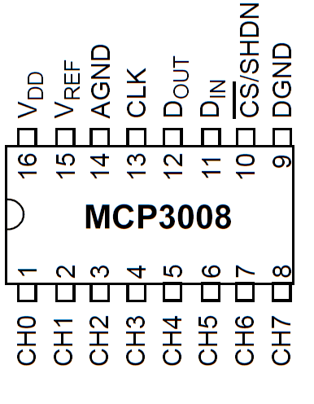
Software SPI
To connect the MCP3008 to the Pi using a software SPI configuration use the male to male jumper cables to connect the terminals from the chip to the Pi breakout board. The included code will use this pin numbering. The breakout board will be attached to the breadboard as shown below.

- MCP3008 VDD to Raspberry Pi 3.3V
- MCP3008 VREF to Raspberry Pi 3.3V
- MCP3008 AGND to Raspberry Pi GND
- MCP3008 CLK to Raspberry Pi pin 18
- MCP3008 DOUT to Raspberry Pi pin 23
- MCP3008 DIN to Raspberry Pi pin 24
- MCP3008 CS/SHDN to Raspberry Pi pin 25
- MCP3008 DGND to Raspberry Pi GND
- MCP3008 CH0 to Moisture Sensor OUT
- Moisture Sensor GND to Raspberry Pi GND
- Moisture Sensor VCC to Raspberry Pi 5V
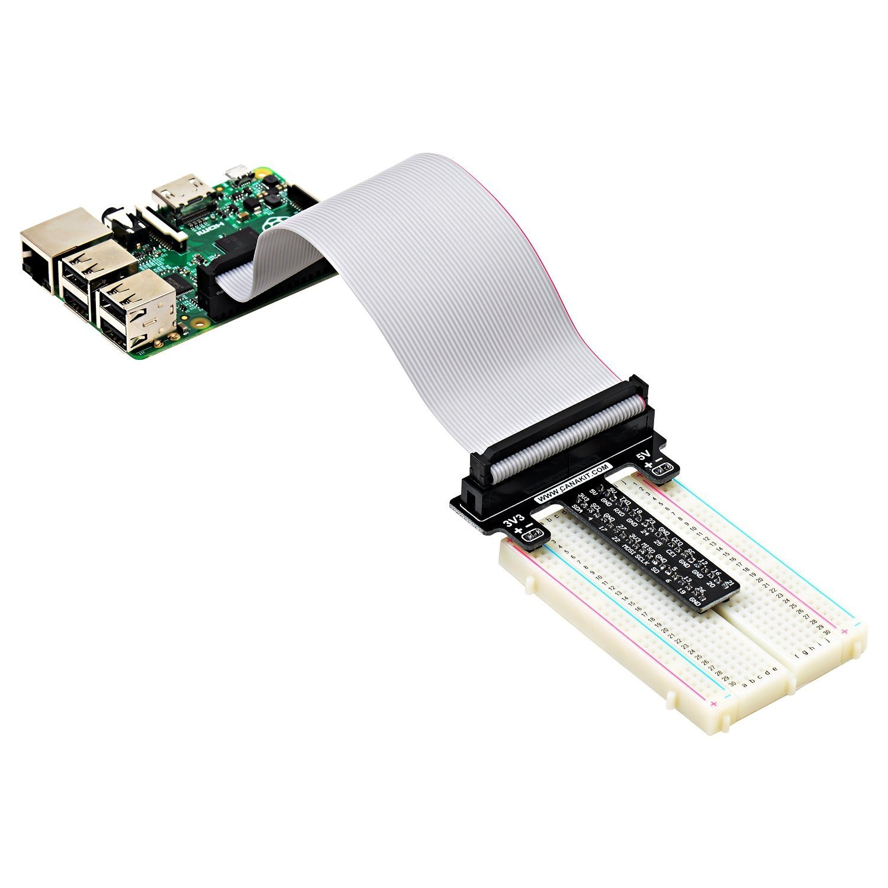

Necessary software installations

The Raspbian Operating System
The Raspbian Operating System is a OS based off Linux. It will allow you to use the Pi as if it were a real computer with a Terminal or Desktop view if necessary. The links to the software and pre-loaded SD card retailer will be in the Appendix of links. OS will be in the appendix section under To begin first you must have a micro SD card with a recommended size of 4GB. You may also choose to purchase an SD card that is pre-loaded with the OS to avoid manual installation. If you choose to install the OS manually you will need a micro SD card reader and the Win32DiskImager utility. Then download the zip containing the Raspian OS.

Insert the SD card into your SD card reader and check for a newly assigned drive letter. Once found unzip and run the Win32DiskImager, you will need to Run as Administrator, right click on the executable to find the option. Select the file extracted for the Raspbian zip file and select the SD card drive letter. Then click “Write” and wait for it to finish. Once finished exit the Imager and safely eject the drive to avoid data corruption. The SD card can now be inserted into the Raspberry Pi and booted.

Before startup connect the USB Mouse and Keyboard. Then plug in the Micro USB power and the Pi will power on automatically, then the Pi will ask for a ID and password, the default ID is “pi” and the password is “raspberry”. The Pi will begin to initialize for startup, once finished a terminal will be displayed and can be operated as a normal Linux terminal. If you prefer a Desktop view type “startx” then hit enter, you will be given access to a Desktop UI. Take some time to familiarize yourself with the OS and where files are stored, also this may be a good time to learn some simple Linux commands for using the terminal without a Desktop. The terminal will be the black box in your task bar near the top.

The Python Language and MCP3008 Library
The Python programming language is the main language that the Pi is programmed in, and so it will be the language that all the code will be compiled to. To ensure that all modules of code are up to date you must first install the latest Python updates. To do so open the terminal and type these commands. This will also install the necessary library for the MCP3008 ADC. The MCP3008 library is necessary for the Smart Garden to be able to read Analog data and convert it to a digital stream for the Pi to interpret. To be able to access the Terminal on the Raspberry Pi, an operating system must already be installed. Once logged in type in the following commands in the terminal:
sudo apt-get update
sudo apt-get install build-essential python-dev python-smbus python-pip
sudo pip install adafruit-mcp3008
You should then see a list of messages the installation file will output, it will look something like the image below. Make sure you have typed each command exactly as it is shown to prevent errors.
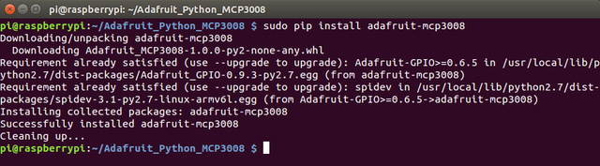

Android OS Application setup
The Smart Garden app is used for creating a profile to store garden metrics to allow users to view the history of the garden's moisture, ambient temperature and humidity. The data is displayed as a 30 day graph that is viewed by month. To use these features an account must first be created. To begin the setup download and install the Smart Garden app, available at this link: link to .apk

The first screen will be the Login and User Registration. If you are a new user enter the username you desire and password, then click Register. If the registration is successful then you can continue to login with the same information. There is also a link to the Smart Garden website with other helpful material.
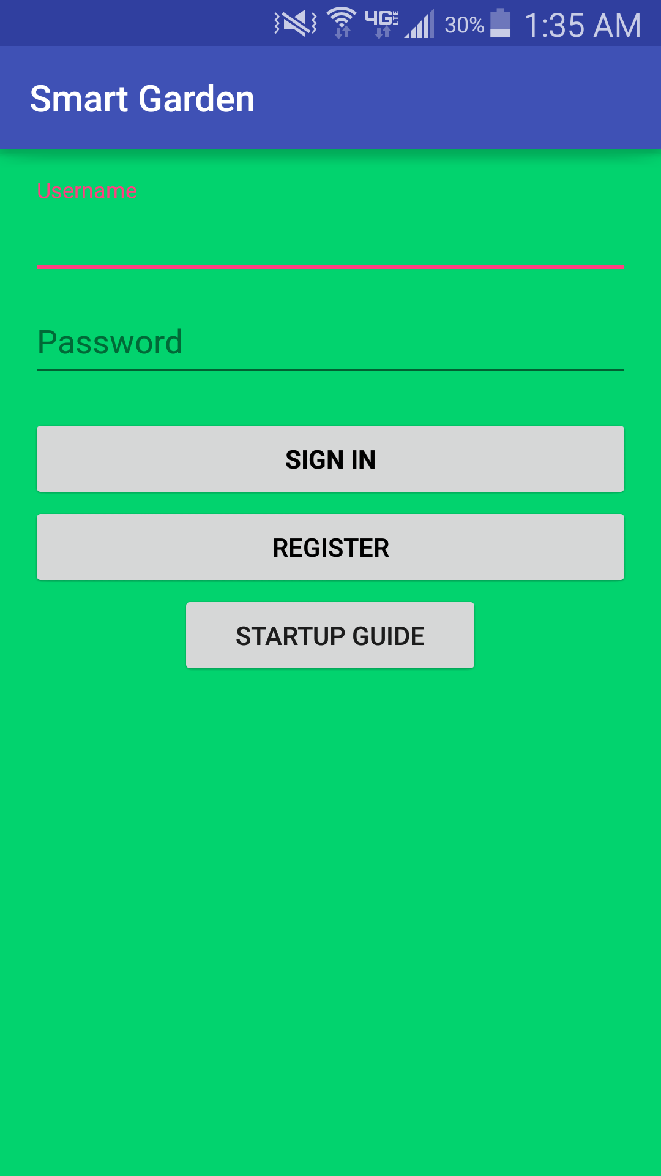

Upon successful login you will be brought to the main screen that will display a greeting and the latest reading taken from the garden if available. There is also a history selection, to select a month simply use the number for the month and year then hit the history button. The current readings will be displayed as: Moisture (0 – 1023), Humidity in percentage, and Temperature in Fahrenheit.
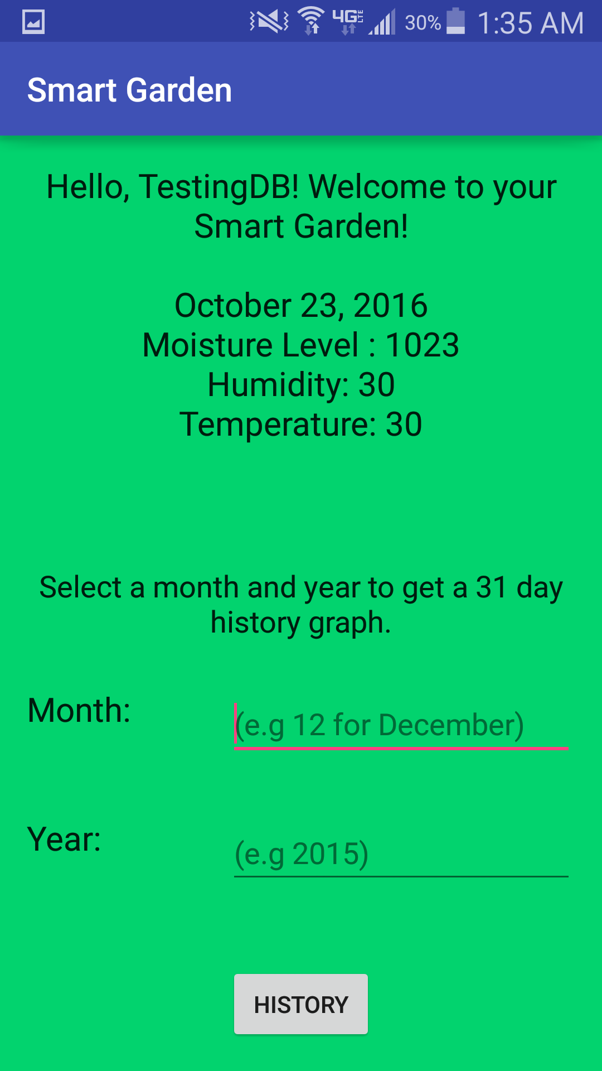

After selecting a month with readings to view a graph will be displayed and have humidity, temperature and moisture boxes to check to display those readings. It also displays the legend for the line colors. These readings will be stored for all future use.
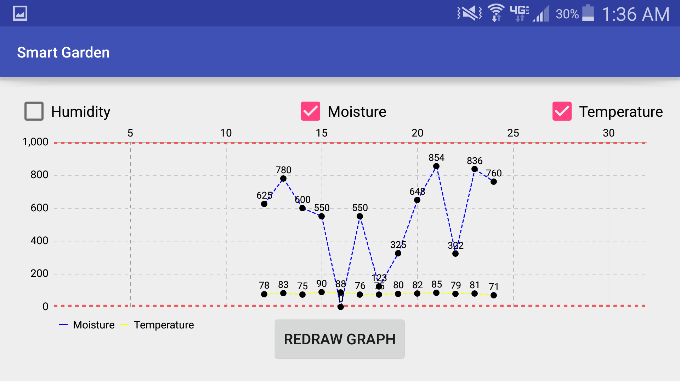

Appendix of links

Win32 Disk Imager - https://sourceforge.net/projects/win32diskimager.
Raspian Operating System - https://downloads.raspberrypi.org/raspbian_latest
Pre-loaded micro SD card with Raspbian - https://www.adafruit.com/products/1121.
MCP 3008 Library - https://github.com/adafruit/Adafruit_Python_MCP3008
DHT22/11 Library - https://github.com/adafruit/Adafruit_Python_DHT

Table 1 Pin Function Table MCP3008
PDIP, SOIC | Symbol | Description
1 | CH0 | Analog Input
2 | CH1 | Analog Input
3 | CH2 | Analog Input
4 | CH3 | Analog Input
5 | CH4 | Analog Input
6 | CH5 | Analog Input
7 | CH6 | Analog Input
8 | CH7 | Analog Input
9 | DGND | Digital ground
10 | CS/SHDN | Chip Select Shutdown input
11 | Din | Serial Data in
12 | Dout | Serial Data out
13 | CLK | Serial Clock
14 | AGND | Analog Ground
15 | Vref | Reference Voltage
16 | VDD | +2.7 to 5.5v Power

Digital Ground (DGND)
Digital ground connection to internal digital circuitry
Analog Ground (AGND)
Analog ground connection to internal analog circuitry
Analog Inputs (CH0 - CH7)
Analog inputs for channels 0 - 7, respectively, for the multiplexed inputs.
Serial Clock (CLK)
The SPI clock pin is used to initiate a conversion and clock out each bit of the conversion as it takes place
Serial Data Input (Din)
The SPI port serial data input pin is used to load channel configuration data into the device.
Serial Data Output (Dout)
The SPI serial data output pin is used to shift out the results of the A/D conversion. Data will always change on the falling edge of each clock as the conversion takes place.
Chip Select/ Shutdown (CS/SHDN)
The CS/SHDN pin is used to initiate communication with the device when pulled low. When pulled high, it will end a conversion and put the device in low-power standby. The CS/SHDN pin must be pulled high between conversions.

