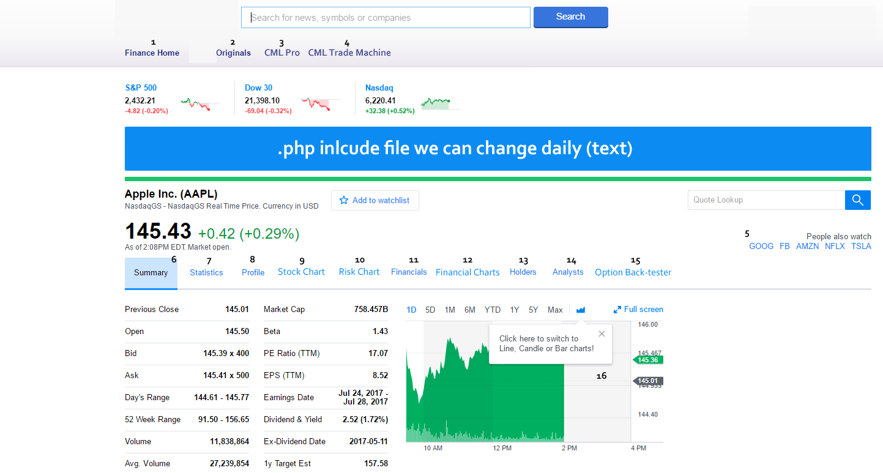

**Quote: Existing API (barchart): Price, change $, change %**

**1.** [www.cmlviz.com](http://www.cmlviz.com)

**2.** <http://www.cmlviz.com/cmld3b/lite.php?app=news>

**3.** <http://pro.cmlviz.com/register/cml-pro-19-per-month-membership-promotion/?source=cmlviz>

**4.** <https://cmlviz.com/register/trademachine-cml-option-back-tester/?source=cmlviz>

**5. use local storage to remember last five tickers**

**6-15. (below)**

**7. Statistics**

**https://finance.yahoo.com/quote/AAPL/key-statistics?p=AAPL**

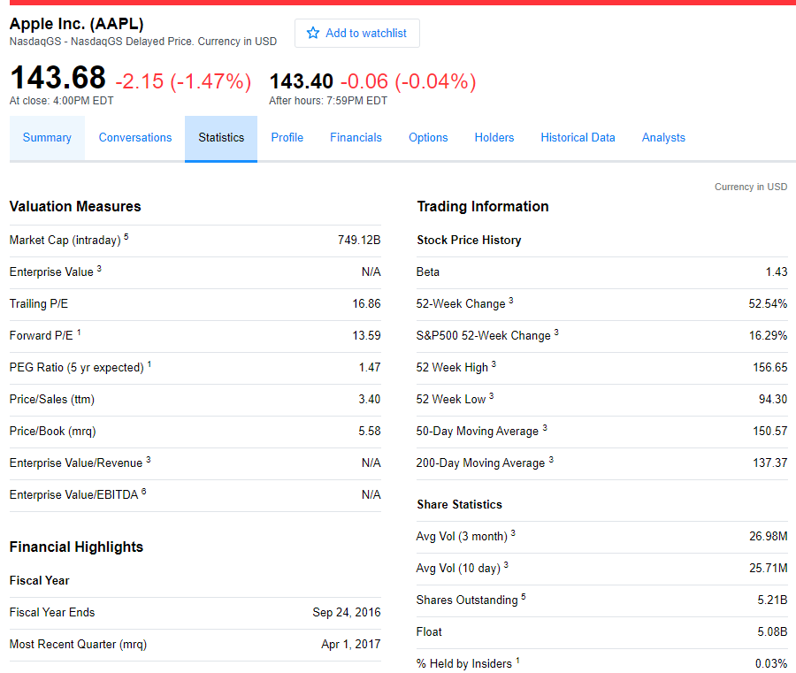

**8. PROFILE**

https://finance.yahoo.com/quote/**AAPL**/profile?p=**AAPL**

### Apple Inc.

1 Infinite Loop  
Cupertino, CA 95014  
United States  
[408-996-1010](tel:408-996-1010)  
[http://www.apple.com](http://www.apple.com/)

## Description

Apple Inc. designs, manufactures, and markets mobile communication and media devices, personal computers, and portable digital music players to consumers, small and mid-sized businesses, and education, enterprise, and government customers worldwide. The company also sells related software, services, accessories, networking solutions, and third-party digital content and applications. It offers iPhone, a line of smartphones; iPad, a line of multi-purpose tablets; and Mac, a line of desktop and portable personal computers. The company also provides iLife, a consumer-oriented digital lifestyle software application suite; iWork, an integrated productivity suite that helps users create, present, and publish documents, presentations, and spreadsheets; and other application software, such as Final Cut Pro, Logic Pro X, and FileMaker Pro. In addition, it offers Apple TV that connects to consumers’ TV and enables them to access digital content directly for streaming high definition video, playing music and games, and viewing photos; Apple Watch, a personal electronic device; and iPod, a line of portable digital music and media players. Further, the company sells Apple-branded and third-party Mac-compatible, and iOS-compatible accessories, such as headphones, displays, storage devices, Beats products, and other connectivity and computing products and supplies. Additionally, it offers iCloud, a cloud service; AppleCare that offers support options for its customers; and Apple Pay, a mobile payment service. The company sells and delivers digital content and applications through the iTunes Store, App Store, Mac App Store, TV App Store, iBooks Store, and Apple Music. It also sells its products through its retail and online stores, and direct sales force, as well as through third-party cellular network carriers, wholesalers, retailers, and value-added resellers. Apple Inc. was founded in 1977 and is headquartered in Cupertino, California.

**9. Stock Chart**

**No work / Skip**

**10. Risk Chart**

**source:** http://www.cmlviz.com/cmld3b/lite.php?app=risk_scatter&ticker=AAPL

**SNAPSHOT SUMMARY**

|  |  |  |
| --- | --- | --- |
| CONTEXT: THE INDICES | | |
| S&P 500 (SPY) | IV30 | **8.76%** |
| Nasdaq 100 (QQQ) | IV30 | **14.42%** |
| Technology ETF (**XLK**) | IV30 | **13.59%** |
| Biotech (IBB) | IV30 | **18.37%** |
|  | | |
|  | | |
| Apple Inc (NASDAQ:AAPL) | | |
| AAPL 52 Week Low | IV30 | **12.66%** |
| AAPL Current | IV30 | **17.81%** |
| AAPL 52 Week High | IV30 | **28.23%** |
|  | | |
| AAPL Current | HV30 | **21.97%** |

|  |
| --- |
| **Apple Inc Implied Risk Scatter Plot** |
| (a new risk chart, built for option traders) |

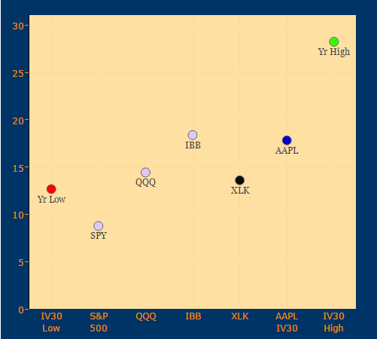

**Scatter Plot Risk Legend**   
The blue point is the current 30-day implied volatility for Apple Inc.   
The black point is the current 30-day implied volatility for the Technology ETF (XLK).   
The red point is the 52 week low in IV30® for Apple Inc.   
The green point is the 52 week high in IV30® for Apple Inc.

**11. FINANCIALS**

**https://finance.yahoo.com/quote/AAPL/financials?p=AAPL**

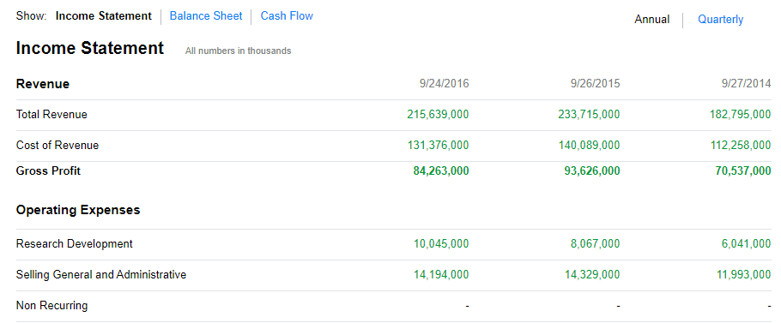

**12. Financial Charts**

**Skip**

**13. HOLDERS**

https://finance.yahoo.com/quote/**AMZN**/holders?p=**AMZN**

##### Breakdown

|  |  |
| --- | --- |
| **17.82%** | Shares Held by All Insider and 5% Owners |
| **67.50%** | % of Shares Held by Institutional & Mutual Fund Owners |
| **82.14%** | % of Float Held by Institutional & Mutual Fund Owners |
| **1,284** | Number of Institutions Holding Shares |

**Data**

|  |  |  |  |  |  |  |  |
| --- | --- | --- | --- | --- | --- | --- | --- |
| Name | Position | Date | Transaction | #Shares | Price | Value | #Shares After |
| PAISLEY CHRISTOPHER B | Director | 2017-06-16 | Option Exercise | 726 | $ | 0 | 12345 |
| VERHALEN ANDREW W | Director | 2017-06-16 | Option Exercise | 726 | $ | 0 | 52172 |
| HU CHENMING | Director | 2017-06-16 | Option Exercise | 726 | $ | 0 | 28454 |
| RICHARDSON DAVID JEFFREY | Director | 2017-06-16 | Option Exercise | 1142 | $ | 0 | 12830 |
| KOHN LESLIE | Chief Technology Officer | 2017-06-16 | Option Exercise | 9088 | $ | 0 | 904530 |
| KOHN LESLIE | Chief Technology Officer | 2017-06-16 | Sale | -5973 | $48.77 | -291303.21 | 898557 |
| LAPLANTE GEORGE | Chief Financial Officer | 2017-06-16 | Option Exercise | 7573 | $ | 0 | 100848 |
| LAPLANTE GEORGE | Chief Financial Officer | 2017-06-16 | Sale | -4836 | $48.77 | -235851.72 | 96012 |
| DAY CHRISTOPHER | VP Marketing | 2017-06-16 | Option Exercise | 2932 | $ | 0 | 22892 |
| DAY CHRISTOPHER | VP Marketing | 2017-06-16 | Sale | -1526 | $48.77 | -74423.02 | 21366 |
| WANG FENGMING | CEO | 2017-06-16 | Option Exercise | 15429 | $ | 0 | 290691 |
| WANG FENGMING | CEO | 2017-06-16 | Sale | -11628 | $48.77 | -567097.56 | 279063 |

**Design**

**http://www.nasdaq.com/symbol/twtr/insider-trades?sortname=insider&sorttype=0**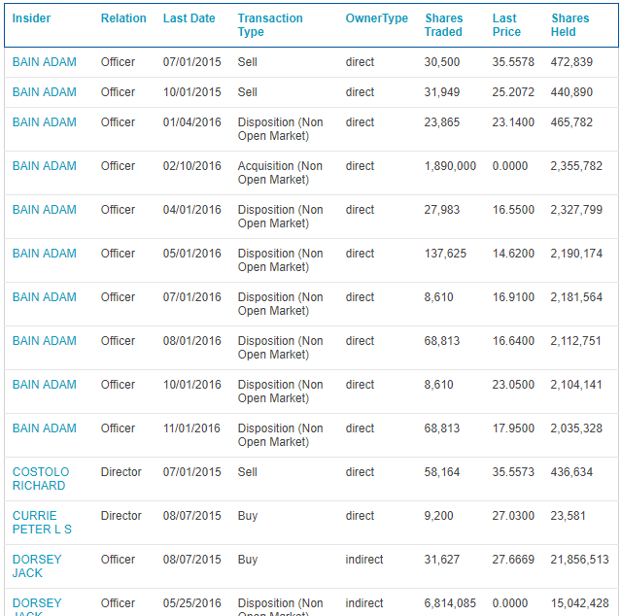

**14. ANALYSTS**

http://www.reuters.com/finance/stocks/analyst?symbol=**AMZN**

|  |  |  |  |  |  |
| --- | --- | --- | --- | --- | --- |
|  | **# of Estimates** | **Mean** | **High** | **Low** | **1 Year Ago** |
| **SALES (in millions)** | | | | | |
| Quarter Ending Jun-17 | 35 | 37,164.40 | 37,747.00 | 36,445.50 | 35,659.30 |
| Quarter Ending Sep-17 | 34 | 39,893.10 | 40,859.00 | 38,775.30 | 37,722.80 |
| Year Ending Dec-17 | 38 | 166,152.00 | 168,643.00 | 162,225.00 | 162,151.00 |
| Year Ending Dec-18 | 37 | 201,012.00 | 210,090.00 | 190,793.00 | 194,871.00 |
| **Earnings (per share)** | | | | | |
| Quarter Ending Jun-17 | 35 | 1.41 | 2.42 | 1.04 | 2.18 |
| Quarter Ending Sep-17 | 35 | 1.09 | 1.84 | 0.24 | 2.07 |
| Year Ending Dec-17 | 39 | 6.68 | 8.93 | 4.09 | 9.89 |
| Year Ending Dec-18 | 38 | 11.31 | 15.00 | 6.33 | 16.66 |
| LT Growth Rate (%) | 5 | 22.91 | 38.80 | 5.00 | 41.14 |

**HISTORICAL SURPRISES**

Sales and Profit Figures in US Dollar (USD)  
Earnings and Dividend Figures in US Dollar (USD)

|  |  |  |  |  |
| --- | --- | --- | --- | --- |
| **Estimates vs Actual** | **Estimate** | **Actual** | **Difference** | **Surprise %** |
| **SALES (in millions)** | | | | |
| Quarter Ending Mar-17 | 35,296.60 | 35,714.00 | 417.40 | 1.18 |
| Quarter Ending Dec-16 | 44,676.80 | 43,741.00 | 935.77 | 2.09 |
| Quarter Ending Sep-16 | 32,687.30 | 32,714.00 | 26.69 | 0.08 |
| Quarter Ending Jun-16 | 29,545.80 | 30,404.00 | 858.23 | 2.90 |
| Quarter Ending Mar-16 | 27,978.80 | 29,128.00 | 1,149.23 | 4.11 |
| **Earnings (per share)** | | | | |
| Quarter Ending Mar-17 | 1.08 | 1.48 | 0.40 | 36.46 |
| Quarter Ending Dec-16 | 1.35 | 1.54 | 0.19 | 14.34 |
| Quarter Ending Sep-16 | 0.78 | 0.52 | 0.26 | 33.26 |
| Quarter Ending Jun-16 | 1.11 | 1.78 | 0.67 | 60.65 |
| Quarter Ending Mar-16 | 0.58 | 1.07 | 0.49 | 83.69 |

**CONSENSUS ESTIMATES TREND**

Sales and Profit Figures in US Dollar (USD)  
Earnings and Dividend Figures in US Dollar (USD)

|  |  |  |  |  |  |
| --- | --- | --- | --- | --- | --- |
|  | **Current** | **1 Week Ago** | **1 Month Ago** | **2 Month Ago** | **1 Year Ago** |
| **SALES (in millions)** | | | | | |
| Quarter Ending Jun-17 | 37,164.40 | 37,164.60 | 37,152.70 | 36,843.40 | 35,659.30 |
| Quarter Ending Sep-17 | 39,893.10 | 39,894.20 | 39,882.70 | 39,720.90 | 37,722.80 |
| Year Ending Dec-17 | 166,152.00 | 166,166.00 | 166,120.00 | 165,273.00 | 162,151.00 |
| Year Ending Dec-18 | 201,012.00 | 200,978.00 | 200,692.00 | 199,459.00 | 194,871.00 |
| **Earnings (per share)** | | | | | |
| Quarter Ending Jun-17 | 1.41 | 1.40 | 1.39 | 1.84 | 2.18 |
| Quarter Ending Sep-17 | 1.09 | 1.11 | 1.12 | 1.35 | 2.07 |
| Year Ending Dec-17 | 6.68 | 6.67 | 6.66 | 7.10 | 9.89 |
| Year Ending Dec-18 | 11.31 | 11.36 | 11.30 | 12.27 | 16.66 |

**15. Option Back-tester**

**Skip**