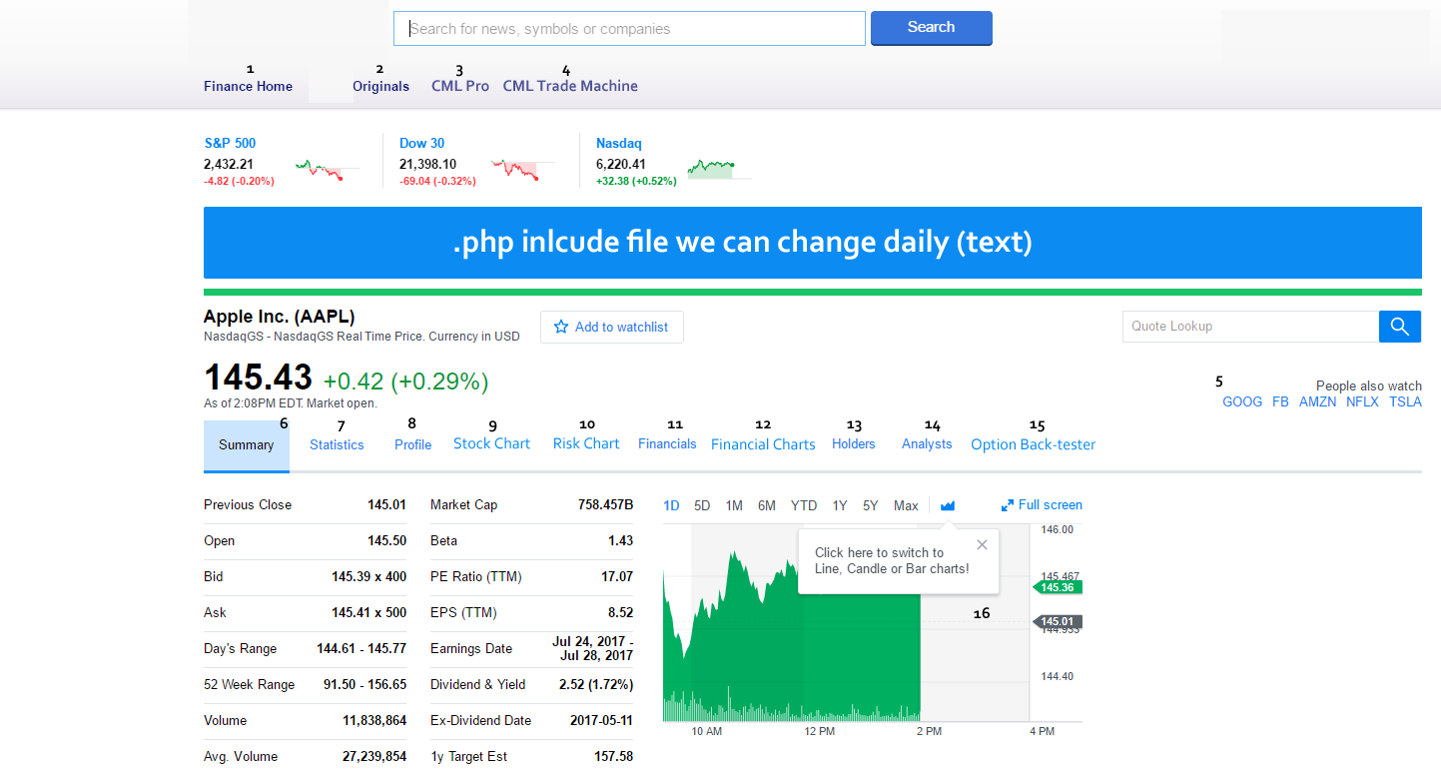

**Quote: Existing API (barchart): Price, change $, change %**

**1.** [www.cmlviz.com](http://www.cmlviz.com)

**2.** <http://www.cmlviz.com/cmld3b/lite.php?app=news>

**3.** <http://pro.cmlviz.com/register/cml-pro-19-per-month-membership-promotion/?source=cmlviz>

**4.** <https://cmlviz.com/register/trademachine-cml-option-back-tester/?source=cmlviz>

**5. use local storage to remember last five tickers**

**6-15. (below)**

**6. Summary**

