WHAT DO WE KNOW, version 2011

Well MAYBE NOT! Why NASS would jump to such low yield numbers with no data to back it up is quite unusual. BUT>>>THIS IS GREAT NEWS. We may actually get a "HAMMER TIME" opportunity in the next few weeks.

I just can't believe they jumped so far out in front of the curve. What can we trust if we can't trust their consistent incompetence. :-) just kidding...sort of.

So a quick update to these points.

1. NASS is under immense pressure to "GET IT RIGHT". Funny, if you take out the silly stocks lowering mistake in the June 10th report, they had it right all along. Of course, no one wants to believe them. I think this puts them in a position where they become overly conservative, and thus will over-estimate yields in this report. Not for the 2010 reason, but for the 1995 reason. This does not mean prices have to rally, they already have rallied from $3.45 to $8 remember.

NOT...they panic all the way to the other extreme. Going to be pretty tough to get yields lower than 153.

2. Rainfall in the next 10 days for about 40% of the belt will make or break yields. The report is as of August 1st and does not capture this. Since they are required to assume normal weather going forward it is highly likely that this report over-estimates yields.

Please go to this link and make your own conclusions. (**http://water.weather.gov/precip/).**

Below the map you can select the time period and the percent of average. Great yield predictor, especially for beans. What I see is roughly 40% of the bean acres are in deep trouble. 30% should be very good. 30% average. No way beans make trend yields in this scenario when you consider planting date as well.

Obviously I hit this one correctly according to those guys.

3. The weather continues to be very much like 1974. The grain markets really want to go down, just like everything else, but they just can't because of supply problems. Especially corn. Seems a frost is pretty likely the way things are going. Right I guess.

4. What will the NASS boys say this morning? I really don't know. Acres probably come down a little for corn, beans unchanged, prevent plant takes out 500k, corn and bean yields will be high versus the final but probably nothing like the error last year.

No longer a known, yields could easily still outpace these low numbers, or at least not decline farther. This becomes an unknown going forward in my view. Means the high will probably come sooner, not later.

5. Great bean yields are normally driven by tropical storm moisture. None forecasted yet. Looks like we have high odds of getting the hurricane moisture just in time for harvest :-) Big rains the dry areas this weekend are needed across the dry areas.

6. INTEREST RATES...talk about a blow-off spike higher in the face of contrary news. It is clearly the greatest Ponzi scheme in all of human existence. Lower the credit score so that the bond funds are required to sell poorer bonds and buy more treasuries to maintain their funds average rating? People who fly to "Perceived" safety many times find it is not as safe as they thought. I've attached the long-term bond charts. **Hedging rates sometime in the next 10 days is a pretty good idea. Always want to sell into a panic buying spree.**

**IT IS HAMMER TIME BABY!!!! Implement your triggers. Did you notice the 27 week reinforced by the 27 day count. Break it down..."HAMMER TIME". :-)**

7. Also attached the chart of the Dow. Talk about an easy short!! We don't have stock investments and thus would not have anything to hedge, but that chart is another in a long list of all time classic sell patterns. It was clearly "HAMMER TIME". Sorry I wasn't even looking at stock charts since we don't invest there.

CONCLUSION:

Just about everything we know is already in the market this time around. That means there is not a clear answer to what to do. It also means that we are very comfortable going into the report with little price risk.

So, we will wait for a clearer picture and FOCUS on the 2012 charts, cz12 and sx12. Much like wn12, those markets have an extreme amount of downside given where we are in the Big Picture. Plus they are easier to manage with less emotional noise. They are attached.

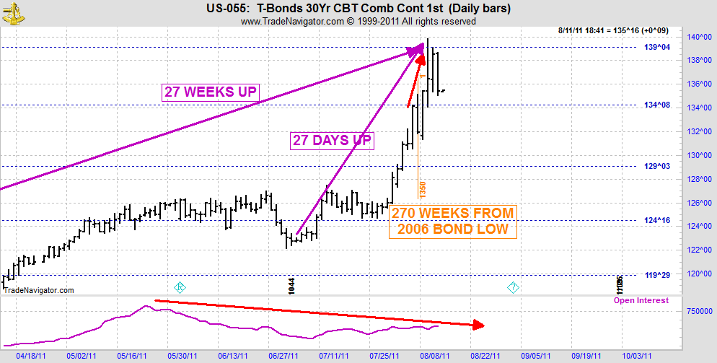

THIS IS A "HAMMER TIME" POINT IN THE BONDS IF YOU NEED TO HEDGE RATES.

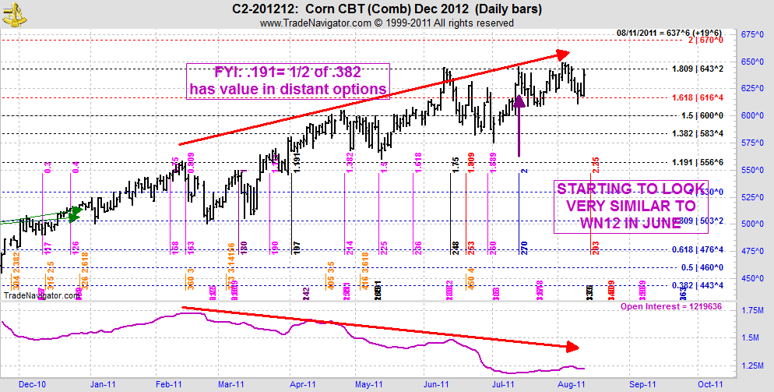

The day wasn't all that earth shattering on the charts.

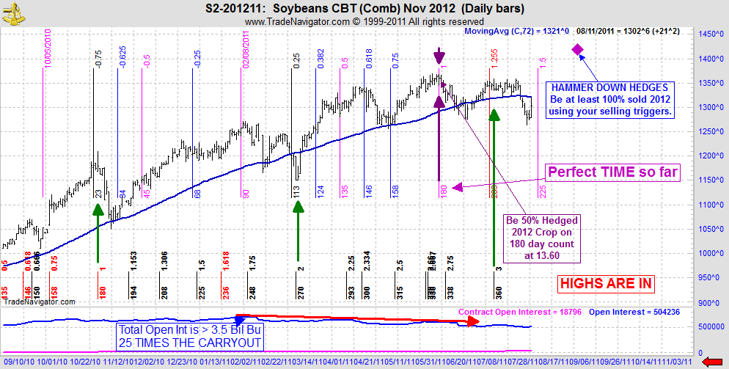

Hard to get bullish this chart if you ignore the weather forecast for beans.