Several Methods for Monte Carlo Fission Source Iterations
Bill Martin
9/8/06

Conventional fission source iterations
The idea is to express the mathematics in terms of actual quantities used during a Monte Carlo simulation. Begin with the transport equation in operator formalism:

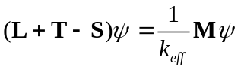

where L is leakage, T is loss due to collisions, and S is scatter. Define the transport-collision operator A = L + T - S and the fission source 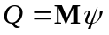 and manipulate Eq. to find:

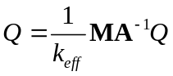

Equation is in a form that directly corresponds to Monte Carlo fission source iterations because Q is the fission bank, 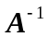is the inverted transport-collision operator (random walk plus collision analysis), M is the fission operator (store expected number of fission sites following a collision), and 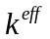 is the multiplication factor.

Define the index n to be a fission generation and express the solution of Eq. by fission source iterations as follows:

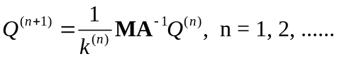
where 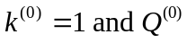= the initial fission source guess. The actual Monte Carlo implementation of the operator 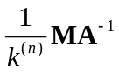 in Eq. consists of a random walk plus collision analysis resulting in the following number of fission sites for the next cycle created as a result of a collision:

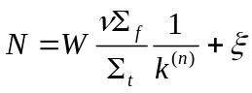

In Eq. , W is the weight of the neutron entering the collision, is a random number, and 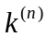 is the estimate of 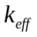 from the previous cycle. Now define I to be a unit diagonal matrix and U to be a unity vector of ones, e.g., U = col [1, 1, 1].

At the end of the current generation, the eigenvalue must be updated. Since Eq. is the original equation that was to be solved, use it to solve for:

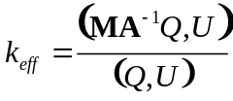

Now use the latest information available for Q to estimate at the end of the current generation:

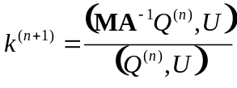

Here 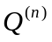is used instead of 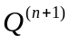 because 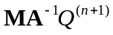 is not known and the numerator and denominator must be evaluated at the same time. Now substitute Eq. into Eq. to find the expression for the updated eigenvalue at the end of generation n+1:

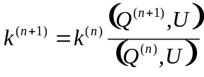

The ratio in Eq. is simply the ratio of the new to old fission sources. Equivalently, one can use the tracklength estimator to estimate these quantities. For convenience, we will express the ratio in terms of the fission sources.

Wielandt method
The Wielandt method starts with the following equivalent expression for Eq.:

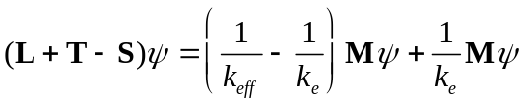

where 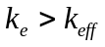. Wielandt’s method is consistent with solving Eq. using one fission generation for the first term on the RHS and following all generations for the second term:

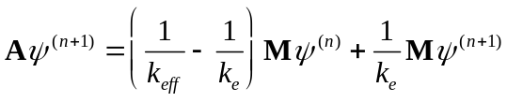

The index n corresponds to the current cycle, which is a mix of generations. Now express Eq. in terms of the fission source and manipulate to find:

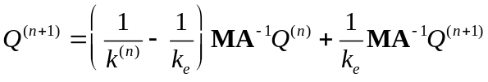

Formally solve Eq. for,
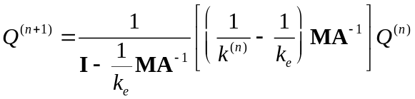

Expand the operator in Eq. :

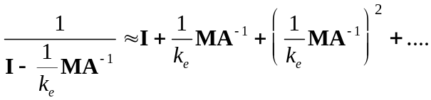

Substitute Eq. into Eq. to obtain:

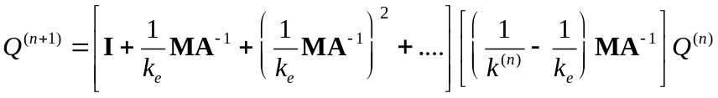

Rearrange to show the explicit contributions to the fission bank for the next cycle due to within-cycle generations in the current cycle:

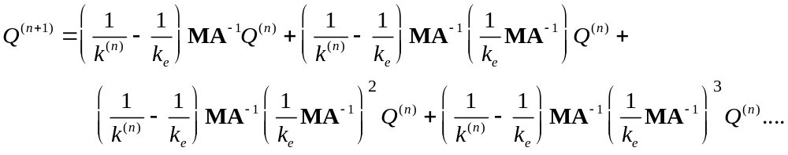

The right hand side of Eq. gives the contributions to the next fission bank due to first generation, second generation, etc. neutrons. The following rearrangement of Eq. makes this more apparent:

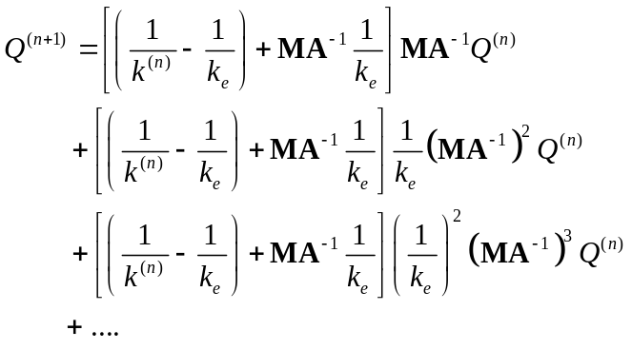

The actual Monte Carlo implementation of the terms on the RHS of Eq. is similar to what was done with Eq. , but there is a key difference. After each collision, fission sites are created for both the current fission bank and the next fission bank, not just the next fission bank as in Eq. . The number of fission sites that are added to the next fission bank is given by:

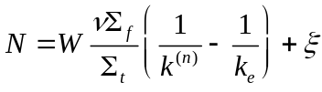

The number of fission sites added to the current fission bank is given by:

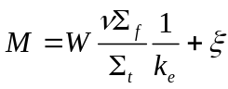
Notice that the total number of fission sites created per collision is 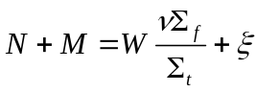, identical to Eq. . However, M of these fission sites are processed during the current cycle, while N are stored for the next cycle fission bank . Therefore, Eq. implements the operator 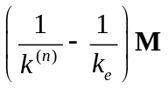 while Eq. implements the operator 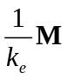. At the end of cycle n+1, the eigenvalue is updated as before with Eq. :

Superhistory method
In this method, the fission neutrons are followed for K generations. Begin with Eq. , the original equation to be solved:

Then the Superhistory approach may be expressed as follows:

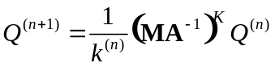
where the operator 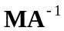 is a random walk-collision analysis that results in the following number of fission sites added to the current fission bank:

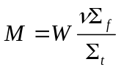

Equation is valid for collisions due to neutrons in generations 1 though K-1. For the K^{th} generation neutrons, the following number of fission sites are stored for the next fission bank following a collision:

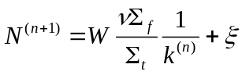

The eigenvalue at the end of cycle n is updated as before:

Reference
[Yam2004] Yamomoto, T. and Miyoshi, Y., “Reliable Method for Fission Source Convergence of Monte Carlo Criticality Calculation with Wielandt’s Method,” J. Nucl. Sci. Tech. 41, 99-107 (2004).

