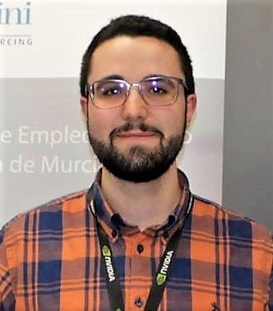Jose Luis Canovas received the B.S. degree in Computer Science and the B.S. degree in Mathematics from the University of Murcia in 2017. He is currently pursuing the M.S. degree in Computer Science for Applied Mathematics. Jose Luis is a research fellow in the Department of Information and Communications Engineering of the University of Murcia. His research interests include security and privacy technologies for the Internet of Things.

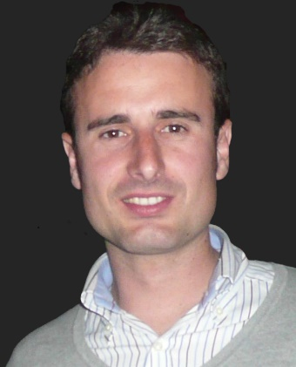Jorge Bernal Bernabe received the B.S., M.S., and Ph.D. degrees in computer science as well as the M.B.A. degree from the University of Murcia, Murcia, Spain. He was granted with the Best Ph.D. Thesis Award from the School of Computer Science of the University of Murcia. Currently, he is a Research Fellow in the Department of Information and Communications Engineering of the University of Murcia as well as Adjunct Professor in the same department. Jorge Bernal has been Visiting Researcher in the Cloud and Security Lab of Hewlett-Packard Laboratories, Bristol, UK, and author of several book chapters and more than 25 papers in international top level conferences and journals. He has been involved in the scientific committee of numerous conferences and served as a reviewer for multiple journals. During the last years, he has been working in several European research projects FP6, FP7 and H2020, such as DESEREC, Semiramis, Inter-Trust, SocIoTal, or ARIES. His scientific activity is mainly devoted to the security, trust, and privacy management in distributed systems. He is also interested in security and privacy aspects in the Internet of Things.

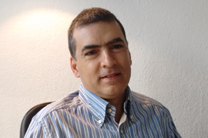Antonio Skarmeta received his Ph.D. degree in computer science from the University of Murcia, Murcia, Spain, M.S. degree in computer science from the University of Granada, Granada, Spain, and B.S. degree (with honors). Since 2009, he has been Professor at University of Murcia, Murcia, Spain. Skarmeta has worked on different research projects in the national and international area in the networking, security, and IoT area, like Euro6IX, ENABLE, DAIDALOS, SWIFT, SEMIRAMIS, SMARTIE, SOCIOTAL, and IoT6. His main interest is in the integration of security services, identity, IoT, and smart cities. He has been the Head of the research group ANTS since its creation in 1995. He is also an Advisor to the Vice Rector of Research of the University of Murcia for international projects and Head of the International Research Project Office. Since 2014, he has been the Spanish National Representative for the MSCA within H2020. He has published over 200 international papers and has been a member of several program committees. He has also participated in standardization for IETF, ISO, and ETSI.