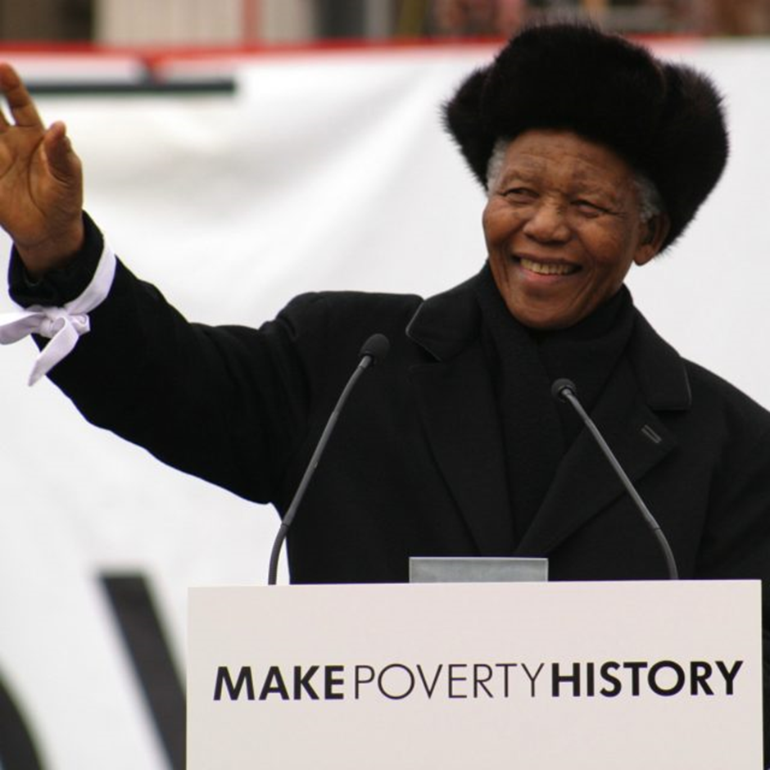

**LETS MAKE POVERTY HISTORY**

**BACKGROUND**

Poverty is the most crucial problem for all developing countries. It is the root cause of all other problems. Most of the countries are in catch 22 situations and for decades have not been able to come out. It is the BLOT on humanity and we all should be ashamed to have it.

Before the advent of internet, this was almost impossible / very difficult to address it

Now it is not difficult but has turned out to be opportunity as many interesting business models are available on internet .

We took up the challenge to help poor / physically challenged / uneducated rural men/women etc ( say XYZ ). We wanted a self sustainable business model so as to scale and replicate globally.

**THE MODEL**

Our target group XYZ’s only strength is

1 They have body and time ( available cheap)

2 They know local conditions

3They may have local relationship or can easily develop it

**DEMAND SCENERIO**

All most all products , government schemes are struggling to reach last mile. They have to spend huge amount for new market development.

HERE IS A POSSIBLE MATCH. i.e XYZ can take last mile delivery

We had to address many challenges before we can make IT HAPPEN.

.We did not want to enter the crowded market as we cannot compete with giants in each area . So we created new approach.

**CAPTIVE CONSUMPTION**

We picked up NGO / group who has two things 1) Credibility 2) membership of at least 100,000 families. (say THE CROWD ) . We leveraged on captive consumption of the crowd. Due to big volume we could negotiate good discount from manufacturer and farmers etc

Now it was easy to put jigsaw puzzle in place. The NGO who negotiated the price at state/ national level and entered in contractual agreements with farmers and manufacturers . We aggregated the demand of the crowd . Selected low hanging fruits and entered in to supply contracts with selected parties.We also created alliance with logistic companies .

OUR MODEL IN AGRI IS FARM TO FORK.

Meaning we buy from farmer and deliver home directly by our last mile rep from XYZ. Our model is shown by PPT attached herewith.

The model design, selection of product/services is such that farmer get better price. ,Customer get it cheap and last mile man (XYZ) makes his living as self employed.

We started getting very attractive discounts ( 50% and above ). Our task was to make it economically viable and deliver to client cheaper.

We started with vegitables in lockdown and supplied it with profit FROM DAY ONE.

Our model worked on three pillars 1) ICT –information communication technology 2) Power of crowd/ captive consumption 3) Last mile delivery.

We are scaling it now and also launching it in other staes.

**WIN-WIN FOR ALL**

Customer gets a price advantage / cheaper

Farmer gets better price

We create self-employment by last mile delivery

We try to reduce gap between demad and supply

**( This has multiple benefits like 1 ) cheaper price increase demand and create more employment at bottom of pyramid 2) 40% agri produce goes waste due to lack of demand . We try to reduce this 40% .3) we try to make food affordable so as to reach hungry - 10-15 % people slip hungry 4) we distribute wealth at bottom of pyramid and hence reduce concentration at the top )**

We create supply chain as infrastructure for other products and services.

This is an institutional bottleneck now which is addressed by our supply chain

This is repeated with other products and services.

**DOWN SIDE ? IS IT ?**

It is argued that we eliminate all middlemen e.g wholeseller, retailer , stockist , broker etc. and hence reduce employment.

If you look at the system , the most productive and important link i.e farmer is least benefitted and lesser productive people have milked the system not only that but they have created bottlenecks and strangled the growth ( hence the recent farm bill by GOI ). We want a system so as to reward the stakeholder based on their contribution. We also want free market so nobody can exploit it.

**. WHY IT WAS NOT DONE SO FAR**

Many have this question. I narrate a story of Einstein. When he was teaching in USA , he circulated a question paper in final exam . Soon his secretary came in his office rushing and shouting … Sir …Sir … by mistake you have given last years’ question paper this year .

Einstein smiled …he said ….dont worry ….ANSWERS HAVE CHANGED

This we do not recognise in most of situation. ICT has changed the world and hence

Hunger, poverty, unemployment all are opportunities.

( e,g freerice.com and greatergood .com etc.Here they feed hungry and MAKE MONEY . They mainly depend on advertisement revenue.)

**FAQ**

Thanks Covid-19 , due to ICT , power of crowd and leveraging captive consumption we will make world free of hunger and poverty

**How does your proposed solution support emerging middle-class families in urban areas in the Global South to adapt and thrive during the COVID-19 pandemic?**

Middle class and poor people are worst effected and many have lost jobs. We have designed a business model to empower and support them. Our model is self sustainable, scalable and can be replicated globally. In India , we located opportunity in agriculture . Its supply chain was disturbed and government relaxed all controls. It was business mafia who took the advantage by creating bottlenecks. We started FARM TO FORK model , means we take agri-products from farmer and deliver directly to home . This created self employment opportunities for new entrepreneur by last mile delivery services. Our NGO who connected 10,000 farmers and bought its produce and distributed to end consumers through young entrepreneurs . Thus supporting middle class and poor families by creating job opportunities . End customer were happy due to home delivery of fresh and CHEAP products in Covid crisis. We trained and supported new entrepreneurs at all stages.

**What stage of development is your Idea in?**

Pilot: I have started to implement the solution as a whole with a first set of real users.

**Do you intend to implement your idea in GLOBALLY?**

Yes

**In what countries do you expect to implement your idea initially (in the first 2 years)?**

India , Kenya , Uganda , Camaroon.

**Feasibility: where are you with understanding the feasibility of your idea? Describe what you’ve accomplished to date, what barriers to implementation might exist, and what next steps you plan to take.**

We design the business model to make economically feasible considering all ground realities. Our model is based on CAPTIVE CONSUMPTION OF TARGET GROUP (this is our USP -nowhere you will find such model ) . We leverage it and create entrepreneurs for last mile deliveries. We choose products and services so as to give us advantage in FARM TO FORK or Factory to Customer logistic . We have successfully run the pilot and now we are scaling it in different states of India . All barriers or challenges are factored while designing the model. We now see a run away success. Off course we will have different products , services , pricing based on the target groups in different states of India

**Viability: what needs to be true for you to be able to implement your idea? What stakeholders, partnerships and resources might be required to implement this solution?**

You need to have a target group on whose captive consumption we design the project. In India we have 100,000 families connected with our NGO . This was the starting point . We supply them all they need if it is profitable to us. We aggregate their demand and we get attractive price discount due to large volume.( We get up to 50 % additional discount from producers ). We can design a model where you need very small capital say less than USD 1000-2000 . We buy goods on credit so we do not require working capital . You need a smart entrepreneur at the helm (NGO ) who understand business economics and dynamics. We need to train young entrepreneurs for last mile delivery and manage it profitably.

**Adaptability: how does your idea adapt to frequent changes within the context you are implementing, due to COVID-19? Consider the rapidly shifting government policies, and healthcare economic realities that might influence end users.**

As said earlier all these factors are taken in to consideration while designing the model . However as market changes our model also changes as there are no fixed investments and we are a service provider. Our model is most successful in Covid-19 crises. We generate new opportunity and distribute wealth to the needy. We provide self employment to poor with in the vicinity of their homes.

Authored by JC SHUKLA –

Pilot executed by – Ekata Mehul –AMAYA ---BARODA--INDIA

Contact details [jcshukla43@gmail.com](mailto:jcshukla43@gmail.com) , Whatsapp no +91-98250-63236