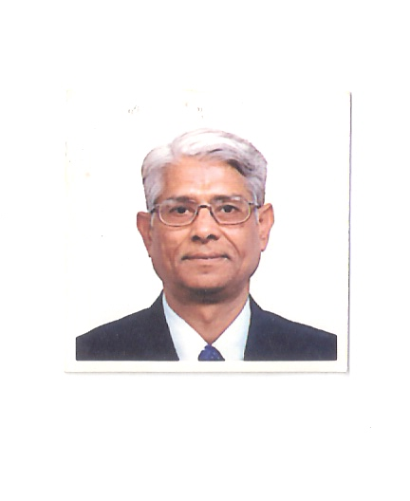
VIDEO LINK : https://www.youtube.com/watch?v=OtgJYk6RGVA

J C Shukla’s brief profile

Name : J C Shukla
Sex / Age : Male / 72 years
Contact details : Details given in footer

Qualification : A) Bachelor of Engineering – Mechanical
B) MBA from IIM Ahmedabad – 1971 batch

Experience : I have handled various assignments in different
capacities. I have 35 years experience in operating as CEO, Managing director, Advisor, consultant etc

Present engagement : Managing Director of Nahak Overseas Limited

(www.nahak.com)

Special Achievements :

- I am on the board of USA company as director (www.hawthorneworld.com)
- I am consultant to Government of Germany for attracting investment near Berlin.
- I am consultant to Government of Kenya to address shortage of housing by arranging funds and technology from USA.
- UNO appointed me as Observer in WSIS (World Summit on Information Society) Geneva-2003
- ITC / WTO / UNCTAD invited me to conduct a hands on seminar about how to use ICT (Information & Communications Technology) for global marketing. It was conducted in Geneva in 2003 and was attended by representatives of 50 countries

ICT projects, conceived by me, under implementation/ execution:

- Highway rescue project
- Food for all – RAM ROTI
- Blood for all
- Jobs for all - ESAF

PROJECT NAME : A MILLION JOBS FOR PHYSICALLY CHALLENGED

INTRODUCTION OF THE VENTURE PLAN

ICT (Information Communication Technology) has revolutionized the way we work in each walk of life.

I was invited in a special session of ICT at UNO, as an observer in 2003. Since then, I have conducted global seminars in ICT for WTO/UNCTAD/ ITC to create opportunities.

Highway rescue project and blood for all, which are running successfully in India has saved many lives (maybe a million). I was fortunate to participate and design its ICT application.

It’s my passion to create million jobs for handicapped through ICT in India and Africa.

THE PROBLEM:

India has approximately 100 million physically challenged population. Out of which 70% are employable in suitable jobs. Due to high unemployment and underemployment in India, these people, even though competent, do not get chance due to some physical disability.

It is my endeavour to create an option for honorable livelihood for them, within the vicinity of their homes.

THE SOLUTION:

I have designed a business model, which is self sustainable and have been tested on small pilot scale

The model works on three main principles.

1) ICT: Most of these people are having cell phones and hence they are connected.

2) POWER OF CROWD: It is for the first time, history is experiencing that what one person
can't do.. that group can achieve easily. Hence 'Tragedy of Commons' can be
converted to "Power of Crowd" (there are many example like political coup in
Egypt, Wikipedia , London bombing etc. )

3) LAST MILE SOLUTION:

The business model is simple and doable. It’s a mega project and it is only viable economically at big numbers.

We are collecting database of few million handicapped / challenged people in India as it is available with government. They may be at different locations all over the country. As mentioned above, most of them have cell phones and it is possible to connect them easily. We will collect their details on their capacity to work, background information etc and create a detailed database. We may float an NGO or tie up with one who has national reach and make all of them its member.

Each member is asked to look into various tasks related last mile solution / problems in the neighborhood of their homes and what product/service can be delivered.
After having these datas, it is easy to aggregate them and find out most critical and doable services or product, we can deliver to the target group i.e. neighborhood. The project has high economical viability as we do away with middlemen and related expenses like exhibiting in super market, logistic, stocking etc. The NGO will tie up at national level with multinational companies for products and services to be delivered at last mile.

