CHAPTER I
INTRODUCTION

Background of the Study
Today, technology has made life much easier in accessing to information and can be done anywhere, anytime. As technology improves in the area of wireless facilities and mobile computers, mobile computing has become feasible. A variety of advanced mobile devices, some mobile wireless systems, and mobile computing applications already exist. For example, people can send and receive emails and access the Internet using mobile computers via wireless networks. Now, with the advent of such modernization in education, one way to globalize the process of research is to realize that technology is advancing at an incredibly fast phase. Computers are not confined to being used for entertainment but their role in education is also vast. Digital information is electronic information, the result of computer processing.

According to Naik (2017), online grade viewing systems can help both students and educators meet course objectives and course learning outcomes more effectively. Likewise, with the Student Academic e-Record Manager with Android Support Application, the students can view their grades and submit their scholarship requirements anytime and anywhere.

Most of the students encounter difficulties in knowing the results of their grades because they are unaware of their academic status. In submitting the scholarship requirements, there are always incomplete requirements/documents sent to the Scholarship Program Coordinator. We conducted an interview at the registrar’s office and at the scholarship program coordinator’s office to observe the flow of submitting the student scholarship requirements and also to know the flow of the student grades on how the registrar’s office processes the grade of the students.

This paper is a proposed application to be used by the students of Colegio de Sta. Ana de Victorias. This uses mobile technology that can help the students in monitoring their academic progress and also in passing requirements for their scholarship programs. This proposed system plays a key role in the management system of the school. But, such systems do not often relate expectations, outcomes, and performance. As each student desires to achieve a good score for each assignment, exam, project, and/or report, the whole process adds a heavy workload for teachers in order to make their evaluation fair, comprehensive, and accurate. From the registrar’s perspective, these are necessary to avoid disagreement from students and parents.

Conceptual Framework
This section shows the conceptual framework of the study based on Input-Process-Output-Outcomes in the flow of data of the Student Academic eRecord Manager with Android Support Application.

Table 1.0 Conceptual Framework of the System

Student grades

Data Gathering

Results

End User Requirements

Observation

Interview

Pre Evaluation

Design and Develop an Application

User acceptability

Student Academic eRecord Manager with Android Support Application.

Efficiently accommodate student’s inquiry

Quickly reserve student’s request

Effectively provide grade information to students

Efficiency in sending of student scholarship requirements

It increases the ability of the school to monitor student’s grades

Input
Process
Output
Outcomes

Objectives of the Study
The aim of this study is to develop a Student Academic e-Record Manager with an Android Support Application to produce a workable computerized grading system and scholarship program assistance system for Colegio de Sta. Ana de Victorias.

Specifically, this study aims to:
- Design a system that can help to support the school-based academic process such as:
  - Grading management system
  - Scholarship program assistance management
  - Android support grades inquiry access
- Develop a system that has a capability and functionality that support the overall workflow such as:
  - E-record of student grades
  - Can assist in collecting student scholarship requirements.
  - Provide monitoring of students that are qualified for their application on scholarship programs.
  - Capable of providing inquiry access of student’s grades.
- Determine the system quality and performance based on the IT Expert testing using ISO/IEC 9126-1:25021.
- Identify the level of User-Acceptability based on modified ISO standard and self-made instrument.

Scope and Limitations of the Study

This proposed study of Student Academic e-Record Manager with Android Support Application is intended only for Colegio de Sta. Ana de Victorias. This study covers the Registrar's Office and Scholarship Office.

The Student Academic e-Record Manager with Android Support Application is designed to provide incentives for achievement and assist in identifying problem areas of a student and also in submitting the scholarship requirements without any conflicts. It is the most commonly used means of analyzing student performance, talents, and skills. As the workload gradually increases with growing amounts of grades and student lists that need to be attended to, it becomes tedious on the part of the teacher and for the school’s scholarship coordinator to proficiently manage them in time for documentation and file submission to the higher education authorities. As such, this study aims to develop an application to address these issues.

Significance of the Study
The study will benefit several areas or person/s of Colegio de Sta. Ana de Victorias to manage the issues and to help the process to improve the system. It will be beneficial to students because of the improvement in the accuracy of calculations and in the proficiency and productivity of the teachers.

This study is significant to the following:

Students. This study is beneficial to students for they will be able to view their grades through the application and they will be aware of their academic results.

Teachers/Professors. Professors would be able to record and compute the grades of their students faster without any interruptions and thereby lessening their workload.

Registrar's office. The registrar’s office can release the inquiries of the students by using the application.

Future Researcher. This study may serve as a reference for future researchers for the improvement of the system. This study will serve as training for the proponents to enhance their skills.

Definition of Terms
This includes the following key terms that are conceptually/operationally defined to help readers understand the words as used in the context of this research.

eRecord Manager. Electronic records management is the broadest term that refers to electronically managing records on varied formats, be they electronic, paper, microform, etc.
eRecord Manager. It refers to a set of activities required for the application/system creation, distribution, use, maintenance, and disposition of recorded information maintained as evidence of business activities and transactions to students.
System. A collection of elements or components that are organized for a common purpose.
System. It refers to an output of the research developing application that is built to use and replace the manual process of the students into computer-based.

Android Support. An operating system for smartphones and tablets.
Android Support. It provides application to allow students to submit requirements and view grades.

CHAPTER II
RELATED LITERATURE AND PRIOR ARTS SEARCH
This chapter presents the review of related literature and prior arts from various sources that are relevant to the study of Student Academic E-record Manager with Android Support Application.

On related Studies

Android Based College Application for Students
According to this author, a mobile application is easier to use and obtain information by nature, and this requirement promoted the development of mobile applications. There is a need for a college application that all students and faculty may utilize. The elements that have been included in the methodologies utilized to accomplish them, as well as the purpose of each of the functionalities, are detailed. This document highlights all of the application's primary features, such as sharing lecture notes and push notifications, Notifications, navigation, and an open forum all contribute to the site's optimal use and efficacy. (Rajat Porwal, Srajan Singhal, Srijan Sinha,2021)

Web-based Usability Measurement for Student Grading Information System
This paper demonstrates the usability measurement of web-based student grade processing information systems. Atisa Dipamkara High School has been using an online application system to process the Student’s Grade. One factor in measuring the quality of an information system is usability. Usability level refers to the ease of use of such information systems or software. The higher the usability value means the higher the benefits of the information system in helping the users.(Hendra, S.Kom., M.T., Yulyani Arifin, S.Kom., M.M., 2018).

Concept-Based Students Data Retrieval and Repository System
According to the author, Concept-based student data retrieval and repository systems are web-based application software that helps deal with storing students’ academic information and displays them when required by the legitimate user. The main purpose of the study was to develop an online concept-based student data retrieval and repository System. The specific objectives were to identify software requirement specifications for the System design, identify the problem of the file system and the design system techniques. Data analysis was done with the help of (SPSS) Statistical Package for Social Science which was used during data manipulation. The findings obtained as the system was tested in a comprehensive manner and running in a friendly way, Therefore, it's recommended that concept-based student’s data retrieval and repository System has to enable students and staff to learn not more than 24 hours for those having low knowledge about computer skills so as to meet accessibility and effectiveness of the system (Edward Onyango Orunda, Habiba Njeri Ngugi, 2018).

Development of an Android-Based Class Record for Teachers
The author of this document develops the mClassRecord is a stand-alone mobile application that automates the manual process of a class information recording and management practices of teacher educators in the Philippines. The app allows the teacher to record students, manage class information, monitor attendance, assign groupings, manage tasks, assess students, and view a dictionary of teacher education terms. The study recommends making mClassRecord online to incorporate data-syncing features. (Dave E. Marcial1, Chuchi S. Montenegro, Ranel B. Ubarre, Melody Angelique C. Rivera, Marianne S. Yao, Fairy May G. Katada 2018).

On Prior Arts (Related System)
Student Academic Management System using Android Application
According to the author, our everyday routines and lifestyles have been altered by technological advancements. Students in college and high school demand modern technology that supports smartphones in order to get information and notifications about exams, placement, absence (leave/OD), transportation, and other topics. Students and teachers can access lecture notes, assignments, quizzes, and other materials more easily with online tools like Google Classroom. However, Google's classroom tool does not support details like accessing information about their attendance percentage, requesting permission for leave/OD, no due, semester results, and examination details. Since the authorities spend so much time at an institution, keeping academic records becomes a top priority. (M.A.Mohamed Suhail, S.Naveena, S.Prasannabalaji, C.Rachana, P.Ponmurugan, C.Venkatesh, 2020).

Spamast Mobile Grade Inquiry System
According to the author, they aim to develop a system that allows students to inquire about their grades online using android phones or tablets and develop a workable grade inquiry system using an android phone or tablet. This application acts as a mobile version of the current system that is being used by the students.

The system enables the users to view grades from smartphones which are required to be connected to the internet. The system can operate using an android version 4.4 or higher. During the application testing, the researchers used sample data to test its functionality. Based on the result, the application was able to achieve the specified objectives. It can be applied directly to the current problems of the users. The application was developed using Android Studio IDE with Java programming language. During the development period, the waterfall model was used since it has the flow on how to properly use and run the application. It has a process that directly provides the output. The application connects to the school’s database to fetch the student's grade.(Iteit Spamast-Malita, Southern Philippines Agribusiness, and Marine and Aquatic School of Technology, 2018).

Student Academic Record Management System Framework using Oracle Apex
According to the author, The Student Academic Record System is an increasingly important aspect in any of the academic Institutions especially in the Technical and Higher Education. The challenges for the administrator and management to make several academic decisions with reference to academic reports are very high. In some cases, the system could not provide ample solutions to several problems such as improper course registration, tracking of advised courses, and inaccurate marks calculation due to manual entry. These things could lead to erroneous reports that could affect the management’s decision. In addition, a data or a record that is wrongly entered into a system could affect the result of one or more academic reports that are being required. This paper will provide a structural framework that gives an alternative, complete solution for record keeping and management of useful information for management decisions. It will address many issues related to course assessment, course record management that includes record keeping of the student marks, and course tracking. The Smart College Solution-Student Academic Record System (SCS-SARS) will provide a user friendly, reliable and accurate web-based system using Oracle Apex. It will provide an accurate academic statistical and graphical report that can be used by the management in their decision-making.
Automated SQL Grading System

According to the author, the grading system is a procedure used by teachers to assess and evaluate a student’s educational performance. The method employed by tutors in a general grading system for grading structure query language (SQL) assignments is laborious, time-consuming, and inaccurate. In this paper, an automated grading system for SQL queries is proposed which thus provides an efficient way to assess a student’s performance by awarding appropriate scores. The automated grading system is implemented for part marking using PostgreSQL. The front-end of our system is executed with a database-driven website in Django. We believe that the system will be very useful to global educational systems. (Shona Kanchan, Samruddhi Kalsekar, Nitsita Dubey, Chelsea Fernandes, Safa Hamdare, 2021).

Synthesis
Grades are a measure of how broadly and deeply you have mastered the objectives in a course. Student grades are vital information needed in advancing to the next grade year level and its accuracy is very important. Our study on Student Grades Centralized Repository with Android-Based Support Application helps in monitoring the grades of every student to improve their learning based on the result of their grades and also it promotes transparency to give the answer to those students who have doubts with regards to their grades. The awareness of the students about their grades will serve as their reference to their learnings to have a high grade. And also with the help of our system, the guardian of the student can monitor the grades of their children and because of that, the guardian can educate their children if there is a problem with the grades in their academic studies.

CHAPTER III
METHODOLOGY
This study dealt with the methods being used to conduct this study in Colegio de Sta ana De Victorias. It includes the Research Design Methodology, Feasibility Studies, System Design, Software Development Life Cycle Model and the Requirement Specification. This study explained the data and information gathered, analyzed, and presented. It also discusses the different charts, graphs and diagrams presented.
THESIS RESEARCH COMPONENT
Research Design
In this study, it will use the developmental research approach. Instead of experimenting, this research approach was used every time you developed a certain project or product. It will conduct research and surveys with the department of the CSAV to determine the existing problems that could be solved and enhanced. It will also observe the manual process of distribution of student grades and submission of the student scholarship requirements.

Respondents of the Study
The respondents of the CSAV Student Academic E-record Manager with Android Support Application were the Students (), Registrar Office(), Scholarship Office (), Faculty & staff() A total of 30 respondents were asked to participate in the study’s evaluation form.

Table 1.0 Summary of Respondents of the Study
Categories | Actual Population
Student  ITol  Registrar Office  Scholarship Office  Faculty & Staff | 20  3  2  5
Total | 30

Table 1.0, shows the summary of the population of respondents. Coordinators of the different programs were assigned to handle area(s) and are responsible for collecting needed data/evidence and compilation of documents for presentation as preparation for the survey visitation.

Sampling Technique
The respondents of this study are the Students, Registrar’s Office, Scholarship Office and Faculty Staff. In this case, the researchers will use purposive sampling to the respondents to evaluate and measure the extent, efficiency/effectiveness, and satisfaction of the system implementation.

THESIS SOFTWARE DESIGN AND DEVELOPMENT COMPONENT
Software Development Life Cycle Model

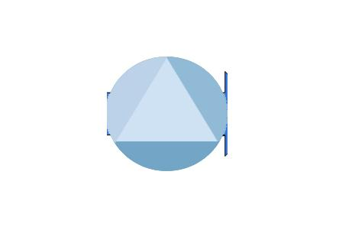
Rapid Application Development (RAD) is a development model that prioritizes rapid prototyping and includes six stages: Planning and Analysing, Coding, Testing Phase, System Design, Implementation, Maintenance.

Planning & Analyzing

Prototype
Cycles
Design
Coding
Testing
Implementation
Maintenance
Figure 2.0 Rapid Application Development Model of the Student Academic E-record Manager with Android support Application.

Data Gathering
In this phase, the researcher crafted the questionnaire as a tool to determine and identify the needs and requirements of the system to meet the solution of the existing problem in the perspective of the end-users. Likewise, interview questions were prepared to seek the views of the Students, Registrar Office, Scholarship Office, and the Faculty and Staff.

Data Analysis
After data gathering, the researcher analyzed the data based on the objectives of the system development adherent to the software development life cycle model.

Planning and Analyzing
The researcher will conduct an interview and a survey with the system's intended beneficiary at this phase. The researchers use tools like questionnaires to conduct research interviews and surveys. The next step is to collect data in order to identify the preferred and required features for the proposed system. Regarding the collection of data, the researchers evaluate the potential problem in terms of the user's needs and requirements.

Source Coding
During this phase, the proposed system will be developed. During the data-gathering phase, the researchers evaluated the system design including the collected data. The researcher used this information to ensure that the application achieved all of the criteria stated in the topic of this research. The researcher uses to develop a program using Hypertext Processor (PHP) as a back-end programming language, Cascading Style Sheet (CSS), JavaScript, and Bootstrap for the front-end user interface, design and responsiveness, and Structured Query Language (mySQL) for the database management.

System Design
The system design will start after all of the planning and analysis have already been completed. It will ensure the end requirements of the users on overall design and user interface are achieved. The physical and logical design of the developed system is defined in this chapter. This Will display the proposed system's interface layout and the system's architectural design.

Program Testing
In this phase, the researcher will conduct a survey for the specialists to evaluate and test the system's functionality when it was completed. During this phase, researchers will determine if the system is functioning as intended or even if the user interface is functional and user-friendly.

System Implementation
In this stage, the system underwent another round of tests, the User Acceptance Testing (UAT). The UAT testing instrument was distributed to the end-users and actual running/testing was done with the presence of the researcher. UAT is done to ensure end-users acceptability and integration of suggestions/recommendations.

Data Flow/Context Diagram
It describes the context data flow of the developed system in this part to help users comprehend their information needs. It allows a graphical model of the system flow and processes to be shown.

Figure 2.0 Context Data Flow Diagram
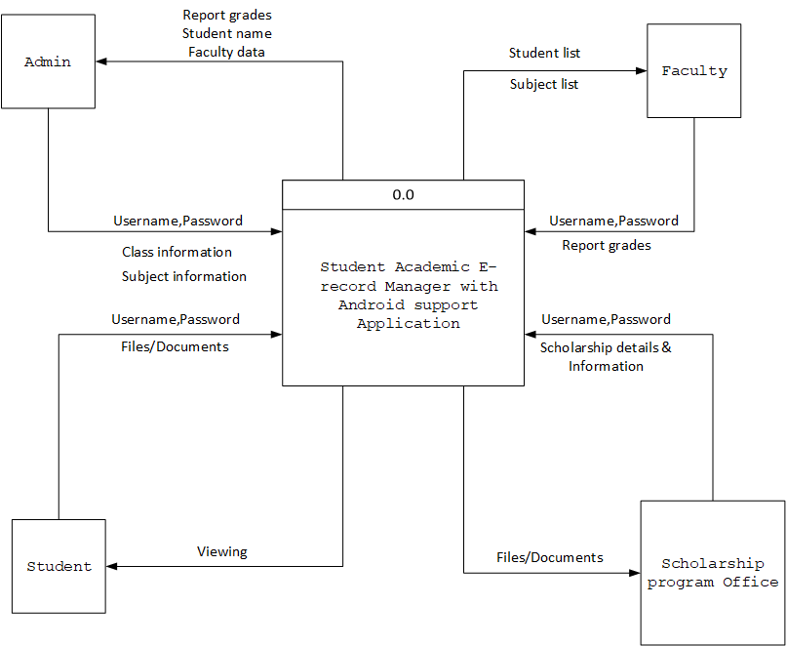

Student Academic E-record Manager with Android support Application data flow diagram admin login

Operational Framework
kulang

Use Case Diagram
It provides an overview based on the usability and requirements of the developed system. The researcher gives emphasis about the actual development to identify the functional requirements and the accessibility level of the users on the system.

Details of Technology
NONESCOST Economic Enterprise Recording with Decision Support system
Log-In
This involves hardware, software and other relevant technologies in the development and implementation of the system.
Hardware and Software Compatibility
The following are the list of hardware and software required in the development of the system.
Hardware Specification:
Processor - A10-7700K Radeon R7, 10 Compute Cores 4C+6G 3.40 GHz
Hard disk drive - SSD 250GB and HDD 500GB
Memory - 8.00 GB RAM

Software Specification:
- Operating system Windows 10 or Windows 11 (64 bit)
- Installed Xampp Server (Latest version)
- Installed Visual Studio Code or notepad++ (Any Version)

Relevance of the technologies
The Student Academic eRecord Manager with Android Support Application was designed to run using the android support devices and web browsers.
Development
- Xampp Server
Developers use this development tool to create web applications with Apache2, PHP and MySQL database.
- Visual Studio Code
It is a source-code editor made by Microsoft for Windows, Linux and macOS. Features include support for debugging, syntax highlighting, intelligent code completion, snippets, code refactoring, and embedded Git.
- Programming
- Hypertext Markup Language (HTML5)
The markup tells the Web browser how to display a Web page's words and images for the user.
- Cascading Style Sheet (CSS)
Adding style to Web documents and it contains to display the design on the web.
- JavaScript
Client-side scripting language use for validate form input, create image rollovers, and to open those annoying pop-up windows.
- PHP
Server-side programming language provides functionality of the system in accessing database.

Implementation Requirements
This section presents the Server specification and Network Architecture for the implementation of the developed Student Academic eRecord Manager with Android Support Application.

Network Architecture

Figure 6.0 Network Architecture for the implementation of the developed system

References

Akhtar, Bahareh. An Automated Grading and Feedback System for a Computer Literacy Course. Diss. Appalachian State University, 2015.

Brillantes, Alex B., Karen Dominique B. Brillantes, and Justine Beatrice B. Jovellanos. Process evaluation of the CHED K to 12 adjustment assistance program. No. 2018-05. PIDS Discussion Paper Series, 2018.

Hendra, S., and Yulyani Arifin. "Web-based usability measurement for student grading information system." Procedia Computer Science 135 (2018): 238-247.

Jagadeeswari, M., et al. "Virtual Learning Assistance for Students." 2021 Third International Conference on Inventive Research in Computing Applications (ICIRCA). IEEE, 2021.

Kanchan, Shohna, et al. "Automated SQL Grading System." Innovations in Computer Science and Engineering. Springer, Singapore, 2021. 701-708.

Marcial, Dave E., et al. "Development of an Android-Based Class Record for Teachers." Development 2.4 (2018): 83-90.

Varat, Abhishek, et al. "Online interactive educational system for submission and evaluation of programming assignments." 2017 International Conference on Intelligent Computing and Control (I2C2). IEEE, 2017.

