 | AFMS/AMMS | SLM-AFMS-AMMS
 |  | Edition :1 Rev: 0
 |  | Date:17/06/2026
 |  | Page: 1/25

SLM for Glider
Life Extension Project
A/C : GENERIC

This document includes the Aircraft Flight Manual Supplement (AFMS) and the Aircraft Maintenance Manual Supplement for SLM operations.
It must be attached to the approved AIRCRAFT FLIGHT MANUAL (AFM) kept on board the aircraft.
The maintenance-related sections shall also be included in, or referenced by, the aircraft Aircraft Maintenance Manual.

LIST OF EDITION/REVISION INCORPORATED
Edition | Revision | Date | Description | Page
1 | 0 | 17/06/2026 | Original SLM AFMS AMMS | 1-25

Scope
The device installed in the glider records in-flight acceleration data used to derive load-factor variations. These data are processed as part of the Structural Life Monitoring solution to calculate the measured usage spectrum and its Equivalent Fatigue Index (EFI). The EFI is compared with the approved reference EFI (EFI calculated using certification hypothesis). When the applicable EFI, inspection, and continued-airworthiness criteria are satisfied, the process may support operation beyond the originally certified safe-life limit.

Limitations
This supplement does not introduce new aircraft flight-envelope limitations.
Operation beyond the certified safe-life limit is permitted only when the approved SLM process and associated Instructions for Continued Airworthiness (ICA) are satisfied.
Before the certified safe-life limit, flights without valid SLM data receive no measured-usage credit.
Beyond the certified safe-life limit, the SLM recorder, required calibration status, validated EFI status report, and required inspections are conditions for continued airworthiness.

Emergency procedures
There is no emergency procedure associated with this supplement.

Normal procedures

Recorder Description

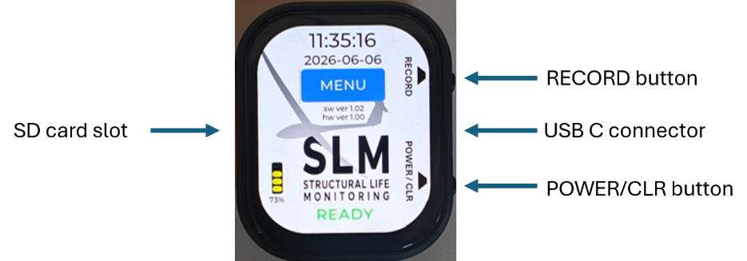

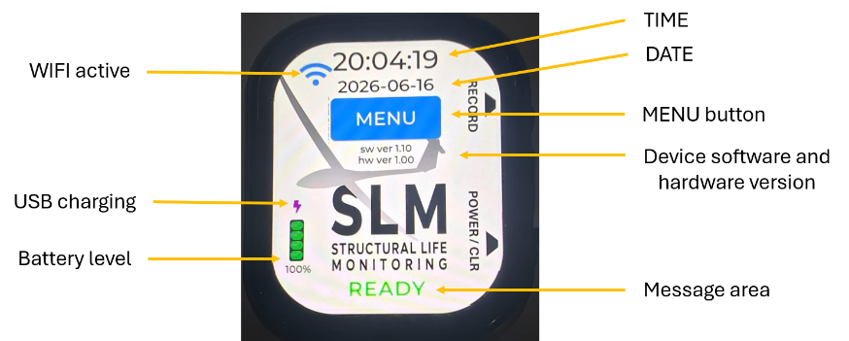
The recorder is installed in the glider using a specific support (see installation instructions, section 7).
The USB-C connector should always be connected to the recorder.
All recorder controls are performed using the touch screen, the POWER/CLR and the RECORD buttons.
A 16GB Class 10 micro SD card is provided with the recorder.

Recorder Power Up
The recorder starts when the POWER/CLR button is pressed momentarily or when USB-C power is available.
There should be a green READY message at the bottom of the display.
/!\ If Amber or Red error messages are displayed at the bottom of the display, they should be corrected before flying (see message section 5).
/!\ If the recorder does not automatically start when the glider battery is connected, check USB-C and power connection.

Recorder Power Down
The recorder stops when the POWER/CLR button is pressed for ~3 seconds or when USB-C power is removed.
In some error conditions, this may require holding the button for up to 8 seconds.
When the recorder is in recording mode:
- if USB-C power is lost, the recorder continues to record.
- if the POWER/CLR button is pressed or the battery level is below 5%, recording will stop and recorder will power down.

Recorder Special Screens
When there is no interaction with the recorder for more than 10 seconds, the display goes to stand-by mode to save battery power. Display can be activated by touching the screen.
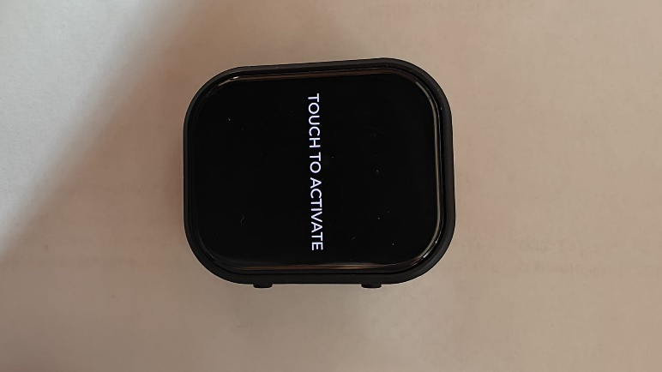
When battery level goes below 5%, the recorder display a red message asking the user to connect active USB-C power, before shutting down.
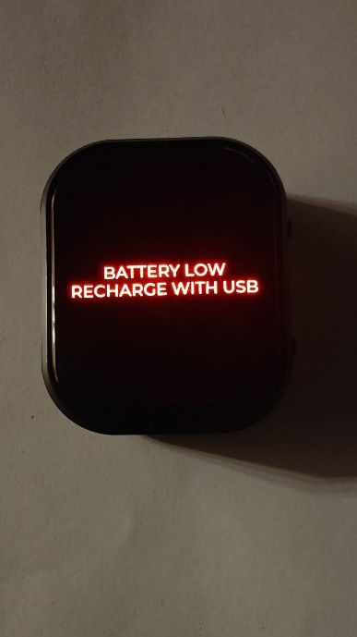

Start Recording Mode
The recorder can be started by pressing ~1 second on the hardware RECORD button or on the display MENU -> START RECORD button.
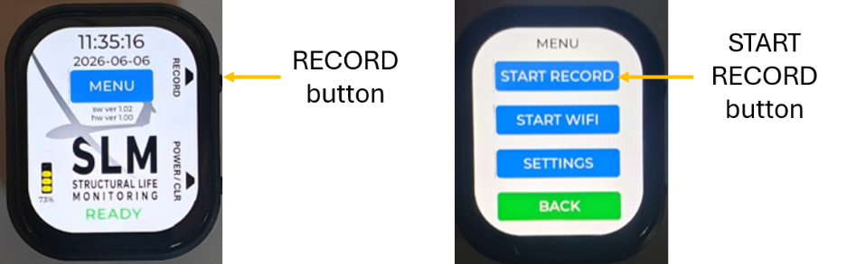
The recorder should display STARTING and immediately after, RECORDING
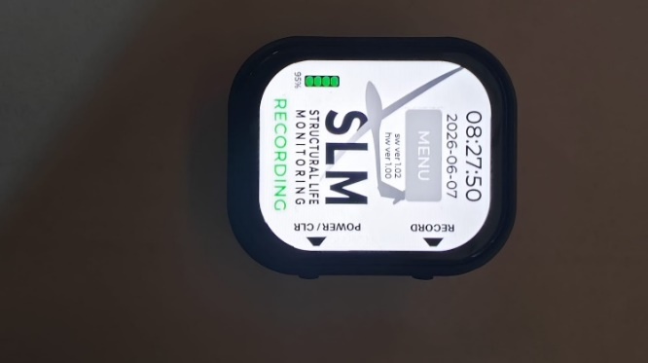
The recorder creates one daily binary file. Additional same-day recording sessions are appended to the same daily file, and the suffix is updated to show the number of recording sessions contained in the file, for example FCJAF_20260616_1.bin, then FCJAF_20260616_2.bin.

Stop Recording Mode
The recording mode is stopped by:
- pressing on the hardware RECORD button for ~3 seconds
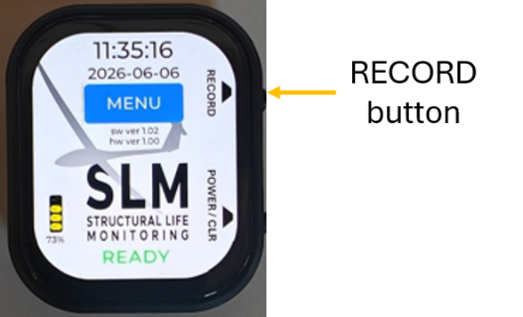
- pressing on the display red STOP RECORD button for ~1 second (MENU page)
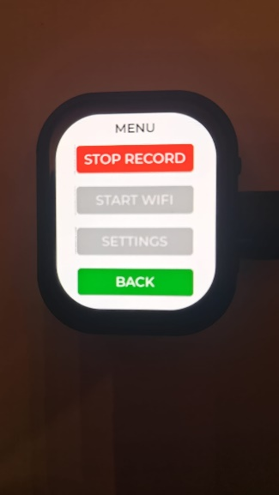
- pressing the POWER/CLR button for ~3 seconds *
- if the battery level goes below 5% *
* : in this case the recorder will also power down.

Pre-Flight Check

When the glider's battery is installed and connected, the recorder should automatically start and the display should be active with a green READY message at the bottom of the display.
/!\ If the recorder does not automatically start when glider battery is connected, check USB-C and power connection.
/!\ If Amber or Red error messages are displayed at the bottom of the display, they should be corrected before flying (see message section 5).

Before Flight
Start recording mode.
/!\ If a flight is performed without SLM recording, or if the recorded data is invalid, the flight shall be treated in accordance with the approved missing-data procedure and No measured-usage credit is granted for that flight.

After flight

Stop the recording mode.

At the end of flying day
The last pilot-in-command to fly the glider must update the glider's usage information on the Structural Life Monitoring (SLM) website.
Using a device capable of WIFI (a smart phone or a PC), the files should be first downloaded from the recorder to the device and then transferred to the SLM website.
See section 6.3 for access to the recorder Web pages.
Select File Management.
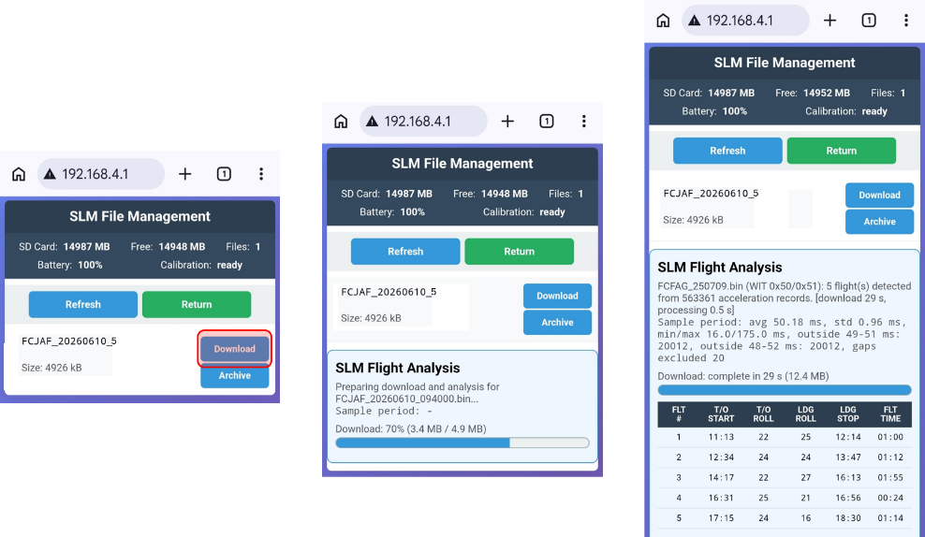
Selecting Download will transfer and process the selected file from the recorder to the device.
When a file is transferred to the device, it is necessary to upload it to the main SLM server using the address:
https://planeur-la-llagonne.com/gestion-vols/index.php
You need an account and a password to access the SLM server (contact support to get an account)
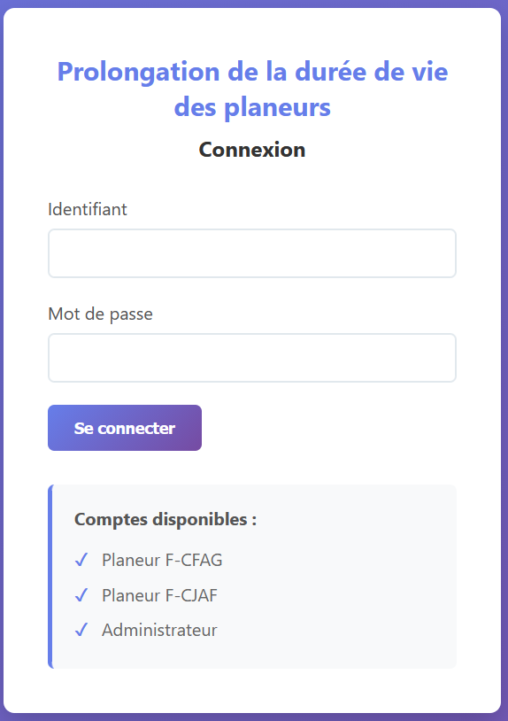
When the account and password are entered, you have access to the main SLM server page
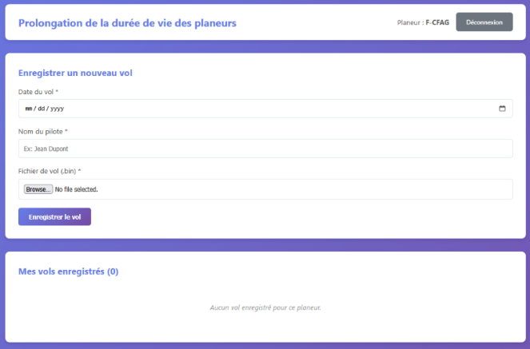
To upload a file to the SLM server, you need to enter the date, the pilot name and select a file previously downloaded from the recorder to the device.
When the file is correctly uploaded to the SLM webserver, it can be archived from the recorder by selecting Archive on the SLM Recorder web page.
/!\ The recorder only accepts 50 files.
When all operations associated with the recorder are finished, the recorder should be stopped.
- Messages

Message | Type |  | Operator action
BOOT | Startup transient
READY | normal operation
RECORDING | normal operation
STARTING | recording start transient
STOPPING | recording stop transient
SHUTDOWN | Shutdown transient
SD OK/CLR | SD recovered / clear prompt |  | press clear to confirm SD error correction
NEED SETTINGS | setup required |  | perform date, time, registration and password SETTINGS
ACC CAL REQ | accelerometer calibration required |  | perform Web acceleration calibration menu (START WIFI)
INST CAL REQ | installation calibration required |  | Perform Web installation calibration menu (START WIFI)
NO SD | SD not detected warning |  | insert a valid SD card
SD LOW | SD memory low |  | insert an SD card with enough free space (500 MB min.)
SD FULL (FILES) | SD has too many files (50 max.) |  | download/delete files from recorder Web interface (START WIFI)
LOW BATT | Low power warning |  | connect USB
CAL FAULT | calibration fault |  | perform factory reset and perform new calibrations
FATAL WDG/CLR | watchdog fault acknowledgement |  | press the power/clear button to acknowledge/clear error *
ACCEL ERR | hardware/runtime error |  | press the power/clear button to stop recorder, then restart *
RTC ERROR | hardware/runtime error |  | press the power/clear button to stop recorder, then restart *
PMU ERROR | hardware/runtime error |  | press the power/clear button to stop recorder, then restart *
REC FAIL | recording failure |  | press the power/clear button to stop recorder, then restart *
TOUCH ERROR | hardware/runtime error |  | press the power/clear button to stop recorder, then restart *
ERROR | generic fallback error |  | press the power/clear button to stop recorder, then restart *
SD ERROR | SD/storage fault |  | press the power/clear button to stop recorder, then restart *
GENERIC ERROR | fatal error |  | press the power/clear button to stop recorder, then restart *
* It might require pressing the power/clear button up to 8 seconds to stop device.
* If the error persists after restart, report problem to support

Recorder Special Functions

Recorder Reset
/!\ when resetting the device, all SETTINGS and CALIBRATIONS parameters are lost.
To reset device, press the RECORD button and immediately press the POWER/CLR button until the device stops.
When the device is restarted, it should ask the user to configure SETTINGS and CALIBRATIONS.
Corresponding amber messages are displayed.
To help the user navigate through the configuration pages, the required button are in Amber color.
Buttons return to their normal color when all required configuration changes are done.

Access to the recorder Web pages
Using a device capable of WIFI connection (a smart phone or a PC), the recorder file-management, maintenance, calibration, and firmware-update pages are accessed from the recorder local web page.
To connect to the recorder WIFI and Website, select MENU and START WIFI.
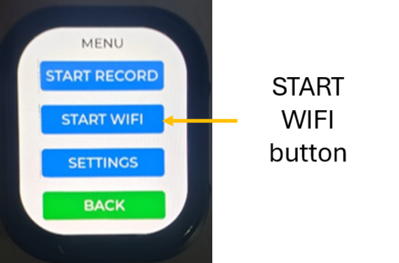
Open the WIFI connection manager on your device and select the recorder WIFI SSID which is SLM- followed by the glider registration.
Then open a browser in incognito mode on the device and type http://192.168.4.1/
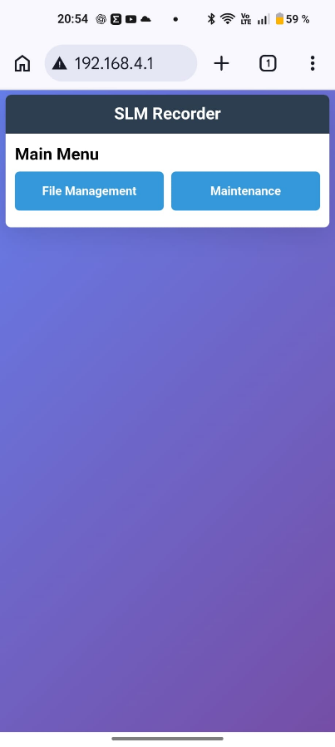
When the WIFI activities are finished, you need to stop the WIFI by selecting the STOP WIFI in the MENU.

