 | AFMS/AMMS | SLM-AFMS-AMMS
 |  | Edition :1 Rev: 0
 |  | Date:17/06/2026
 | CS-STAN 104b | Page: 1/25

SLM for Glider
Life Extension Project
A/C : GENERIC

This document includes the Aircraft Flight Manual Supplement (AFMS) and the Aircraft Maintenance Manual Supplement for SLM operations.
It must be attached to the approved AIRCRAFT FLIGHT MANUAL (AFM) kept on board the aircraft.
The maintenance-related sections shall also be included in, or referenced by, the aircraft Aircraft Maintenance Manual.

LIST OF EDITION/REVISION INCORPORATED
Edition | Revision | Date | Description | Page
1 | 0 | 17/06/2026 | Original SLM AFMS AMMS | 1-25

Scope
The device installed in the glider records in-flight acceleration data used to derive load-factor variations. These data are processed as part of the Structural Life Monitoring solution to calculate the measured usage spectrum and its Equivalent Fatigue Index (EFI). The EFI is compared with the approved reference EFI (EFI calculated using certification hypothesis). When the applicable EFI, inspection, and continued-airworthiness criteria are satisfied, the process may support operation beyond the originally certified safe-life limit.

Limitations
This supplement does not introduce new aircraft flight-envelope limitations.
Operation beyond the certified safe-life limit is permitted only when the approved SLM process and associated Instructions for Continued Airworthiness (ICA) are satisfied.
Before the certified safe-life limit, flights without valid SLM data receive no measured-usage credit.
Beyond the certified safe-life limit, the SLM recorder, required calibration status, validated EFI status report, and required inspections are conditions for continued airworthiness.

Emergency procedures
There is no emergency procedure associated with this supplement.

Normal procedures

Recorder Description

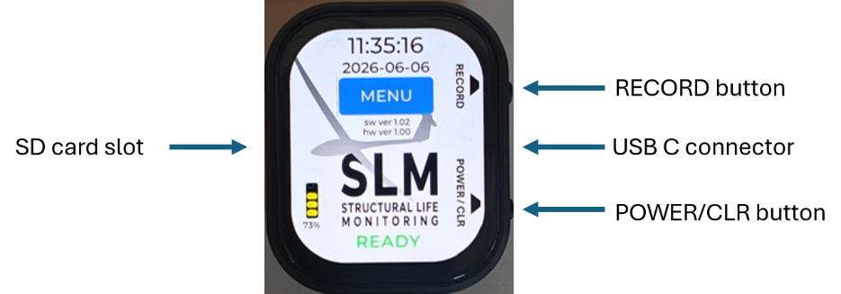

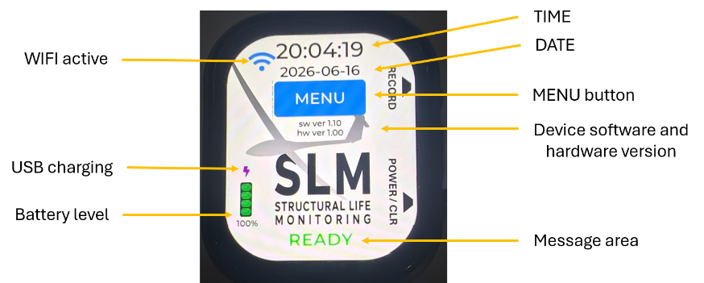
The recorder is installed in the glider using a specific support (see installation instructions, section 7).
The USB-C connector should always be connected to the recorder.
All recorder controls are performed using the touch screen, the POWER/CLR and the RECORD buttons.
A 16GB Class 10 micro SD card is provided with the recorder.

Recorder Power Up
The recorder starts when the POWER/CLR button is pressed momentarily or when USB-C power is available.
There should be a green READY message at the bottom of the display.
/!\ If Amber or Red error messages are displayed at the bottom of the display, they should be corrected before flying (see message section 5).
/!\ If the recorder does not automatically start when the glider battery is connected, check USB-C and power connection.
When there is no interaction with the recorder for more than 10 seconds, the display goes to stand-by mode to save battery power. Display can be activated by touching the screen.
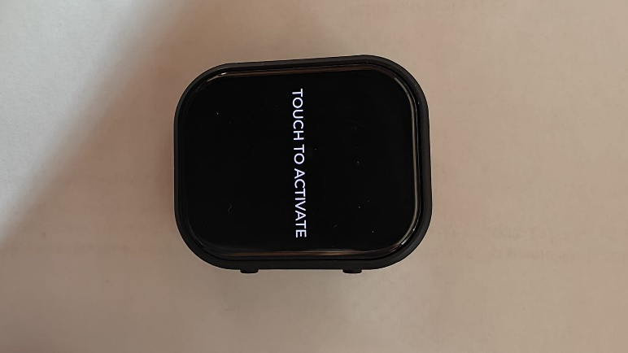

Recorder Power Down
The recorder stops when the POWER/CLR button is pressed for ~3 seconds or when USB-C power is removed.
In some error conditions, this may require holding the button for up to 8 seconds.
When the recorder is in recording mode:
- if USB-C power is lost, the recorder continues to record.
- if the POWER/CLR button is pressed or the battery level is below 5%, recording will stop and recorder will power down.

Start Recording Mode
The recorder can be started by pressing ~1 second on the hardware RECORD button or on the display MENU -> START RECORD button.

The recorder should display STARTING and immediately after, RECORDING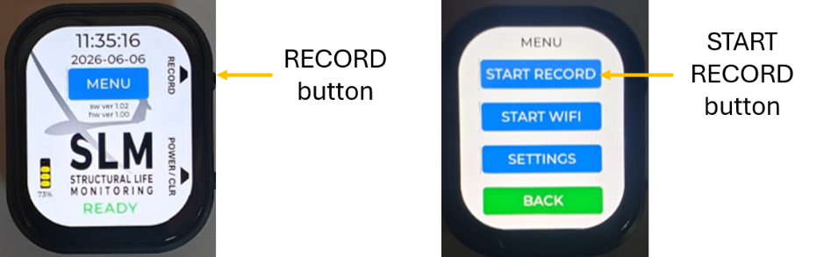
. 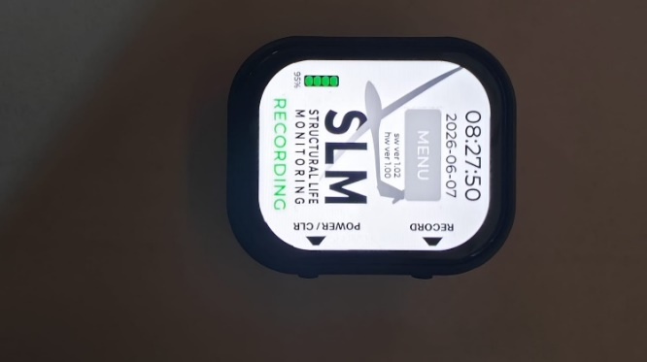
The recorder creates one daily binary file. Additional same-day recording sessions are appended to the same daily file, and the suffix is updated to show the number of recording sessions contained in the file, for example FCJAF_20260616_1.bin, then FCJAF_20260616_2.bin.

Stop Recording Mode
The recording mode is stopped by:
- pressing on the hardware RECORD button for ~3 seconds
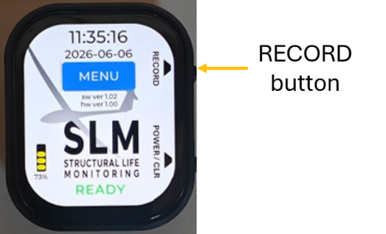
- pressing on the display red STOP RECORD button for ~1 second (MENU page)
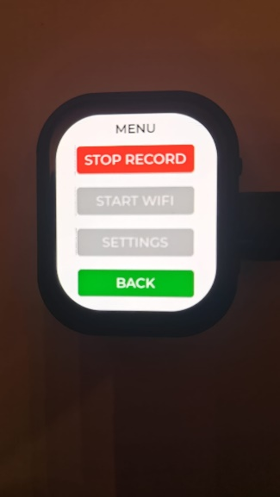
- pressing the POWER/CLR button for ~3 seconds *
- if the battery level goes below 5% *
* : in this case the recorder will also power down.

Pre-Flight Check

When the glider's battery is installed and connected, the recorder should automatically start and the display should be active with a green READY message at the bottom of the display.
/!\ If the recorder does not automatically start when glider battery is connected, check USB-C and power connection.
/!\ If Amber or Red error messages are displayed at the bottom of the display, they should be corrected before flying (see message section 5).

Before Flight
Start recording mode.
/!\ If a flight is performed without SLM recording, or if the recorded data is invalid, the flight shall be treated in accordance with the approved missing-data procedure and No measured-usage credit is granted for that flight.

After flight

Stop the recording mode.

At the end of flying day
The last pilot-in-command to fly the glider must update the glider's usage information on the Structural Life Monitoring (SLM) website.
Using a device capable of WIFI (a smart phone or a PC), the files should be first downloaded from the recorder to the device and then transferred to the SLM website.
See section 6.3 for access to the recorder Web pages.
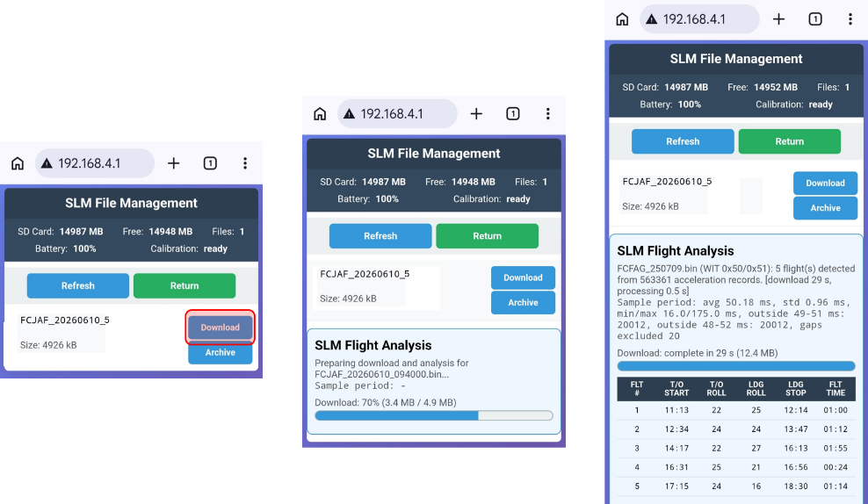
Selecting Download will transfer and process the selected file from the recorder to the device.
When a file is transferred to the device, it is necessary to upload it to the main SLM server using the address:
https://planeur-la-llagonne.com/gestion-vols/index.php
You need an account and a password to access the SLM server (contact support to get an account)
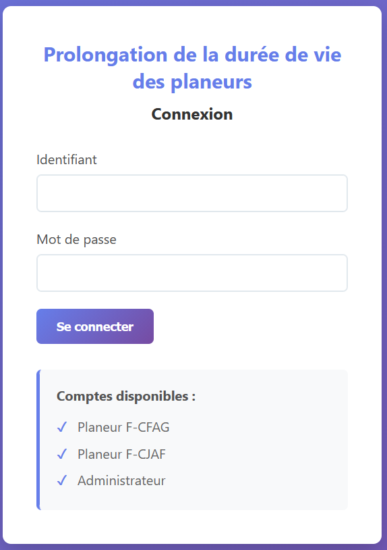
When the account and password are entered, you have access to the main SLM server page
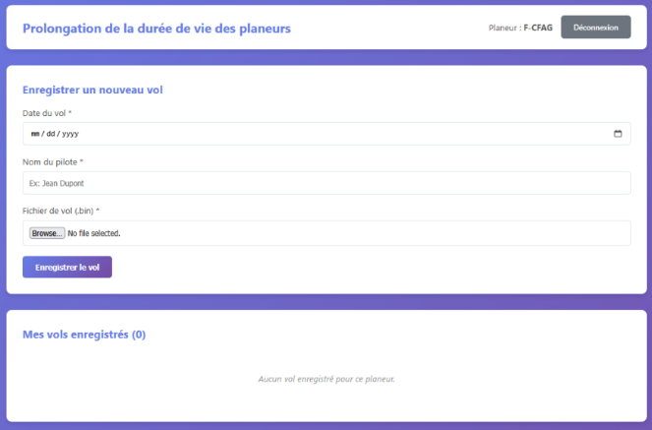
To upload a file to the SLM server, you need to enter the date, the pilot name and select a file previously downloaded from the recorder to the device.
When the file is correctly uploaded to the SLM webserver, it can be archived from the recorder by selecting Archive on the SLM Recorder web page.
/!\ The recorder only accepts 50 files.
When all operations associated with the recorder are finished, the recorder should be stopped.
- Messages

Message | Type |  | Operator action
BOOT | Startup transient
READY | normal operation
RECORDING | normal operation
STARTING | recording start transient
STOPPING | recording stop transient
SHUTDOWN | Shutdown transient
TOUCH TO ACTIVATE | Recorder on stand-by |  | touch screen to activate recorder display
SD OK/CLR | SD recovered / clear prompt |  | press clear to confirm SD error correction
NEED SETTINGS | setup required |  | perform date, time, registration and password SETTINGS
ACC CAL REQ | accelerometer calibration required |  | perform Web acceleration calibration menu (START WIFI)
INST CAL REQ | installation calibration required |  | Perform Web installation calibration menu (START WIFI)
NO SD | SD not detected warning |  | insert a valid SD card
SD LOW | SD memory low |  | insert an SD card with enough free space (500 MB min.)
SD FULL (FILES) | SD has too many files (50 max.) |  | download/delete files from recorder Web interface (START WIFI)
LOW BATT | Low power warning |  | connect USB
BATTERY / LOW RECHARGE WITH USB | power too low |  | connect USB, shown for 10 seconds before shutdown
CAL FAULT | calibration fault |  | perform factory reset and perform new calibrations
FATAL WDG/CLR | watchdog fault acknowledgement |  | press the power/clear button to acknowledge/clear error *
ACCEL ERR | hardware/runtime error |  | press the power/clear button to stop recorder, then restart *
RTC ERROR | hardware/runtime error |  | press the power/clear button to stop recorder, then restart *
PMU ERROR | hardware/runtime error |  | press the power/clear button to stop recorder, then restart *
REC FAIL | recording failure |  | press the power/clear button to stop recorder, then restart *
TOUCH ERROR | hardware/runtime error |  | press the power/clear button to stop recorder, then restart *
ERROR | generic fallback error |  | press the power/clear button to stop recorder, then restart *
SD ERROR | SD/storage fault |  | press the power/clear button to stop recorder, then restart *
GENERIC ERROR | fatal error |  | press the power/clear button to stop recorder, then restart *
* It might require pressing the power/clear button up to 8 seconds to stop device.
* If the error persists after restart, report problem to support

Recorder Special Functions

Recorder Reset
/!\ when resetting the device, all SETTINGS and CALIBRATIONS parameters are lost.
To reset device, press the RECORD button and immediately press the POWER/CLR button until the device stops.
When the device is restarted, it should ask the user to configure SETTINGS and CALIBRATIONS.
Corresponding amber messages are displayed.
To help the user navigate through the configuration pages, the required button are in Amber color.
Buttons return to their normal color when all required configuration changes are done.

Recorder settings
/!\ the recorder cannot be operated until all settings have been performed.
From the main page with the device ready, select MENU then SETTINGS.
The SETTINGS page allows user to set DATE, TIME, REGISTRATION and WIFI PASSWORD.
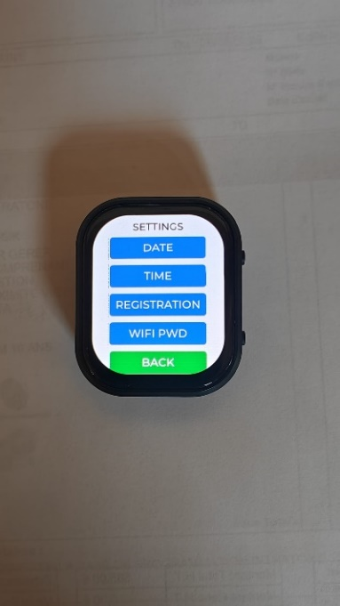 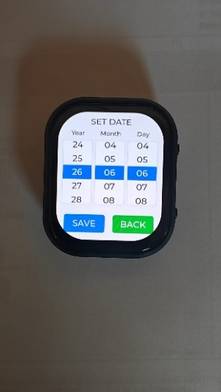 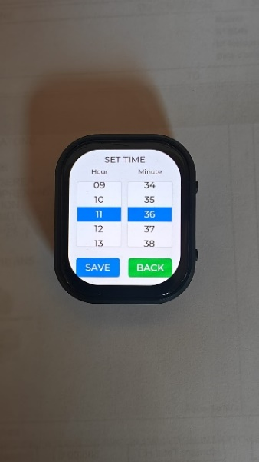 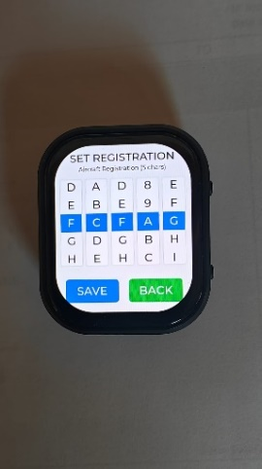 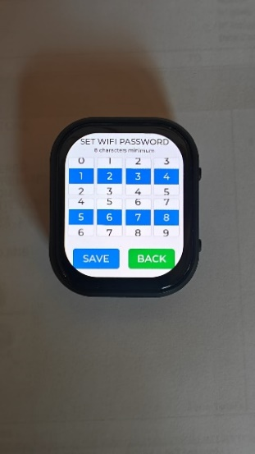
The values are adjusted using the rollers.
When values are set correctly, select SAVE.
If you are on a setting page by mistake, select BACK.
When settings need to be updated, amber messages should be displayed on the main screen, to indicate which setting should be updated.
The device also turns amber the buttons which lead to the required setting. When all required settings have been configured, messages and buttons are back to their normal color.

Access to the recorder Web pages
Using a device capable of WIFI connection (a smart phone or a PC), the recorder file-management, maintenance, calibration, and firmware-update pages are accessed from the recorder local web page.
To connect to the recorder WIFI and Website, select MENU and START WIFI.
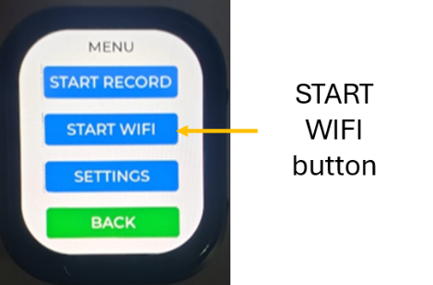
Open the WIFI connection manager on your device and select the recorder WIFI SSID which is SLM- followed by the glider registration.
Then open a browser in incognito mode on the device and type http://192.168.4.1/
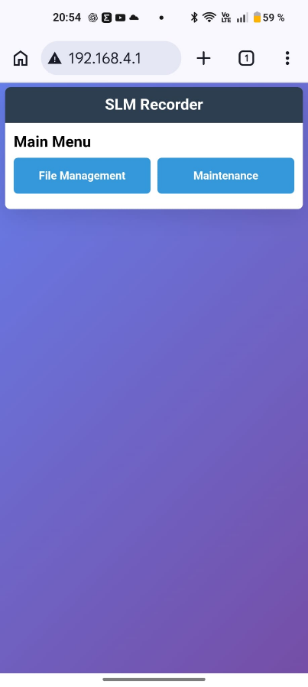
When the WIFI activities are finished, you need to stop the WIFI by selecting the STOP WIFI in the MENU.
  - Initial calibrations
/!\ Access to the Maintenance/Calibration pages requires a password.
Access the recorder Web page (see section 6.3)
Select the Maintenance menus.
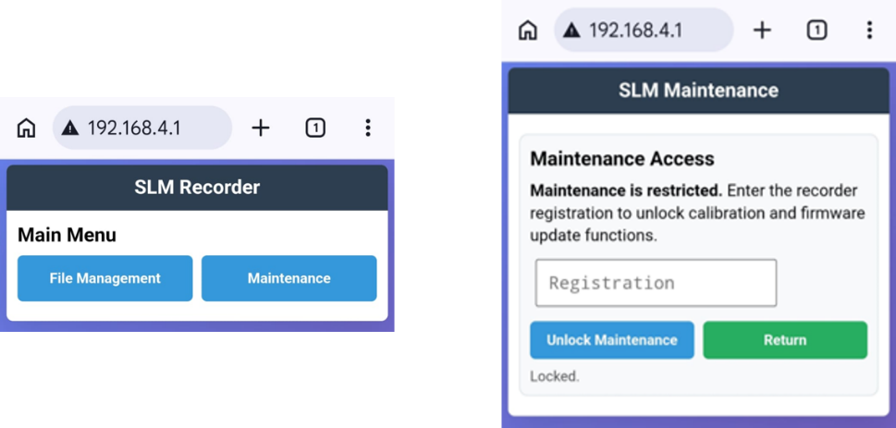
Enter the password to unlock maintenance, then select the required calibration
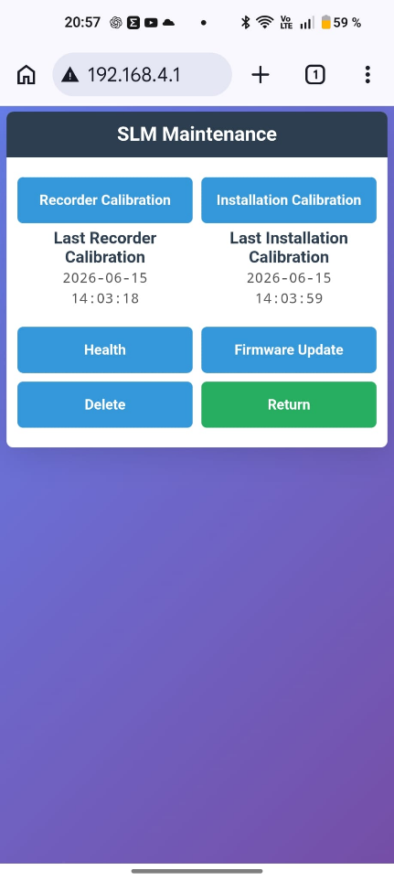
/!\ when previous calibrations have been performed, the calibration date is indicated below the button.
/!\ When calibrations need to be updated, amber messages should be displayed, to indicate which calibration should be updated.
/!\ The device also turns amber the buttons which lead to the required calibration. When all required changes have been performed, messages and buttons are back to their normal color.

Recorder calibration
This is an internal recorder calibration to ensure the acceleration sensor performance is appropriate.
Select the Recorder Calibration.
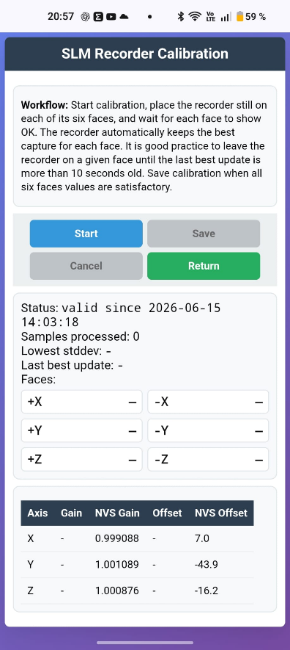
Install the recorder in its calibration support (reference SLM-CAL01).
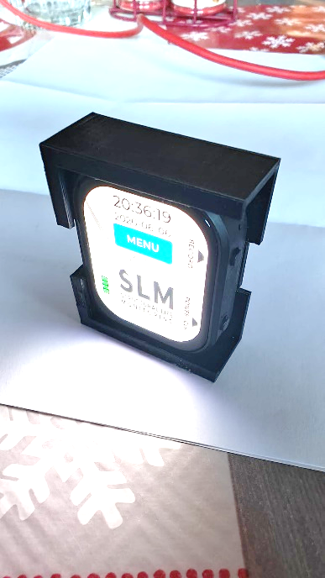
Start the calibration process and follow the workflow.
During calibration, each face is initially not validated, turns amber while the corresponding face is being acquired, and turns green/OK when a satisfactory stable capture has been obtained.
When all six faces have been calibrated, select SAVE.
If there is a problem, select CANCEL and start the process again.
The date of the recorder calibration should be entered in the aircraft logbook

Installation calibration
This calibration compensates the installed orientation of the recorder so that the corrected vertical acceleration corresponds to the aircraft load-factor axis when the glider is in the defined level-flight attitude.
Select the Installation Calibration menu.
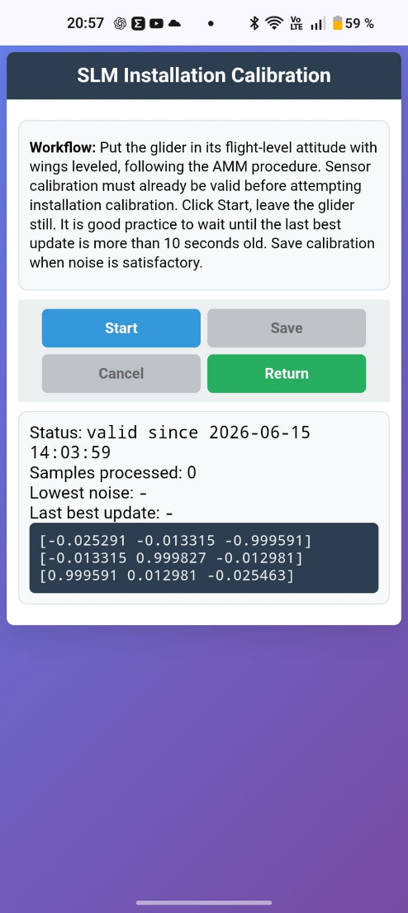
The glider should be positioned in the flight level attitude with wing leveled (same Aircraft Maintenance Manual procedure required when performing Weight & Balance).
Start the calibration process and follow the workflow.
When calibration is correct, select SAVE.
If there is a problem, select CANCEL and start the process again.
The date of the installation calibration should be entered in the aircraft logbook.

Recorder Installation
/!\ When all the installation steps have been performed, the installation details should be entered in the aircraft logbook. Date of installation.
Hardware and software versions.
Aircraft time at the installation date.
/!\ Before starting the installation, it is recommended to reset the settings ( see section 6.1) and configure the recorder with the appropriate date, time, aircraft registration and WIFI password in the SETTINGS menu.

Installation of the recorder in glider
The recorder is provided with an installation support (reference: SLM-SUP01).
The support should be installed in the fuselage, in a rigid area close to the Center of Gravity and wing spar, with suitable access for operation and routing of the USB-C cable (both the buttons and the USB-C socket are located on the right side of the recorder).
/!\ the recorder should not be in an area where there is a risk of object touching it.
  - Electrical wiring and power supply installation
The recorder is provided with a small power supply (reference SLM-POW01).
The power supply electrical wires should be connected to the glider’s battery connector and protected with a fuse.
The power supply USB-C line should be connected to the recorder USB-C socket.
/!\Everything should be secured to ensure there is no electrical risk. The USB-C line should also be secured close to the recorder to make sure it cannot introduce vibration on the recorder.
  - Initial recorder calibration
Before installing the recorder in the glider on its support, it should be calibrated (see section 6.4.1).

Installation calibration
When the recorder is installed in the glider, it is necessary to perform an installation calibration (see section 6.4.2).

Recorder Health
By selecting Maintenance / Health, the user can access the recorder diagnostics page.

Firmware Update

/!\ Firmware update should only be attempted if instructed by SLM support.
Access the recorder Web page.
Select Maintenance / Firmware Update
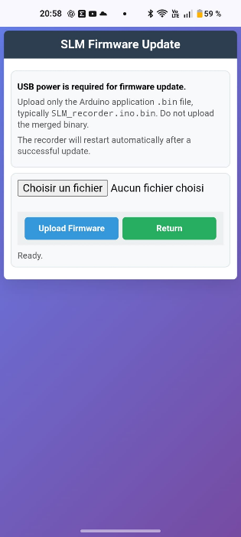
The new firmware file should be provided by SLM support (with a link to download the file) and uploaded to the device which is used to connect to the recorder.
Select the Browse / file select button and select the firmware file which is on the device.
Select Upload Firmware and wait for device to be updated.
Check the device display to verify that the device has restarted.
/!\ After a firmware update, the device restarts in the normal READY condition and WIFI is OFF. You need to activate WIFI on recorder and connect your phone or PC if you want to access WEB services again.
/!\ Following a firmware update, it is possible that settings and calibrations have to be performed. This can happen when the firmware changes the way settings and calibrations are stored in memory.
/!\ When settings and calibrations need to be updated, amber messages should be displayed, to indicate which parameter should be updated.
/!\ The device also turns amber the buttons which lead to the required changes. When all changes have been performed, messages and buttons are back to their normal color.
The date and reference of the firmware should be entered into the aircraft logbook.

File Delete

When files are archived using SLM File Management, they are moved to the “/processed” folder of the SD card. If necessary, the files can be deleted from the SD card.
Selecting Maintain / Delete provides access to the Delete function.
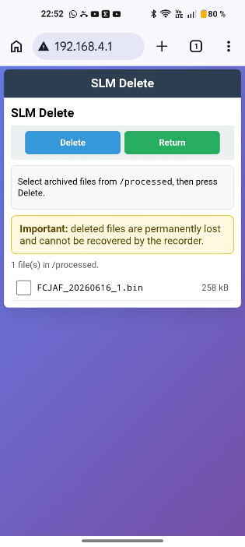
User should select which file to delete before pressing Delete.
/!\ This operation cannot be undone!

Maintenance
During the annual visit and before ARC renewal, a recorder calibration must be carried out and the status report of the Equivalent Fatigue Index (EFI) usage statistics downloaded from the SLM Web site.
The calibration results are a condition for validating the recordings uploaded since the previous calibration.
The EFI status report provides the information required to allow airworthiness renewal and aircraft return to service.
The date and reference of the EFI status report shall be logged into the aircraft logbook and the status included in the aircraft maintenance documentation.
The glider Aircraft Maintenance Program should be updated to reflect these requirements.

Recorder Calibration

The calibration shall be performed at least once a year but can be repeated as many times as desired.
The process to calibrate is described in section 6.4.1

Equivalent Fatigue Index documents
/!\ The recorder calibration should be performed before generating the EFI status report. Flights performed after the last valid calibration and before the EFI report may be treated as non-validated or handled in accordance with the approved data-processing procedure.
The EFI report provides the information required for the Go/No-Go decision supporting Airworthiness Review Certificate renewal and release to service.

Performance
There are no performance changes associated with this supplement
- Weight and balance
Due to very light weight and location, there are no changes associated with this supplement
- Hardware delivered with recorder
1x Recorder SLM-REC01
1x Installation support SLM-SUP01
1x Calibration support SLM-CAL01
1x 12V to USB-C power supply SLM-POW01
- In case of problem
Contact support :
+33 783232334
jeanluc@derouineau.com

