 | AFMS/AMMS | SLM-AFMS-AMMS-EN
 |  | Edition: 1 Rev: 0
 |  | Date: 27/06/2026
 |  | Page: 1/30

SLM for Glider
Service Life Extension
Project
Aircraft: GENERIC

This document includes the Aircraft Flight Manual Supplement (AFMS) and the Aircraft Maintenance Manual Supplement (AMMS) for SLM operations.
It must be attached to the approved AIRCRAFT FLIGHT MANUAL (AFM) kept on board the aircraft.
The maintenance-related sections shall also be included in, or referenced by, the Aircraft Maintenance Manual.
LIST OF EDITIONS/REVISIONS INCORPORATED
Edition | Revision | Date | Description | Page
1 | 0 | 27/06/2026 | Original SLM AFMS/AMMS | 1-30

TABLE OF CONTENTS
1. Purpose 4
2. Limitations 4
3. Emergency procedures 5
4. Normal procedures 5
4.1. Recorder description 5
4.2. Powering up the recorder 6
4.3. Powering down the recorder 6
4.4. Recorder special screens 7
4.5. Starting recording mode 7
4.6. Stopping recording mode 8
4.7. Pre-flight check 9
4.8. Before flight 10
4.9. After flight 10
4.10. At the end of the flying day 10
5. Messages 13
6. Recorder special functions 14
6.1. Recorder reset 14
6.2. Recorder settings 15
6.3. Access to the recorder Web pages 16
6.4. Initial calibrations 17
6.4.1. Recorder calibration 18
6.4.2. Installation calibration 20
6.5. Calibration report management 22
6.6. Deleting files 23
6.7. Firmware update 23
6.8. About the recorder 25
7. Recorder installation 25
7.1. Installing the recorder in the glider 25
7.2. Electrical wiring 26
7.3. Initial recorder calibration 27
7.4. Installation calibration 27
8. Maintenance 27
8.1. Annual inspection 27
8.1.1. Recorder calibration 27
8.1.2. Equivalent Fatigue Index documents 28
8.2. 1000-hour / 5-year inspection 28
8.3. 12000-hour inspection 28
9. Performance 29
10. Mass and balance 29
11. Equipment supplied with the recorder 29
12. In case of problem 30

- Purpose
The device installed in the glider records in-flight acceleration data used to determine load-factor variations. These data are processed as part of the Structural Life Monitoring solution in order to calculate the measured usage spectrum and its Equivalent Fatigue Index (EFI). The EFI is compared with the approved reference EFI (EFI calculated according to the certification assumptions). When the applicable EFI, inspection, and continued-airworthiness criteria are satisfied, the process may allow operation beyond the initially certified service life limit.
- Limitations
This supplement does not introduce any new aircraft flight-envelope limitations.
Operation beyond the certified service life limit is authorized only when the approved SLM process and the associated Instructions for Continued Airworthiness (ICA) are satisfied.
Before the certified service life limit, flights without valid SLM data do not receive any favorable credit and are accounted for in the EFI at the rate of the Kossira & Reinke reference spectrum.
Beyond the certified service life limit, use of the SLM recorder, its calibration status, the EFI report, and the inspections are conditions for continued airworthiness.
- Emergency procedures
No emergency procedure is associated with this supplement.
- Normal procedures
  - Recorder description
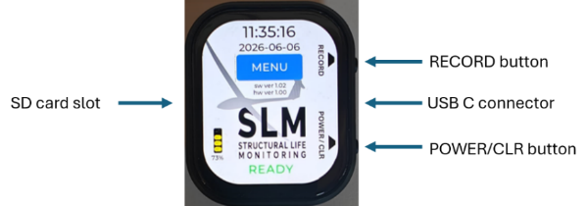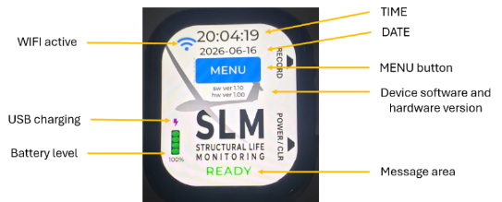
The recorder is installed in the glider using a specific bracket (installation instructions, section 7).
The USB-C connector must always be connected to the recorder.
All recorder controls are performed using the touch screen and the POWER/CLR and RECORD buttons.
A 16 GB Class 10 micro SD card is supplied with the recorder.
  - Powering up the recorder
The recorder starts when the POWER/CLR button is pressed briefly or when USB-C power is available.
A green READY message must appear at the bottom of the display.
/!\ If amber or red error messages are displayed at the bottom of the display, they must be corrected before flight (see messages section 5).
/!\ If the recorder does not start automatically when the glider battery is connected, check the USB-C connection and the power supply.
  - Powering down the recorder
The recorder powers down when the POWER/CLR button is held until the shutdown sequence starts (typically ~2 seconds).
When the recorder is in READY state and WIFI is not active, removal of USB-C power also causes the recorder to power down. When WIFI is active, the recorder remains powered on to allow ongoing Web operations to be completed.
When the recorder is in recording mode:
- if USB-C power is lost, the recorder continues recording using its internal battery.
- if the POWER/CLR button is held until the shutdown sequence starts, or, when the recorder is operating on battery without USB power, if the battery level is below 5%, recording stops and the recorder powers down.
In some error conditions, it may be necessary to hold the POWER/CLR button for up to 8 seconds.
  - Recorder special screens
When there is no interaction with the recorder for more than 10 seconds, the display enters standby mode to save battery power. In standby, the screen is black/off. The display can be reactivated by touching the screen or by pressing a recorder button.
When the recorder operates on battery without USB power and the battery level drops below 5%, the recorder displays a red message asking the user to connect active USB-C power before powering down.
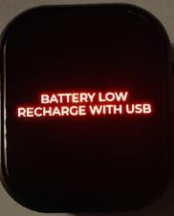
  - Starting recording mode
The recorder can be started by pressing the physical RECORD button for ~0.5 second or by pressing the display MENU -> START RECORD button.
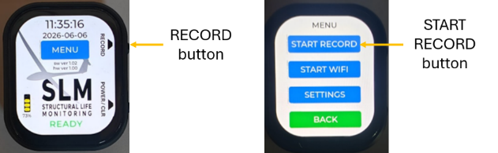
The recorder must display STARTING and then, immediately after, RECORDING
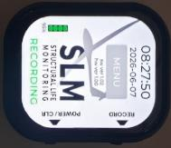
The recorder creates a daily binary file. Additional same-day recording sessions are appended to the same daily file, and the suffix is updated to indicate the number of recording sessions contained in the file, for example FCJAF_20260616_1.bin, then FCJAF_20260616_2.bin.
  - Stopping recording mode
Recording mode is stopped by:
- pressing the physical RECORD button for ~2 seconds
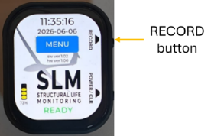
- pressing the red STOP RECORD button on the display for ~1 second (MENU page)
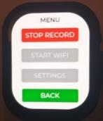
- pressing the POWER/CLR button for ~2 seconds *
- if the recorder operates on battery without USB power and the battery level drops below 5% *
*: in this case, the recorder also powers down.
  - Pre-flight check
When the glider battery is installed and connected, the recorder must start automatically and the display must be active with a green READY message at the bottom of the display.
/!\ If the recorder does not start automatically when the glider battery is connected, check the USB-C connection and the power supply.
/!\ If amber or red error messages are displayed at the bottom of the display, they must be corrected before flight (see messages section 5).
  - Before flight
Start recording mode.
/!\ If a flight is performed without SLM recording, or if the recorded data are invalid, the flight must be handled in accordance with the approved missing-data procedure and no credit is granted for that flight.
  - After flight
Stop recording mode.
  - At the end of the flying day
The last pilot-in-command to have flown the glider must update the glider usage information on the Structural Life Monitoring (SLM) website.
Using a WIFI-capable device (a smartphone or a PC), the files must first be downloaded from the recorder to the device, then transferred to the SLM website.
See section 6.3 for access to the recorder Web pages.
Select File Management.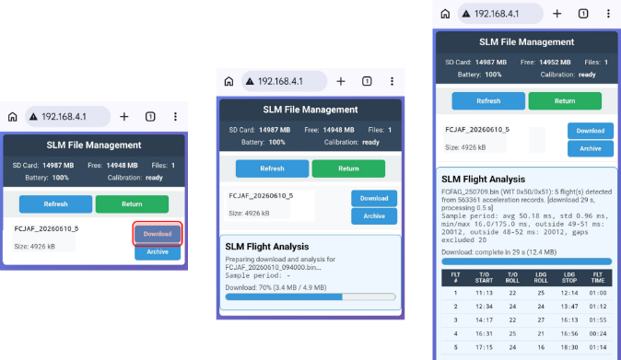
Select Download to transfer and process the selected file from the recorder to the device.
A flight analysis is presented to the pilot, who must validate it and inform support if the flight times do not match reality.
When a file has been transferred to the device, it must be uploaded to the main SLM server at:
https://planeur-la-llagonne.com/gestion-vols/index.php
You need an account and password to access the SLM server (contact support to obtain an account)
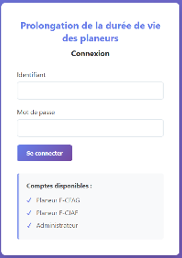
Once the account and password have been entered, you access the main SLM server page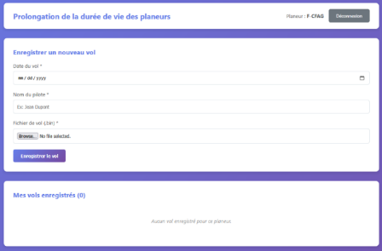
To upload a file to the SLM server, you must enter the date, the pilot's name, and select a file previously downloaded from the recorder to the device.
When the file has been correctly uploaded to the SLM web server, it may be archived from the recorder by selecting Archive on the SLM Recorder Web page.
/!\ The recorder accepts only 50 files.
When all operations associated with the recorder have been completed, the recorder must be stopped.
- Messages

Message | Type |  | Operator action
BOOT | Startup transient
READY | normal operation
RECORDING | normal operation
STARTING | recording startup transient
STOPPING | recording stop transient
SHUTDOWN | power-down transient
SD OK/CLR | SD recovered / confirmation prompt |  | press clear to confirm correction of the SD error
NEED SETTINGS | configuration required |  | complete the SETTINGS for date, time, registration, and password
REC CAL REQ | recorder calibration required |  | perform recorder calibration via the Web menu (START WIFI)
INST CAL REQ | installation calibration required |  | perform installation calibration via the Web menu (START WIFI)
NO SD | SD not detected warning |  | insert a valid SD card
SD LOW | low SD memory |  | free space or insert an SD card: 500 MB required at startup; stop at 250 MB during recording
SD FULL (FILES) | the SD card contains too many files (50 max.) |  | download/delete files from the recorder Web interface (START WIFI)
LOW BATT | low battery warning |  | connect USB
REC CAL FAULT | recorder calibration fault |  | perform a new recorder calibration. If the fault repeats, contact SLM support
FATAL WDG/CLR | watchdog fault acknowledgement |  | press the power/clear button to acknowledge/clear the error *
ACCEL ERR | hardware/runtime error |  | press the power/clear button to stop the recorder, then restart *
RTC ERROR | hardware/runtime error |  | press the power/clear button to stop the recorder, then restart *
PMU ERROR | hardware/runtime error |  | press the power/clear button to stop the recorder, then restart *
REC FAIL | recording failure |  | press the power/clear button to stop the recorder, then restart *
TOUCH ERROR | hardware/runtime error |  | press the power/clear button to stop the recorder, then restart *
ERROR | fallback generic error |  | press the power/clear button to stop the recorder, then restart *
SD ERROR | SD/storage fault |  | press the power/clear button to stop the recorder, then restart *
GENERIC ERROR | fatal error |  | press the power/clear button to stop the recorder, then restart *
* It may be necessary to press the power/clear button for up to 8 seconds to stop the device.
* If the error persists after restart, report the problem to support

- Recorder special functions
  - Recorder reset
/!\ When the device is reset, the SETTINGS parameters are erased. The saved calibrations are retained.
To reset the device, press the RECORD button and then immediately press the POWER/CLR button until the device powers down.
On restart, the device must ask the user to configure the SETTINGS.
The corresponding amber messages are displayed.
To help the user navigate through the configuration pages, the required buttons are colored amber.
The buttons return to their normal color once all required configuration changes have been completed.
  - Recorder settings
/!\ The recorder cannot be used until all parameters have been configured.
From the main page, select MENU then SETTINGS.
The SETTINGS page allows the user to set DATE, TIME, REGISTRATION, and WIFI PASSWORD.
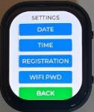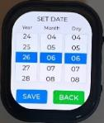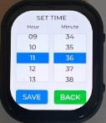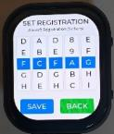
The values are set using the graphic wheels.
Once the values are correctly set, select SAVE.
If you are on a page by mistake, select BACK.
When parameters must be updated, amber messages must be displayed on the main screen to indicate which parameter must be updated.
The device also colors the buttons leading to the required parameter in amber. Once all required parameters have been configured, the messages and buttons return to their normal color.
  - Access to the recorder Web pages
Using a WIFI-capable device (a smartphone or a PC), the recorder file-management, maintenance, calibration, and firmware update pages are accessible from the recorder local Web page.
To connect to the recorder WIFI and Web site, select MENU and START WIFI.
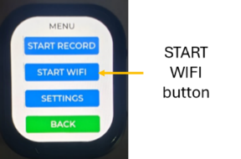
Open the WIFI connection manager on your device and select the recorder WIFI SSID, which is SLM- followed by the glider registration.
Then open a browser in private browsing mode on the device and enter http://192.168.4.1/http://192.168.4.1/
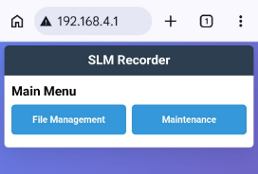
When WIFI activities are finished, you must stop WIFI by selecting STOP WIFI in the MENU.
  - Initial calibrations
/!\ Access to the Maintenance/Calibration pages requires a password.
Access the recorder Web page (see section 6.3)
Select the Maintenance menu.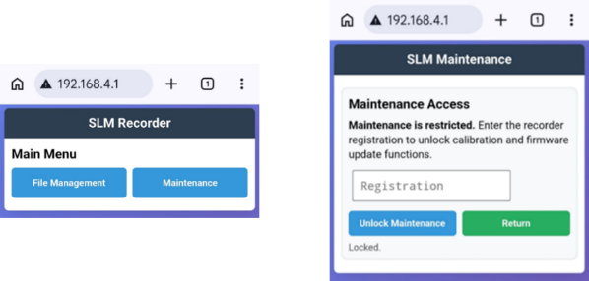
Enter the password to unlock maintenance, then select the required calibration
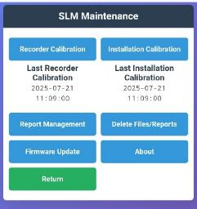
/!\ When previous calibrations have been performed, the calibration date is shown below the button.
/!\ When calibrations must be updated, amber messages must be displayed to indicate which calibration must be updated.
/!\ The device also colors the buttons leading to the required calibration in amber. On the Recorder Calibration and Installation Calibration pages, the enabled Start or Save buttons corresponding to the required calibration are also amber. Cancel remains blue; a disabled button remains grey. Once all required changes have been completed, the messages and buttons return to their normal color.
    - Recorder calibration
This is an internal recorder calibration intended to ensure the performance of the acceleration sensor.
Select Recorder Calibration to access the following page.
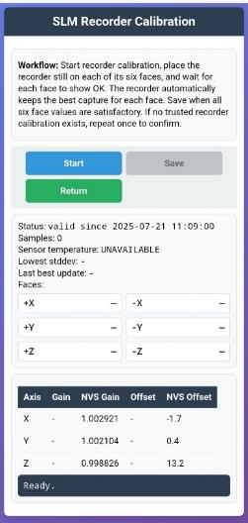
Install the recorder in its calibration fixture (reference SLM-CAL01).
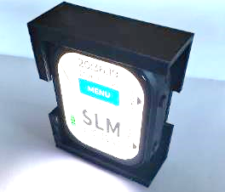
Start the calibration process and follow the procedure.
During calibration, each face is initially not validated, changes to amber while the corresponding face is being acquired, and changes to green/OK when a stable capture has been obtained.
Once the six faces have been calibrated, select SAVE.
/!\ During an initial installation, if no calibration exists, two successive calibrations must be performed.
If the recorder sensor is within the tolerances of the previous calibrations, the new calibration is validated and replaces the previous one.
If the sensor tolerances are not acceptable, check the test fixture, the placement of the recorder in the fixture, the levelness of the test surface, and the temperature, before trying another calibration. If a new calibration cannot be validated, contact support.
It is possible that flights since the last good calibration cannot be taken into account.
In all cases, a calibration report is uploaded and saved on the recorder.
In case of problem, select CANCEL and restart the process.
The recorder calibration report must be added to the aircraft maintenance documentation.
    - Installation calibration
This calibration compensates for the recorder orientation so that the corrected recorder vertical axis corresponds to the gravity axis when the glider is in its level-flight attitude with wings level.
Select the Installation Calibration menu.
The glider must be positioned in the level-flight attitude, with wings level (see the Aircraft Maintenance Manual procedure required for weighing and balance).
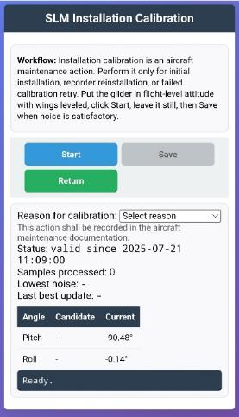
Select the calibration reason:
- initial installation
- recorder relocation
- attempt to correct an incorrect calibration
Start the calibration process and follow the procedure.
During acquisition, the page displays the status and the Pitch/Roll angles of the current candidate.
The SAVE button is available only when a calibration reason is selected and Stability indicates stable.
If the glider or the recorder moves, Stability returns to not stable and SAVE is disabled.
When stability and noise are satisfactory, select SAVE.
A calibration report is uploaded and saved on the recorder.
In case of problem, select CANCEL and restart the process.
The installation calibration report must be added to the aircraft maintenance documentation.
  - Calibration report management
By selecting Maintenance / Report Management, the user accesses the calibration report page.
The reports can be uploaded or archived.
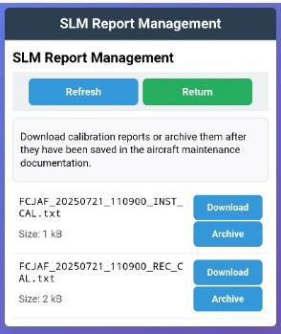
  - Deleting files
When files or reports are archived, they are moved to the “/processed” folder on the SD card. If necessary, files can be deleted from the SD card.
Selecting Maintenance / Delete Files/Reports gives access to the Delete function.
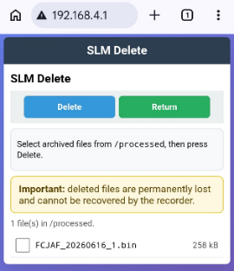
The user must select the file to be deleted before pressing Delete.
/!\ This operation is irreversible!
  - Firmware update
/!\ The firmware update must be attempted only on instruction from SLM support. Active USB-C power must be connected throughout the update;
the device refuses firmware upload if USB power is not detected.
Access the recorder Web page.
Select Maintenance / Firmware Update
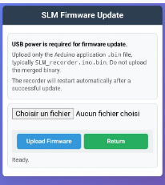
The new firmware file must be provided by SLM support (with a download link) and uploaded to the device used to connect to the recorder.
Select the Browse / file-selection button and choose the firmware file present on the device.
Select Upload Firmware and wait for the device to update.
Check the device screen to confirm that the device has restarted.
/!\ After a firmware update, the device restarts in the normal READY state and WIFI is OFF. You must activate WIFI on the recorder and connect your phone or PC if you want to access the WEB services again.
/!\ Following a firmware update, it is possible that settings and calibrations must be redone. This can occur when the firmware changes the way settings and calibrations are stored in memory.
/!\ When settings and calibrations must be updated, amber messages must be displayed to indicate which parameter must be updated.
/!\ The device also colors the buttons leading to the required changes in amber. Once all changes have been completed, the messages and buttons return to their normal color.
The date and reference of the firmware must be entered in the aircraft maintenance documentation.
  - About the recorder
By selecting Maintenance / About, the user accesses the recorder diagnostic page.
Some functions on this page must be used under support supervision.
- Recorder installation
/!\ Once all installation steps have been completed, the installation details must be entered in the aircraft maintenance documentation in accordance with the appropriate procedure.
/!\ Before starting the installation, it is recommended to reset the settings (see section 6.1) and configure the recorder with the correct date, time, aircraft registration, and WIFI password in the SETTINGS menu.
If the recorder has already been used on another glider, ask support for the method to reset the calibrations.
  - Installing the recorder in the glider
The recorder is supplied with an installation bracket (reference: SLM-SUP01).
The bracket must be installed in the fuselage, in a rigid area close to the center of gravity and the wing spar (<~0.3 m), with suitable access for use of the recorder and routing of the USB-C cable (the buttons and USB-C connector are located on the right-hand side of the recorder).
/!\ The recorder must not be located in an area where an object could touch it.
/!\ The recorder must be installed using strong double-sided adhesive tape or neoprene adhesive. The weight of the recorder and its bracket is approximately 40 g; the bracket attachment must be tested to verify that it can withstand a 640 g forward longitudinal load (16 g).
  - Electrical wiring
The recorder is supplied with a small power supply (reference SLM-POW01).
The power-supply wires must be connected directly to the glider battery connector and protected by a 1 A fuse.
The power-supply USB-C cable must be connected to the recorder USB-C socket.
/!\ Everything must be secured to ensure that there is no electrical hazard. The USB-C cable must also be secured near the recorder to ensure that it cannot induce vibration in the recorder.
  - Initial recorder calibration
Before installing the recorder in the glider on its bracket, it must be calibrated (see section 6.4.1).
  - Installation calibration
When the recorder is installed in the glider, an installation calibration must be performed (see section 6.4.2).
- Maintenance
  - Annual inspection
During the annual inspection, recorder calibration must be performed and the Equivalent Fatigue Index (EFI) usage-statistics status report must be archived.
The calibration results are a condition for validating the records uploaded since the previous calibration.
The EFI status report provides the information needed to authorize release to service of the aircraft.
The calibration report and the EFI status report must be included in the aircraft maintenance documentation.
The glider Maintenance Programme must be updated to reflect these requirements.
    - Recorder calibration
The calibration must be performed at least once per year, but may be repeated as often as desired.
The calibration process is described in section 6.4.1.
    - Equivalent Fatigue Index documents
/!\ Recorder calibration must be performed before generating the EFI status report. Flights performed between the last valid calibration and the EFI report must be treated as not validated.
The EFI report provides the SLM and service-life information for the Go/No-Go decision required before release to service.
  - 1000-hour / 5-year inspection
Every 1000 hours or every 5 years, whichever occurs first, the ageing-glider inspection must be performed. The content of this inspection is identical to the recurrent 1000-hour inspections defined by the type certificate holder, with the addition of a calendar limit.
  - 12000-hour inspection
When the aircraft reaches the certified service life limit (12000 hours), a specific inspection must be performed before any return to operation based on SLM. This inspection includes, at a minimum, the standard periodic inspection for ageing aircraft (8.2), together with:
- a complete review of the aircraft logbook and airframe repair history. The purpose is to verify the general condition of the glider and the quality of its maintenance;
- verification of the SLM data and of the validity of its calibration for the entire history used in the EFI calculation. The purpose is to verify the quality and reliability of the EFI calculations;
- review of the current and projected EFI status report. The purpose is to verify that sufficient hour credits have been generated by the activity of the SLM-equipped glider to justify an extension until the next scheduled inspection.
The release-to-service decision depends on the results of all these inspections.
- Performance
No performance change is associated with this supplement.
- Mass and balance
Because of the very low weight and the location (less than 100 g near the center of gravity for the complete system), it is not necessary to perform a physical mass-and-balance update. However, the equipment must be added to the glider equipment list.
- Equipment supplied with the recorder
1x SLM recorder SLM-REC01
1x Installation bracket SLM-SUP01
1x Calibration fixture SLM-CAL01
1x 12 V to USB-C power supply SLM-POW01
- In case of problem
Contact support:
+33 783232334
jeanluc@derouineau.com

