Software Overview

Year: 2023 Semester: Spring Team: 10 Project: Parking Tracking System

Creation Date: January 24, 2023 Last Modified: January 26, 2023

Author: Heath Aaron Lovell Email: hlovell@purdue.edu

Assignment Evaluation:

| **Item** | **Score (0-5)** | **Weight** | **Points** | **Notes** |
| --- | --- | --- | --- | --- |
| **Assignment-Specific Items** | | | | |
| **Software Overview** |  | x2 |  |  |
| **Description of Algorithms** |  | x2 |  |  |
| **Description of Data Structures** |  | x2 |  |  |
| **Program Flowcharts** |  | x3 |  |  |
| **State Machine Diagrams** |  | x3 |  |  |
| **Writing-Specific Items** | | | | |
| **Spelling and Grammar** |  | x2 |  |  |
| **Formatting and Citations** |  | x1 |  |  |
| **Figures and Graphs** |  | x2 |  |  |
| **Technical Writing Style** |  | x3 |  |  |
| **Total Score** |  | | |  |

5: Excellent 4: Good 3: Acceptable 2: Poor 1: Very Poor 0: Not attempted

General Comments:

*Relevant overall comments about the paper will be included here*

1.0 Software Overview

The following list breaks down the primary software overview of the Parking Tracking System:

* Read in ultrasonic sonar sensor data to determine a car entering/exiting the garage
* Wireless (Wi-Fi) communication between the car detector modules (CDM) and main aggregator module (AM)
  + communicate data when a car enters/exits the garage
* Drive 7-segment display and detail how many spaces are available in the garage on it
* Communicate with OLED display and keypad to configure and update the system when it is installed

**1.1 Read in ultrasonic sonar sensor data**

The parking tracking system will utilize two ultrasonic sonar sensors on each car detector module. The ultrasonic sensors on each car detector module will be used by sending the distance measurement to its module at a frequency of 30 times per second with the UART protocol.

**1.2 Wireless communication between CDMs and AM**

The wireless modules will utilize the Wi-Fi protocol to communicate with each other. The CDMs (car detector modules) will check whenever the ultrasonic sensors detect a change in distance between them (i.e., a car entering or exiting), which will trigger a UDP packet to be sent to the AM (aggregator module). When the AM receives this packet, it will then update the available spaces, as described in 1.3.

**1.3 Driving 7-segment display to show available spaces**

When the AM triggers the interrupt from receiving the packet from a CDM, it will first determine whether the car is entering or leaving by checking the identification bit in the packet (showing whether the CDM that sent the packet is located on an entrance or exit of the garage). Based on this bit, it will then update the saved “total parking spaces available” and use the SPI protocol to update the 7-segment display, either increasing or decreasing the value shown.

**1.4 Communication with OLED display and keypad for system configuration**

When the CDMs and AM are first installed, the AM will communicate with an OLED screen using I2C and will use a row-column matrix to determine what value is pressed on the keypad. These two items will be used to initially configure the system, which will consist of entering the current total number of spots available and setting up the CDMs that will be in use with the AM.

2.0 Description of Algorithms

**2.1 Ultrasonic sensor detection**

The ultrasonic sensor detection will function as shown in Figure 2.1 in Appendix 1. Initially, the car detector module (CDM) will need to be calibrated for the width of the specific garage entrance or exit that it is placed in, as well as setting it to either be an entry or exit module. After this is complete, the CDM will be ready to run its main function. In this function, the CDM will read the values for sensor1 and sensor2 to check whether the full width of the garage is still visible. If it is, the program will end, and wait for the next time it is called. If it is not, it will check whether it is an entry or exit module, and then send a packet to the aggregator module (AM) detailing that a car has entered/exited the garage.

**2.2 Wireless communication**

The wireless communication from the AM will function as shown in Figure 2.2 in Appendix 1. At the start, the AM will check to see if it has received any packets. If it hasn’t, it will simply return to the end of the program and wait for it to be called again. If it has received a packet, it will first check whether it is an event logging or a ping packet. If it is to log an event, the AM will then check whether it is from an entry or exit CDM, and update the number of parking spaces available according to that. The AM will then update the 7-segment display and end. If it is a ping, it will simply return communication back to the address the ping came from, then end.

**2.3 Keypad and OLED**

The keypad and OLED functionality is shown in Figure 2.3 in Appendix 1. The AM will wait for a keypad press that indicates a user is trying to input to the system, triggering an interrupt. Next, it will determine whether the user is wanting to configure a CDM or the number of parking spaces available initially. If the user is configuring a CDM, it will wait for the ID of the CDM to be entered and then ping the CDM. If there is no response, it will prompt the user to enter the ID again. If there is a response, it will end. If the user is entering the number of parking spaces currently available, the AM will prompt them to enter the current number, update the 7-segment display, and end.

3.0 Description of Data Structures

The MCU will utilize a custom data structure that was created for our wireless communication. The first byte will contain information on the serial number of the device sending the data, the next byte will contain the API code, and the last two bytes will be for the data. The API codes are as follows: 0x00 for ACK, 0x01 for Ping, and 0x02 for logging an event. The first byte of the data will contain the segment number, with the second byte containing the direction of the car (either OUT or IN).

4.0 Sources Cited:

Appendix 1: Program Flowcharts

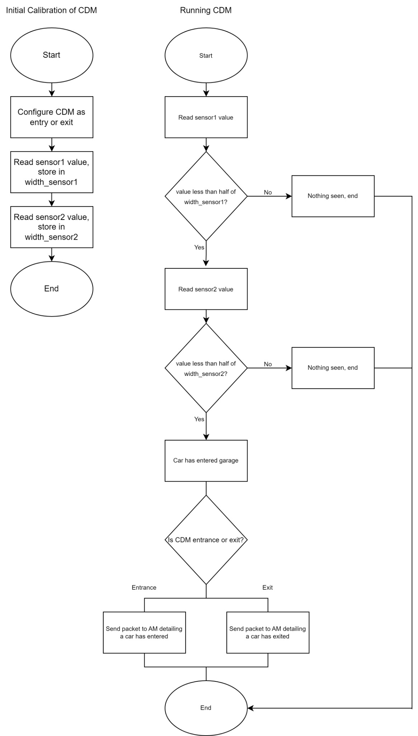

**Figure 2.1:** Car detector module (CDM) flowchart

**Figure 2.2:** Wireless communication from AM flowchart

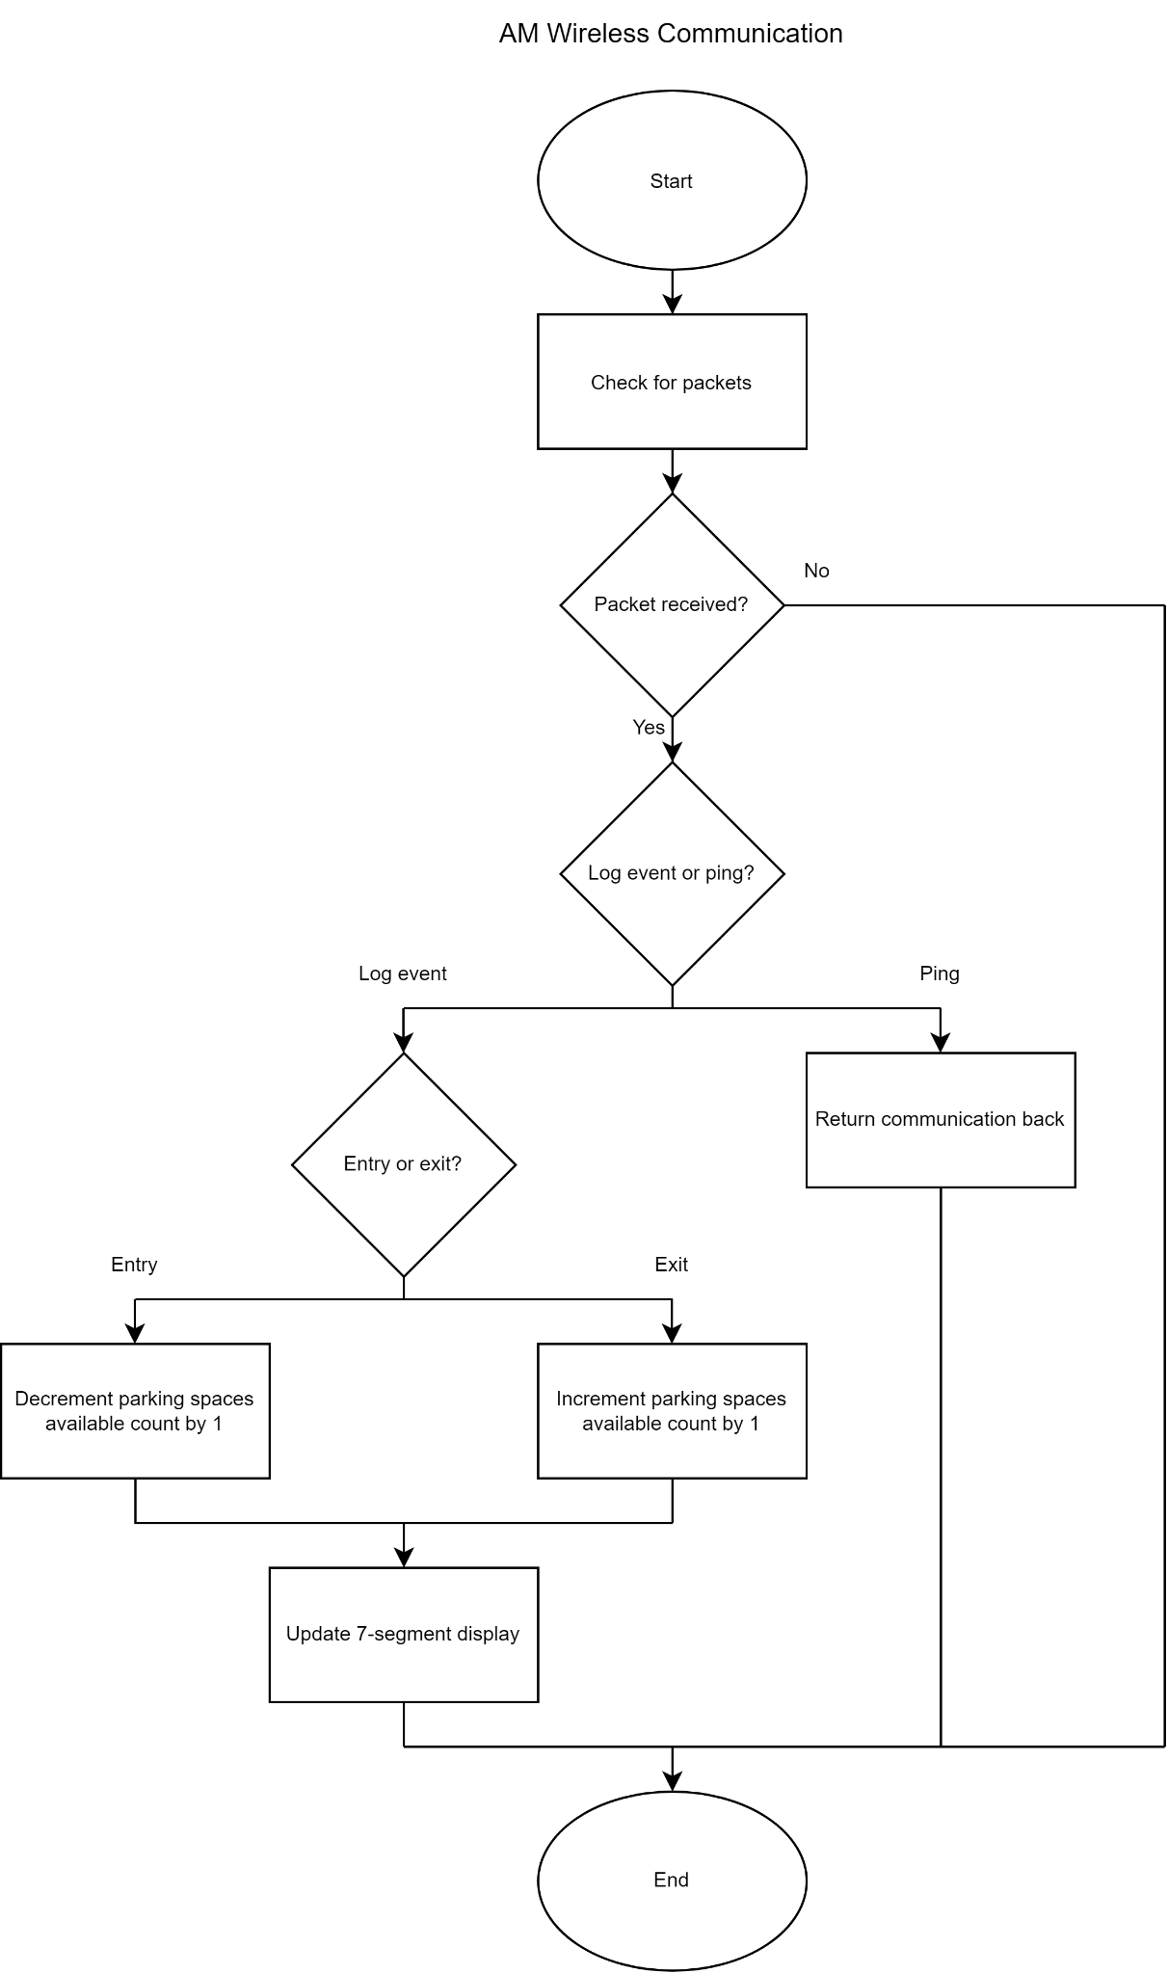

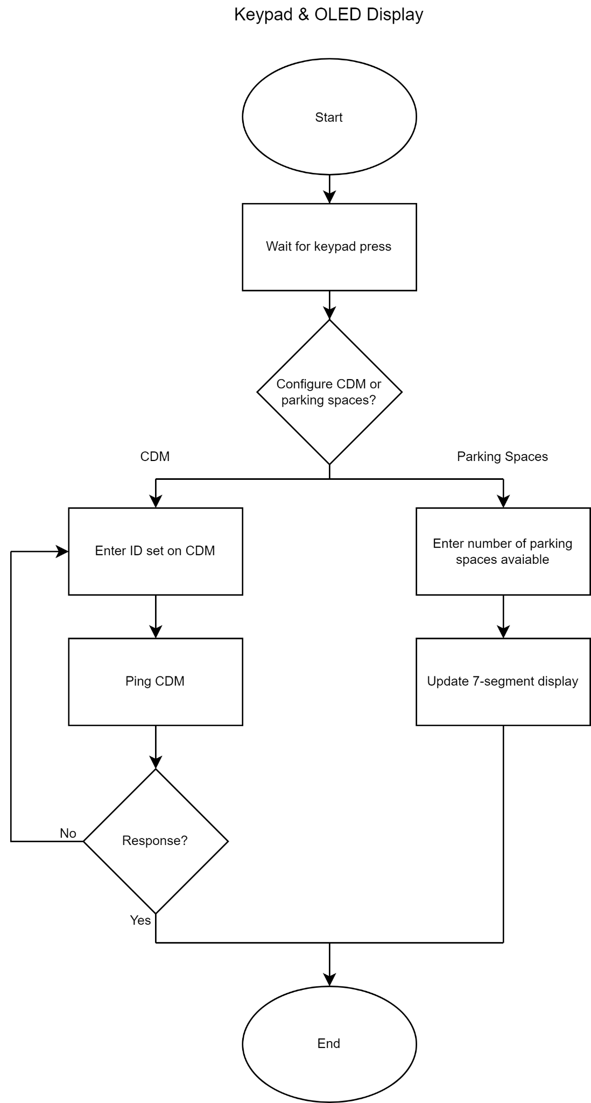

**Figure 2.3:** Keypad and OLED flowchart

Appendix 2: State Machine Diagrams

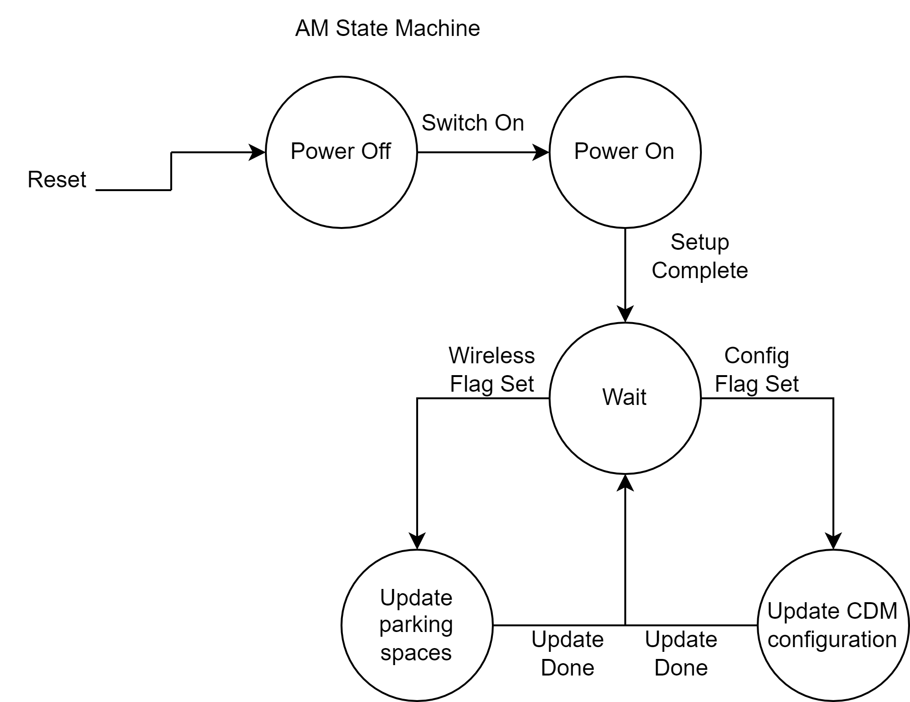

**Figure 3.1:** Aggregator Module state machine

Within the microcontroller, there are two main states: power on and power off. During power off, the microcontroller does not have any current flowing through the system. When the microcontroller is switched on, it will then begin to wait for one of the flags to be set. The wireless flag will be set when the microcontroller receives wireless communication from a CDM, which will then cause the microcontroller to update the total number of parking spaces available and return to the waiting state. If the config flag is set, the microcontroller will take in either the number of parking spaces currently available or the ID of the CDM the user is adding, and update that configuration before returning to the wait state.

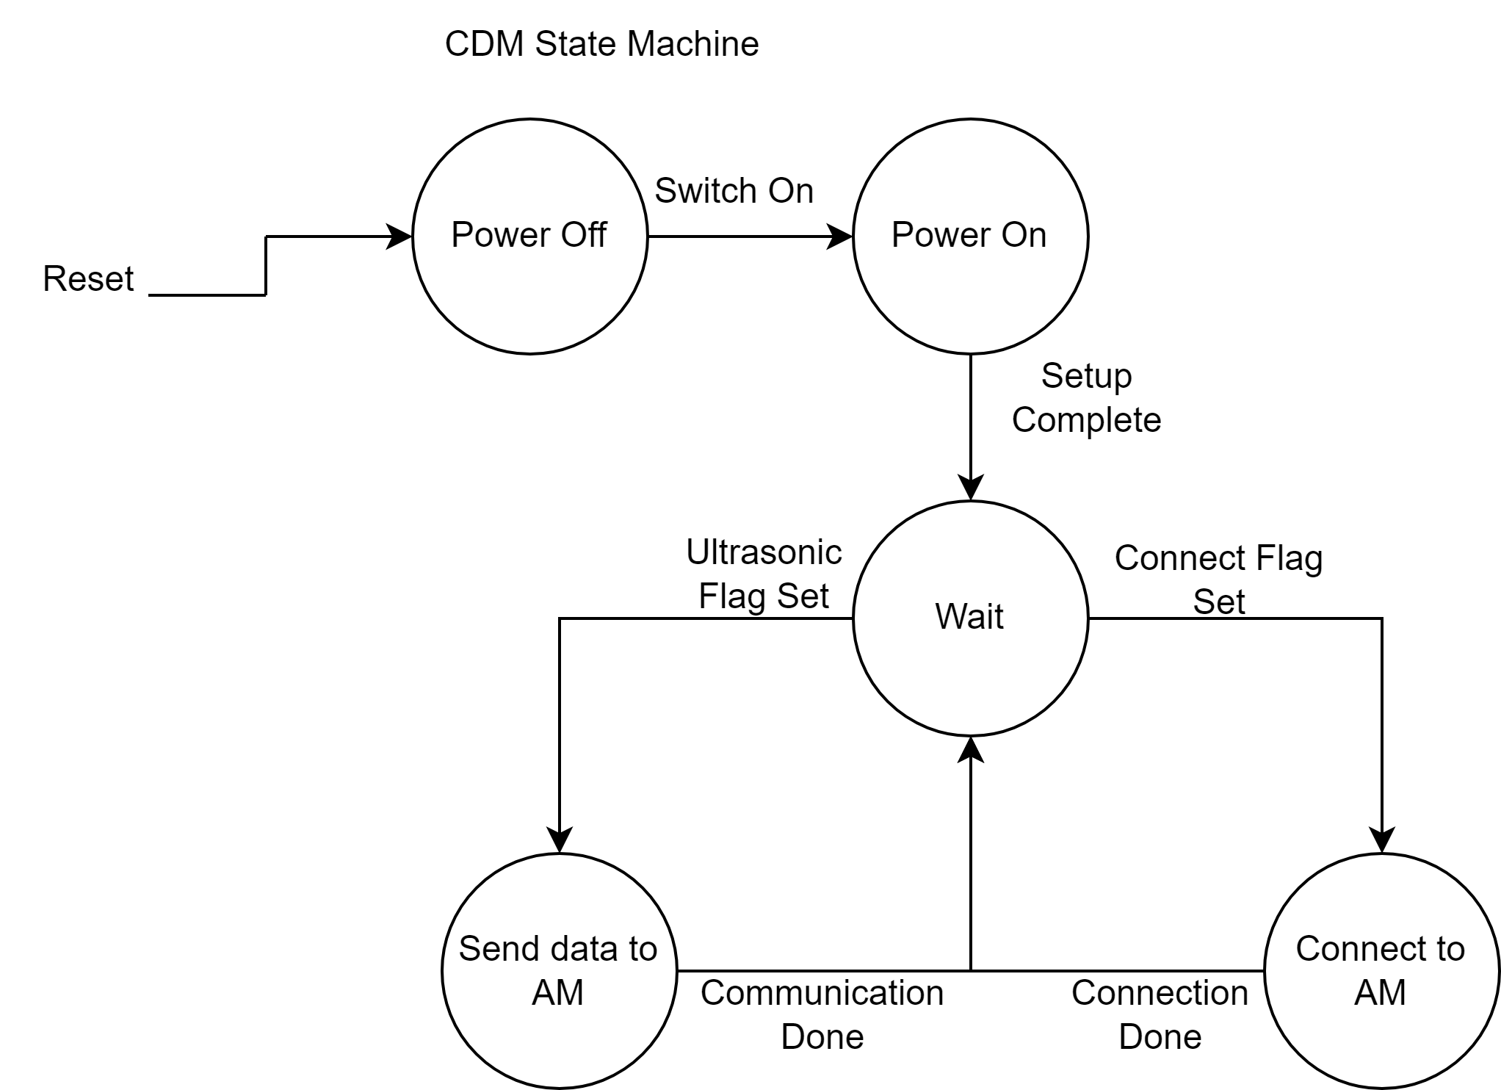

**Figure 3.2:** Car Detector Module state machine

Within the microcontroller, there are two main states: power on and power off. During power off, the microcontroller does not have any current flowing through the system. When the switch is turned on for the microcontroller, it enters a wait state for flags to be set. The ultrasonic flag will be set whenever the ultrasonic sensor detects that a car has entered or exited the garage, causing a wireless data packet to be sent to the AM and will then return to the wait state. When the connect flag is set, it will connect to the AM and ping it to ensure that it has successfully connected before returning to the wait state.