Disney and Universal Studios

An Analysis on Theme Park Reviews and Guest Sentiment

Jacqueline Lee

Table of Contents

Introduction 2

Reasoning Behind the Project 2

Data Preparation 3

The Data 3

Clean Up and Processing 3

Analysis 6

Geographical Analysis of Ratings and Number of Reviews 6

Sentiment Analysis 7

Disneyland 8

Universal Studios 9

Review Text Analysis 10

Future Considerations 14

Conclusion 14

Sources 15

Data 15

Additional Resources 15

Inspirations and Other Sources 15

Appendix 16

Appendix A – Preparation of Data 16

Appendix B – Other Charts and Views 18

# Introduction

My name is Jacqueline Lee, and I am studying in the Applied Data Analytics Certificate program at BCIT. This project report contains an analysis on theme park reviews of specific Disneyland and Universal Studios theme parks. The analysis consisted of three major parts: a regional analysis of Disneyland reviews, a sentiment analysis over time for reviews of both Disney and Universal parks, and a word frequency analysis for reviews of both. This was completed as a course project for viewing by the course instructor and students.

## Reasoning Behind the Project

This topic was selected because, while I’ve always enjoyed going to theme parks, I’ve recently become more interested in the actual management practices of theme parks, and what kind of metrics need to be considered to continue bringing new and old guests in. Guests tend to be enticed by things such as new themed areas and regular refurbishments and rethemes of rides, but guest perception can also be affected by wait times, crowd levels, and other factors. These things tend to be vocalized through reviews of theme parks, whether that be on travel sites, social media, or other public forums. This can affect the general public’s view of the park as well, further impacting ticket sales and attendance (and therefore prices and crowd levels). All of this needs to be considered by management in order to keep more people satisfied by the experience and to keep the general public’s view of the parks positive, in order to keep bringing in guests and generating revenue for the company.

Additionally, recent delves into theme park social media have shown me that there is a whole community of data analysts and scientists who work with theme park analytics. Defunctland, in particular, was the main inspiration for the choice of this topic, with their most recent YouTube video on the evolution of Disney’s FastPass system and its impact on guests and guest satisfaction.

# Data Preparation

## The Data

The first step in the process was finding data to analyze for the purpose of determining guest perception of the parks on different levels. Several sites such as Kaggle and data.world were searched for theme park review data sets (on top of a general Google search), which brought up the first limitation. There were far more datasets on the Disney theme parks than the Universal theme park, such as datasets with ride characteristic data and walkaround character data. If a comparison were to be made between the different parks on those factors, then the data would have to be extracted from other sources and compiled for analysis. As such, the datasets of focus for this analysis consisted of reviews taken from TripAdvisor for Disneyland and Universal theme parks in certain locations, as that was what was already available without additional scraping efforts.

The first dataset contained review data for the Disneyland parks in California, Paris, and Hong Kong from 2010 to 2019 [1]. The dataset contained around 42,000 records, with the following fields:

| **Column** | **Description** |
| --- | --- |
| Review_ID | Unique ID given to each review |
| Rating | Rating on a scale of 1 (unsatisfied) to 5 (satisfied) |
| Year_Month | Date of visit to the park by the visitor |
| Reviewer_Location | Country of origin of visitor |
| Review_Text | Comments made by visitor |
| Disneyland_Branch | Location of Disneyland park |

The second dataset contained review data for the Universal Studios parks in Florida, Singapore, and Japan from 2002 to 2022 [2]. The dataset contained more than 50,000 records, with the following fields:

| **Column** | **Description** |
| --- | --- |
| reviewer | Account name of the reviewer |
| rating | Rating on a scale from 1 (unsatisfied) to 5 (satisfied) |
| written_date | Date of the review |
| title | Title of the review |
| review_text | Comments made by visitor |
| branch | Location of Universal Studios park |

Another limitation with this data should be noted in that only reviews made on TripAdvisor were extracted to the datasets. As such, reviews on any other travel site or forum were excluded, which could be a factor in the discrepancies between attendance numbers and number of reviews of the Asian theme parks, seen most noticeably with Universal Studios Japan.

The time range was also restricted due to limitations of the dataset containing reviews of Disneyland parks. As such, current practices, policies, entertainment offerings, and attractions, if different from previous operations, would not have been mentioned in reviews at that time. It would be expected that, with different policies to handle the pandemic being implemented and taken away over the course of the past few years, guest sentiment and ratings would be greatly impacted.

## Clean Up and Processing

As the analysis was partially focused on review text and word frequencies, as well as general sentiment about the parks, several cleansing and preparation steps had to take place before the data could be analyzed in Tableau. Of note, the review text had to be broken down into the individual words and the frequency of occurrences of each in all reviews had to be calculated before analysis could be conducted on that measure.

The initial preparation step for the data consisted of uploading the datasets to Tableau Prep Builder. Each dataset went through several steps of cleansing and preparation, depending on what was needed for scripting for analysis and what was available in the datasets.

For the Disneyland review data, the flow process can be seen in Figure A1 in the Appendix. The steps were as follows:

| **Step** | **Description** |
| --- | --- |
| Cleaning | * Separated the year and month into their own fields * Removed extra spaces in the review text field |
| Region Grouping | * Duplicated the reviewer location field * Grouped countries into geographic regions [3] * Renamed groups accordingly |
| Sentiment Categorization | * Created a conditional calculated field to categorize ratings into sentiments, where (Rating<=3) were categorized as negative, and (Rating>3) were categorized as positive |

For the Universal Studios review data, the flow process can be seen in Figure A2 in the Appendix. The steps were as follows:

| **Step** | **Description** |
| --- | --- |
| Cleaning and Assigning Review IDs | * Removed extra spaces in the title and review text fields * Create a fixed LOD expression to get the number of reviews for each username, using the distinct count of review dates (initially for the purpose of creating a review ID, kept the field despite figuring out a different method of doing so) * Created a calculated field to rank rows by username using RANK_DENSE * Created the unique review ID by combining the rank and review date into a separate field |
| Extract Year | * Duplicated the review date field to keep only the year number * Filtered the datasets so that the range of years would match the range in the Disneyland dataset |
| Sentiment Categorization | * Created a conditional calculated field to categorize ratings into sentiments, where (Rating<=3) were categorized as negative, and (Rating>3) were categorized as positive |

The resulting datasets were output as CSV files for further preparation in Python, and as Tableau Extract (HYPER) files for analysis as-is in Tableau.

The data was further processed in Python, as seen in Figure A3 in the Appendix. The review text was broken down into a list of words for each record, common words such as ‘and’, ‘a’, and ‘the’ (known as stopwords) were removed from the list, and records were grouped based on various factors (park branch, year, and region) and on sentiment. The frequency of the remaining text in these grouping was calculated, and the top 500 words in each resulting set were exported to Excel. Identifiers such as group category and category value were appended onto the data frames so that sheets could easily undergo the UNION operator in Tableau Prep.

The final processing step was handled in Tableau Prep. The index columns of all relevant sheets were renamed so that they were actually labelled as ‘Index’, and sheets underwent the UNION operation based on their groupings, such that all sets under the Park Branch category in the Disney reviews dataset were grouped into the same output file, for example. The resulting datasets were output as Tableau Extract (HYPER) files for analysis in Tableau. The flow process for the word frequencies in Disneyland reviews dataset can be seen in Figure A4 in the Appendix, and the flow process for the word frequencies in Universal Studios reviews dataset can be seen in Figure A5.

# Analysis

## Geographical Analysis of Ratings and Number of Reviews

As there was no regional data in the Universal reviews dataset, analysis related to regional data could only be conducted on the Disneyland reviews data. With this in mind, the first chart consisted of a map of the average ratings of the different Disneyland parks from each country, and the second chart consisted of a line graph showing the number of reviews made by reviewers from each geographical region for each park over time, highlighting the region with the most reviews. Both charts were broken up into pages depending on park branch (location). The page slider was synchronized across both charts in the dashboard, as seen in the following:

The rating of the parks across the world changed depending on the park that was being reviewed. It should be noted that the number of reviews coming from different countries did have a significant impact on the average ratings, as some countries only had 1 or few reviewers for each park. As such, the decision was made to show average ratings for the parks from each country in this chart. For Disneyland California, the average was fairly high across the different regions, but for Disneyland Hong Kong and Disneyland Paris, the average rating from different countries was noticeably lower. Additionally, the park that was most globally visited appeared to be Disneyland Paris, with Disneyland California and Hong Kong showing a similar spread of reviewer countries. In particular, reviewers from more countries in Africa posted a review for Disneyland Paris, compared to the number of countries from which reviews were made for the California and Hong Kong parks. However, it should be noted that Disneyland California had, by far, the greatest number of reviews of the 3 parks.

An interesting thing to note was that, for each park, most reviewers seemed to be located from the same region as the park. In other words, the most reviews for Disneyland California came from North American reviewers, the most reviews for Disneyland Hong Kong came from Asian reviewers, and the most reviews for Disneyland Paris came from European reviewers. These were not insubstantial leads on other regions, either: while the Disneyland Hong Kong park had the least reviews in general, at its peak (in terms of number of reviews left for the park on TripAdvisor), the number of Asian reviewers exceeded the runner-up region (Oceania) by more than 700 reviews at over 1,000 reviews in 2016.

## Sentiment Analysis

With each record categorized based on their rating into ‘positive’ and ‘negative’ reviews, the number of records following each sentiment was charted in an area chart over time, along with a line chart showing the average rating for the same period of analysis. This was done for both Disneyland and Universal Studios parks, and a different chart was created for an overview of all parks under their respective licencing and for each branch of theme park. A parameter was set up to toggle between the views, such that a user could look at the overview or into specific park branches, with a page slider to show the different park branches, as seen in the following:

For the overview chart, the overall average rating was charted as a reference line, as seen in the following:

### Disneyland

Regarding sentiment for individual Disney parks, overwhelming positivity for the California park (recall the high average rating across the world in geographical analysis) kept the average rating consistent, besides the extremes of the dataset. Sentiment towards the Hong Kong park was somewhat more unstable, resulting in fairly regular fluctuations in average ratings, as sentiments tended towards opposing trends (where the more negative reviews there were, the less positive reviews there were, and vice versa). This could be seen especially clearly in 2012 and 2013, evening out after the big spike in 2015, after which more positive reviews kept the average more consistent.

The general trend for the volume of reviews following each sentiment appeared, for the most part, synchronous: where there were more positive reviews, negative reviews also increased. From this, it can be interpreted that as guest services increased in quality, the Hong Kong park became more able to respond to guest issues and to turn negatives into positives, resulting in the shift in reviews for Disneyland Hong Kong from instability to regularly positive.

Disneyland Paris suffered from the very negative reception it received at opening in 1992, and still suffers from wildly polarized opinions about the park to this day, which could be seen in the wide range of average ratings over the entire period of analysis. Where the average ratings for the other parks evened out after 2015 and the volume of positive reviews steadily outweighed the volume of negative reviews, Disneyland Paris still saw a large proportion of their reviewers giving negative reviews up until 2019 (the end of the analysis period).

Of some importance are key dates in the timeline [4, 5, 6]. 2015 was both the 10th year anniversary of the Hong Kong park and the 60th anniversary of the California park. Possibly due to limitations of the dataset, but also equally possibly due to these anniversary celebrations, the number of reviews for these parks peaked around this period (2015 - 2016). Disneyland California’s Diamond Celebration is still widely regarded as one of the most successful anniversary celebrations Disney has pulled off in North America, with comparisons to current anniversary celebrations still being made to this golden standard today, so it was interesting to see that the number of both positive and negative reviews peaked around this time.

It should also be noted that there were regular fluctuations during the busy seasons of theme parks; most notably, there was a regular spike in the volume of reviews for Disneyland Paris in the summer months, Disneyland Hong Kong saw the spike near the winter holidays, and Disneyland California saw large spikes near American’s spring break, in the summer, and around the winder holidays. In general, however, where there were more reviews for either sentiment, the charted line for average rating was smoother than where there were less reviews, as different proportions of positive and negative reviews had a greater impact on the average with less overall reviews to average over.

### Universal Studios

With the Universal Studios dataset, a vast majority of the reviews were for Universal Studios Florida, which impacted overall averages quite a bit. There were almost twice as many reviews for the Florida park (at 29k reviews) as there were for the runner-up, Singapore (at 15.5k reviews). Japan had the lowest number of reviews in this dataset, despite having the most visitors out of the Universal Studios parks in the period of analysis. As mentioned previously, this could be due to the limitations of the dataset, as all data was extracted from TripAdvisor rather than a variety of travel sites and forums. The attendance numbers for each park for each year of analysis [7] can be seen in Table A1.

Of the data available, the same general trends seen in the Disneyland reviews sentiment analysis could be seen for the Universal Studios reviews. The volumes of negative and positive reviews were generally proportional to each other, such that the more positive reviews there were, the more negative reviews there were, and similarly for less reviews of either sentiment. Similarly, the more reviews there were, the smoother the charted line for average rating was, with more reviews to average over.

Some key dates in the timeline include the opening and anniversary dates of the various parks [8, 9, 10]. Universal Studios Florida celebrated two anniversaries in various ways across the period of analysis, potentially resulting in the spikes in average rating and number of positive reviews. General positivity towards the Universal Studios Florida park after the 25th anniversary in 2015 helped even out the average rating over time. Universal Studios Singapore soft-opened in 2010 and officially opened in 2011, so reviews were minimal for the park at the start of the period of analysis. Sentiment towards the park was generally positive until around the 2018 point, where the volume of positive reviews decreased while the pattern of negative reviews remained around the same as previous years. And, as stated previously, sparseness of data for Universal Studios Japan made it difficult to see any general trends in average ratings, as the average was heavily impacted by the number of reviews of either sentiment.

The number of reviews in both datasets appeared to drop off towards either end of the range of data (in terms of time period of analysis), despite attendance numbers growing over the years. This could potentially be due to the limitation of having reviews extracted from a single source, rather than multiple sources, but could also be due to the growing popularity of informal travel review sites, such as travel blogs and vlogs. Social media accounts based around Disney and theme park culture also grew in popularity. These sites and accounts all received a huge boost from viewers stuck at home during the pandemic, which, while not technically in the time range of the period of analysis, can be seen as more of an extension of the trend of increasing numbers of theme parks-based social media accounts.

## Review Text Analysis

Using data prepared by scripting, word maps were generated for each park using words and the frequency they occurred in review text. As only the top 500 words of each category and sentiment were exported for analysis, there were some limitations with the data as the most unique values weren’t captured in analysis. A highlight table for each category (park branch, region, and year, depending on what was available for each park) was included, showing the frequency of each word occurring in reviews for each category group. An index slider filter was added to the dashboard to filter out either words with the highest frequency in reviews (lower index number) or words with the lowest frequency in reviews (higher index number), as seen in the following:

A set action was added to each dashboard, to filter values in the highlight tables depending on the word selected from the word map. The set action was in action in the following image, with the word ‘universal’ selected out of the Universal Studios reviews word map (the selection is cleared by de-selecting the word):

Additional charts were created to show the highlight tables as broken down into sentiments, but with the number of fields doubled to show frequencies in both sentiments, it was difficult to fit them on a dashboard properly. As such, this dashboard was not intended for presentation, but more for analysis purposes. A parameter was created to only show the highlight table for a certain category at a time, as well as the average rating and number of reviews for each category as appropriate. The words, park branches, and geographical regions were ordered in descending order by frequency of occurrence. Years were kept in original order (ascending in order of date), and positive frequencies were shown before negative frequencies, as seen in the following:

From the various highlight tables, it could be seen that the most frequently used words tended to be ‘park’, ‘rides’, and the name of the park. Other generic words like ‘great’, ‘kids’, ‘good’, and ‘food’ also tended to be very high up, no matter the category. It should be noted that the specific words ‘harry’ and ‘potter’ were very high up on the Universal Studios highlight tables, lending credence to the idea that the general public’s perception of Universal Studios was mainly focused around the Wizarding World areas. The exception to this was Universal Studios Singapore, which didn’t have a Wizarding World area during the period of analysis. Universal’s Express Pass was also mentioned frequently (appearing just under ‘harry’ and ‘potter’), while Disney’s equivalent, FastPass, wasn’t mentioned until further down the list and at around the same frequency as the word ‘wait’ in that list. This could have been a contributing factor towards Disney changing their wait-time management system from the FastPass to the current system, GeniePlus, as theorized by the theme park community online. While Express Pass was (and still is) simple to purchase and use throughout any visit to the park, the FastPass was notoriously complicated and difficult to manage, especially over the period of analysis.

It was interesting to see specific IPs brought up more frequently in reviews of Universal Studios compared to Disneyland. This could potentially be due to Disney having built more of an independent identity with respect to their park attractions and shows. Consider rides such as their mountain rides (the word ‘mountain’ was frequently mentioned in reviews of Disneyland), like Big Thunder Mountain, Splash Mountain, and Space Mountain: while not all of them were in operation at the time of opening Disneyland California, those rides are frequently considered an integral part of the parks, such that there is usually at least one of each in overseas parks.

While Disney has a set of attractions and shows that are integral to the identity of the parks, Universal Studios tends to market their parks using the IPs they theme attractions and shows around. As such, it would make more sense for visitors to bring up specific IPs they found particularly relevant to their review, such as the Wizarding World franchise, as well as the Transformers, Mummy, and Simpsons franchises (where relevant - some of the parks did not have these areas over the period of analysis).

Comparisons between Disneyland and Universal were also made in reviews, as ‘disney’ was mentioned somewhat frequently in Universal reviews. It was brought up only in negative reviews of Universal Studios Singapore, and negative reviews containing that word made up a large portion of the overall reviews of each of the other Universal Studios parks, although positive reviews containing ‘disney’ still outweighed the negative reviews in those parks. On the Disneyland side, comparisons seemed to be made more frequently to the Orlando parks, with a nearly equal amount of occurrences of ‘florida’ appearing in negative and positive reviews of Disneyland Paris. From general theme park social media (blogs, travel and touring sites, and so on), the consensus appears to be that Europeans (particularly people from the UK) tend to travel to Disney World in Florida when they can, so comparisons being made more frequently between Disney World and Disneyland Paris is understandable, especially with Disneyland Paris’ previously very poor reputation in Europe.

Looking at the bottom words in terms of frequency of occurrences in reviews, the words that show up at this level in Disneyland appeared to be mostly typos or words that were combined incorrectly. As the preparation steps were only intended to remove extra spaces between words, these typos appeared in the original extracted data from TripAdvisor. As they mostly occurred in reviews from regions with less reviews, and based on the scripting process that was done in data preparation (separating out reviews based on region and then on sentiment, and exporting the top 500 words in terms of frequency), the appearance of these typos could be due to the limited number of words that were passed from review text to prepared dataset. Comparing this to reviews for Universal Studios, where the lowest frequency any word occurred at was 24 times in reviews, gave some credence to this idea.

The bottom words in Universal Studios reviews also tended to be well-separated into reviews for different park branches. These were mostly seen in negative reviews of Universal Studios Japan and Singapore, with mentions of ‘overcrowd[ing]’, ‘fastpass’, ‘subtitles’, ‘cheap’, and ‘staffs’ being among the words mentioned. However, on the positive reviews side of things (which were mostly for Universal Studios Japan at that frequency), mentions were made to various IPs such as the Wizarding World (‘broomsticks’ and ‘hippogriff’) and Peanuts (‘snoopy’). A potential reference to the Sanrio IP could be seen in ‘kitty’ appearing at around the same level of frequency, as well as the word ‘wonderland’, a reference to the park area the Hello Kitty boutique is located in. As these IPs only appear in certain parks, it would make sense for reviewers to bring them up, especially if they were not used to experiencing them regularly.

# Future Considerations

There were several other analyses that I would have liked to have completed for the project, but I did not have the resources or time available to do so. One such addition would be to compile attendance data for each park on a monthly basis and chart that with the sentiment analysis and other charts. It would have been interesting to see the volume of reviews compared to the number of people who actually visited the parks, and to see whether crowd levels impacted guest sentiment towards those parks.

Another analysis that could be interesting is a cross-reference to attraction and entertainment keywords in the word frequency highlight tables and word maps. It was assumed that certain words could be referencing different attractions, but having a formal list to cross-reference and possibly filter by to show the commonalities would be immensely helpful for that kind of analysis. This holds especially true for attractions and entertainment in parks that I am unfamiliar with, such as the Asian Disneyland and Universal Studios parks.

# Conclusion

In conclusion, from analysis of reviews of Universal Studios and Disneyland theme parks around the world, it was determined that guest perception of Disneyland parks was rooted more firmly in the identity that the Disney parks have created for themselves, while guest perception of Universal Studios was more relative to the IPs the Universal parks holds. Additionally, while comparisons to Disney counterparts may have been made in more frequency in reviews of the Universal parks, the Disney parks tended to be compared to other Disney parks, such as Disney World and other Disney parks in the dataset. Wait time management in the form of Express Pass (Universal) and FastPass (Disney) were mentioned frequently, but not as frequently as common words such as ‘kids’, ‘food’, ‘great’, and ‘good’. Sentiment towards the theme parks was generally positive, but ratings were drastically affected by the number of reviews available over the range of analysis, as seen in the analysis of sentiment over time. It could be concluded that, due to different theme park locations managing guest relations differently, guest sentiment could trend in either opposing ways (negative reviews increasing while positive reviews decrease) or proportionally increase and decrease together, affecting the average rating over time.

# Sources

## Data

[1] Arush Chillar. “Disneyland Reviews.” *Kaggle*, July 2021, <https://www.kaggle.com/datasets/arushchillar/disneyland-reviews?resource=download>

[2] Dwi Gustin Nurdialit. “Reviews of Universal Studios.” *Kaggle*, July 2021, <https://www.kaggle.com/datasets/dwiknrd/reviewuniversalstudio>

[3] Office of Immigration Statistics. “Geographic Regions.” *U.S. Department of Homeland Security*, Dec. 21, 2021, <https://www.dhs.gov/geographic-regions>

## Additional Resources

[4] “Disneyland.” *Wikipedia*, June 20, 2022, <https://en.wikipedia.org/wiki/Disneyland>

[5] “Hong Kong Disneyland.” *Wikipedia*, July 11, 2022, <https://en.wikipedia.org/wiki/Hong_Kong_Disneyland>

[6] “Disneyland Paris.” *Wikipedia*, July 15, 2022, <https://en.wikipedia.org/wiki/Disneyland_Paris>

[7] “Universal Studios.” *The Park Database*, <https://www.theparkdb.com/results/in/brand/Universal%20Studios>

[8] “Universal Studios Florida.” *Wikipedia*, July 10, 2022, <https://en.wikipedia.org/wiki/Universal_Studios_Florida>

[9] “Universal Studios Singapore.” Wikipedia, July 18, 2022, <https://en.wikipedia.org/wiki/Universal_Studios_Singapore>

[10] “Universal Studios Japan.” Wikipedia, July 15, 2022, <https://en.wikipedia.org/wiki/Universal_Studios_Japan>

## Inspirations and Other Sources

[11] Defunctland. “Disney’s FastPass: A Complicated History.” *YouTube*, Nov. 21, 2021, <https://www.youtube.com/watch?v=9yjZpBq1XBE>

[12] Tableau Prep Help. “Create level of detail, rank, and tile calculations.” *Tableau*, <https://help.tableau.com/current/prep/en-us/prep_calculations.htm#calculate-rank-or-row-number>

[13] “Python – Frequency of each word in String.” *Data Science Parichay*, <https://datascienceparichay.com/article/python-frequency-of-each-word-in-string/>

# Appendix

## Appendix A – Preparation of Data

Figure A1: Disneyland Reviews dataset prep flow

Figure A2: Universal Studios Reviews dataset prep flow

Figure A3: Python scripts to extract word frequencies from review text based on different factors

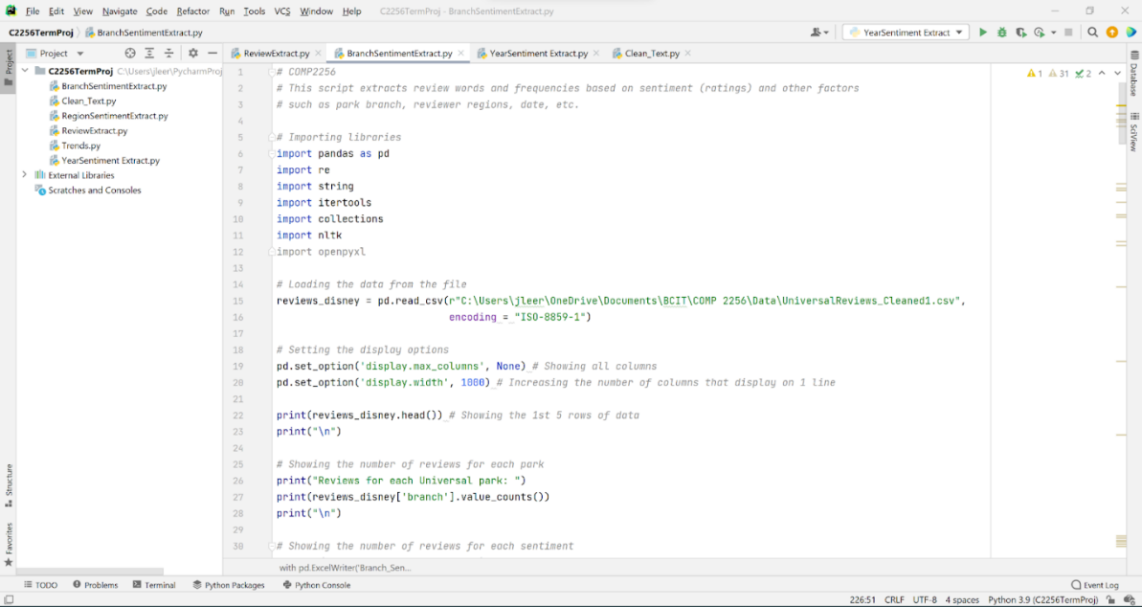

Figure A4: Prep flow for word frequencies datasets for Disneyland reviews

Figure A5: Prep flow for word frequencies datasets for Universal Studios reviews

Table A1: Attendance numbers for each Universal Studios park over the period of analysis.

|  |  |  |  |
| --- | --- | --- | --- |
| **Year** | **Universal Studios Florida** | **Universal Studios Singapore** | **Universal Studios Japan** |
| 2010 | 5,925,000 | 2,000,000 | 8,160,000 |
| 2011 | 6,044,000 | 3,411,000 | 8,500,000 |
| 2012 | 6,195,000 | 3,480,000 | 9,700,000 |
| 2013 | 7,062,000 | 3,650,000 | 10,100,000 |
| 2014 | 8,263,000 | 3,840,000 | 11,800,000 |
| 2015 | 9,585,000 | 4,200,000 | 13,900,000 |
| 2016 | 9,998,000 | 4,100,000 | 14,500,000 |
| 2017 | 10,198,000 | 4,220,000 | 14,935,000 |
| 2018 | 10,708,000 | 4,400,000 | 14,300,000 |
| 2019 | 10,922,000 | 4,500,000 | 14,500,000 |

## Appendix B – Other Charts and Views

Figure B1: Regional Analysis of ratings and reviews of Disneyland Hong Kong

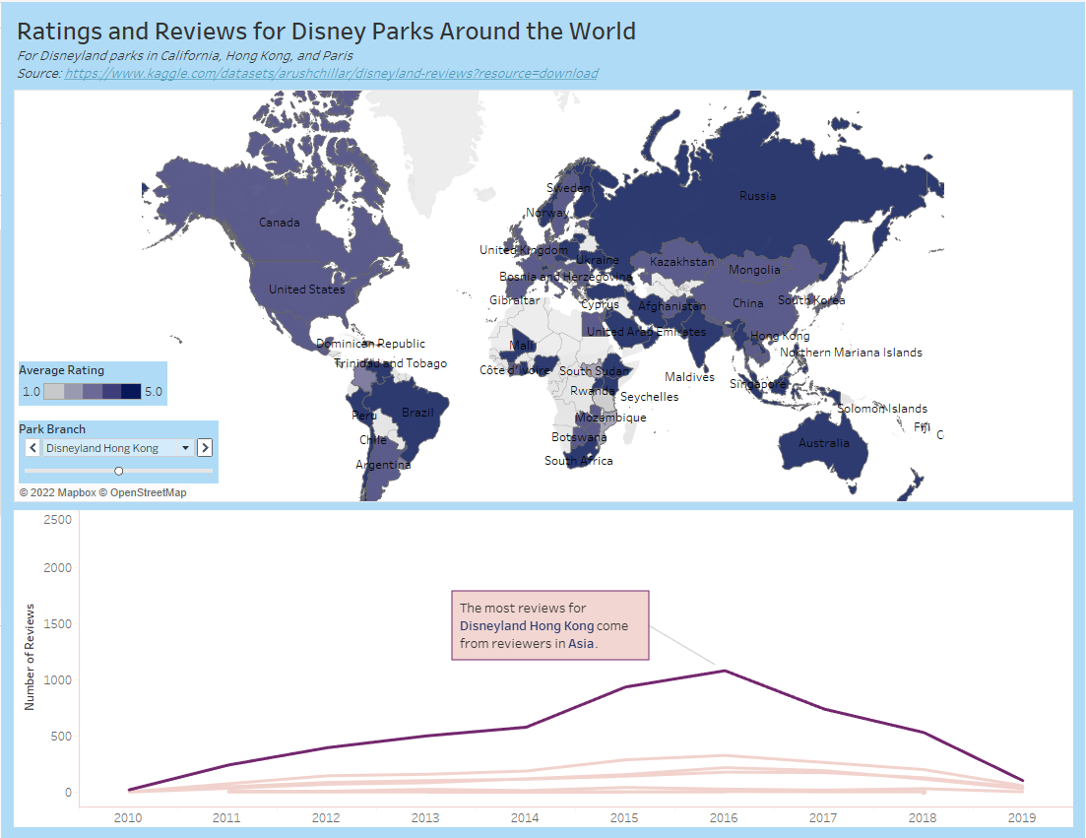

Figure B2: Regional Analysis of ratings and reviews of Disneyland Paris

Figure B3: Overview version of Disneyland Reviews Sentiment Analysis

Figure B4: Sentiment Analysis for reviews of Disneyland Hong Kong

Figure B5: Sentiment Analysis for reviews of Disneyland Paris

Figure B6: Sentiment Analysis for reviews of Universal Studios Florida

Figure B7: Sentiment Analysis for reviews of Universal Studios Japan

Figure B8: Sentiment Analysis for reviews of Universal Studios Singapore

Figure B9: Universal Studios Word Map in full

Figure B10: Universal Studios word frequency highlight table

