Online Retail Customer Analytics Report
Sales Performance, Product Insights and Customer Behavior
Purpose: To analyze historical retail transactions, identify customer and product patterns, and develop practical recommendations for business decision-making.
Reporting note: Monetary values use the source dataset's currency. The currency is not inferred by this script.

1. Executive Summary
- Total Revenue: 10,642,110.80
- Total Orders: 19,960.00
- Unique Customers: 4,338.00
- Unique Products: 3,922.00
- Units Sold: 5,572,420.00
- Average Order Value: 533.17
- Average Unit Price: 3.92
- Average Revenue per Identified Customer: 2,453.23
Finding: The highest-revenue month was 2011-11, with revenue of 1,503,866.78.
Finding: The leading product by revenue was DOTCOM POSTAGE, generating 206,248.77.
Finding: The leading country by revenue was United Kingdom, with revenue of 9,001,744.09.
Interpretation: Total revenue measures sales value in the retained records. Average order value estimates revenue per distinct invoice. These measures describe performance but do not, by themselves, measure profit.

2. Data Quality Assessment
column | dtype | missing_count | missing_pct | unique_values
description | object | 1454 | 0.27 | 4223
invoiceno | object | 0 | 0.00 | 25900
stockcode | object | 0 | 0.00 | 4070
quantity | int64 | 0 | 0.00 | 722
invoicedate | object | 0 | 0.00 | 23260
unitprice | float64 | 0 | 0.00 | 1630
customerid | int64 | 0 | 0.00 | 4372
country | object | 0 | 0.00 | 38

1 columns contain missing values.
The highest missing-value percentage is in 'description' (0.27%). Review these missing values before relying on affected analyses.
Interpretation: Missing customer IDs prevent some transactions from being attributed to known customers. The cleaning procedure also removes duplicate rows, invalid dates and records with non-positive quantities or unit prices.

3. Monthly Sales Performance
year_month | revenue | orders | customers | units | aov
2010-12 | 821,452.73 | 1559 | 886 | 358019 | 526.91
2011-01 | 689,811.61 | 1086 | 742 | 387099 | 635.19
2011-02 | 522,545.56 | 1100 | 759 | 282934 | 475.04
2011-03 | 716,215.26 | 1454 | 975 | 376599 | 492.58
2011-04 | 536,968.49 | 1246 | 857 | 307953 | 430.95
2011-05 | 769,296.61 | 1681 | 1057 | 395001 | 457.64
2011-06 | 760,547.01 | 1533 | 992 | 388511 | 496.12
2011-07 | 718,076.12 | 1475 | 950 | 399693 | 486.83
2011-08 | 757,841.38 | 1361 | 936 | 421020 | 556.83
2011-09 | 1,056,435.19 | 1837 | 1266 | 569573 | 575.09
2011-10 | 1,151,263.73 | 2040 | 1365 | 621029 | 564.34
2011-11 | 1,503,866.78 | 2769 | 1664 | 751377 | 543.11
2011-12 | 637,790.33 | 819 | 616 | 313612 | 778.74

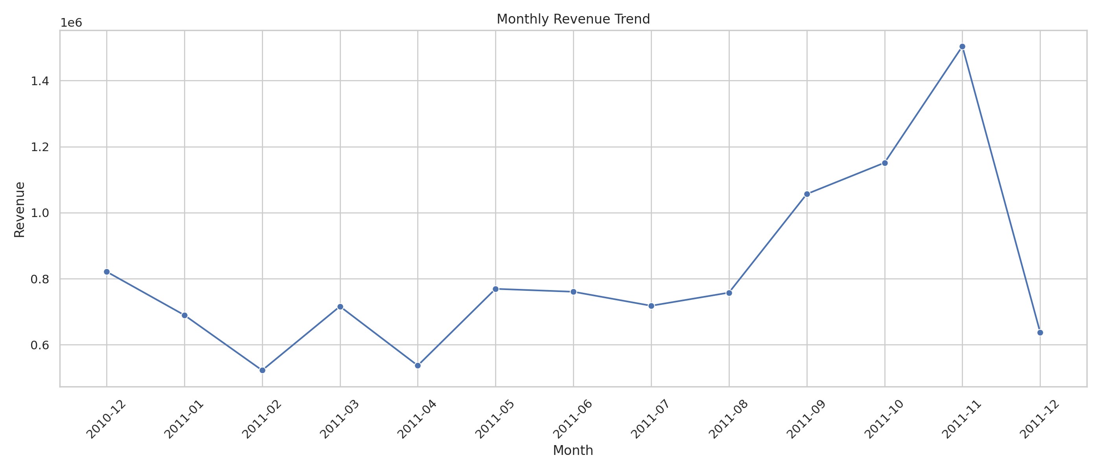
Figure 1. Monthly revenue trend.
Interpretation: Revenue peaked in 2011-11 at 1,503,866.78 and was lowest in 2011-02 at 522,545.56. Investigate seasonal demand, promotions and the number of trading days before attributing the difference to a particular cause.

4. Product Performance
stockcode | description | revenue | units_sold | orders | customers | revenue_share
DOT | DOTCOM POSTAGE | 206,248.77 | 706 | 706 | 2 | 0.02
22423 | REGENCY CAKESTAND 3 TIER | 174,156.54 | 13851 | 1988 | 882 | 0.02
23843 | PAPER CRAFT , LITTLE BIRDIE | 168,469.60 | 80995 | 1 | 1 | 0.02
85123A | WHITE HANGING HEART T-LIGHT HOLDER | 104,284.24 | 37580 | 2189 | 857 | 0.01
47566 | PARTY BUNTING | 99,445.23 | 18283 | 1685 | 709 | 0.01
85099B | JUMBO BAG RED RETROSPOT | 94,159.81 | 48371 | 2089 | 636 | 0.01
23166 | MEDIUM CERAMIC TOP STORAGE JAR | 81,700.92 | 78033 | 247 | 139 | 0.01
POST | POSTAGE | 78,101.88 | 3150 | 1126 | 332 | 0.01
M | Manual | 77,750.27 | 6984 | 289 | 198 | 0.01
23084 | RABBIT NIGHT LIGHT | 66,870.03 | 30739 | 994 | 451 | 0.01
22086 | PAPER CHAIN KIT 50'S CHRISTMAS | 64,875.59 | 19329 | 1160 | 614 | 0.01
84879 | ASSORTED COLOUR BIRD ORNAMENT | 58,927.62 | 36362 | 1455 | 679 | 0.01
79321 | CHILLI LIGHTS | 54,096.36 | 10302 | 661 | 206 | 0.01
23298 | SPOTTY BUNTING | 42,513.48 | 8320 | 1140 | 572 | 0.00
22386 | JUMBO BAG PINK POLKADOT | 42,401.01 | 21448 | 1218 | 373 | 0.00

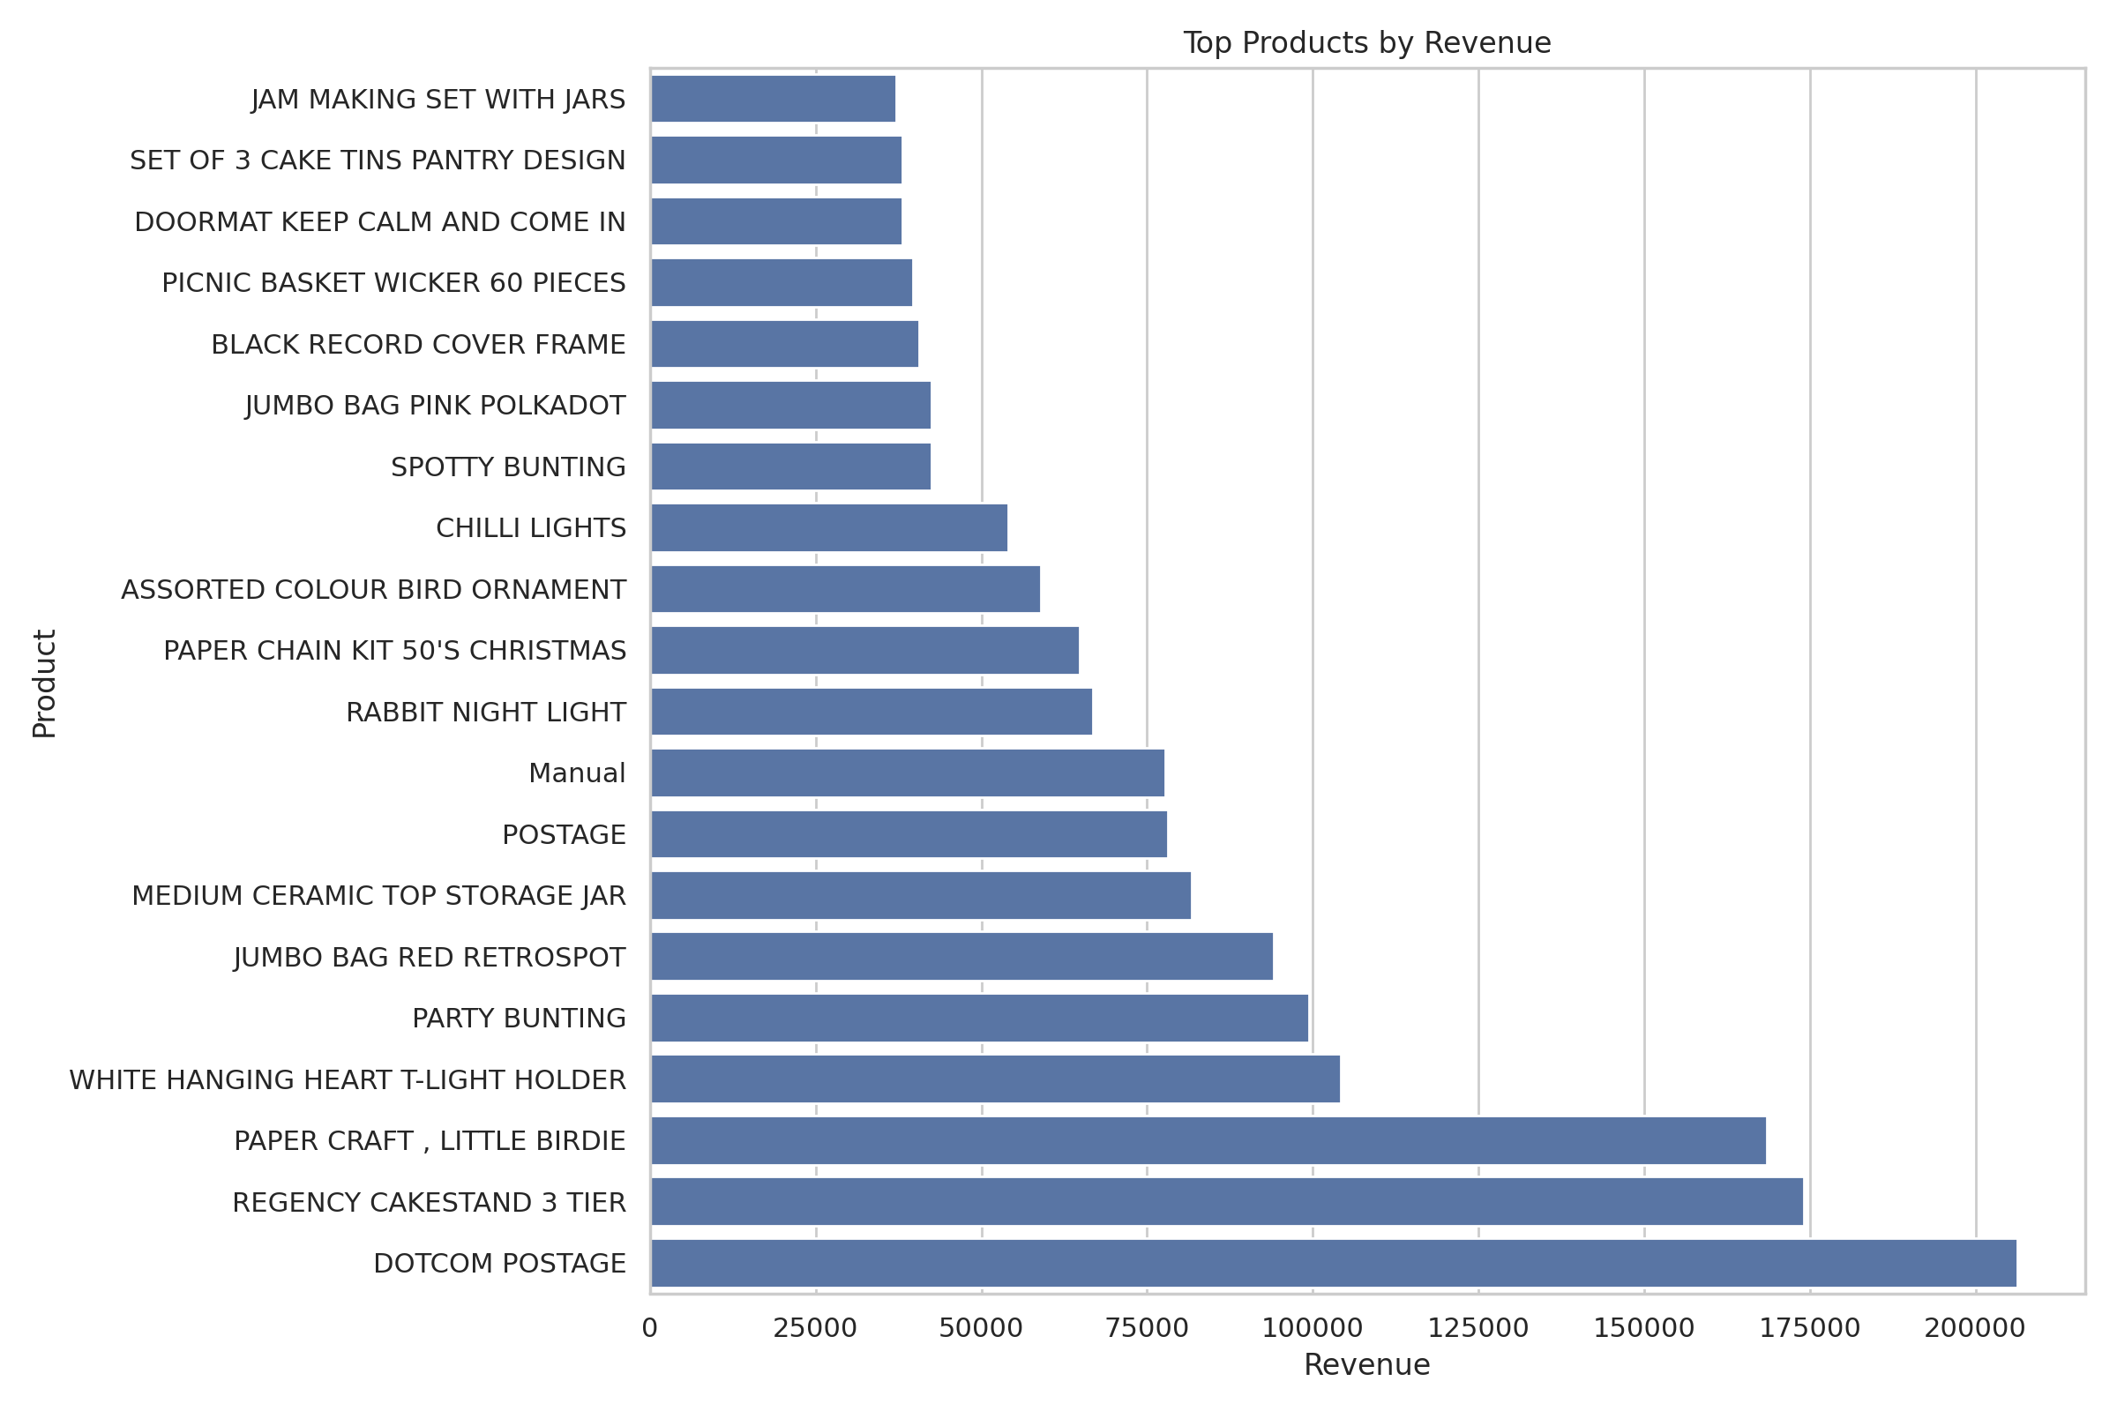
Figure 2. Highest-revenue products.
Interpretation: DOTCOM POSTAGE is the highest-revenue product in the ranking, with 206,248.77 in sales. Revenue share helps show how much each product contributes to the total revenue of the products in the full cleaned dataset.

5. Customer Analysis
The customer-level dataset contains 4,338 customers with an identifiable ID.
customerid | revenue | orders | units | products | first_purchase | last_purchase | average_order_value | orders_per_distinct_product | customer_lifetime_days
15287 | 1,755,388.60 | 1430 | 420851 | 3409 | 2010-12-01 14:32:00 | 2011-12-09 10:26:00 | 1,227.54 | 0.42 | 372
14646 | 280,206.02 | 73 | 196915 | 700 | 2010-12-20 10:09:00 | 2011-12-08 12:12:00 | 3,838.44 | 0.10 | 353
18102 | 259,657.30 | 60 | 64124 | 150 | 2010-12-07 16:42:00 | 2011-12-09 11:50:00 | 4,327.62 | 0.40 | 366
17450 | 194,390.79 | 46 | 69973 | 124 | 2010-12-07 09:23:00 | 2011-12-01 13:29:00 | 4,225.89 | 0.37 | 359
16446 | 168,472.50 | 2 | 80997 | 3 | 2011-05-18 09:52:00 | 2011-12-09 09:15:00 | 84,236.25 | 0.67 | 204
14911 | 143,711.17 | 201 | 80240 | 1787 | 2010-12-01 14:05:00 | 2011-12-08 15:54:00 | 714.98 | 0.11 | 372
12415 | 124,914.53 | 21 | 77374 | 444 | 2011-01-06 11:12:00 | 2011-11-15 14:22:00 | 5,948.31 | 0.05 | 313
14156 | 117,210.08 | 55 | 57768 | 714 | 2010-12-03 11:48:00 | 2011-11-30 10:54:00 | 2,131.09 | 0.08 | 361
17511 | 91,062.38 | 31 | 64549 | 453 | 2010-12-01 10:19:00 | 2011-12-07 10:12:00 | 2,937.50 | 0.07 | 370
16029 | 80,850.84 | 63 | 40108 | 44 | 2010-12-01 09:57:00 | 2011-11-01 10:27:00 | 1,283.35 | 1.43 | 335
12346 | 77,183.60 | 1 | 74215 | 1 | 2011-01-18 10:01:00 | 2011-01-18 10:01:00 | 77,183.60 | 1.00 | 0
16684 | 66,653.56 | 28 | 50255 | 119 | 2010-12-16 17:34:00 | 2011-12-05 14:06:00 | 2,380.48 | 0.24 | 353
14096 | 65,164.79 | 17 | 16352 | 1119 | 2011-08-30 10:49:00 | 2011-12-05 17:17:00 | 3,833.22 | 0.02 | 97
13694 | 65,039.62 | 50 | 63312 | 366 | 2010-12-01 12:12:00 | 2011-12-06 09:32:00 | 1,300.79 | 0.14 | 369
15311 | 60,632.75 | 91 | 38147 | 567 | 2010-12-01 09:41:00 | 2011-12-09 12:00:00 | 666.29 | 0.16 | 373

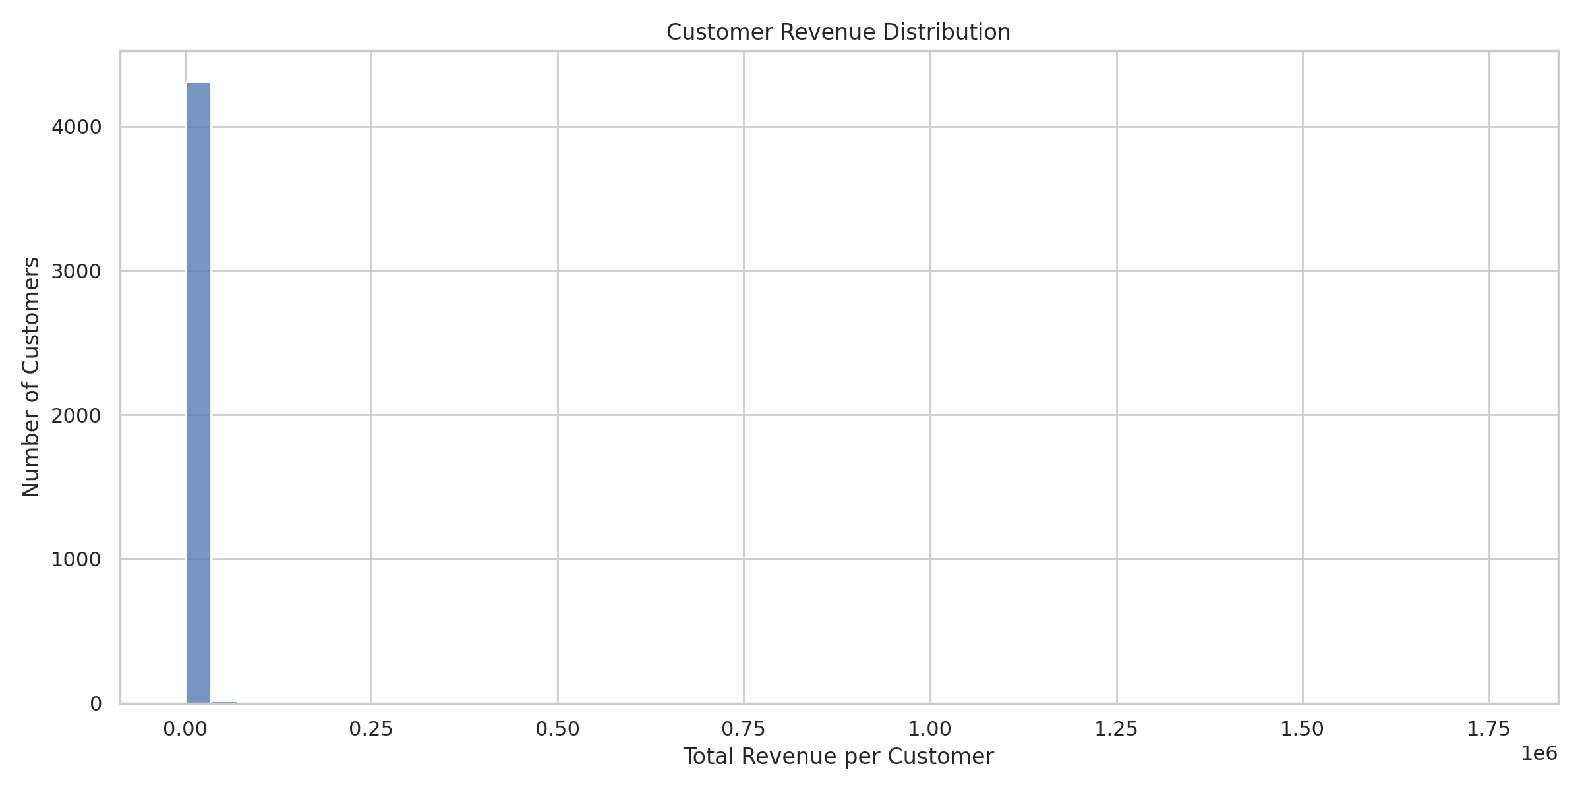
Figure 3. Distribution of customer revenue.
Average revenue per identified customer is 2,453.23, while median customer revenue is 670.13. If the mean is substantially higher than the median, revenue may be concentrated among a smaller number of high-spending customers.
Interpretation: Prioritize customer retention using multiple measures, including revenue, order frequency and purchase recency. Revenue alone does not establish customer profitability.

6. RFM Customer Segmentation
segment | customers | customer_share_pct
Potential Loyalists | 1318 | 30.38
Hibernating | 962 | 22.18
Champions | 912 | 21.02
At Risk | 765 | 17.63
Loyal Customers | 381 | 8.78

Interpretation of RFM: Recency measures how recently a customer purchased, frequency counts distinct invoices, and monetary value measures retained sales.
- Champions: customers scoring highly on recency, frequency and monetary value.
- Loyal Customers: recently active customers with relatively frequent purchases.
- At Risk: customers with older purchases but relatively high historical purchase frequency.
- Hibernating: customers with older purchases and relatively low purchase frequency.
- Potential Loyalists: customers not captured by the preceding rules.
Recommendation: Test segment-specific campaigns and measure conversion, repeat purchases and incremental revenue rather than assuming the campaigns will work.

7. Country Performance
country | revenue | orders | customers | units | aov
United Kingdom | 9,001,744.09 | 18019 | 3920 | 4646906 | 499.57
Netherlands | 285,446.34 | 94 | 9 | 200361 | 3,036.66
EIRE | 283,140.52 | 288 | 4 | 147007 | 983.13
Germany | 228,678.40 | 457 | 94 | 119154 | 500.39
France | 209,625.37 | 392 | 88 | 112060 | 534.76
Australia | 138,453.81 | 57 | 9 | 83891 | 2,429.01
Spain | 61,558.56 | 90 | 30 | 27933 | 683.98
Switzerland | 57,067.60 | 54 | 22 | 30617 | 1,056.81
Belgium | 41,196.34 | 98 | 25 | 23237 | 420.37
Sweden | 38,367.83 | 36 | 8 | 36078 | 1,065.77
Japan | 37,416.37 | 19 | 8 | 26016 | 1,969.28
Norway | 36,165.44 | 36 | 10 | 19336 | 1,004.60
Portugal | 33,683.05 | 58 | 20 | 16231 | 580.74
Finland | 22,546.08 | 41 | 12 | 10704 | 549.90
Singapore | 21,279.29 | 7 | 1 | 5241 | 3,039.90

Interpretation: United Kingdom ranks first among the displayed countries by revenue, with 9,001,744.09. Compare order volume, customer count and average order value to understand differences in market size and spending behavior.

8. Product Pricing Analysis
stockcode | description | average_price | median_price | units_sold | revenue | orders
DOT | DOTCOM POSTAGE | 292.14 | 185.47 | 706 | 206,248.77 | 706
22423 | REGENCY CAKESTAND 3 TIER | 13.98 | 12.75 | 13851 | 174,156.54 | 1988
23843 | PAPER CRAFT , LITTLE BIRDIE | 2.08 | 2.08 | 80995 | 168,469.60 | 1
85123A | WHITE HANGING HEART T-LIGHT HOLDER | 3.12 | 2.95 | 37580 | 104,284.24 | 2189
47566 | PARTY BUNTING | 5.80 | 4.95 | 18283 | 99,445.23 | 1685
85099B | JUMBO BAG RED RETROSPOT | 2.49 | 2.08 | 48371 | 94,159.81 | 2089
23166 | MEDIUM CERAMIC TOP STORAGE JAR | 1.47 | 1.25 | 78033 | 81,700.92 | 247
POST | POSTAGE | 31.08 | 18.00 | 3150 | 78,101.88 | 1126
M | Manual | 234.49 | 1.95 | 6984 | 77,750.27 | 289
23084 | RABBIT NIGHT LIGHT | 2.39 | 2.08 | 30739 | 66,870.03 | 994
22086 | PAPER CHAIN KIT 50'S CHRISTMAS | 3.36 | 2.95 | 19329 | 64,875.59 | 1160
84879 | ASSORTED COLOUR BIRD ORNAMENT | 1.72 | 1.69 | 36362 | 58,927.62 | 1455
79321 | CHILLI LIGHTS | 6.80 | 5.75 | 10302 | 54,096.36 | 661
23298 | SPOTTY BUNTING | 5.52 | 4.95 | 8320 | 42,513.48 | 1140
22386 | JUMBO BAG PINK POLKADOT | 2.60 | 2.08 | 21448 | 42,401.01 | 1218

Interpretation: Average and median prices summarize observed transaction prices for each product. Units sold and revenue can help identify products with different sales patterns. This descriptive analysis cannot prove that a price change causes a change in demand.

9. Hourly Sales Behavior
hour | revenue | orders | units
0.00 | 0.00 | 0.00 | 0.00
1.00 | 0.00 | 0.00 | 0.00
2.00 | 0.00 | 0.00 | 0.00
3.00 | 0.00 | 0.00 | 0.00
4.00 | 0.00 | 0.00 | 0.00
5.00 | 0.00 | 0.00 | 0.00
6.00 | 4.25 | 1.00 | 1.00
7.00 | 31,059.21 | 29.00 | 15,370.00
8.00 | 283,750.68 | 566.00 | 158,649.00
9.00 | 990,054.99 | 1,484.00 | 517,985.00
10.00 | 1,444,814.77 | 2,361.00 | 812,678.00
11.00 | 1,236,573.29 | 2,396.00 | 671,281.00
12.00 | 1,439,324.66 | 3,220.00 | 836,642.00
13.00 | 1,261,195.20 | 2,753.00 | 703,750.00
14.00 | 1,177,907.52 | 2,457.00 | 597,056.00
15.00 | 1,350,333.31 | 2,336.00 | 626,989.00
16.00 | 752,487.96 | 1,335.00 | 330,609.00
17.00 | 460,963.92 | 667.00 | 192,512.00
18.00 | 144,603.61 | 192.00 | 66,465.00
19.00 | 50,204.95 | 146.00 | 32,925.00
20.00 | 18,832.48 | 18.00 | 9,508.00
21.00 | 0.00 | 0.00 | 0.00
22.00 | 0.00 | 0.00 | 0.00
23.00 | 0.00 | 0.00 | 0.00

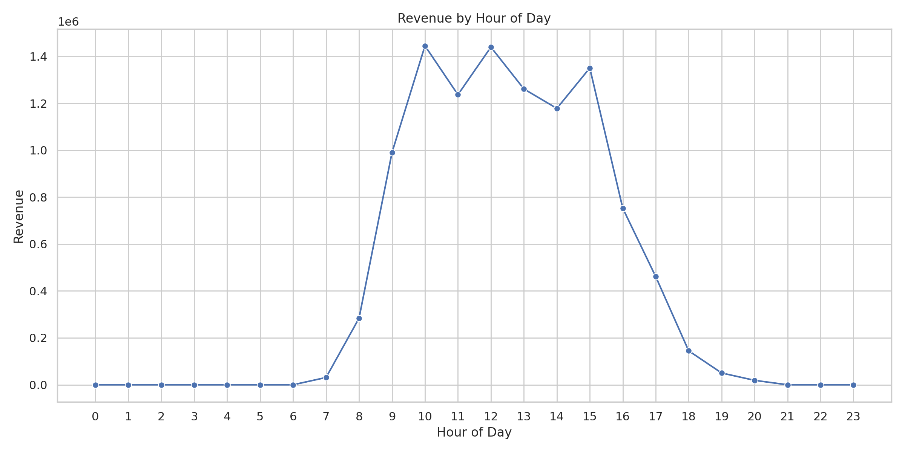
Figure 4. Revenue by hour of day.
Interpretation: The highest-revenue hour is 10:00, with revenue of 1,444,814.77. Check whether this pattern holds across different days, months and seasons before making staffing decisions.

10. Business Recommendations
- Customer retention: Evaluate targeted retention and re-engagement campaigns for RFM segments, measuring incremental outcomes against an appropriate comparison or control group.
- Product management: Review revenue, unit volume, customer reach, and order frequency together when prioritizing inventory and merchandising decisions.
- Market development: Investigate geographic differences in revenue, order volume, and average order value before allocating additional marketing resources.
- Sales planning: Monitor monthly sales performance and investigate seasonal patterns, trading-day effects, and changes in customer demand.
- Operational planning: Examine hourly activity across different periods before making staffing or service-capacity decisions.
- Data quality: Validate unusual transaction patterns and distinguish sales from returns, cancellations, and other adjustments before using the metrics for financial reporting.
These recommendations are hypotheses for business investigation, not proven interventions. Their effectiveness should be evaluated using appropriate measurement and validation methods.

11. Limitations and Definitions
- Revenue is not profit: Cost of goods, operating expenses, and other cost components are not modeled.
- Returns and cancellations: Excluding non-positive quantities and prices can result in sales metrics that do not reflect net revenue after returns and refunds.
- Customer coverage: Transactions without customer identifiers cannot be attributed to known customers in customer-level analyses.
- Historical scope: RFM recency is calculated relative to the dataset's analysis date, not the present day.
- Causal interpretation: Descriptive relationships between price, customer behavior, and sales do not establish causal effects.
- Data source and licensing: Verify the original dataset page and its license, and include the correct source link. Avoid committing sensitive or restricted data.

