Project Plan Template

Project Title:
Evolutionary Art

Team Members:
- Names: Josh Lee
- Skills: Super Fast

Problem Statement:
- What is the problem that you want to solve?
Can a computer be trained to create aesthetically pleasing artwork?
  - What groups of people are going to benefit from your solution?
- Why is this an important problem?
  - Why is it better than existing technologies?
  - Why would a business buy this solution?
  - What good things will come from your solution?
  - What bad things won’t happen as a result of your solution?

Project Description:
- What is your proposed solution?
Use a genetic algorithm (see http://en.wikipedia.org/wiki/Genetic_algorithm).
  - Describe your solution.
  - Create a number of expression trees that take two parameters, x and y, and evaluate to a color.
    - Example tree:
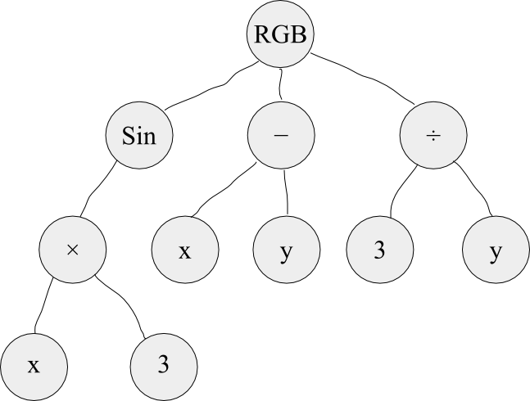
  - Render each tree to a bitmap image.
  - Present each picture to the user with a “thumbs up” and “thumbs down” button.
  - Breed the trees:
    - Select the top n% (weighted by user ratings)
    - Crossover by swapping random subtrees.
    - Mutate random nodes.
    - The resulting set of trees is the next generation.
    - Go back to step 2.
  - How does your solution address the problem?
Each generation will contain only the images that got voted up. Breeding and mutating the images will (hopefully) result in a new generation of images that are more aesthetically pleasing.
  - How will you implement your solution?
Tree data structure, Python.

Technologies you want to work with:
- Are you limited to certain technologies?
- What are your technologies of choice?
  - Platform (Windows, Linux, etc.) Debian GNU/Linux
  - Programming Languages (Java, Python, etc.) Python
  - Databases (PostgreSQL, MySQL, mSQL, etc.) MySQL
  - Web Server (IIS, Apache, Tomcat, etc.) Apache with the Django framework
  - Other devices (mobile computing, robotics, etc.) After the initial algorithm is perfected, a future improvement might be an evolutionary art display that passers-by can interact with.
  - Any other technology decisions

Draft Project Plan
- Give a rough layout of your project schedule.

