# BAN 502

## Jacqulyn Leer and Jennafer Hinman

### Course Project Phase 1

Reading in the dataset.

ames <- read_csv("ames_student.csv")

## Warning: Missing column names filled in: 'X1' [1]

##   
## -- Column specification --------------------------------------------------------  
## cols(  
## .default = col_character(),  
## X1 = col_double(),  
## Lot_Frontage = col_double(),  
## Lot_Area = col_double(),  
## Year_Built = col_double(),  
## Year_Remod_Add = col_double(),  
## Mas_Vnr_Area = col_double(),  
## BsmtFin_SF_1 = col_double(),  
## BsmtFin_SF_2 = col_double(),  
## Bsmt_Unf_SF = col_double(),  
## Total_Bsmt_SF = col_double(),  
## First_Flr_SF = col_double(),  
## Second_Flr_SF = col_double(),  
## Low_Qual_Fin_SF = col_double(),  
## Gr_Liv_Area = col_double(),  
## Bsmt_Full_Bath = col_double(),  
## Bsmt_Half_Bath = col_double(),  
## Full_Bath = col_double(),  
## Half_Bath = col_double(),  
## Bedroom_AbvGr = col_double(),  
## Kitchen_AbvGr = col_double()  
## # ... with 15 more columns  
## )  
## i Use `spec()` for the full column specifications.

Getting rid of unnecessary first column “X1” that just numbers the rows within the dataset as well as latitude and longitude.

ames = ames[-c(1, 80, 81)]

Convert the characters as well as the columns for years and months in the dataset to factors.

ames = ames %>%   
 mutate_if(is.character, as_factor) %>%  
 mutate(Year_Built = as_factor(Year_Built)) %>%  
 mutate(Year_Remod_Add = as_factor(Year_Remod_Add)) %>%  
 mutate(Year_Sold = as_factor(Year_Sold)) %>%  
 mutate(Mo_Sold = as_factor(Mo_Sold))

Look for any missing data

summary(ames)

## MS_SubClass MS_Zoning   
## One_Story_1946_and_Newer_All_Styles :772 Residential_Low_Density :1600   
## Two_Story_1946_and_Newer :383 Residential_High_Density : 20   
## One_and_Half_Story_Finished_All_Ages:204 Floating_Village_Residential: 87   
## One_Story_PUD_1946_and_Newer :129 Residential_Medium_Density : 326   
## One_Story_1945_and_Older : 98 C_all : 17   
## Two_Story_1945_and_Older : 95 A_agr : 2   
## (Other) :372 I_all : 1   
## Lot_Frontage Lot_Area Street Alley   
## Min. : 0.00 Min. : 1300 Pave:2046 No_Alley_Access:1914   
## 1st Qu.: 43.00 1st Qu.: 7500 Grvl: 7 Paved : 45   
## Median : 62.00 Median : 9548 Gravel : 94   
## Mean : 57.38 Mean : 10258   
## 3rd Qu.: 78.00 3rd Qu.: 11600   
## Max. :313.00 Max. :215245   
##   
## Lot_Shape Land_Contour Utilities Lot_Config   
## Slightly_Irregular : 714 Lvl:1833 AllPub:2052 Corner : 359   
## Regular :1275 HLS: 94 NoSewr: 1 Inside :1495   
## Moderately_Irregular: 53 Bnk: 81 CulDSac: 135   
## Irregular : 11 Low: 45 FR2 : 56   
## FR3 : 8   
##   
##   
## Land_Slope Neighborhood Condition_1 Condition_2 Bldg_Type   
## Gtl:1951 North_Ames : 327 Norm :1771 Norm :2027 OneFam :1706   
## Mod: 89 College_Creek: 183 Feedr : 113 Feedr : 12 TwnhsE : 157   
## Sev: 13 Old_Town : 181 Artery : 67 PosA : 4 Twnhs : 67   
## Edwards : 129 RRAn : 35 Artery : 4 Duplex : 76   
## Somerset : 119 PosN : 24 PosN : 3 TwoFmCon: 47   
## Gilbert : 109 RRAe : 19 RRNn : 1   
## (Other) :1005 (Other): 24 (Other): 2   
## House_Style Overall_Qual Overall_Cond   
## One_Story :1052 Average :587 Average :1143   
## Two_Story : 590 Above_Average:518 Above_Average: 376   
## One_and_Half_Fin: 225 Good :411 Good : 286   
## SLvl : 90 Very_Good :237 Very_Good : 98   
## SFoyer : 56 Below_Average:169 Below_Average: 73   
## Two_and_Half_Unf: 19 Excellent : 70 Fair : 35   
## (Other) : 21 (Other) : 61 (Other) : 42   
## Year_Built Year_Remod_Add Roof_Style Roof_Matl Exterior_1st  
## 2005 : 104 1950 : 256 Hip : 404 CompShg:2023 VinylSd:705   
## 2006 : 93 2006 : 147 Gable :1607 WdShake: 8 MetalSd:319   
## 2007 : 76 2007 : 116 Mansard: 9 Tar&Grv: 17 Wd Sdng:313   
## 2003 : 62 2005 : 94 Gambrel: 14 WdShngl: 3 HdBoard:303   
## 2004 : 60 2004 : 80 Shed : 5 Roll : 1 Plywood:151   
## 1977 : 40 2003 : 70 Flat : 14 Metal : 1 CemntBd: 90   
## (Other):1618 (Other):1290 (Other):172   
## Exterior_2nd Mas_Vnr_Type Mas_Vnr_Area Exter_Qual   
## VinylSd:699 Stone : 166 Min. : 0.0 Typical :1272   
## MetalSd:317 None :1231 1st Qu.: 0.0 Good : 682   
## Wd Sdng:302 BrkFace: 638 Median : 0.0 Excellent: 78   
## HdBoard:277 BrkCmn : 17 Mean : 103.8 Fair : 21   
## Plywood:190 CBlock : 1 3rd Qu.: 164.0   
## CmentBd: 90 Max. :1600.0   
## (Other):178   
## Exter_Cond Foundation Bsmt_Qual Bsmt_Cond   
## Typical :1787 CBlock:880 Typical :911 Good : 80   
## Good : 213 PConc :911 Good :849 Typical :1833   
## Fair : 43 Wood : 4 Excellent :178 Poor : 4   
## Excellent: 9 BrkTil:216 No_Basement: 57 No_Basement: 57   
## Poor : 1 Slab : 36 Fair : 57 Fair : 76   
## Stone : 6 Poor : 1 Excellent : 3   
##   
## Bsmt_Exposure BsmtFin_Type_1 BsmtFin_SF_1 BsmtFin_Type_2  
## Gd : 199 BLQ :196 Min. :1.00 Unf :1740   
## No :1331 Rec :216 1st Qu.:3.00 LwQ : 64   
## Av : 284 ALQ :298 Median :3.00 BLQ : 47   
## Mn : 179 GLQ :578 Mean :4.21 Rec : 79   
## No_Basement: 60 Unf :602 3rd Qu.:7.00 GLQ : 23   
## LwQ :106 Max. :7.00 No_Basement: 58   
## No_Basement: 57 ALQ : 42   
## BsmtFin_SF_2 Bsmt_Unf_SF Total_Bsmt_SF Heating   
## Min. : 0.00 Min. : 0.0 Min. : 0 GasA :2019   
## 1st Qu.: 0.00 1st Qu.: 226.0 1st Qu.: 793 GasW : 21   
## Median : 0.00 Median : 460.0 Median : 988 Grav : 6   
## Mean : 52.57 Mean : 561.2 Mean :1055 Wall : 5   
## 3rd Qu.: 0.00 3rd Qu.: 801.0 3rd Qu.:1304 Floor: 1   
## Max. :1526.00 Max. :2336.0 Max. :5095 OthW : 1   
##   
## Heating_QC Central_Air Electrical First_Flr_SF Second_Flr_SF   
## Fair : 61 Y:1916 SBrkr :1887 Min. : 432 Min. : 0.0   
## Typical : 618 N: 137 FuseA : 126 1st Qu.: 882 1st Qu.: 0.0   
## Excellent:1040 FuseF : 33 Median :1088 Median : 0.0   
## Good : 333 FuseP : 6 Mean :1168 Mean : 326.1   
## Poor : 1 Unknown: 1 3rd Qu.:1402 3rd Qu.: 701.0   
## Max. :5095 Max. :1862.0   
##   
## Low_Qual_Fin_SF Gr_Liv_Area Bsmt_Full_Bath Bsmt_Half_Bath   
## Min. : 0.000 Min. : 480 Min. :0.0000 Min. :0.00000   
## 1st Qu.: 0.000 1st Qu.:1137 1st Qu.:0.0000 1st Qu.:0.00000   
## Median : 0.000 Median :1447 Median :0.0000 Median :0.00000   
## Mean : 4.973 Mean :1499 Mean :0.4301 Mean :0.05796   
## 3rd Qu.: 0.000 3rd Qu.:1737 3rd Qu.:1.0000 3rd Qu.:0.00000   
## Max. :1064.000 Max. :5095 Max. :3.0000 Max. :2.00000   
##   
## Full_Bath Half_Bath Bedroom_AbvGr Kitchen_AbvGr   
## Min. :0.000 Min. :0.0000 Min. :0.000 Min. :1.000   
## 1st Qu.:1.000 1st Qu.:0.0000 1st Qu.:2.000 1st Qu.:1.000   
## Median :2.000 Median :0.0000 Median :3.000 Median :1.000   
## Mean :1.564 Mean :0.3751 Mean :2.855 Mean :1.047   
## 3rd Qu.:2.000 3rd Qu.:1.0000 3rd Qu.:3.000 3rd Qu.:1.000   
## Max. :4.000 Max. :2.0000 Max. :6.000 Max. :3.000   
##   
## Kitchen_Qual TotRms_AbvGrd Functional Fireplaces   
## Typical :1070 Min. : 3.000 Typ :1896 Min. :0.000   
## Good : 790 1st Qu.: 5.000 Min2 : 54 1st Qu.:0.000   
## Excellent: 142 Median : 6.000 Min1 : 51 Median :1.000   
## Fair : 50 Mean : 6.442 Mod : 27 Mean :0.603   
## Poor : 1 3rd Qu.: 7.000 Maj1 : 15 3rd Qu.:1.000   
## Max. :15.000 Maj2 : 6 Max. :4.000   
## (Other): 4   
## Fireplace_Qu Garage_Type Garage_Finish Garage_Cars   
## Good :538 Attchd :1204 Fin :509 Min. :0.000   
## No_Fireplace:993 BuiltIn : 127 Unf :872 1st Qu.:1.000   
## Typical :409 Basment : 29 RFn :563 Median :2.000   
## Poor : 36 Detchd : 549 No_Garage:109 Mean :1.774   
## Excellent : 21 No_Garage : 108 3rd Qu.:2.000   
## Fair : 56 CarPort : 15 Max. :5.000   
## More_Than_Two_Types: 21   
## Garage_Area Garage_Qual Garage_Cond Paved_Drive   
## Min. : 0 Typical :1839 Typical :1872 Partial_Pavement: 42   
## 1st Qu.: 320 No_Garage: 109 No_Garage: 109 Paved :1848   
## Median : 478 Fair : 85 Fair : 53 Dirt_Gravel : 163   
## Mean : 472 Good : 16 Excellent: 1   
## 3rd Qu.: 576 Excellent: 2 Poor : 8   
## Max. :1488 Poor : 2 Good : 10   
##   
## Wood_Deck_SF Open_Porch_SF Enclosed_Porch Three_season_porch  
## Min. : 0.00 Min. : 0.00 Min. : 0.00 Min. : 0.000   
## 1st Qu.: 0.00 1st Qu.: 0.00 1st Qu.: 0.00 1st Qu.: 0.000   
## Median : 0.00 Median : 27.00 Median : 0.00 Median : 0.000   
## Mean : 93.52 Mean : 48.17 Mean : 23.02 Mean : 2.799   
## 3rd Qu.: 168.00 3rd Qu.: 72.00 3rd Qu.: 0.00 3rd Qu.: 0.000   
## Max. :1424.00 Max. :742.00 Max. :584.00 Max. :407.000   
##   
## Screen_Porch Pool_Area Pool_QC Fence   
## Min. : 0.00 Min. : 0.000 No_Pool :2047 No_Fence :1661   
## 1st Qu.: 0.00 1st Qu.: 0.000 Excellent: 2 Minimum_Privacy : 225   
## Median : 0.00 Median : 0.000 Typical : 2 Good_Privacy : 81   
## Mean : 16.68 Mean : 1.339 Fair : 1 Good_Wood : 77   
## 3rd Qu.: 0.00 3rd Qu.: 0.000 Good : 1 Minimum_Wood_Wire: 9   
## Max. :576.00 Max. :800.000   
##   
## Misc_Feature Misc_Val Mo_Sold Year_Sold Sale_Type   
## None:1978 Min. : 0.00 6 :352 2006:442 WD :1789   
## Gar2: 5 1st Qu.: 0.00 7 :320 2007:499 New : 163   
## Shed: 66 Median : 0.00 5 :275 2008:445 COD : 54   
## Othr: 3 Mean : 60.12 4 :187 2009:456 ConLD : 16   
## Elev: 1 3rd Qu.: 0.00 8 :169 2010:211 ConLI : 8   
## Max. :17000.00 3 :164 CWD : 8   
## (Other):586 (Other): 15   
## Sale_Condition Above_Median  
## Normal :1712 Yes:1043   
## Partial: 169 No :1010   
## Family : 30   
## Abnorml: 121   
## Alloca : 16   
## AdjLand: 5   
##

skim(ames)

Data summary

|  |  |
| --- | --- |
| Name | ames |
| Number of rows | 2053 |
| Number of columns | 79 |
| _______________________ |  |
| Column type frequency: |  |
| factor | 51 |
| numeric | 28 |
| ________________________ |  |
| Group variables | None |

**Variable type: factor**

|  |  |  |  |  |  |
| --- | --- | --- | --- | --- | --- |
| skim_variable | n_missing | complete_rate | ordered | n_unique | top_counts |
| MS_SubClass | 0 | 1 | FALSE | 16 | One: 772, Two: 383, One: 204, One: 129 |
| MS_Zoning | 0 | 1 | FALSE | 7 | Res: 1600, Res: 326, Flo: 87, Res: 20 |
| Street | 0 | 1 | FALSE | 2 | Pav: 2046, Grv: 7 |
| Alley | 0 | 1 | FALSE | 3 | No_: 1914, Gra: 94, Pav: 45 |
| Lot_Shape | 0 | 1 | FALSE | 4 | Reg: 1275, Sli: 714, Mod: 53, Irr: 11 |
| Land_Contour | 0 | 1 | FALSE | 4 | Lvl: 1833, HLS: 94, Bnk: 81, Low: 45 |
| Utilities | 0 | 1 | FALSE | 2 | All: 2052, NoS: 1 |
| Lot_Config | 0 | 1 | FALSE | 5 | Ins: 1495, Cor: 359, Cul: 135, FR2: 56 |
| Land_Slope | 0 | 1 | FALSE | 3 | Gtl: 1951, Mod: 89, Sev: 13 |
| Neighborhood | 0 | 1 | FALSE | 28 | Nor: 327, Col: 183, Old: 181, Edw: 129 |
| Condition_1 | 0 | 1 | FALSE | 9 | Nor: 1771, Fee: 113, Art: 67, RRA: 35 |
| Condition_2 | 0 | 1 | FALSE | 8 | Nor: 2027, Fee: 12, Pos: 4, Art: 4 |
| Bldg_Type | 0 | 1 | FALSE | 5 | One: 1706, Twn: 157, Dup: 76, Twn: 67 |
| House_Style | 0 | 1 | FALSE | 8 | One: 1052, Two: 590, One: 225, SLv: 90 |
| Overall_Qual | 0 | 1 | FALSE | 10 | Ave: 587, Abo: 518, Goo: 411, Ver: 237 |
| Overall_Cond | 0 | 1 | FALSE | 9 | Ave: 1143, Abo: 376, Goo: 286, Ver: 98 |
| Year_Built | 0 | 1 | FALSE | 114 | 200: 104, 200: 93, 200: 76, 200: 62 |
| Year_Remod_Add | 0 | 1 | FALSE | 61 | 195: 256, 200: 147, 200: 116, 200: 94 |
| Roof_Style | 0 | 1 | FALSE | 6 | Gab: 1607, Hip: 404, Gam: 14, Fla: 14 |
| Roof_Matl | 0 | 1 | FALSE | 6 | Com: 2023, Tar: 17, WdS: 8, WdS: 3 |
| Exterior_1st | 0 | 1 | FALSE | 16 | Vin: 705, Met: 319, Wd : 313, HdB: 303 |
| Exterior_2nd | 0 | 1 | FALSE | 17 | Vin: 699, Met: 317, Wd : 302, HdB: 277 |
| Mas_Vnr_Type | 0 | 1 | FALSE | 5 | Non: 1231, Brk: 638, Sto: 166, Brk: 17 |
| Exter_Qual | 0 | 1 | FALSE | 4 | Typ: 1272, Goo: 682, Exc: 78, Fai: 21 |
| Exter_Cond | 0 | 1 | FALSE | 5 | Typ: 1787, Goo: 213, Fai: 43, Exc: 9 |
| Foundation | 0 | 1 | FALSE | 6 | PCo: 911, CBl: 880, Brk: 216, Sla: 36 |
| Bsmt_Qual | 0 | 1 | FALSE | 6 | Typ: 911, Goo: 849, Exc: 178, No_: 57 |
| Bsmt_Cond | 0 | 1 | FALSE | 6 | Typ: 1833, Goo: 80, Fai: 76, No_: 57 |
| Bsmt_Exposure | 0 | 1 | FALSE | 5 | No: 1331, Av: 284, Gd: 199, Mn: 179 |
| BsmtFin_Type_1 | 0 | 1 | FALSE | 7 | Unf: 602, GLQ: 578, ALQ: 298, Rec: 216 |
| BsmtFin_Type_2 | 0 | 1 | FALSE | 7 | Unf: 1740, Rec: 79, LwQ: 64, No_: 58 |
| Heating | 0 | 1 | FALSE | 6 | Gas: 2019, Gas: 21, Gra: 6, Wal: 5 |
| Heating_QC | 0 | 1 | FALSE | 5 | Exc: 1040, Typ: 618, Goo: 333, Fai: 61 |
| Central_Air | 0 | 1 | FALSE | 2 | Y: 1916, N: 137 |
| Electrical | 0 | 1 | FALSE | 5 | SBr: 1887, Fus: 126, Fus: 33, Fus: 6 |
| Kitchen_Qual | 0 | 1 | FALSE | 5 | Typ: 1070, Goo: 790, Exc: 142, Fai: 50 |
| Functional | 0 | 1 | FALSE | 8 | Typ: 1896, Min: 54, Min: 51, Mod: 27 |
| Fireplace_Qu | 0 | 1 | FALSE | 6 | No_: 993, Goo: 538, Typ: 409, Fai: 56 |
| Garage_Type | 0 | 1 | FALSE | 7 | Att: 1204, Det: 549, Bui: 127, No_: 108 |
| Garage_Finish | 0 | 1 | FALSE | 4 | Unf: 872, RFn: 563, Fin: 509, No_: 109 |
| Garage_Qual | 0 | 1 | FALSE | 6 | Typ: 1839, No_: 109, Fai: 85, Goo: 16 |
| Garage_Cond | 0 | 1 | FALSE | 6 | Typ: 1872, No_: 109, Fai: 53, Goo: 10 |
| Paved_Drive | 0 | 1 | FALSE | 3 | Pav: 1848, Dir: 163, Par: 42 |
| Pool_QC | 0 | 1 | FALSE | 5 | No_: 2047, Exc: 2, Typ: 2, Fai: 1 |
| Fence | 0 | 1 | FALSE | 5 | No_: 1661, Min: 225, Goo: 81, Goo: 77 |
| Misc_Feature | 0 | 1 | FALSE | 5 | Non: 1978, She: 66, Gar: 5, Oth: 3 |
| Mo_Sold | 0 | 1 | FALSE | 12 | 6: 352, 7: 320, 5: 275, 4: 187 |
| Year_Sold | 0 | 1 | FALSE | 5 | 200: 499, 200: 456, 200: 445, 200: 442 |
| Sale_Type | 0 | 1 | FALSE | 10 | WD: 1789, New: 163, COD: 54, Con: 16 |
| Sale_Condition | 0 | 1 | FALSE | 6 | Nor: 1712, Par: 169, Abn: 121, Fam: 30 |
| Above_Median | 0 | 1 | FALSE | 2 | Yes: 1043, No: 1010 |

**Variable type: numeric**

|  |  |  |  |  |  |  |  |  |  |  |
| --- | --- | --- | --- | --- | --- | --- | --- | --- | --- | --- |
| skim_variable | n_missing | complete_rate | mean | sd | p0 | p25 | p50 | p75 | p100 | hist |
| Lot_Frontage | 0 | 1 | 57.38 | 33.20 | 0 | 43 | 62 | 78 | 313 | ▇▇▁▁▁ |
| Lot_Area | 0 | 1 | 10258.40 | 8427.38 | 1300 | 7500 | 9548 | 11600 | 215245 | ▇▁▁▁▁ |
| Mas_Vnr_Area | 0 | 1 | 103.75 | 183.59 | 0 | 0 | 0 | 164 | 1600 | ▇▁▁▁▁ |
| BsmtFin_SF_1 | 0 | 1 | 4.21 | 2.24 | 1 | 3 | 3 | 7 | 7 | ▅▆▁▁▇ |
| BsmtFin_SF_2 | 0 | 1 | 52.57 | 175.99 | 0 | 0 | 0 | 0 | 1526 | ▇▁▁▁▁ |
| Bsmt_Unf_SF | 0 | 1 | 561.19 | 441.72 | 0 | 226 | 460 | 801 | 2336 | ▇▅▂▁▁ |
| Total_Bsmt_SF | 0 | 1 | 1054.57 | 435.33 | 0 | 793 | 988 | 1304 | 5095 | ▇▇▁▁▁ |
| First_Flr_SF | 0 | 1 | 1167.52 | 391.79 | 432 | 882 | 1088 | 1402 | 5095 | ▇▃▁▁▁ |
| Second_Flr_SF | 0 | 1 | 326.07 | 422.44 | 0 | 0 | 0 | 701 | 1862 | ▇▂▂▁▁ |
| Low_Qual_Fin_SF | 0 | 1 | 4.97 | 49.09 | 0 | 0 | 0 | 0 | 1064 | ▇▁▁▁▁ |
| Gr_Liv_Area | 0 | 1 | 1498.56 | 487.84 | 480 | 1137 | 1447 | 1737 | 5095 | ▇▇▁▁▁ |
| Bsmt_Full_Bath | 0 | 1 | 0.43 | 0.53 | 0 | 0 | 0 | 1 | 3 | ▇▆▁▁▁ |
| Bsmt_Half_Bath | 0 | 1 | 0.06 | 0.24 | 0 | 0 | 0 | 0 | 2 | ▇▁▁▁▁ |
| Full_Bath | 0 | 1 | 1.56 | 0.55 | 0 | 1 | 2 | 2 | 4 | ▁▇▇▁▁ |
| Half_Bath | 0 | 1 | 0.38 | 0.50 | 0 | 0 | 0 | 1 | 2 | ▇▁▅▁▁ |
| Bedroom_AbvGr | 0 | 1 | 2.86 | 0.82 | 0 | 2 | 3 | 3 | 6 | ▁▃▇▂▁ |
| Kitchen_AbvGr | 0 | 1 | 1.05 | 0.22 | 1 | 1 | 1 | 1 | 3 | ▇▁▁▁▁ |
| TotRms_AbvGrd | 0 | 1 | 6.44 | 1.54 | 3 | 5 | 6 | 7 | 15 | ▅▇▃▁▁ |
| Fireplaces | 0 | 1 | 0.60 | 0.65 | 0 | 0 | 1 | 1 | 4 | ▇▇▁▁▁ |
| Garage_Cars | 0 | 1 | 1.77 | 0.76 | 0 | 1 | 2 | 2 | 5 | ▅▇▂▁▁ |
| Garage_Area | 0 | 1 | 471.96 | 213.43 | 0 | 320 | 478 | 576 | 1488 | ▃▇▂▁▁ |
| Wood_Deck_SF | 0 | 1 | 93.52 | 127.71 | 0 | 0 | 0 | 168 | 1424 | ▇▁▁▁▁ |
| Open_Porch_SF | 0 | 1 | 48.17 | 69.51 | 0 | 0 | 27 | 72 | 742 | ▇▁▁▁▁ |
| Enclosed_Porch | 0 | 1 | 23.02 | 60.59 | 0 | 0 | 0 | 0 | 584 | ▇▁▁▁▁ |
| Three_season_porch | 0 | 1 | 2.80 | 25.65 | 0 | 0 | 0 | 0 | 407 | ▇▁▁▁▁ |
| Screen_Porch | 0 | 1 | 16.68 | 57.94 | 0 | 0 | 0 | 0 | 576 | ▇▁▁▁▁ |
| Pool_Area | 0 | 1 | 1.34 | 27.74 | 0 | 0 | 0 | 0 | 800 | ▇▁▁▁▁ |
| Misc_Val | 0 | 1 | 60.12 | 662.76 | 0 | 0 | 0 | 0 | 17000 | ▇▁▁▁▁ |

vim_plot = aggr(ames, numbers = TRUE, prop = c(TRUE, FALSE),cex.axis=.7)

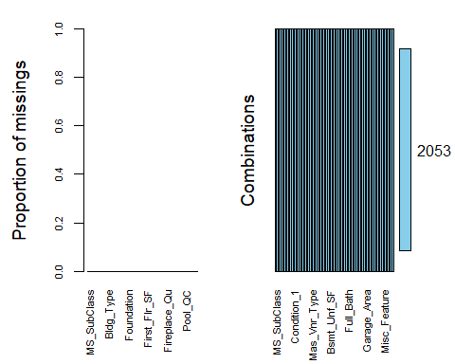

It does not appear as though we have any missing data in this dataset upon looking at the summary, skim, and VIM for this dataset.

Visualizations:

ggplot(ames, aes(x=Year_Built, fill = Above_Median)) + geom_bar() + theme_bw()

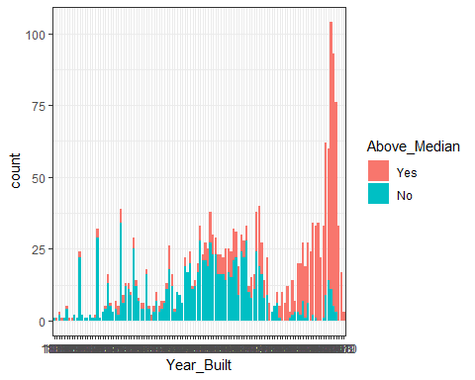

ggplot(ames, aes(x=Kitchen_Qual, fill = Above_Median)) + geom_bar() + theme(axis.text.x = element_text(angle = 90))

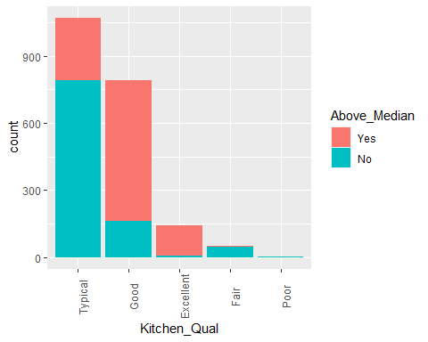

ggplot(ames, aes(x=Overall_Qual, fill = Above_Median)) + geom_bar() + theme(axis.text.x = element_text(angle = 90))

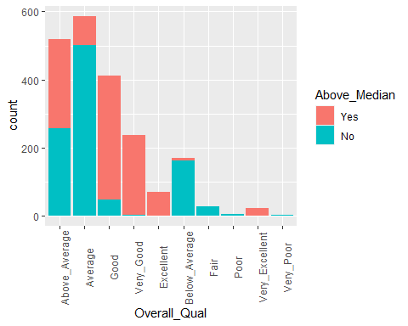

ggplot(ames, aes(x=Neighborhood, fill = Above_Median)) + geom_bar() + theme(axis.text.x = element_text(angle = 90))

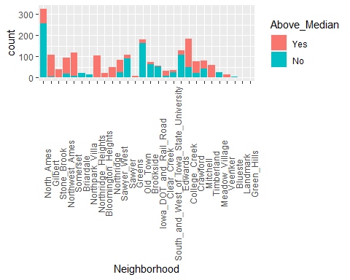

ggplot(ames, aes(x=Full_Bath, fill = Above_Median)) + geom_bar() + theme_bw()

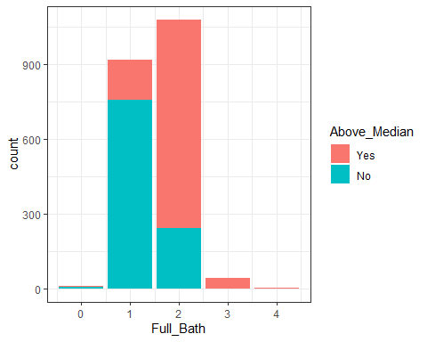

ggplot(ames, aes(x=Year_Remod_Add, fill = Above_Median)) + geom_bar() + theme_bw()

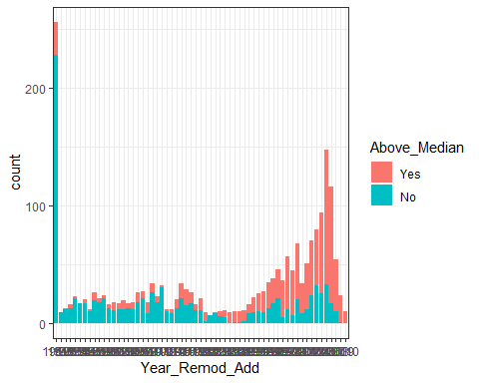

ggplot(ames, aes(x=Year_Sold, fill = Above_Median)) + geom_bar() + theme_bw()

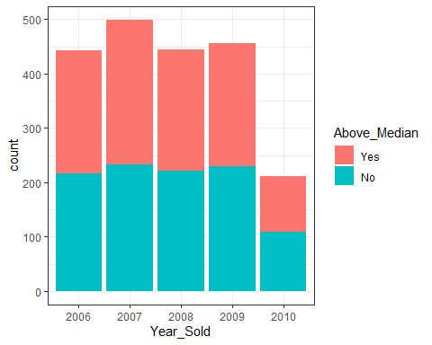

ggplot(ames, aes(x=Mo_Sold, fill = Above_Median)) + geom_bar() + theme_bw()

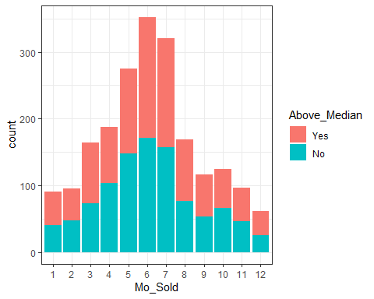

Another thing we wanted to look at was variable importance.

set.seed(1234)  
ames_split = initial_split(ames, prop = 0.7, strata = Above_Median)  
train = training(ames_split)  
test = testing(ames_split)

set.seed(100)  
rPartMod <- train(Above_Median ~ ., data=train, method="rpart")  
rpartImp <- varImp(rPartMod)  
print(rpartImp)

## rpart variable importance  
##   
## only 20 most important variables shown (out of 483)  
##   
## Overall  
## FoundationPConc 100.000  
## Garage_Cars 98.969  
## Full_Bath 86.854  
## Gr_Liv_Area 82.313  
## Exter_QualGood 75.024  
## Kitchen_AbvGr 28.065  
## Garage_FinishUnf 20.376  
## Garage_TypeDetchd 18.932  
## Fireplaces 13.010  
## Fireplace_QuNo_Fireplace 13.010  
## Lot_Area 8.555  
## Overall_QualGood 6.561  
## Overall_CondFair 0.000  
## NeighborhoodNorthwest_Ames 0.000  
## MS_ZoningFloating_Village_Residential 0.000  
## Year_Built1991 0.000  
## Year_Remod_Add1974 0.000  
## Exterior_2ndHdBoard 0.000  
## `Exterior_2ndWd Sdng` 0.000  
## NeighborhoodBloomington_Heights 0.000

ggplot(ames, aes(x=Foundation, fill = Above_Median)) + geom_bar() + theme_bw()

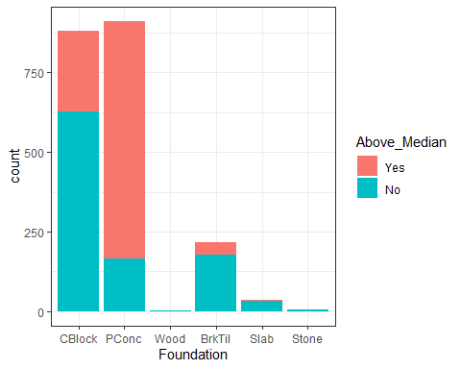

ggplot(ames, aes(x=Full_Bath, fill = Above_Median)) + geom_bar() + theme_bw()



ggplot(ames, aes(x=Garage_Cars, fill = Above_Median)) + geom_bar() + theme_bw()

