Teaching an AI Coach to Remember
Building an agentic memory layer for a lifestyle app — what I borrowed from MemGPT, and where I went my own way.
I'm building Cadence, a conversational fitness-and-nutrition coach. You talk to it like a person — “I got out of shape this winter and I want to run a Spartan Beast in October” — and it captures your goals, builds you a plan, and adapts as life happens.
The chat was the easy part. The hard part is memory.
An LLM has no memory between turns. And over months, a real user generates far more data — workouts, meals, weigh-ins, injuries, check-ins, the time they tweaked a knee at a wedding — than will ever fit in a model's context window. So the core question isn't “how do I make a chatbot.” It's: *how do I keep the coach grounded in your life without stuffing your entire life into every prompt?*
Here's how I'm solving it, and why it ended up looking a lot like an operating system.

The naive version (and why it falls apart)
The obvious move: render everything I know about you into a “dossier” and jam it into the system prompt. Goals, plan, recent adherence, injuries — all of it, every message.
It works great for about a week. Then three things break:
- It overflows. Three months in, the dossier is bigger than the budget I want to spend on context, and most of it is irrelevant to today's conversation.
- It quietly kills caching. Modern model APIs cache your prompt prefix to save money and latency. If the changing part of your prompt lives in the system prefix, you bust the cache on every turn. (One documented case went from a 7% to an 84% cache-hit rate by doing nothing but moving the mutating bit out of the system prompt.)
- It's a black box. The dossier was being assembled in application code. As the person responsible for the AI's behavior, I had no clean way to see how a given prompt was built, or to tune it without a deploy. For a health app, that's a non-starter.
The fix wasn't a better string. It was a reframe: this isn't a query problem, it's a memory problem. Treat the coach like an agent with working memory — and curate that memory deliberately.

The design, in four ideas
1. A semantic layer, not raw SQL. The tempting shortcut is to let the model write SQL against the database. Don't. Even read-only, a model-written query can scan a billion rows, lock a table, or leak across users — and it'll answer the same question two different ways on two different days. Instead, the AI picks from a registry of safe, parameterized retrieval functions — get_adherence(range), get_recent_nutrition(days), get_injuries(). A bounded, governed action space. The model chooses; my code executes.
2. A Broker that curates. A cheap, fast model (I call it the Broker) reads a small catalog — what data exists, how much of it, how recent — decides what's worth pulling for the conversation at hand, calls the right functions, and summarizes the results into a compact “context pack.” That pack, not the raw database, is what the coach reasons over.
3. The pack is working memory, not a transcript. It's structured, it carries provenance (which functions produced it, and when), and it has a TTL. It refreshes on a timer — but also early, when enough new data piles up, or when the coach notices mid-conversation that it's missing something.
4. Cache-aware placement. The stable persona lives in the cacheable system prefix. The changing context pack goes at the end of the prompt. That one move is the 7%-to-84% trick — and it cleanly separates the part the platform owns (who the coach is) from the part I inject as data (what it knows about you right now).

Seeing it run
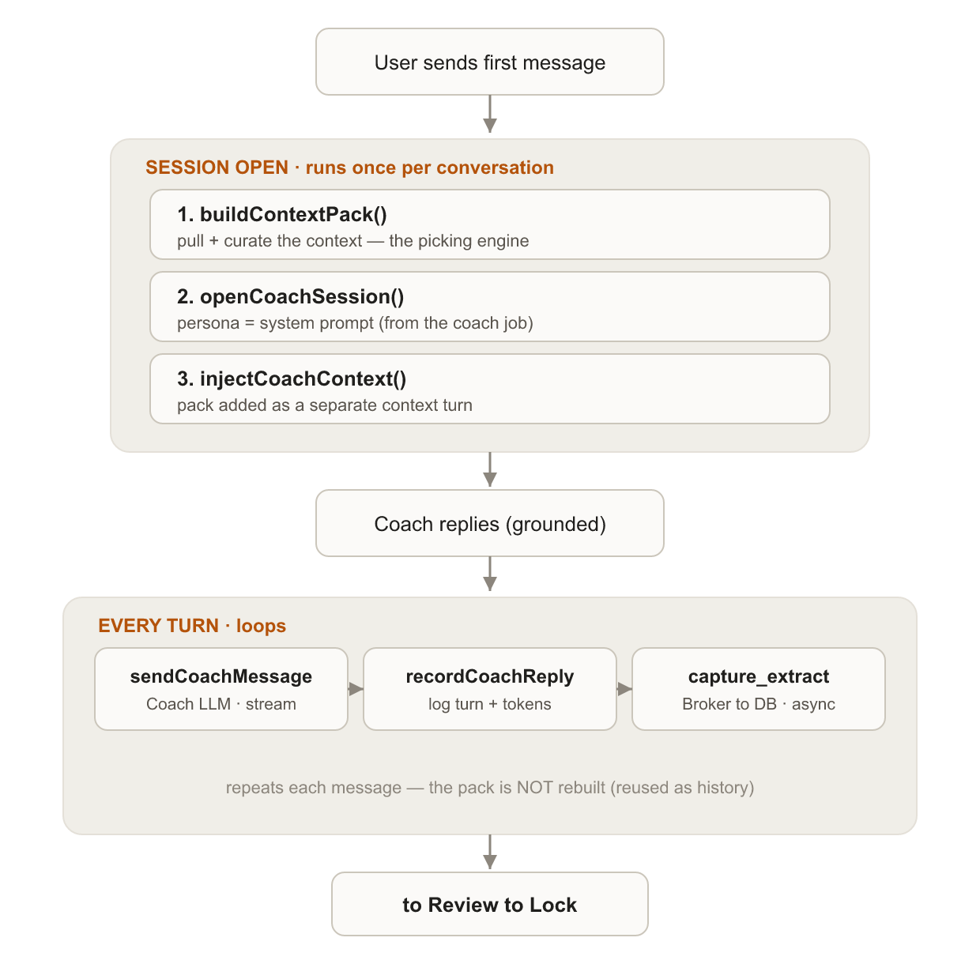
Figure 1 — When the context engine runs: the pack is built once at session open, then reused every turn.
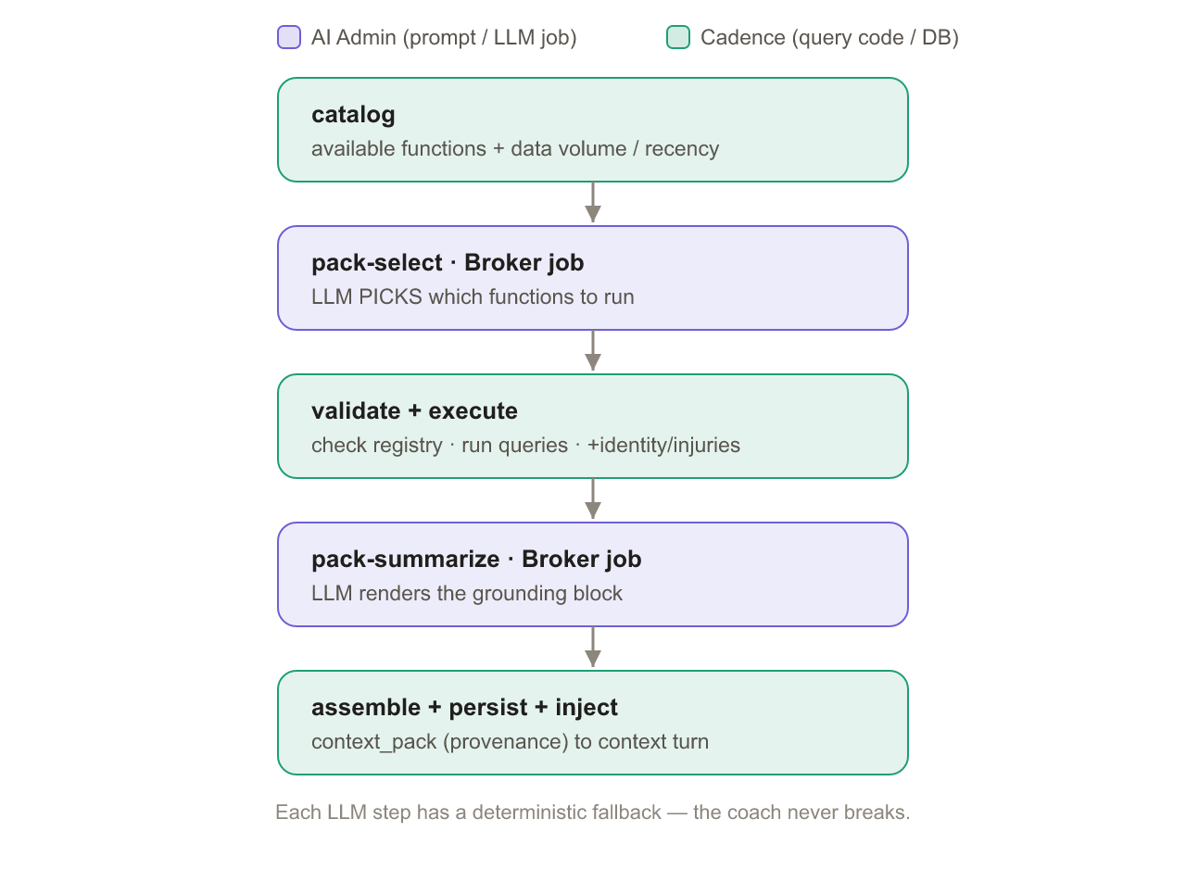
Figure 2 — Inside the picking engine: the Broker chooses which functions to run; Cadence executes them and assembles the pack.

Where this meets MemGPT — and where it leaves
If this smells like MemGPT / Letta, that's because it is, in spirit. MemGPT treats the context window like RAM and pages memory in and out of an external store; my “context pack” is essentially its “human” memory block, and my refresh loop is a cousin of its reflection heartbeat. I'm not pretending I invented memory for agents — I read the same papers everyone else did.
But Cadence diverges in three deliberate ways:
- Governed retrieval instead of free search. MemGPT lets the agent search its own archival memory. I put a semantic layer in between — parameterized functions over a relational store — because this is health data and I want every read to be bounded and validated.
- A separate curator, not pure self-editing. Rather than the agent rewriting its own memory, a dedicated Broker curates the pack; the coach only signals when memory feels stale. Cheaper, and easier to reason about.
- An auditable substrate. It's built on devs.ai models behind an orchestration layer that logs every retrieval, every prompt, and every token, and lets me tune the prompts as managed templates — not code. For anything touching personal health data, that governance isn't a nice-to-have.

The honest part
None of the individual pieces are new. Text-to-SQL, semantic layers, MemGPT-style memory, prompt caching — all well-trodden. What I think is mildly new is the assembly: a longitudinal personal-coaching agent that uses a metadata-driven semantic layer to feed a Broker-curated, provenance-tagged working memory, and decides for itself when to refresh. I'm building it in public, which means I'll be wrong about parts of it — and I'd rather hear that now than ship it quietly.

What's next
The next problem is juicier than it sounds: the gap between a goal (“run a Spartan in October”) and a commitment (“Tuesday: 5k zone-2; Thursday: hill repeats”). Turning a high-level objective into something you actually execute weekly — and re-planning it when a knee flares up — is where a coach earns its keep. That's post #2.
If you're building agents that have to remember things over months, follow along — I'll share the schemas, the failure modes, and the parts that blow up in my face.
— Building Cadence on devs.ai. Series: post 1 of n.

