Operative forest conservation needs more open data: A comparison between coarse open and detailed proprietary forest inventory data in Finland
Joona Lehtomäki^{1,2*} Sakari Tuominen³ and Antti Leinonen⁴
1 Department of Biosciences, P.O. Box 65 (Viikinkaari 1), FI-00014 University of Helsinki, Finland
2 Finnish Environment Institute, Natural Environment Centre, P.O. Box 140 (Mechelininkatu 34a), FI- 00251 Helsinki, Finland
3 Finnish Forest Research Institute (Metsäntutkimuslaitos), Vantaa, Finland
4 The Finnish Forest Centre (Suomen Metsäkeskus), Kajaani, Finland
Corresponding author
Contact:
joona.lehtomaki@helsinki.fi, tel. +358-9-191-57714
sakari.tuominen@metla.fi
antti.leinonen@metsakeskus.fi
Journal:
PLoS ONE
Type of paper:
Original research paper
Short title:
Open vs proprietary data in forest conservation
Version:
v0.4.4
Manuscript statistics:
Abstract length = 294
Main text length = 7935
Figures = 6
Tables = 1
References = 91

Abstract
The boreal region is facing intensifying resource extraction pressure, but the lack of extensive biodiversity data makes operative forest conservation planning difficult. Many countries in the region have implemented forest inventory schemes producing extensive and up-to-date databases that are becoming increasingly available. Many detailed regional inventory databases, however, remain proprietary. We investigated how well different types of open and proprietary forest inventory data sets in Finland suit the purpose of conservation prioritization and how much priorities are affected by using the less accurate, but open data. We validated the results by comparing them to known areas of high conservation value. We constructed a set of indexes for forest conservation value based on quantitative information commonly found in forest inventories, such as the maturity of the trees, tree species composition, and forest habitat types described by site fertility. Based on these data and accounting for connectivity between forest types, we investigated the patterns in conservation priority using Zonation, a method and software for spatial conservation prioritization. We show that prioritization analyses based on the coarser open data produce informative results, but only when the reference level is set to mature continuous forest areas. Analyses based on more detailed inventory data always outperform the analyses based on coarser data mostly by being able to account for more small-scaled conservation value. The location of high priority area seems to be relatively robust across different data sources and analysis options. The results underline the importance of making detailed inventory data publicly available, because basing conservation land-use decisions on too coarse data may entail serious risk of omission and commission errors. We also discuss how the prioritization methodology we used could be integrated to operative forest management in especially countries in the boreal zone.
Keywords: open data; conservation planning; forest conservation management; boreal forests; spatial conservation prioritization; Zonation software

1. Introduction

1.1 Multitude of objectives for prioritization
Biodiversity conservation deals with multifaceted and complex problems [1]⁠ that call for inter- or transdisciplinary research and decision-making [1–3]⁠. Several different kinds of data are typically required [4]⁠, such as spatial data on species distributions [5]⁠, costs associated with conservation actions [6]⁠, the structure and representativeness of the existing reserve network [7]⁠, and increasingly information the present and future state of dynamic environments [8,9]⁠ and anthropogenic threats [10]⁠.
Spatial conservation prioritization is a form of conservation assessment primarily interested in when, where, and how should conservation action taken in order to achieve conservation goals [11,12]⁠. In other words, conservation prioritization seeks to provide support for decision-making by looking for ways to optimally allocate limited resources [13]⁠. Conservation prioritization problems have been extensively studied conceptually and mathematically over the years [14]⁠ and consequently many software methods for solving a wide array of problems have also been published [15–19]⁠. The scientific field of spatial conservation prioritization has been extensively described and reviewed elsewhere [e.g. 13,15,20]⁠; Here we are interested in how well different types of forest inventory data are suitable as input for spatial conservation prioritization. Furthermore, on-ground conservation decision are almost always tied to a relatively fine spatial scale which implies that the data used for conservation prioritization should also have resolution relevant for the prioritization problem at hand [13,21]⁠. Lack of quantitative spatial data in fine enough spatial resolution severely restricts the application of conservation prioritization tools into real-life conservation problems.

1.2 Informative conservation decision-making depends on available data
A plethora of studies have been published regarding the occurrence of biodiversity and new technological advancements such as relatively cheap and very accurate remote sensors [22] have lead to a formidable increase in the available biodiversity data. However, in most regions of the world primary biodiversity data for conservation decision-making still remains woefully scarce [23,24] and biased [25,26]⁠. For most species and most parts of the world we simply do not have sufficient data [24,27]⁠ and even when we do, it is not necessarily accessible. Sharing data is especially desirable from decision-making point of view because of the many benefits it entails, such as enabling integrative and synthesizing science [28]⁠, enabling exploration of new topics not envisioned by the data originators [29]⁠, and providing more verifiable research for policymakers [30]⁠. Many public and private organizations collect and maintain research and monitoring databases that could be valuable for conservation decision-making, but remain unavailable because of lacking data-policies or technical barriers for data sharing. Often there are good reasons for withholding the data, such as detailed location data on endangered species or confidential information concerning the privacy of individuals [29,31,32]⁠. Restricting access to such information is not only an ethical obligation, but often also a legal one. Much of the potentially useful biodiversity data thus remains within restricted use, but regardless of the available data to base decision on, decisions still have to be made [24,33]⁠. With great potential for more informed decision-making., open access to relevant data is crucial for addressing complex conservation issues [23,32,34–36]⁠.
Effective conservation planning is done simultaneously with general land-use and natural resource use planning [13]⁠, which further emphasizes the need to be able to synthesize and utilize data from various sources. Costs and benefits of various land-use decisions should be assessed together, not sequentially so that whatever land is not suitable for other types of land-use are assigned for conservation, which has often been the case [7,37]⁠. Data for land and natural resources use planning may also be useful for conservation planning, given that they act as surrogates for biodiversity features of conservation interest. The upside is that resources allocated for collecting these types of data usually exceed that allocated for conservation related data collection, because costs of planning and optimizing e.g. natural resources extraction directly translate into economic gains or losses. For example, countries with an active forest sector typically have large-scale forest inventory systems, such as national forest inventories (NFIs), in place [38,39]⁠. In addition to NFIs, many other public and private operators collect detailed forest inventory data often on national or regional scale for their own operational planning. Recently especially governments and public research institutions have started opening up their databases. For example, the Finnish Forest Research Institute has quite recently opened up their multi-source national forest inventory database (http://www.metla.fi/ohjelma/vmi/vmi-moni-en.htm).

1.3 Forest inventory data in spatial conservation prioritization and validation
Forest inventory data has historically been collected to asses the productive functions of forests [40]⁠, but especially large-scale NFIs are increasingly being used for monitoring forest biodiversity [41]⁠. Following the classification by Corona et al. [41]⁠, biodiversity indicators estimated from forest inventory data can be classified into two categories: (i) compositional indicators directly measuring biodiversity, and (ii) structural indicators based on key structural features (e.g. variability in tree size and the amount of dead wood) acting as correlates or surrogates for biodiversity [41]⁠. The latter approach largely relies on the assumption that larger structural and tree species diversity provides more habitats for different forest species [41–43]⁠ and that the features can be reliably estimated from the forest inventory data [38,44]⁠. The approach does, however, have many desirable qualities from spatial conservation prioritization perspective. First, as structural components as easier to measure they are commonly found in different types of forest inventories [40,41]⁠. Second, the effects different forest management options have on structural features and thus on biodiversity are can be easily assessed [45]⁠ which enables the comparison of different management scenarios. Third, forest inventories are typically repeated periodically which makes it possible the assess the changing conditions [41]⁠. Fourth, since forest inventory data are still primarily collected for forest management and planning purposes conservation, conservation prioritization based on forest inventory data can be more easily grasped by practitioners and foresters. Finally, the data and thus the results of conservation prioritization analyses are produced on scale directly relevant for operative planning.
Validating the results of a conservation prioritization analysis is an important, but often overlooked part of the whole prioritization process (REF). In other words, maps and other results of prioritization assessments are often produced assuming that the input data is correct and thus the priorities reflect the on-ground situation correctly [46]⁠. Validating the results is even more important when relying on surrogate data such as structural forest inventory data. If there are no direct biodiversity occurrence data available for validating the results, one can use the locations of known conservation value, such as existing protected areas, as crude validation data. Sites contained in the validation data, such as individual protected areas, are on average more valuable than the surrounding landscape and should thus receive higher than average priority in the analyses.

1.4 Aims and scope
Here, we develop a set of conservation prioritization analyses based on freely available and proprietary forest inventory data with a varying degree of detail in the province of South Savonia, Finland. We use conservation prioritization software Zonation to produce complementarity-based priority maps while also accounting for connectivity in the solutions. With this approach, we are studying the following questions:
  - Can conservation prioritization analysis based on forest inventory data capture conservation value in boreal managed forest landscapes?
  - How well does freely available coarse forest inventory data perform compared to more detailed proprietary stand-based inventory data?
  - Given the differences in the data reliability and prioritization results, under what kind of planning circumstances is open but coarse inventory data sufficient for informative conservation decision-making?
We limit our attention to the spatial prioritization analysis and the effects that different data sources have on the results fully acknowledging, that the computational analysis described here is just one part of a full conservation planning process [15,47]⁠. While the results will be case-specific to a certain degree, in principle the procedure is applicable to other countries that have similar kind of forest inventory data available. Similarly, the results should also be applicable to countries with similar kind of forest management history and current forest and conservation management needs. The work has been done in collaboration with the Finnish Forest Center and the results have been used in implementing on-gound conservation programme.
To encourage other scientists and practitioners to build upon the work presented here, we also make available the full analysis implementation (REF) and the code necessary to produce the results from the prioritization analyses. While the proprietary data we have used cannot be shared because of privacy issues (however, see section 2.3.2), we have made all the stages of the implementation openly available for examination and re-use.

2. Material and Methods

2.1 Study design
The main objectives of this work are to 1) study the relative performance of conservation prioritization based on forest inventory data with different precision and availability, and to 2) assess the overall performance of the prioritizations compared to validation data. The address the former, we compare prioritization results based on coarser open data to those based on more detailed proprietary data. To answer to latter question, we compare all prioritization results to areas with known high conservation value.
Different forestry operators in the region collect inventory data in different parts of the region (Table 1) and for different purposes, but for the most part the motivation is to provide commercial services for forest owners such as forest management planning [9]. To compare the suitability of different types of forest inventory data for conservation prioritization, we acquired all available inventory data from Southern Savonia. These data include both coarser data based on remote sensing and more detailed inventory data based on visual inspection of the forest stands. The former type of data comes from a single source (see 2.3.1) and the latter from two separate sources (see 2.3.2). We are interested only in forest land on mineral soils. The index of conservation value (see Section 3.1) is based on the characteristics of the growing stock and it does not account for important ecological characteristics of mires. Mires are still included in the analyses, but because mires on average have less forest than mineral soils, they systematically receive lower priorities.
Since the extensive forest inventory data does not contain information on the occurrence of primary biodiversity features, such as species, we rely on available surrogate features. To derive an index of conservation value, we used knowledge elicited from experts to transform to inventory data into an index (see 2.5) of conservation value. Although the more detailed stand-based inventory data contains more information, the construction of the indexes was limited to information available in least information-rich data source to keep indexes from all data sources comparable. We hypothesize that the performance of the coarser data can be improved by further dividing the index features into site fertility classes that better correspond to actual forest habitats. After the data acquisition and pre-processing we use 3 different input data sets for the conservation prioritization analysis: 1) Coarse data, 2) coarse data with classes, and 3) detailed data with classes. The first two input data sets are completely based on open data whereas the third is partly based on proprietary data (see Figure 1 and 2.5 for more details).
For the actual conservation prioritization we use Zonation software, which is capable to account for complex ecological phenomena such as connectivity. Since connectivity is an important feature of conservation planning both from the ecological (REF) and administrative (REF) perspective, we use two analysis variants for each input data set: One without and with connectivity (see 2.6 for more details). With the inclusion of connectivity we want to study if the potentially scale-dependent patterns in the input data sets produce notably different outcomes when the results are compared to the validation data. Thus we have 6 different Zonation runs (Figure 1).
We analyze the six different result sets produced by Zonation in two main ways. First, we compare characterize the patterns of priorities within each run and compare particular fractions (e.g. the best and the worst part of the landscape) between the different runs. Secondly, we examine the prioritization results in areas with known conservation value. If the forest inventory data sets and the index used truly capture features relevant for conservation, then we expect that these locations will stand out with higher average priority than the surrounding landscape.

2.2 Study area
The study area covers the region of Southern Savonia located in South-Eastern part of Finland (Figure 1). The size of the region is ca. 13990 km² and it is characterized by a large number of lakes and fragmented waterways which covers ca. 25% of the total area. Of the reminding land area, approximately 88 % or 12250 km² is forestry land further divided into mineral soils (79%) and mires (21%). South boreal vegetation zone covers the whole region and forests are mostly dominated by the Scots pine (Pinus sylvestris) and the Norway Spruce (Picea abies) with varying amounts of broadleaved trees. Land ownership is highly fragmented with private forest owners being the largest group (77.3%) followed by private companies (11.5%) and the state (6.2%) [48]⁠. Most of the forestry land is under silvicultural management with 2.5% strictly protected. This number closely reflects the average for forestry land in Southern Finland (2.5%).
Whereas private forest land has several different operators (including Finnish Forest Centre), the state-owned land is managed by a single organization Metsähallitus, which is further divided into two independent departments: Forestry department manages state production forests and Natural Heritage Services manage forests outside commercial operation, including protected areas.

2.3 Data for conservation prioritization

2.3.1 Coarse data
National Forest Inventory (NFI) is sampling-based inventory system maintained by the Finnish Forest Research Institute (Metla). The NFI is a sampling-based inventory system that covers all land-use classes and ownership categories throughout the whole country [39,49,50]⁠. Main purpose of NFI is to “produce reliable information on forest resources and growth, the health of forests, forest biodiversity, and future cutting possibilities at national and regional forest level.” [49]⁠.
Multi-source national forest inventory (MS-NFI) is a method developed in Metla for producing estimates of forest resources for areas smaller than regional level and, furthermore, in the form of thematic digital maps. The method employs satellite images, digital maps and NFI field measurements as data sources. Non-parametric k-Nearest Neighbor (k-NN) estimation method is used in MS-NFI calculations for deriving forest estimates of individual satellite image pixels on the basis of NFI field plots as reference data. The MS-NFI thematic maps are raster format digital maps with a spatial resolution of 20 m. MS-NFI data contain over 40 forest variables in the form of thematic maps, including, e.g., the volumes by tree species and timber assortments, stand mean variables, the biomass by tree species groups and tree compartments and forest site type characteristics [e.g. 39,51,52]⁠. In Finland, the MS-NFI is being used mostly for regional level forestry planning, but it has also been used for large-scale conservation prioritization studies [21,53,54]⁠. Estimates produced in MS-NFI cover in principle 100% of the land area, but there might be some missing regions because of cloud coverage.
MS-NFI data has been publicly available since late 2012 and the thematic maps can be viewed through a web portal or the rasters can be downloaded through a file service [55]⁠. For the purpose of this study, the rasters were acquired directly from the FRI. The conservation value indexes used for the prioritization (see 2.3) require that for each tree species group information on both the average diameter and the volume are available. The standard MS-NFI rasters include only one estimate for average diameter over all tree species groups. In order to calculate estimates of average diameter for each tree species group, stand level variables were derived from MS-NFI by the way of automatic stand delineation.
Stand delineation was carried out in the study area by automatic segmentation of MS-NFI forest maps of the 10th NFI. The thematic map layers used as the input data for the segmentation were stand mean height and volumes of the tree species groups: pine, spruce, birch and other broadleaved trees. The segmentation was carried out using a modified implementation of the “segmentation with directed trees” algorithm by Narendra & Goldberg [56]⁠. The algorithm is based on using the local edge gradient for linking individual pixels into larger spatially continuous units, i.e. segments. The automatical segmentation process is guided by parameters such as the allowed heterogeneity within the segments and the desired minimum size of the segments [57]⁠. Here the desired size of segments was approx. 1-2 ha. The stand level variables variables were calculated as average values of the individual pixels within each segment. The variables per tree species were calculated by weighting the pixel level variables by the volumes of individual tree species.
From here onwards, we will generally refer MS-NFI data with term “coarse data”.

2.3.2 Detailed stand-based data
With “detailed”, we refer to detailed stand-based data means visual inventories of stands or forestry compartments which are usually produced to provide information for forest management planning on very fine scale [49]⁠. The inventories are typically carried out by different organizations depending on the land tenure. For this study, we used data from two organizations operating in the study region: Finnish Forest Centre (FC) and Metsähallitus (Finnish Forest and Park Service) Natural Heritage Services (NHS).
Finnish Forest Center inventories stands XX times every XX or whenever new operations are implemented. The inventory is implemented by professional staff members visiting the site compartment by compartment and [ANTTI] South Savonia is one of 13 regional administrative units of Finnish Forest Centre and the inventory procedure is the same in all regions. Since the forest compartments are inventoried only on need-basis or when forestry operation take place, some of the inventory data can be relatively old and thud does not represent the current state of the forest very well. To account for this, we only used data gathered in year 2000 or after. After the filtering the data, the data available from FC covered ~44% of the land area (#41). Another additional source of information we used was spatial data on the planned forestry operations which contains information on planned operations such as thinnings and clear-cuts. We used these data to discount the value of forest areas that are planned to go through forest operations of varying degree (SI 1.3).
Forest inventory data gathered and managed by Finnish Forest Center is not freely available as the Finnish Personal Data Act restricts the distribution of the data in resolution that can be linked to individuals (REF?). It possible, however, to get access to the data for example for research purposes [58]⁠.
Metsähallitus carries out similar inventories on state-owned land and the methodology and the collected information is largely the same as on private land. Metsähallitus information systems are updated computationally yearly to simulate the growth of forests and therefore we did not do any filtering based on the age of the information. We received detailed stand-based data for regions governed by Metsähallitus Natural Heritage Services after research collaboration agreement as the data is not freely available for public use. We were unable the get any data from regions governed by Metsähallitus Forestry for reasons unknown to us. Detailed data from Metsähallitus NHS covers ~2.4% of the land area (#41).

2.4 Data for validation
Ideally, the results of a conservation prioritization analysis should be compared against the known occurrences of biodiversity, i.e. species or habitat occurrence data. If such data are lacking, the results can still be compared against spatial data on areas considered to be ecologically valuable.

2.4.1 Existing protected are network
Overall, protected areas cover 2.5% of the whole landscape in Southern Savonia [48]⁠. Part of this the protected areas cover mires and for the validation purposes, protected areas only on mineral soils (~1.9% of the whole landscape, Table 1) were included for the validation. The data include both state-owned protected areas as well as protected areas on private land.
The data was acquired from Metsähallitus Natural Heritage Services who is responsible for the maintenance of the database for protected areas, both public and private. The delineation of PAs is public information, but since the data requested contains other attribute data as well, it required separated research agreement.

2.4.2 Woodland key-habitats
Woodland key-habitats (WKH) are a conservation instrument designed for maintaining landscape-level bio-diversity in production forests by delineating and preserving small habitat patches [59]⁠. The concept is in use in many Fennoscandian and Baltic countries and while their effectiveness as a conservation measure varies depending on the country and definition [59–61]⁠, on average WKHs seem to be hotspots for dead wood, species richness, and red-listed species [59]⁠. The average size of a Woodland key-habitat designation in Southern Savonia is XX ha (#35), which is close to the national mean of 0.67 ha in Finland [62]⁠, and they cover 0.5% of the whole landscape (Table 1).
Because of potential privacy issues, the exact spatial location (i.e. on scales that can be linked to an individual forest owner) of the woodland key-habitats are not public information. It is possible, however, to gain access to the data when the purpose is scientific research.

2.4.3 Recently acquired protected areas
The forest biodiversity conservation programme METSO is an ongoing effort to halt the decline of forest biodiversity by year 2016 [63]⁠. Individual forest owners can offer their forest into METSO and if the offered forest fulfills programme’s scientific selection criteria, the offer is admitted into METSO and the forest owner is compensated based on the economic value of the growing stock and timber [64]⁠. The agreement can be either fixed-term (10 years) or permanent. Overall the relatively simple selection criteria seem to be working quite well both for habitat characteristics such as abundance of dead wood as well as the number of red-listed species [65]⁠.
Regional implementation of the METSO programme is managed by the Centre for Economic Development, Transport and the Environment which also collects implementation statistics and maintains a spatial database on the sites admitted into the programme. Data is not publicly available, but can be acquired for research purposes. We used only permanent the conservation contracts as the conservation effectiveness of temporary or fixed-term contracts is questionable [66]⁠.

2.5 Calculating index for conservation value
All data used from both the coarse and detailed data sources were categorized into four tree species groups: Pine, spruce, birch, or other broadleaved (Table S1). Detailed data (see 2.3.2) contain finer classification into individual tree species, but the tree species were grouped into the 4 classes in order to correspond to classification of MS-NFI (#39). We calculated an index of conservation value for each of the tree species groups in each of the data sources separately. This index measures an expert-opinion based view on how the average diameter and the volume of the growing stock relate to ecological features desirable for conservation. The average diameter of the growing stock per tree species group is transformed by a sigmoidal benefit function (see SI 1.2 and Figure S1) and the resulting figure is multiplied by the volume of the growing stock. The adopted approach has been used before in large-scale conservation prioritization [21,53]⁠ and species-oriented prioritization (Reference 2).
Effective conservation prioritization needs to be able to account for complementarity and rarity of biodiversity features (REF). For example, if the objective is to prioritize for new protected areas, one should consider what is already protected (REF). Rarity is often associated on the risk of becoming more threatened or even extinct and thus the overall range size of a biodiversity feature should be considered. In their simplest form, our indexes are based on the occurrence of tree species groups alone. We hypothesize, that further subdivision of the spatial data into classes that correspond roughly to existing forest habitat types would improve the prioritization because especially many endangered species are associated with particular and often restricted habitats (REF). The more detailed inventory data has enough additional information in it to enable detailed habitat classification, but again we are constricted by the information content of the coarser data. All available data sets do have, however, information on site fertility class, which is often also associated with the formation and extent of particular forest habitats (REF). Therefore we further created two input data sets based on the coarse data: One with just the 4 index rasters (“Coarse”), one with the 4 index rasters each divided into 5 site fertility classes (“Coarse with classes”, Figure 1). We also hypothesized that prioritzation based on the more detailed - and more precise - inventory data would outperform those based on the coarser data, we found it reasonable to use as detailed data as possible (“Detailed with classes”)(Table S1). Note that input data set “Detailed with” is actually a combination of coarse and detailed as the detailed data only covers ~46% of the landscape (Table 1). Both “coarse” and “coarse with classes” are completely based on MS-NFI and thus publicly available data.
The spatial resolution of the MS-NFI data is 20x20 meters so all detailed vector data was first converted to rasters of same resolution and extent (SI 1.3). All data preprocessing was done at this resolution using Python [67]⁠ bindings to GDAL [68]⁠. For spatial conservation prioritization the data was first aggregated to 60 x 60 meters for computational reasons using ArcGIS [69]⁠. We wanted to retain as high resolution as possible because conservation prioritization analyses should be carried out on spatial scale that is in line with the ecological components (e.g connectivity and average size of habitat patches) and the scale of operative planning [21]⁠.

2.6 Prioritizing locations for conservation
For the spatial prioritization, we used Zonation [16,70]⁠ version 4.0 [71]⁠. Zonation operates with a set of input rasters describing the occurrence levels of given biodiversity features, in our case the index rasters of forest conservation value (see 2.5).
It proceeds by iteratively removing the least valuable cells in the landscape, accounting for factors such as occurrence of features in the cell, remaining occurrence of each feature across the landscape, and connectivity. Zonation maximizes retention of a quantity that is summed across features (e.g., species), where features can have different weights and their local occurrence levels are normalized by range size. In other words, it seeks to remove cells with low species richness and to remove preferentially cells with occurrences of species that have low weights and extensive distributions in the remaining landscape. The repeated range-size normalization [28,29] leads to maintenance of a balance among all features at all iterations. Ranking of cells is especially suitable for comparing spatial overlap in areas prioritized for conservation because one can compare solutions of equal areas.
Following best-practices for constructing Zonation runs [15]⁠, we started from the simplest possible configurations enabling more complex features one by one. This way, it is possible to test for the exact effects that each feature has and the sensitivity of the results for different parameter values. After testing with several different combinations, we set up 2 runs for each input data sets (“Coarse”, “Coarse with classes”, and “Detailed with classes”): one with and one without connectivity and had thus 6 different analysis runs (R1-R6 in Figure 2).
All six runs R1-R6 have certain Zonation configuration options in common. We used the additive benefit function mode in Zonation [72]⁠, because it emphasizes overall feature richness in a given cell and is especially suitable when dealing with habitat data [53]⁠. The weight that each individual feature receives (Table S2) was based on expert opinion and weights reflect subjective importance to given particular tree species groups and site fertility classes (see SI 1.3). The exact configuration options and parameters used in the Zonation runs can be found at http://dx.doi.org/10.6084/m9.figshare.1018708.
Runs R1-R6 also had differences (Figure 2). Number of biodiversity features (the index rasters) varied from 4 in R1 and R2 to 20 in R3-R6. Analysis runs based on the detailed data (R5 and R6) used additional information available on the planned forestry operation (see 2.3.2). Technically, this was implemented in Zonation using the data as a condition layer [71]⁠. Runs R1, R3, and R5 are so called “local” variants in a sense that they do not include any connectivity transformations. Runs R2, R4, and R6 on the other hand account for connectivity between different forest types (see SI 1.2 and Table S3). We used so called matrix-connectivity feature of Zonation [53,71]⁠ where connectivity is defined pair-wise between the input biodiversity features by connectivity coefficients (SI 1.3). The distance of the connectivity transformation effect in Zonation is controlled by α value which is derived from an assumed average dispersal capabilities of species [15,21,53]⁠. We used α value of 0.001 which corresponds to an average dispersal distance of 2 kilometers (see [53]⁠ and [54]⁠ for further discussion and references for the distance chosen). We also tested the sensitivity of results to distances of XXX and ZZZ, but these did not change the qualitative interpretation of results significantly (see also [21]⁠ for further discussion on role of selected distances).

2.7 Comparison and validation of analysis runs
The spatial patterns of rank priorities can be examined on different scales and between different priority ranges. The comparisons between different runs have two dimensions: One between runs based on the same input data set (i.e. the effect of connectivity) and one between different input data sets (i.e. the effect of the input data). We performed all the comparisons using the standard Zonation outputs and data described in section 2.4. We used R (version 3.1.0) statistical language and environment [73]⁠ and zonator R package [74]⁠.
Visual examination of the rank priority maps should give an initial idea how well the different runs - and hence the different input data sets - converge especially in terms of high or low priorities. We also compare the spatial overlap of different runs by calculating Jaccard coefficients (the intersection of two sets divided by the union of those sets) for different priority ranges. In other words, we divide each rank raster into 10 equal range bins and compare each bin to every other. This way we can compare for example the spatial overlap of the best 10% of the landscape in runs R1 and R3, but also for example the worst 10% in R1 with the best 10% in R3.
It possible to load the rank order of a Zonation solution and run a prioritization using different input features or Zonation options using the removal order from the previous run and examine how much performance of the solution is lost [15,71]⁠. We used this technique to see how much lower the representation levels are for the input features based on the detailed data (R5) when the rank order is taken from analyses based on the coarser data. Assuming that the detailed data is also more precise, we can then ask the question of how much feature representation do we risk losing by using the coarser data.
We examined how well the results of different runs were able to capture forest region with conservation value by simply examining the priority distributions within each of the validation data sets (see 2.4).

3. Results

3.1 Spatial patterns of rank priorities
On the scale of the whole study area, the spatial pattern of priorities in non-spatial runs accounting for local quality only (R1, R3, R5) were located in roughly the same places (Figure 3A, 3C, and 3E). A major concentration of high-priority locations can be found in the southwestern corner of the study area. Classifying the coarse input dataset according to the site fertility classification (R3, see 2.1 and Figure 2) had a minor effect of distributing the top priorities more equally across the study area (Figure 3A and 3C). R5 which is based on the more detailed data produced slightly different priority patterns (Figure 3E). Top priorities are yet more equally distributed over the study area (see the marginal plots in Figure 3E). Regions of high-concentrations of top-priority areas are sifted to the northeastern part of the study area.
Runs including connectivity between forest types (R2, R4, R6) display very similar overall rank priority patterns as the their non-spatial counterparts with regions with high density of high-priority sites further emphasized (Figure 3B, 3C, and 3F).

3.2 Spatial overlap of priority fractions
Comparing binned rank priorities between runs shows the effect of the site fertility classification. Figure 4A shows an asymmetrical pattern of overlap between close priority bins. Priorities in R1 systematically spatially overlap with lower priorities in R3, or large areas in R3 receive lower priorities than in R1. There is very little overlap between high priorities in R1 and low priorities in R3 (upper-left part of panel 4A) whereas inversely the situation is different: There is some overlap with relatively high priorities in R3 and low priorities in R1 (lower-right part of panel 4A). The best and worst 10% of the priorities have to largest overlaps. Spatial overlaps of priorities are smaller when the results of R1 and R3 are compared against the results of R5 (Figure 4B and 4C). There is also more overlap between high and low priorities between the runs. The largest overlaps are still found between the best and worst 10% of the priorities.
Overlap comparisons between runs based on different input data sets and accounting for connectivity (R2, R4, and R4) show very similar patterns as the previous ones without connectivity. The only difference is that general pattern is smoother in all comparison (Figure 4D-4F). Comparisons between runs based on the same input data set with and without accounting for connectivity (Figure 4G-4I) show a strong overlap between the same priority bins in different runs. Overlap tends to increase when moving towards the best or the worst sections of the study area.

3.3 Feature representation
Loading the priority rank order from the runs based on the coarse input datasets (R1 and R3) reveled differences in performance. Figure 5 shows the overall performance, i.e. how much of the initial representation levels from the detailed data can be covered by protecting a given fraction of the landscape. Figure 4A shows that on average, using priority rankings from R1 or R3 performs much worse when compared to performance of R5. For example, protecting the best 10% of the landscape using the ranking from R5 would still cover approximately 54% of the original distributions of all features from the detailed input dataset. In comparison, the rankings from R1 and R3 would cover ~15% and ~16% respectively (Figure 5A). The difference is even more pronounced when examining the results using feature grouping, such as the site fertility class. For example, the best 10% of the landscape covers ~93% of features on herb-rich sites, whereas rankings from R1 and R3 achieve coverage of ~15% and ~14% (Figure 5B). For every other site fertility class except for mesic the performance of R5 is superior to that of R1 and R3. The performance levels of runs accounting for connectivity (R2, R4, R6) are very similar to those of R1, R3, and R5 and are omitted here.

3.4 Comparison to spatial validation data
Protected areas have relatively high median priorities in all runs R1-R6 (Figure 6). R5 and R6 have the highest median priorities (~0.85 and ~0.90), followed by R1 and R2 (~0.71 and ~0.69) (REF). R3 and R4 have to lowest median priorities for protected areas (~0.68 and ~0.63) (REF). Woodland key-habitats also have quite high median priorities for R5 and R6 (both ~0.69), but the distribution of priorities is not as skewed as with protected areas (REF). For R3 and R4, woodland key-habitats have a median priority of ~0.48, for R1 and R2 the median values are even lower (~0.42 and ~0.41). Locations admitted to METSO programme receive the highest median priorities values in R5 and R6 (both ~0.82). R1 and R2 have a median priority value similar to those of protected areas (~0.72 and ~0.70), as do R3 and R4 (~0.68 and ~0.65). In all cases, the difference between a run with and without connectivity is small, except for protected areas (REF).

4. Discussion

4.1 Can forest inventory data be used to identify valuable areas for conservation?
Our results demonstrate that 1) inventory data collected primarily for operational forest planning is indeed informative for spatial conservation prioritization, and 2) openly available remote-sensing based data performs reasonable well for large mature forest areas, but fails to detect valuable sites of restricted size.
On the scale of the whole study area, priority patterns between runs based on the coarse and the detailed data are relatively similar with at least three key differences. First, analyses based on the coarser data give higher priority the a large area at the southwestern part of the province. This is because the MS-NFI data has high estimate values for birch and other deciduous trees in the region which also has a high incidence of fertile soils. Deciduous trees and fertile soil types all are less common than other tree species and soil types and have furthermore higher weights assigned in the Zonation analysis (see S1.2 for further explanation). Second, analyses based on the more detailed data show existing large protected areas with much higher priorities. This is most because the detailed data available from the protected areas describes the mature stands with PAs more accurately than the coarse data. Third, since the detailed data has reliable information also on the occurrence valuable sites of restricted size, the high-priority sites are more evenly distributed over the whole study area (see the marginal plots in Figure 3).
[Paragraph about the classification]
Although the analyses based on the coarser data are not able to account for the fine-grained occurrence of valuable forest, it nevertheless can be useful enough for informative conservation prioritization. Conservation planning and prioritization based on incomplete data runs the risk of commission and omission errors [25]⁠. In the words, the risk involves selecting sites that are not valuable in reality or missing sites that are. It seems that the spatial overlap of the top priorities is fairly consistent between the analysis based on coarse and the detailed data (Figure 4). The same applies also for the low priorities. Perhaps even more importantly the top priorities of any of the run do not much overlap with the low priorities in another run or vice versa. Another way of looking at the issue of how much more worse can we do using coarser data, is to look at how much of the occurrence levels of biodiversity features based on detailed data is included in different fractions of the solutions in different runs. Figure 5 clearly shows that especially for the rarer - and thus more valuable - site fertility types coarse-data analyses perform much worse than the detailed-data analysis. Even if the top priority locations have a fairly large overlap spatially, using the coarser data misses much of the occurrence of for example the herb-rich sites.
Existing protected areas received relatively high median priorities in all analyses (Figure 6). PAs in the region are quite large and contain mature forest (…). Sites acquired into METSO-programme had also relatively high median priorities potentially indicating that they contain similar features to the larger PAs. Woodland key-habitats have the smallest average size per site out of the three validation data sets and they constitute perhaps also the most heterogeneous (REF) group. Runs based on detailed data clearly outperform all runs based on the coarser data when compared against the validation data sets. Median priority is clearly higher for the variants based on the detailed data and furthermore, the priority rank distribution shows conspicuous peaks for the very highest priorities. Because of the more detailed and accurate data - also for the soil fertility classification - analysis are able to distinguish small-scale woodland key-habitats quite well. Whether or not such areas (e.g. PAs) truly are highly valuable in the sense that they contain significant amounts of biodiversity or resources supporting biodiversity is a different thing (REF).
The small effect of connectivity has on both the overall distribution of priorities and the priority rank distributions of the validation data sets may feel slightly surprising. However, even combined the validation data sets cover only a small fraction of the total landscape (2.5%, see XX) and therefore the absolute amount of cells affected by connectivity transformation is low. Usually spatial conservation prioritization is concerned about the absolutely best part of the landscape, the defining what is the “best part” is a subjective decision. For example, METSO-programme has a defined objective for additional conservation in South-Savo, which correspond to ca. 5000 hectares or less than 0.5% of the total forest area (CHECK). On the other hand, if different conservation instruments are to employed over a significantly larger areas [75,76]⁠, we must in fact be looking at top fractions significantly higher than few percent. Over larger areas, the role of connectivity also becomes more apparent (fig. 2) as regions with higher density of high quality sites are emphasized. Emphasizing connectivity will almost certainly happen at the expense of local habitat quantity and quality [77]⁠. Increasing the priority of medium-quality forests that are well-connected will lower the value of other similar quality sites and possibly even poorly connected high-quality sites (fig. 2). Trade-offs introduced by taking into account connectivity will naturally depend on the implementation of a particular method (in our case Zonation), but the issues related to it are conceptually quite well understood [21,77]⁠.
The validation procedure we use relies on few key assumptions. First, if the index layers constructed from different input data sets truly reflect forest characteristics desirable for conservation purposes, then the sites in the validation data sets should receive high priority in the results. Second, we assume that the validation data sets actually describe location of high conservation value. Protected areas have traditionally been established on less productive soils [37,78]⁠ and therefore it is likely that they usually do not represent the full spectrum of species or habitats in any given region. However, over a period of time being set-aside from the prevailing forest management regimes will produce resources such as dead-wood that many forest species depend on [79]⁠. Woodland key-habitats on the other hand are scattered more evenly over the landscape and according to recent meta-analysis [59]⁠ they contain higher amounts of critical resources such as dead-wood and consequently larger number of species as well (check the details for Finland). On average the size of a WKH site is very small (0.67 ha in Finland [62]⁠) and thus their capability to support populations in the long run in uncertain.

4.2 Is there a need to open detailed forest inventory data?
Given the results discussed above, it can be concluded that using methodology introduced before [53,54]⁠ and refined in this work, openly available MS-NFI-data is best suited for situations where objective is to target regions with larger extents of mature forest. Therefore if the spatial prioritization includes objectives for detecting small scale biodiversity feature occurrences such as the WKHs, a more detailed input data set is clearly needed. Given the amount of available forest inventory data in countries like Finland and Sweden, it is very important that these data sources can be used also for conservation planning purposes for several reasons. First, since high-resolution, large-scale, and systematic observational biodiversity data is scarce (REF) suitable proxies for species and habitat occurrence are needed. Second, over 95% of the forest landscapes in Finland and Sweden is under silvicultural management (CHECK METLA 2013; Skogstyrelsen XXXX) which uses these data for operative planning.
Open data has a major role in the play in conservation planning and decision-making, because it enables equal access to best available data, it makes the supporting scientific analysis more transparent, and it enhances the repeatability of the whole process (REF). The last point is especially important for applied research supporting decision-making, because underlying may change objectives, data updates, and new information accumulates sometimes rapidly. Adaption and repeatability are crucial in translating regional planning into local action [80]⁠ which in the context of the current work implies that the conservation prioritization methods would become an integral part of operative forest management planning.
Trade-offs introduced by using less accurate data is more case-specific, but it can be estimated. Conservation scientists, foresters and other practitioners are often faced with tight deadlines and limited budgets, and thus have to decide whether it is worth the time and money to try to secure access to more detailed data if coarser but easily available data exists. We found that using coarser MS-NFI-data can lead to a serious drop in the representation of especially the less abundant biodiversity features such as the herb-rich and xeric forest types (fig. 4). For example, if we are interested in the best 10% of the landscape prioritization based on MS-NFI with classes captures, on average, only half of the representation levels of the biodiversity features derived from the detailed data. For biodiversity feature on herb-rich soils, analysis based of MS-NFI with classes captures less than 10% (check the exact figures) of representation levels. These differences are probably mostly due to less accurate soil fertility classification in the MS-NFI data (…). For the rarest, and hence most valuable, soil fertility classes (herb-rich and xeric) MS-NFI with classes performs slightly better than MS-NFI without classes. Hence, an ecologically justified classification of the data can improve the results even if the quantitative information (i.e. the index values) is the same.
The availability of the forest inventory data – i.e. whether the data is openly available for everyone – concerns not only the spatial prioritization analysis, but it affects several other phases of the process.

4.3 Ways to integrate conservation planning into operative forestry management and planning
Forest inventory data may play especially important role in conservation planning in the countries of the boreal zone. Circumpolar boreal forest is the second largest biome in the world [81]⁠ and consequently countries in the boreal zone have traditionally utilized their forest-based natural resources extensively which has lead to change in the forest structure, species composition, habitat diversity, and large-scale disturbance dynamics [82–85]⁠. While not the most species rich or threatened biome on the planet [86,87]⁠, there are still at least three reasons for increasing the current conservation efforts in the boreal zone. First, boreal forests host a great number of species of highly specialized species dependent on resources such as dead wood [88–90]⁠ that have become endangered because of intensive forestry practices. Second, because of their large extent and biomass, boreal forests have a major role in carbon sequestration and climate change adaption [76,81]⁠. Third, many parts of boreal zone, especially in Russian Federation and Canada, remain inaccessible presenting an opportunity to protect still relatively intact large tracts of forest [78,91]⁠.

References
1. Game ET, Meijaard E, Sheil D, MacDonald-Madden E (2014) Conservation in a wicked complex world; challenges and solutions. Conserv Lett 7: 271–277. doi:10.1111/conl.12050.This.
2. Reyers B, Roux DJ, Cowling RM, Ginsburg AE, Nel JL, et al. (2010) Conservation Planning as a Transdisciplinary Process. Conserv Biol 24: 957–965. doi:10.1111/j.1523-1739.2010.01497.x.
3. Pooley SP, Mendelsohn JA, Milner-Gulland EJ (2013) Hunting Down the Chimera of Multiple Disciplinarity in Conservation Science. Conserv Biol 28: 22–32. doi:10.1111/cobi.12183.
4. Keane A (2013) Unusual data in conservation science: searching for validation. Anim Conserv 10: 604–605. doi:10.1111/acv.12091.
5. Ferrier S, Drielsma M (2010) Synthesis of pattern and process in biodiversity conservation assessment: a flexible whole-landscape modelling framework. Divers Distrib 16: 386–402. doi:10.1111/j.1472-4642.2010.00657.x.
6. Naidoo R, Balmford A, Ferraro PJ, Polasky S, Ricketts TH, et al. (2006) Integrating economic costs into conservation planning. Trends Ecol Evol 21: 681–687.
7. Branquart E, Verheyen K, Latham J (2008) Selection criteria of protected forest areas in Europe: The theory and the real world. Biol Conserv 141: 2795–2806. doi:10.1016/j.biocon.2008.08.015.
8. Scheller RM, Mladenoff DJ (2007) An ecological classification of forest landscape simulation models: tools and strategies for understanding broad-scale forested ecosystems. Landsc Ecol 22: 491–505.
9. Kujala H, Moilanen A, Araújo MB, Cabeza M (2013) Conservation planning with uncertain climate change projections. PLoS One 8: e53315. doi:10.1371/journal.pone.0053315.
10. Visconti P, Pressey RL, Segan DB, Wintle BA (2010) Conservation planning with dynamic threats: The role of spatial design and priority setting for species’ persistence. Biol Conserv 143: 756–767. doi:10.1016/j.biocon.2009.12.018.
11. Pressey RL, Cabeza M, Watts ME, Cowling RM, Wilson KA (2007) Conservation planning in a changing world. Trends Ecol Evol 22: 583–592.
12. Wilson KA, Underwood EC, Morrison SA, Klausmeyer KR, Murdoch WW, et al. (2007) Conserving Biodiversity Efficiently: What to Do, Where, and When. PLoS Biol 5: 12.
13. Ferrier S, Wintle BA (2009) Quantitative Approaches to Spatial Conservation Prioritization: Matching the Solution to the Need. In: Moilanen A, Wilson KA, Possingham HP, editors. Spatial Conservation Prioritization: Quantitative Methods & Computational Tools. Oxford: Oxford University Press. p. 304.
14. Moilanen A, Possingham HP, Polasky S (2009) A Mathematical Classification of Conseravation Prioritization Problems. In: Moilanen A, Wilson K, Possingham HP, editors. Spatial Conservation Prioritization: Quantitative Methods & Computational Tools. Oxford: Oxford University Press. pp. 28–42.
15. Lehtomäki J, Moilanen A (2013) Methods and workflow for spatial conservation prioritization using Zonation. Environ Model Softw 47: 128–137. doi:10.1016/j.envsoft.2013.05.001.
16. Moilanen A, Kujala H, Leathwick JR (2009) The Zonation framework and software for conservation prioritization. In: Moilanen A, Wilson KH, Possingham HP, editors. Spatial Conservation Prioritization. Oxford University Press. pp. 196–210.
17. Pressey RL, Watts ME, Barrett TW, Ridges MJ (2009) The C-Plan Conservation Planning System: Origins, Applications and Possible Futures. In: Moilanen A, Wilson K, Possingham HP, editors. Spatial Conservation Prioritization: Quantitative Methods & Computational Tools. Oxford University Press. pp. 211–234.
18. Ciarleglio M, Barnes JW, Sarkar S (2009) ConsNet: new software for the selection of conservation area networks with spatial and multi-criteria analyses. Ecography (Cop) 32: 205–209. doi:10.1111/j.1600-0587.2008.05721.x.
19. Possingham HP, Ball IR, Andelman SJ (2000) Mathematical methods for identifying representative reserve networks. In: Ferson S, Burgman MA, editors. Quantitative methods for conservation biology. New York: Springer-Verlag. pp. 291–305.
20. Kukkala AS, Moilanen A (2012) Core concepts of spatial prioritisation in systematic conservation planning. Biol Rev 88: 443–464. doi:10.1111/brv.12008.
21. Arponen A, Lehtomäki J, Leppänen J, Tomppo E, Moilanen A (2012) Effects of connectivity and spatial resolution of analyses on conservation prioritization across large extents. Conserv Biol 26: 294–304. doi:10.1111/j.1523-1739.2011.01814.x.
22. Pettorelli N, Laurance WF, O’Brien TG, Wegmann M, Nagendra H, et al. (2014) Satellite remote sensing for applied ecologists: Opportunities and challenges. J Appl Ecol 44: early view. doi:10.1111/1365-2664.12261.
23. Maeda EE, Torres JA (2012) Open environmental data in developing countries: who benefits? Ambio 41: 410–412. doi:10.1007/s13280-012-0283-4.
24. Pressey RL (2004) Conservation planning and biodiversity: assembling the best data for the job. Conserv Biol 18: 1677–1681. doi:10.1111/j.1523-1739.2004.00434.x.
25. Rondinini C, Wilson K a, Boitani L, Grantham H, Possingham HP (2006) Tradeoffs of different types of species occurrence data for use in systematic conservation planning. Ecol Lett 9: 1136–1145. doi:10.1111/j.1461-0248.2006.00970.x.
26. Boitani L, Maiorano L, Baisero D, Falcucci A, Visconti P, et al. (2011) What spatial data do we need to develop global mammal conservation strategies? Philos Trans R Soc London - Ser B Biol Sci 366: 2623–2632.
27. Grantham HS, Pressey RL, Wells JA, Beattie AJ (2010) Effectiveness of Biodiversity Surrogates for Conservation Planning: Different Measures of Effectiveness Generate a Kaleidoscope of Variation. PLoS One 5: 1–12. doi:10.1371/journal.pone.0011430.
28. Carpenter SR, Armbrust EV, Arzberger PW, Iii FSC, Elser JJ, et al. (2009) Accelerate Synthesis in Ecology and Environmental Sciences. Bioscience 59: 699–701. doi:10.1525/bio.2009.59.8.11.
29. Uhlir PF, Schröder P (2007) Open data for global science. Data Sci J 6: 36–53.
30. Wolkovich EM, Regetz J, O’Connor MI (2012) Advances in global change research require open science by individual researchers. Glob Chang Biol 18: 2102–2110. doi:10.1111/j.1365-2486.2012.02693.x.
31. Egloff W, Patterson DJ, Agosti D, Hagedorn G (2014) Open exchange of scientific knowledge and European copyright: The case of biodiversity information. Zookeys 135: 109–135. doi:10.3897/zookeys.414.7717.
32. Arzberger P, Schroeder P, Beaulieu A, Bowker G, Casey K, et al. (2004) An International Framework to Promote Access to Data. Science 303: 1777–1778. doi:10.1126/science.1095958.
33. Bode M, Wilson KA, Brooks TM, Turner WR, Mittermeier RA, et al. (2008) Cost-effective global conservation spending is robust to taxonomic group. Proc Natl Acad Sci U S A 105: 6498–6501. doi:10.1073/pnas.0710705105.
34. Reichman OJ, Jones MB, Schildhauer MP (2011) Challenges and Opportunities of Open Data in Ecology. Science 331: 703–705. doi:10.1126/science.1197962.
35. Pullin AS, Salafsky N (2010) Save the whales? Save the rainforest? Save the data! Conserv Biol 24: 915–917. doi:10.1111/j.1523-1739.2010.01537.x.
36. Huang X, Hawkins B a., Lei F, Miller GL, Favret C, et al. (2012) Willing and unwilling to share primary biodiversity data: results and implications of an international survey. Conserv Lett 5: 399–406. doi:10.1111/j.1755-263X.2012.00259.x.
37. Scott JM, Davis FW, McGhie RG, Wright RG, Groves C, et al. (2001) Nature reserves: Do they capture the full range of America’s biological diversity? Ecol Appl 11: 999–1007. doi:10.1890/1051-0761(2001)011[0999:NRDTCT]2.0.CO;2.
38. Chirici G, Winter S, McRoberts RE (2011) National Forest Inventories: Contributions to Forest Biodiversity Assessments. Dordrecht: Springer.
39. Tomppo EO, Haakana M, Kaitila M, Peräsaari J (2008) Multi-source national forest inventory – methods and applications. Managing F. Springer.
40. Chirici G, Mcroberts RE, Winter S, Bertini R, Bra U, et al. (2012) National Forest Inventory Contributions to Forest Biodiversity Monitoring. For Sci 58: 257–268.
41. Corona P, Chirici G, Mcroberts RE, Winter S, Barbati A (2011) Contribution of large-scale forest inventories to biodiversity assessment and monitoring. For Ecol Manage 262: 2061–2069. doi:10.1016/j.foreco.2011.08.044.
42. Winter S, Chirici G, Mcroberts E, Hauk E, Tomppo E (2008) Possibilities for harmonizing national forest inventory data for use in forest biodiversity assessments. Forestry 81. doi:10.1093/forestry/cpm042.
43. Kallio AM, Hänninen R, Vainikainen N, Luque S (2008) Biodiversity value and the optimal location of forest conservation sites in Southern Finland. Ecol Econ 67: 232–243. doi:10.1016/j.ecolecon.2008.05.005.
44. Tomppo E, Gschwantner T, Lawrence M, McRoberts RE (2010) National Forest Inventories Pathways for Common Reporting. Media: 612.
45. McElhinny C, Gibbons P, Brack C, Bauhus J (2005) Forest and woodland stand structural complexity: Its definition and measurement. For Ecol Manage 218: 1–24. doi:10.1016/j.foreco.2005.08.034.
46. Langford WT, Gordon A, Bastin L, Bekessy S, White MD, et al. (2011) Raising the bar for systematic conservation planning. Trends Ecol Evol 26: 634–640. doi:10.1016/j.tree.2011.08.001.
47. Guisan A, Tingley R, Baumgartner JB, Naujokaitis-Lewis I, Sutcliffe PR, et al. (2013) Predicting species distributions for conservation decisions. Ecol Lett 16: 1424–1435. doi:10.1111/ele.12189.
48. Finnish Forest Research Institute (2013) Finnish Statistical Yearbook of Forestry: 450.
49. Tuominen S, Balazs A, Korhonen KT, Muinonen E (2014) NFI plots as complementary reference data in forest inventory based on airborne laser scanning and aerial photography in Finland. Silva Fenn 48: 1–20. doi:10.14214/sf.983.
50. Tomppo EO (2006) The Finnish National Forest Inventory. In: Kangas A, Maltamo M, editors. Forest inventory: Methodology and applications. Dordrecht: Springer. pp. 179–194.
51. Tomppo EO (2006) The Finnish multi-source National Forest Inventory-small area estimation and map production. In: Kangas A, Maltamo M, editors. Forest inventory: Methodology and Applications. Dordrecht: Springer. pp. 195–224.
52. Tomppo EO (1990) Satellite image-based national forest inventory of Finland. Photogramm J Finl 12.
53. Lehtomäki J, Tomppo E, Kuokkanen P, Hanski I, Moilanen A (2009) Applying spatial conservation prioritization software and high-resolution GIS data to a national-scale study in forest conservation. For Ecol Manage 258: 2439–2449. doi:10.1016/j.foreco.2009.08.026.
54. Sirkiä S, Lehtomäki J, Lindén H, Tomppo E, Moilanen A (2012) Defining spatial priorities for capercaillie Tetrao urogallus lekking landscape conservation in south-central Finland. Wildlife Biol 18: 337–353.
55. Finnish Forest Research Institute (2014) Multi-source National Forest Inventory (MS-NFI). Available: http://www.metla.fi/ohjelma/vmi/vmi-moni-en.htm. Accessed 4 May 2014.
56. Narendra PM, Goldberg M (1980) Image Segmentation with Directed Trees. IEEE Trans Pattern Anal Mach Interligence 1: 185–191.
57. Pekkarinen A (2002) Image segment-based spectral features in the estimation of timber volume. Remote Sens Environ 82: 349–359. doi:10.1016/S0034-4257(02)00052-4.
58. Mönkkönen M, Juutinen A, Mazziotta A, Miettinen K, Podkopaev D, et al. (2014) Spatially dynamic forest management to sustain biodiversity and economic returns. J Environ Manage 134C: 80–89. doi:10.1016/j.jenvman.2013.12.021.
59. Timonen J, Gustafsson L, Kotiaho JS, Mönkkönen M (2011) Hotspots in cold climate: Conservation value of woodland key habitats in boreal forests. Biol Conserv 144: 2061–2067. doi:http://dx.doi.org/10.1016/j.biocon.2011.02.016.
60. Aune K, Jonsson BG, Moen J, Gunnar B (2005) Isolation and edge effects among woodland key habitats in Sweden: Is forest policy promoting fragmentation? Biol Conserv 124: 89–95. doi:10.1016/j.biocon.2005.01.015.
61. Pykälä J, Heikkinen RK, Toivonen H, Jääskeläinen K (2006) Importance of Forest Act habitats for epiphytic lichens in Finnish managed forests. For Ecol Manage 223: 84–92. doi:10.1016/j.foreco.2005.10.059.
62. Timonen J, Siitonen J, Gustafsson L, Kotiaho JS, Stokland JN, et al. (2010) Woodland key habitats in northern Europe: concepts, inventory and protection. Scand J For Res 25: 309–324. doi:10.1080/02827581.2010.497160.
63. Finnish Government (2008) Government Resolution on the Forest Biodiversity Programme for Southern Finland 2008-2016 (METSO): 15. Available: http://www.mmm.fi/attachments/metsat/5yckfcmWR/METSOResolution2008-2016_ENGL.pdf. Accessed 3 May 2014.
64. Korhonen K, Hujala T, Kurttila M (2013) Diffusion of voluntary protection among family forest owners: Decision process and success factors. For Policy Econ 26: 82–90. doi:10.1016/j.forpol.2012.08.010.
65. Siitonen J, Penttilä R, Ihalainen A (2012) METSO-ohjelman uusien pysyvien ja määräaikaisten suojelualueiden ekologinen laatu Uudenmaan alueella. Metsätieteen Aikakausik: 259–284.
66. Mönkkönen M, Ylisirniö A-L, Hämäläinen T (2008) Ecological Efficiency of Voluntary Conservation of Boreal-Forest Biodiversity. Conserv Biol 23: 339–347. doi:10.1111/j.1523-1739.2008.01082.x.
67. Python Development Team (2014) Python Language Reference, version 2.7. Python Software Foundation.
68. GDAL Development Team (2014) GDAL - Geospatial Data Abstraction Library, version 1.10.1. Open Source Geospatial Foundation.
69. ESRI (2014) ArcGIS Desktop, version 10.2.1. Redlands, CA: Environmental Systems Research Institute.
70. Moilanen A, Franco AMA, Early RI, Fox R, Wintle B, et al. (2005) Prioritizing multiple-use landscapes for conservation: methods for large multi-species planning problems. Proc R Soc B Biol Sci 272: 1885–1891. doi:10.1098/rspb.2005.3164.
71. Moilanen A, Meller L, Leppänen J, Montesino-Pouzols F, Kujala H, et al. (2014) Zonation spatial conservation planning framework and software V4.0, User manual. Helsinki.
72. Moilanen A (2007) Landscape Zonation, benefit functions and target-based planning: unifying reserve selection strategies. Biol Conserv 134: 571–579.
73. R Core Team (2014) R: A Language and Environment for Statistical Computing, version 3.1.0. Vienna, Austria: R Foundation for Statistical Computing.
74. Lehtomäki J (2014) zonator: Utilities for Zonation spatial conservation prioritization software. R package version 0.3.9. Helsinki.
75. Hanski I (2011) Habitat loss, the dynamics of biodiversity, and a perspective on conservation. Ambio 40: 248–255. doi:10.1007/s13280-011-0147-3.
76. Moen J, Rist L, Bishop K, Chapin III FS, Ellison D, et al. (2014) Eye on the Taiga: Removing global policy impediments to safeguard the boreal forest. Conserv Lett. doi:10.1111/conl.12098.
77. Hodgson JA, Thomas CD, Wintle BA, Moilanen A (2009) Climate change, connectivity and conservation decision making: back to basics. J Appl Ecol 46: 964–969. doi:10.1111/j.1365-2664.2009.01695.x.
78. Elbakidze M, Angelstam PK, Sobolev N, Degerman E, Andersson K, et al. (2013) Protected area as an indicator of ecological sustainability? A century of development in Europe’s boreal forest. Ambio 42: 201–214. doi:10.1007/s13280-012-0375-1.
79. Siitonen J, Martikainen P, Punttila P, Rauh J (2000) Coarse woody debris and stand characteristics in mature managed and old-growth boreal mesic forests in southern Finland. For Ecol Manage 128: 211–225. doi:10.1016/S0378-1127(99)00148-6.
80. Pressey RL, Mills M, Weeks R, Day JC (2013) The plan of the day: Managing the dynamic transition from regional conservation designs to local conservation actions. Biol Conserv 166: 155–169. doi:10.1016/j.biocon.2013.06.025.
81. Bradshaw CJ, Warkentin IG, Sodhi NS (2009) Urgent preservation of boreal carbon stocks and biodiversity. Trends Ecol Evol 24: 541–548. doi:10.1016/j.tree.2009.03.019.
82. Mönkkönen M (1999) Managing Nordic boreal forest landscapes for biodiversity: ecological and economic perspectives. Biodivers Conserv 8: 85–99.
83. Kuuluvainen T, Tahvonen O, Aakala T (2012) Even-aged and uneven-aged forest management in boreal Fennoscandia: a review. Ambio 41: 720–737. doi:10.1007/s13280-012-0289-y.
84. Stephens SL, Burrows N, Buyantuyev A, Gray RW, Keane RE, et al. (2014) Temperate and boreal forest mega-fires: characteristics and challenges. Front Ecol Environ 12: 115–122. doi:10.1890/120332.
85. Halme P, Allen KA, Auninš A, Bradshaw RHW, Brumelis G, et al. (2013) Challenges of ecological restoration: Lessons from forests in northern Europe. Biol Conserv 167: 248–256. doi:10.1016/j.biocon.2013.08.029.
86. Mace GM, Masundire H, Baillie JEM (2005) Chapter 4: Biodiversity. In: Hassan R, Scholes RJ, Ash N, editors. Ecosystems and human well-being: current state and trends, Volume 1. Washington D.C.: Island Press. pp. 79–122.
87. Puumalainen J, Kennedy P, Folving S (2003) Monitoring forest biodiversity: a European perspective with reference to temperate and boreal forest zone. J Environ Manage 67: 5–14. doi:10.1016/S0301-4797(02)00183-4.
88. Esseen P, Ehnström B, Ericson L, Sjöberg K (1992) Boreal forests - the focal habitats of Fennoscandia. In: Hansson L, editor. Ecological Principles of Nature Conservation. London: Elsevier. pp. 252–325.
89. Hanski I (2000) Extinction debt and species credit in boreal forests: modelling the consequences of different approaches to biodiversity conservation. Ann Zool Fennici 37: 271–280.
90. Martikainen P, Siitonen J, Punttila P, Kaila L, Rauh J (2000) Species richness of Coleoptera in mature managed and old-growth boreal forests in southern Finland. Biol Conserv 94: 199–209.
91. Andrew ME, Wulder MA, Coops NC (2012) Identification of de facto protected areas in boreal Canada. Biol Conserv 146: 97–107. doi:10.1016/j.biocon.2011.11.029.

Tables
Table 1 Different spatial data set used in the study. Column Use indicates whether the data set is used as input for the analyses or to validate the results.
Dataset | Type | Use | Coverage (%) | Source* | Availability**
Multi-source National Forest Inventory Data | Raster | Analysis | 100.00 | FRI | 1
Stand-based forest inventory data | Vector | Analysis | 46.36 | FC, FPS | 2/3
Protected areas | Vector | Validation | 1.87 | FPS | 2
Woodland key-habitats | Vector | Validation | 0.50 | FC | 3
METSO-deals | Vector | Validation | 0.13 | CEDTE | 2
* FRI = Finnish Forest Research Institute, FC = Finnish Forest Centre, FPS = Metsähallitus (Finnish Forest and Park Service) Natural Heritage Services, CEDTE = Centre for Economic Development, Transport and the Environment
** 1 = freely available, 2 = available for research purposes upon request with lax conditions, 3 = available for research purposes upon request with strict conditions

Figures
Figure 1. Location of Southern Savonia in Finland and Northern Europe. Map in ETRS89 / ETRS-LAEA coordinate reference system.
Figure 2. Schematics of the prioritization analysis and how the results are analyzed. Figure is divided in three different sections: First describes how the index rasters (see 2.5 for description) were combined to produce the input datasets used in the prioritization analysis. Second describes the main characteristics of the spatial conservation prioritization analysis using Zonation. The third section summarizes how the results produced by six different Zonation runs were analyzed.
Figure 3. Rank priority maps showing the distribution of different priority classes over the landscape for runs (Figure2) R1 (A), R2 (B), R3 (C), R4 (D), R5 (E), and R6 (F). The marginal plots on top and on the left side of each rank priority map show the count of cells in the top 10% of the overall landscape (i.e. the best 10% of the landscape) along both latitudinal and longitudinal gradient (or rows and columns).Note that the y-scale in each marginal plot (i.e. count) is different. Smaller insets show the priority pattern on a more local scale.
Figure 4. The spatial overlap of priority classes of 10% between different variants as defined by Jaccard coefficient. Rank priority map of each variant is divided into 10 equal interval bins (i.e. 10% priority class) and the spatial coverage is compared to each bin of another variant. Having a value of 1 indicates that the spatial coverages match completely whereas 0 means that there is no overlap. Panels A-F show comparisons between runs based on different input data sets. Panels G-I show comparisons between runs based on the same input data set with and without connectivity. Note that the scale is different for panels A-F and G-I.
Figure 5. The performance of solution based on coarser data measured by the ability to cover features from detailed data. Curves represent the occurrence levels of biodiversity features from the detailed data over all features (topr right) and per site fertility class. Solid curves are results from R5. Other lines show the occurrence levels of the same biodiversity features from R5, but using the rank order from R1 (dotted line) and R3 (dashed line). The difference between the solid and other curves show how much representation of the detailed – and presumably more accurate – data would be lost or gained if the prioritization is based on coarser data. Same comparison for R2, R4, and R6 resulted in very similar results and is not shown here.
Figure 6. The average priority rank and the distribution of rank priorities of the landscape within the independent spatial validation data. First row corresponds to protected areas, second to woodland key habitats, and the third one to made METSO-deals. Columns show the difference between variants with and without connectivity included. Each of the spatial validation data is assumed to have on average higher conservation value than the surrounding managed forest.
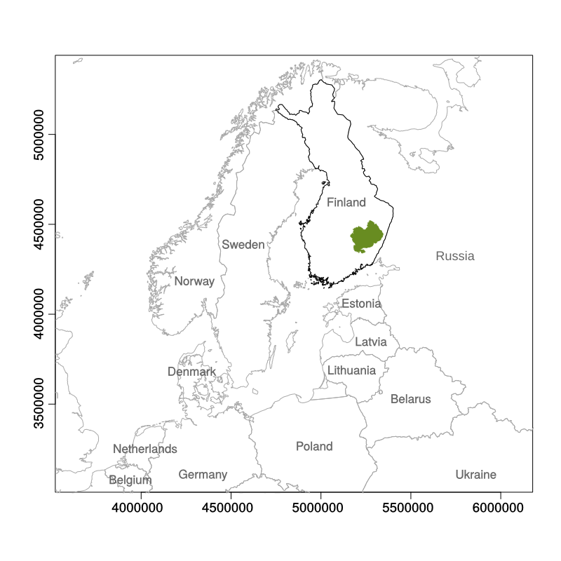
Figure 1
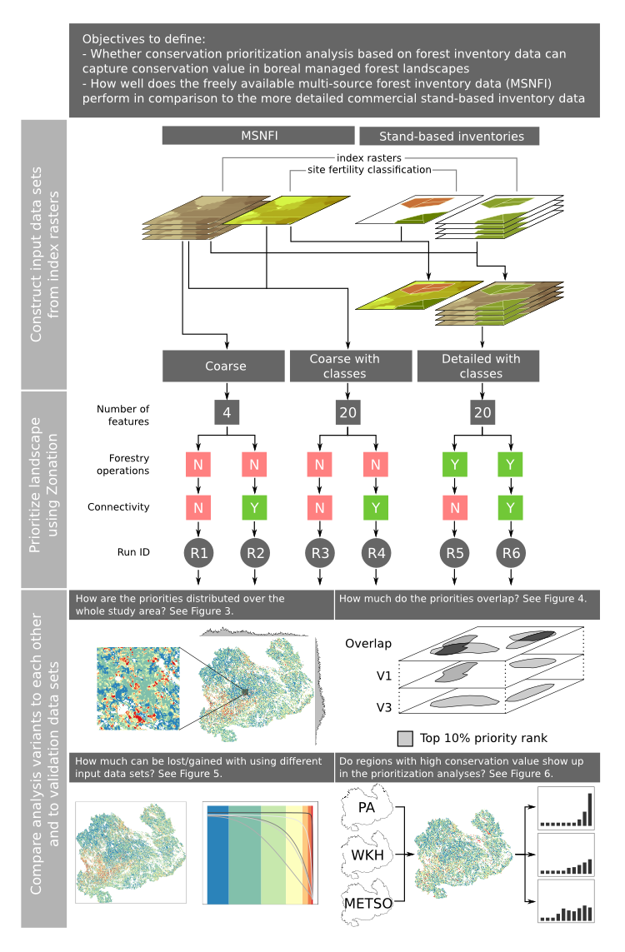
Figure 2
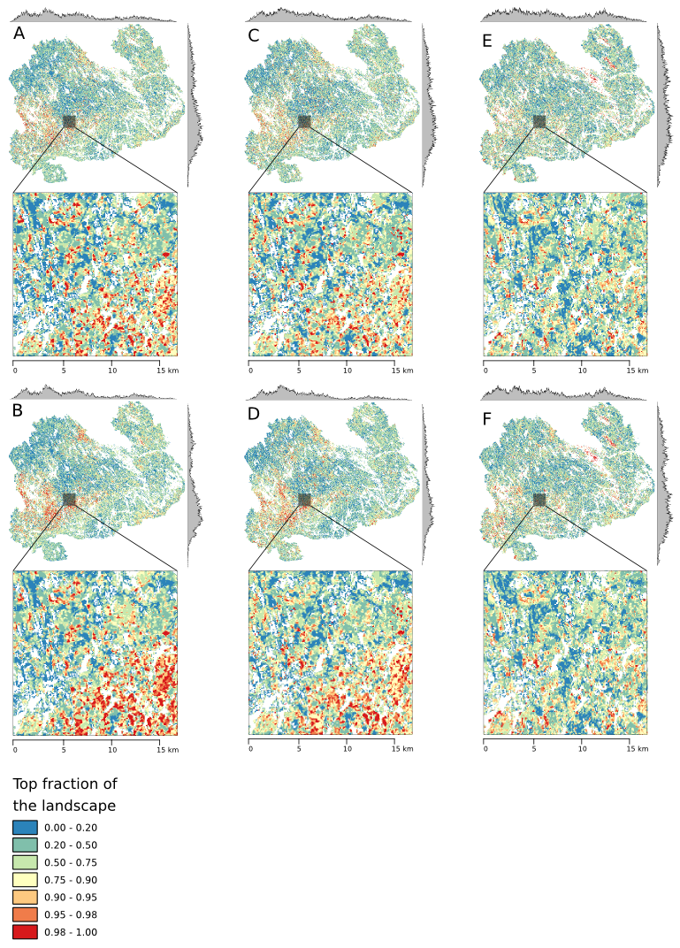
Figure 3
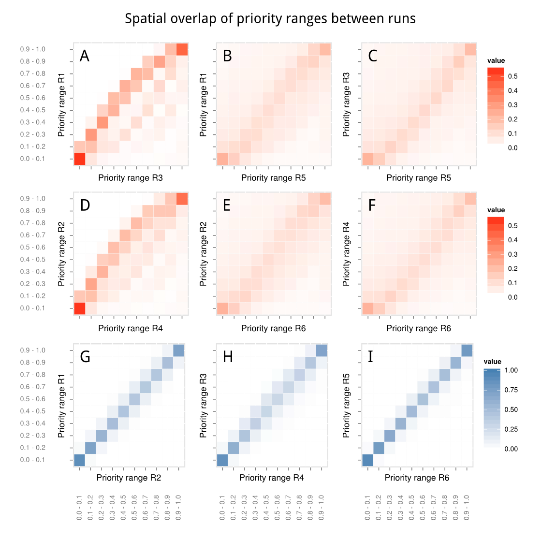
Figure 4
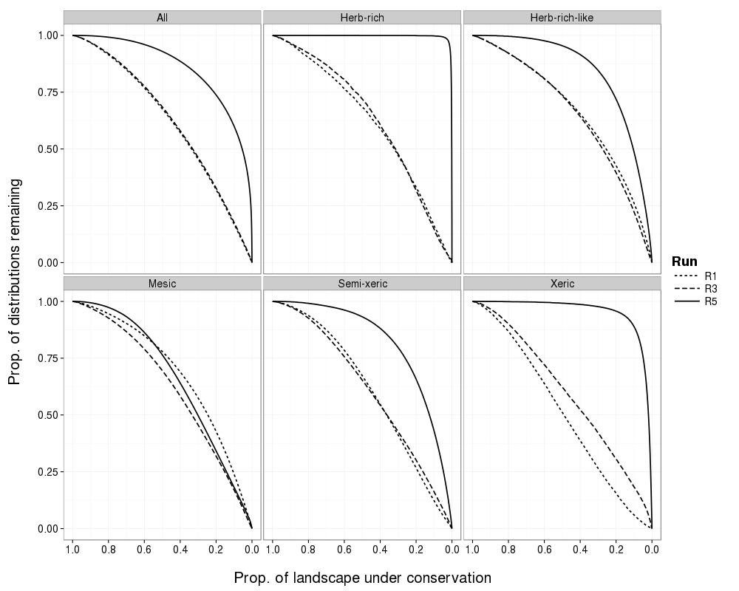
Figure 5
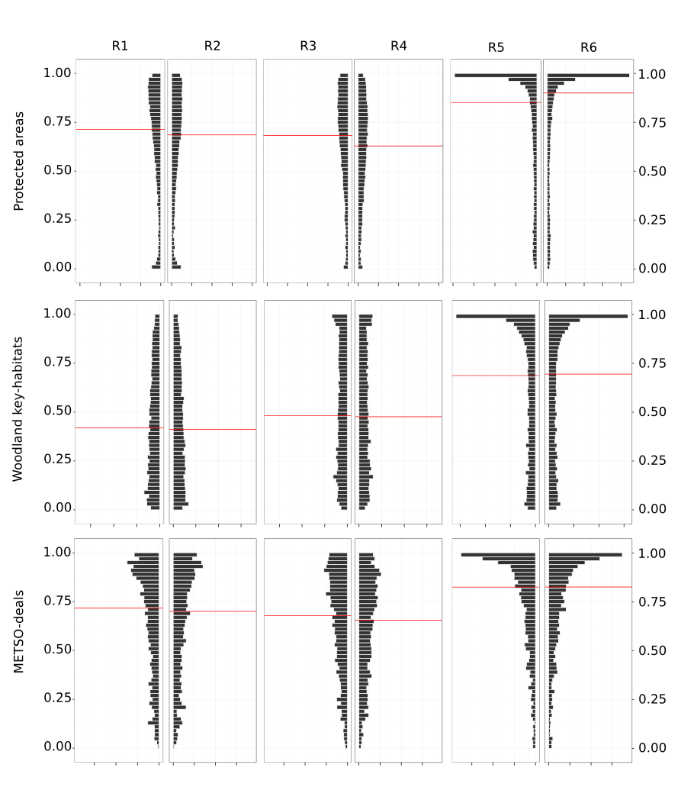
Figure 6

Supplementary material

S1.1 Data, results, and implementation of data pre-processing and Zonation analysis
Following online repositories contain the data and results that can be shared, and the implementation of various steps of study in the form of source code or configuration files. Each repository has it’s own licensing information.
Data is still missing, should be deposited in Dryad etc.
- https://github.com/jlehtoma/validityms - The sources of this manuscript including text, figures and all coded needed to analyze the results.
- https://github.com/jlehtoma/zsetup-esmk/ - Zonation configuration files.
- https://github.com/cbig/zonator - zonator: Utilities for Zonation spatial conservation prioritization software.

S1.2 Expert elicitation
Figure S1: The benefit functions used to scale the perceived, expert opinion based conservation value (y-axis) to forest structural characteristics (x-axis)
- Weights and connectivity coefficients in the connectivity matrix were decided based on the more detailed classification (feature number 20). For R1 and R2 which only have 4 features, weights and connectivity coefficients were averaged (CHECK).

S1.3 Data pre-processing
- Segmentation of the MSNFI data

S1.4 Zonation analysis setup:
- Table S1: Input data features
  - Include categorical variable for one of [“MS-NFI”, “MS-NFI with classes”, “Detailed”]
- Table S2: Feature weights
- Table S3: Connectivity matrix

Glossary
Analysis feature/Biodiversity feature = Input data that Zonation uses, in this study equals the index rasters.
Data source = One of the three data sources that are used to produce input data sets (see below): MS-NFI (Finnish Forest Research Institute), stand-based data on public non-production land (Metsähallitus Natural Heritage Services), and stand-based data on private land (Finnish Forest Centre).
Forest type = A class created by how the indices are built, i.e. a combination of tree species group (e.g. birch) and soil fertility class (e.g. herb-rich) creates a forest type of “birch-herb-rich”.
Index raster = A raster with values of index describing the perceived conservation value of a given location (pixel). Index value determined by average diameter and volume of standing stock by tree species. There are 4 tree species groups (pine, spruce, birch, other deciduous) and thus there are 4 index rasters in the most basic situation. There 4 index rasters may be further divided into discrete classes based on soil fertility classes (n=5) in which case the number of index layers is 20.
Input data set = Data set in which a Zonation analysis is based. In this work, we are using 3 different input data sets (MSNFI, MSNFI with classes, and detailed with classes) of increasing detail to compare the performance of freely available, but less accurate data to more detailed, but less available inventory data.
Landscape = The study area, or the whole area for which the spatial conservation prioritization is done for.
Site fertility class = One of “herb-rich”, “herb-rich-like” (CHECK), “mesic”, “semi-xeric”, “xeric”.
Tree species group = One of “pine”, “spruce”, “birch”, or “other broadleafed”. A categorization following the one used in MS-NFI. More detailed data is pooled into these groups according to…
Validation data sets = Three data sets that are used to validate and compare the Zonation results: 1) Protected areas (PAs), 2) Woodland key-habitats (WKHs), and 3) METSO-deals (MD).
Validation sites = Sites (spatially separate locations, polygons) included in the validation data sets. Each site can constitute of several polygons in the original data.
Variant = A Zonation analysis version with A) given input data set, and B) given Zonation analytical options (such as connectivity) enabled. In this study, we have Zonation analysis based on 3 different input data sets and for each we have 2 different Zonation setups: with and without connectivity. Hence, this study has 6 different variants (V1-V6).

