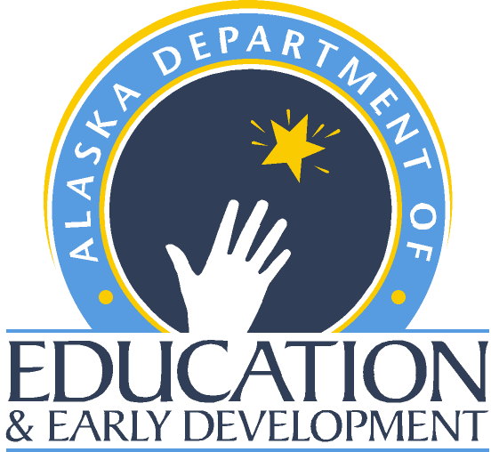 Teacher State-Approved Program Verification
  - Teacher Certification - Alaska Department of Education and Early Development

APPLICANT INFORMATION
Last Name: First Name: M.I.:
Social Security Number: Date of Birth: Gender:
- The remaining sections below are to be completed by the state approved program, NOT the applicant.

STATE-APPROVED EDUCATOR PREPARATION PROGRAM INFORMATION
Applicants who have completed a state-approved educator preparation program and have met all the associated testing requirements of the state with jurisdiction over the program are eligible for Alaska certification. A state-approved educator preparation program must include a program of study and a supervised clinical practice. To qualify for a certificate or endorsement in Alaska, applicants must be eligible to gain a comparable certificate or endorsement in the state that holds jurisdiction over the approved program. Certifications and endorsements based on testing alone cannot be used for Alaska certification.
Program Type: Indicate the type of state-approved educator preparation program:
Traditional program/University-based Non-traditional/University-based
Non-traditional/Alternative
Program Standards: Specify which standards the approved program meets:
CAEP/NCATE/TEAC State Standards Other:
Clinical Practice: Indicate the type of supervised clinical practice required by the state-approved program completed by the applicant:
Student Teaching Internship Met requirement through a state-approved alternative
Field Experience Practicum Other (Provide an explanation on a separate page)
Degree Information: Specify the degree the applicant earned as part of the approved program:
Bachelors Masters M.A.T Ed.D. Ph.D.
No degree/endorsement/certification ONLY Other:
Certificate/Endorsement Information: Indicate the certificate and/or the endorsement areas in which the applicant has completed the state-approved educator preparation or endorsement program, and met all associated testing requirements (if applicable).
Certificate/Endorsement Area Grade Level(s) Date Completed

Testing Requirements for the above endorsement (if applicable) Passing Score Applicant’s Score

By signing below, I verify the applicant has:
- Satisfied all the requirements of the state-approved educator preparation or the endorsement program to be eligible for certification/endorsement in the areas listed above;
- Passed all the jurisdiction’s testing requirements in place at the time the applicant completed the program listed above; and
- Maintained ethical standards required of an educator while participating in the state-approved program.
Signature of Certifying Official: Printed Name Title Date

 Teacher State-Approved Program Verification
  - Teacher Certification - Alaska Department of Education and Early Development

APPLICANT INFORMATION
Last Name: First Name: M.I.:
Social Security Number:

SIGNATURE
Name of College/University/State Agency City State Regional Accrediting Association

Signature of Certifying Official: Printed Name Title Date

Phone Number: Fax Number:

Email Address:

INSTITUTIONAL OR STATE STAMP OR SEAL

IF NOT AVAILABLE, FORM MUST BE SIGNED IN BLUE INK

CONTACT TEACHER CERTIFICATION
If you have questions, please use the following information to contact the Teacher Education & Certification Office:
Email: Teacher Certification (tcwebmail@alaska.gov)
Phone: (907) 465-2831 Fax: (907) 465-2441
Teacher Certification Website (https:/education.alaska.gov/teachercertification)

 Teacher State-Approved Program Verification
  - Teacher Certification - Alaska Department of Education and Early Development

AVAILABLE ENDORSEMENTS

ART/FINE ARTS
- Art
- Music
- Music – Choral
- Music – Instrumental
- Theater Arts
- Visual Arts

ALASKA NATIVE STUDIES
- Alaska Native Studies
- Aleut Language/Culture
- Athabascan Language/Culture
- Haida Language/Culture
- Inupiaq Language/Culture
- Tlingit Language/Culture
- Yupik Language/Culture

BUSINESS
- Business Education
- Business Communication
- Computer Education
- Marketing

EARLY CHILDHOOD
- Early Childhood Education

EDUCATIONAL TECHNOLOGY
- Distance Teaching & E-Learning
- Educational Technology

ELEMENTARY EDUCATION
- Elementary Education

LANGUAGE ARTS
- Communication
- English
- English Literature
- Humanities
- Journalism
- Language Arts
- Literature
- Russian Literature
- Speech

MATHEMATICS
- Mathematics
LIBRARY
(Only available if done through a teacher preparation program.)
- Library Science
- Media Specialist
- School Librarian

MIDDLE SCHOOL
- Middle School
- Middle School English / LA
- Middle School Math
- Middle School Science
- Middle School Social Studies

PHYSICAL EDUCATION / HEALTH
- Coaching
- Health
- Health Education
- Kinesiology
- Physical Education

READING
- Reading
- Reading Specialist
- Remedial Reading

SCIENCE
- Biology
- Chemistry
- Earth Science
- Environmental Science
- General Science
- Geology
- Life Science
- Natural Science
- Physical Science
- Physics
- Science
- Zoology

SOCIAL SCIENCES / STUDIES
- Anthropology
- Economics
- Geography
- Government
- History
- Political Science
- Psychology
- Russian History
- Social Science
- Sociology
- Social Studies
- U.S. History
- World History

SPECIAL EDUCATION
- Adaptive E.
- Cognitively Impaired
- Communication Disorders
- Emotionally Disturbed
- Hearing Impaired
- Learning Disability
- Multi-Handicapped
- Physically Handicapped
- Resource
- Special Ed – Early Childhood
- Special Education
- Visually Handicapped

VOCATIONAL EDUCATION
- Agriculture
- Family/Consumer Science
- Industrial Arts
- Industrial Technology
- Natural Resources
- Technology Education
- Vocational Education

WORLD LANGUAGES
- Bilingual Education
- Chinese
- English as a Foreign Language
- English as a Second Language
- French
- German
- Italian
- Japanese
- Latin
- Russian
- Spanish

Statewide English as a Second Language Acquisition, Bilingual and Literacy Education (SLABEL)

