MTCollatz

Jacob Leiner

COP 5518 Computing Essentials

Date of Project Submission: 7/5/2020

Background
The purpose of this project is to calculate the Collatz stopping number for a given range of numbers, recording the frequency of the stopping time in an array as well as the amount of time it takes to calculate all Collatz Stopping Times in the range in milliseconds. The user must enter the max number in the range to calculate, the number of threads used to calculate, as well as an optional argument to determine whether the program is synchronized or not when running the program from the command line.
Each thread computes a Collatz sequence according to the following formula:

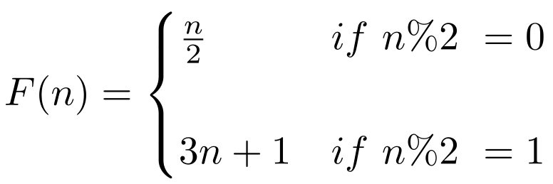

Experiment
There are two parts of this experiment. The first is to show the frequency of Collatz stopping times for a given N. I decided to use an N value of 500,000 as well as 10 threads for my histogram depicting the frequency of each Collatz stopping time from 1 to 500,000.
The second portion of the experiment was seeing the difference in elapsed time for different numbers of threads when synchronizing the threads vs removing the synchronization. I took the average of 5 stopping times for each thread when using synchronization as well as not.

Results
The histogram of my results for N = 500,000 and NumThreads = 10:
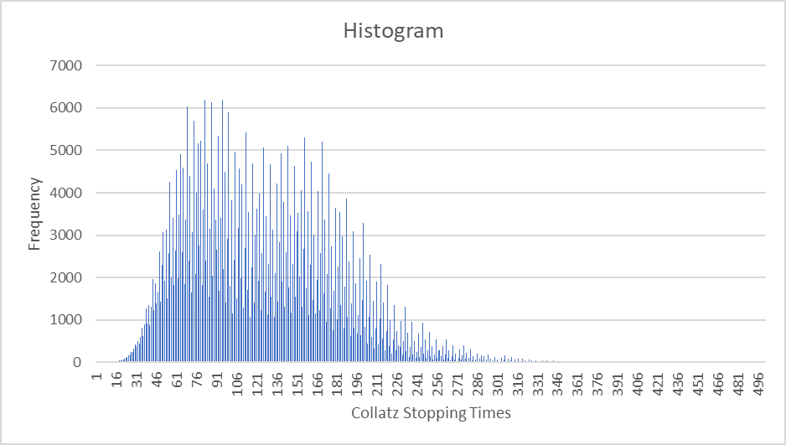
The elapsed time when N = 500,000 for each number of threads from 1 to 10 when the threads are synchronized:
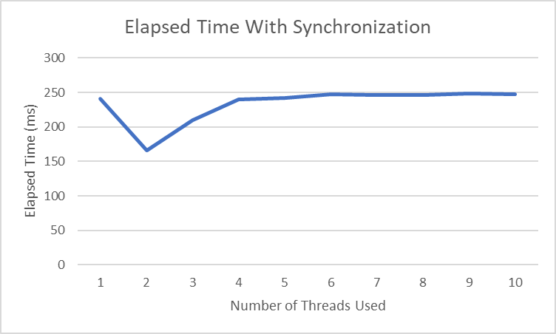
The elapsed time when N = 500,000 for each number of threads from 1 to 10 when the threads are not synchronized:

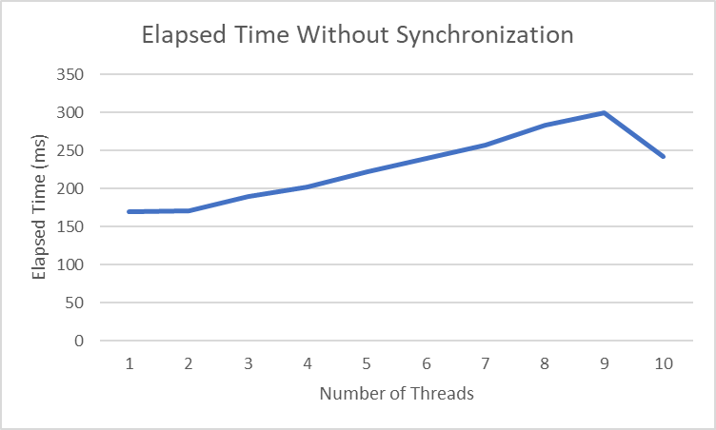
As expected, the histogram shows a left skewed distribution of Collatz stopping times. A stopping time of 500 or more is fairly rare unless you begin to test extremely large numbers. This program set constraints on the number to test, as well as the size of the array to hold the frequency of each Collatz stopping time occurring for a given value in the sequence.
What was not expected was the effect of using increased numbers of threads on the elapsed time to complete the process. When synchronizing threads access to shared data, the performance improved at first when comparing one vs two threads but then increased to it’s original average elapsed time after three threads were used and remained at a very flat average elapsed time for each number of threads used up to ten. The impact of using threads without synchronizing threads was even more surprising. The average elapsed time for each thread increased until reaching 10 threads, where a slight decrease in elapsed time occurred.

Conclusions
This project was very interesting and a challenge. The results of this analysis do not fall in line with what I had expected to see when beginning to perform it. There are several factors that may be causing the unexpected results. The first may be that each new thread’s overhead outweighs any boost to performance that it may achieve. The second is that real increases to performance are only seen when comparing a greater number of threads to a smaller number. The third is that there is an error in the code, or that the code should be refactored to optimize the amount of locks that are performed and at what point in the code they are performed.

