To: Bruce Bolden March 14, 2014
From: Jordan Leithart
Subject: 3-D Modeling and Display

Introduction:
This is the report for the development of a basic 3-D modeling and display function. The program was built to run using Java on my i5 Intel processor running Windows 7.

Overview:
I was tasked to develop a basic 3D modeling system as described in the handout, a function that would output my name and class information to the screen, plot a given three dimensional function, display a Rubik's cube with each cube separated and drawn touching, a model of the CS department hallway, and the word “Jordan” in 3D block letters.

Appendices:
To begin, I created the functions below. These functions called other functions that I had previously made for my 2D system.
    - DefineWindow() - Set the current window to the given dimensions
    - DefineViewport() - Set the current viewport to the given dimensions
    - WindowToViewport() - Uses linear interpolation to convert between window and viewport
    - Move3D() - Moves the draw point to the given point
    - Draw3D() - Draws between the current draw point and the given point
    - DefineElementaryTransform – Defines a transformation matrix
    - BuildElementaryTransform – Given a transformation matrix, multiply it with a basic transformation matrix
    - DefineCameraTransform – Defines the transformation for our camera
    - MultiplyTransform() - Multiplies two transformations together
    - ApplyTransform() - Applies a transformation to the point passed in.
Each of these functions built on some aspect of the 2D modeling system that I was tasked with creating earlier in the semester.

Next, I created a function that would plot the function z = x² + y² – x³ – 8*x*y⁴. I set up a for loop that incremented from my minimum x range to my maximum x value. I decided to make a quadrilateral from each point. I did this to make sure I didn't have to loop through the ranges twice. If I didn't do a quadrilateral, I would have to loop while the y-value was the outer loop and also while the x-value was the outer loop. The other part of this function was drawing all of the axes. At first, I had a small problem drawing the z-axis because my perspective was too close and it was drawing to infinity. Once, I fixed my camera transform, it looked great! See page 2 for the graph.

I decided to build my Rubik's cube procedurally. My first step was to create a square using data. I created a 2x2 square with the origin at (0, 0, 0). At that point, I made a list of assemblies by rotating the square. This list of assemblies gave me an individual cube. My next step was to translate that cube in the x direction. So I made another list of assemblies for a row. To make my side assembly, I translated the row in the y direction. Lastly, I made a z translation assembly for the entire cube. See page 3 for the output

The next thing to work on was to model the CS Department office hallway. I first attempted to do this procedurally, like with the Rubik's cube. I quickly realized that this was a bad idea. While I could easily create a door object and transform it around the hallway (which I did), the amount of data that I needed for the hallway meant that doing it completely procedurally was a bad idea. The end result was that I created a door object and a board object and transformed those around as needed. The output is on page 4.

The last thing I was tasked with was to write my name, Jordan, in 3D block letters. I had to do this data driven as well. I calculated out the locations of the points for all the vertices for each letter. Once I had done that, I just had to translate them to the correct location. See page 5 for the output:

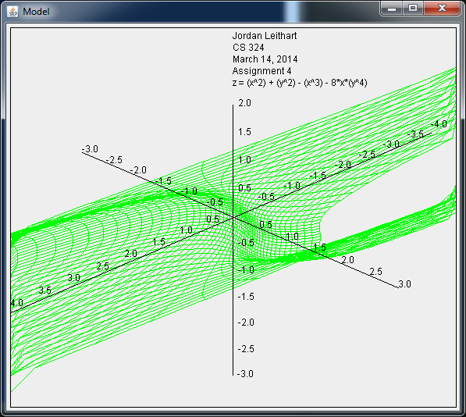
List of Outputs:

The surface I was tasked with plotting.

Rubik's Cube without spaces. You can tell the green overpowers the red in the middle.
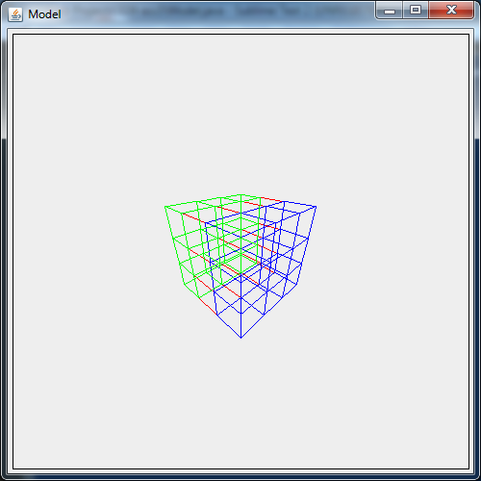
The Rubik's Cube with space between each cube:
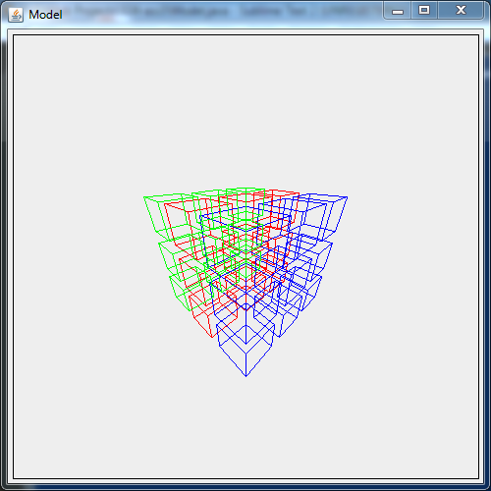
The model of the Computer Science hallway:
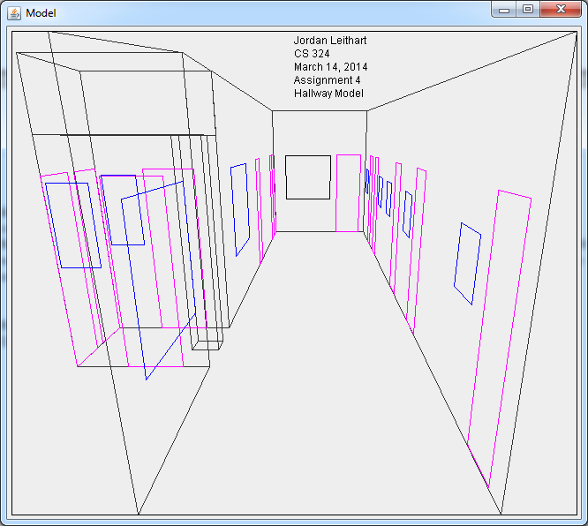

The 3D block letters:
