Santa Fe Trail Learning
Jordan Leithart
Abstract: The task for this assignment was to create a genetic program that would learn how to search for food along the Santa Fe trail. The Santa Fe trail is a trail of “food pellets” on a 2 dimensional grid (see image below). By using genetic programming, I hoped to train an agent (or ant) to find all the food along the trail efficiently. One difference between this Genetic Program, and others that I have created, was that I was attempting to maximize the fitness. Usually I try to minimize. I expected to get an ant that would find the majority of the food. I did end up getting that. But, if I made my population size large enough, i.e. got a good starting tree, my ant would end up being nearly perfect. That was something I wasn't expecting in the least.
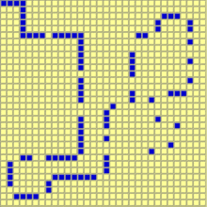
Algorithm | Generational
Population size
Selection method | Tournament Select (tournament size was 3)
Elitism (if used) | Yes, the best two individuals were copied over
Crossover method | I used subtree crossover
Crossover rate | I took a random integer whose range was the size of each parent, then traversed the tree in a depth-first method. When I had visited a number of nodes equal to that random integer, I crossed over on that node.
Mutation method | Node mutation
Mutation rate | 5% chance that each node in each individual would be mutated
Operator/non-terminal set | {prog3, prog2, iffoodahead}
Terminal set | {turn left, turn right, move forward}
Fitness function | Total amount of food collected
Size control (if any) | No size control

Graph showing average fitness and best fitness evolving over time after the first run-through:
Picture of the route after the first run-through:
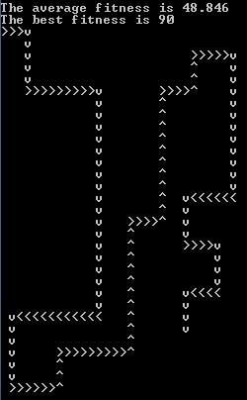
Graph showing average fitness and best fitness evolving over time after the second run-through:
Picture of the route after the second run-through:
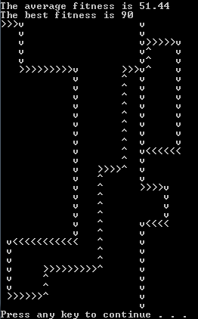
Discussion: I was very surprised that my ant gathered all the food. I was even more surprised when it followed the trail very well. I actually went to go talk to my instructor about my ant because I thought it was cheating somehow. I realized after that discussion that my ant was most likely checking the spaces to the left and right before moving forward. If I was going to do this again, I would put a 1 at the location whenever the ant entered a square, then increment for every action it performed in the square. That way I could see if it was turning left and right instead of just hoping that it was.
The graphs look a little strange to me since this is the first time that I was attempting to maximize fitness, instead of minimizing it. I had to make sure that all my fitness checking functions were getting the max instead of the min. The only other thing that I wish I had put in was size checking. For my tournament selection (and get best ant function) on tie-breakers I would have preferred to have the tie breaker ant be a smaller tree. Even without this, the ants performed very well. All in all, it was a good genetic program.

