Workbook: present-trends

Overview
Unit ID: tejal-apc-c1-m1-p2-trends
Fulfills target: tejal-apc-c1-m1-p2-trends@1
This workbook is the read-in-depth companion to the narrated deck: it carries the transcript, the fuller narrative deferred off the glance-slides, the exercises, and the citations.
How to use this workbook with the deck: watch the glance-deck for the perception-tuned claim per card, then read here for the deferred depth, work the self-check exercises, and follow the further reading into primary sources. The deck carries the glance channel; this workbook carries the read channel (dual-coding partners).

Learning Objectives
- `obj-lo2-analyze-trends` — _analyze_: Analyze the macro-economic and structural trends — administrative burnout, healthcare consumerism, and technological acceleration — that necessitate intrapreneurial physician leadership. (served by section(s): sec-ch2-macro-trends)
- `obj-lo3-idea-opportunity` — _analyze_: Differentiate between a superficial idea and a rigorously vetted opportunity using the core tenets of the Intrapreneurship Formula. (served by section(s): sec-ch3-idea-vs-opportunity)
- `obj-lo4-root-cause` — _evaluate_: Evaluate systemic operational failures through root-cause analysis and defend the findings against the structural evidence. (served by section(s): sec-ch3-case-for-change)

Transcript-narrative

seg-01
The main message: two structural forces now define your operating reality. U.S. national health expenditures have surpassed $4.5 trillion — nearly 17% of GDP, putting constant pressure on margins and care models. At the same time, consolidation has shifted authority — over 74% of physicians now employed by hospitals or corporate entities, while independent practice keeps declining. You feel that in autonomy and decision rights. To shape care today, it’s not enough to perfect one clinic; you need the skills to influence a large, complex enterprise — visual context for why this capability becomes non‑optional.

seg-02
A system under strain shows up at the bedside as exhaustion. More than 50% of U.S. physicians report at least one burnout symptom — not because medicine is hard, but because administrative burden consumes the time meant for care. Prior authorization alone can absorb a full workday every week, and the EHR burden means 2 hours of documentation for every 1 hour of patient contact. It’s no surprise 1 in 5 physicians intend to leave practice within 2 years. Bureaucratic friction isn’t background noise; it’s a targetable inefficiency at the center of the cost crisis. The human takeaway: burnout is not a resilience failure — it’s a system design problem you can redesign.

seg-03
The main message is scale: the U.S. wastes an estimated $760 to $935 billion annually — roughly 25 cents of every healthcare dollar. Administrative complexity is the single largest category, dwarfing clinical inefficiencies. That is time, money, and attention pulled away from patient care. Every dollar of administrative waste is a concrete innovation target — not an inevitability. Visual context, then, becomes a mandate: if you can remove friction, you recover resources and reduce burnout at the same time.

seg-04
First, broken workflow — redundant handoffs, paper-based approvals, fragmented communication. Then EHR workarounds — physicians build shadow systems to compensate for interface failures. That produces risk, rework, and lost clinical time. Each pain point feeds an innovation opportunity where redesign, automation, or AI can restore time and quality. Launch something small and iterate. Reframing burnout as a signal, not a sentence is the first act of clinical leadership.

seg-05
Closing the loop on burnout and waste: the friction you mapped is exactly where innovation must land. Now, the knowledge and technology curve demands you lead that change. Medical knowledge is estimated to double every 73 days — compared to every 50 years in 1950. AI, wearables, genomics, and remote diagnostics are compressing the gap between research and clinical application. FDA-cleared AI tools surpassed 500 in 2023. Precision medicine is moving from research to routine care, and continuous biosensors are enabling proactive, real-time intervention. Clinicians who can evaluate, adopt, and govern these tools are no longer optional — they are essential.

seg-06
Here’s the tension in the framework: static training cannot keep pace with a landscape where knowledge doubles fast. The diagram traces a familiar flow — Medical School with a fixed 4‑year curriculum, Residency bound to a single era’s protocols, and Practice Reality where AI and new standards keep arriving. Clinical knowledge has a shrinking shelf life; guidelines updated in 2020 may be obsolete by 2025. Curriculum lag means content cycles take 3–5 years to update, and protocol drift means evidence changes faster than CME can deliver. The structure is mismatched to the speed of change — which is why continuous learning infrastructure is now a safety issue, not a luxury.

seg-07
Adoption is already ahead of oversight. Thirty‑eight percent of physicians are using AI‑assisted tools in clinical decision support, yet fewer than 1 in 10 have received formal preparation on governance, bias, or clinical validation. There are 500+ FDA‑cleared AI tools across specialties. Physicians are adopting tools faster than institutions are training them to oversee those tools — a governance gap with real patient safety implications. Your role is to close that gap.

seg-08
The upside is real when clinicians lead. Continuous remote monitoring enables proactive intervention before hospitalization — reducing readmissions by up to 38% in heart failure populations when clinically guided. In training, VR surgical simulation reduces operating room errors and compresses learning curves — but only when physician educators design, validate, and oversee curricula. The common thread: technology succeeds when clinicians lead its implementation, not merely adopt it.

seg-09
We just saw that technology can shift care proactively and safely when clinicians lead it. Now bring the same discipline to access: patients now expect Amazon‑level access and rate digital convenience alongside clinical quality when choosing providers. Scheduling frictions, portal failures, and slow responses drive silent attrition — patients simply leave without complaint. Same‑day digital booking and transparent wait times are baseline expectations. Patients move fluidly between telehealth, in‑person, and messaging and still expect continuity. MyChart access alone is no longer sufficient — proactive outreach and personalization are required. This is service design, not a portal feature.

seg-10
In a consumer‑driven system with accelerating tech, great design still fails without clinical leadership in the room. Health systems are complex adaptive organizations. Strategy, finance, operations, and technology decisions made without physician input routinely produce solutions that fail at the bedside. Clinical Expertise Alone Is Insufficient. The system needs clinicians who speak both languages: medicine and management — across Practice, Business, and Technology, including AI governance, digital health, and implementation science.

seg-11
Here’s the mismatch: nearly 70% of physicians report wanting greater influence over organizational strategy — yet fewer than 1 in 5 have received any formal business or executive preparation. That gap explains the day‑to‑day frustration you’ve felt trying to move ideas forward. This is not a motivation deficit. It is a training infrastructure gap that programs like this one are designed to close.

seg-12
Bridge leaders translate across domains. Management fluency — strategy, finance, operations — pairs with clinical credibility trusted by frontline teams. Systems thinking keeps the whole in view, and technology governance guides safe AI adoption. Returning to the center, academic health centers sit at the intersection of patient care, education, and research — environments where siloed expertise fails. Leaders who integrate these capabilities turn expertise into scalable, lasting organizational improvement.

seg-13
We’ve named the leadership gap and the bridge capabilities institutions need. Now synthesize the case for change. System complexity — consolidation and rising expenditures — demands leaders who understand business and policy, not just care delivery. Technology acceleration requires clinicians who can evaluate, govern, and scale innovation. Consumer expectations insist on frictionless digital access and omnichannel continuity. The physician leader who bridges practice, business, and technology is the most scarce and most needed figure in modern healthcare. Awareness of these forces is the starting point. Choosing to act on them — to lead — is the defining move from awareness to agency.

Depth-delta narrative

Chapter 2 — The Macro Trends (economic & human cost)
Objective: obj-lo2-analyze-trends (section sec-ch2-macro-trends)
Depth deferred off the slide: The system-design reframe of burnout the glance-deck only gestures at: burnout is not a resilience failure but a system-design problem. Over half of physicians report a burnout symptom, and the top driver is administrative bloat — so the daily workarounds clinicians invent are the innovation surface. The deck shows the 25% administrative-waste figure; the workbook argues WHY that waste is a concrete, redesignable innovation target rather than an inevitability.
Walk the reader from the economic and structural reality (national health expenditure growth and the consolidation of physicians into large systems) to the human cost (burnout as a system-design problem) and finally to the reframe that administrative friction is a targetable innovation opportunity. The point a busy clinician should leave with: the workarounds you invent to survive a broken EHR or admission process are exactly where redesign, automation, and AI can recover time and reduce burnout at the same time.

Chapter 3 — The Case for Change (root-cause of failure)
Objective: obj-lo4-root-cause (section sec-ch3-case-for-change)
Depth deferred off the slide: What safe AI oversight actually requires, and why the leadership gap is a root-cause of systemic failure rather than a motivation deficit: adoption of clinical AI is already ahead of governance training, and physicians want influence over strategy but lack formal business preparation. The deck glances the gap; the workbook traces it to a training-infrastructure cause the learner is positioned to close.
Develop the case for change across the knowledge explosion (static training cannot keep pace), the rising adoption of clinical AI ahead of oversight, the consumer shift toward a digital front door, and the leadership gap. Frame each as a root-cause analysis: the failure is structural (training infrastructure, governance, service design), and the physician who can bridge practice, business, and technology is the scarce, needed figure who resolves it.

Bridge — From idea to vetted opportunity (introduced)
Objective: obj-lo3-idea-opportunity (section sec-ch3-idea-vs-opportunity)
Depth deferred off the slide: The distinction between a superficial idea and a rigorously vetted opportunity — introduced here and carried forward into the Opportunity Diagnostic. The deck names the forward pull; the workbook seeds the vocabulary (scan, size, pressure-test) the learner will apply next.
Close Part 2 by introducing the idea-versus-opportunity discipline: awareness of the macro trends is the starting point, and choosing to act on them — to pressure-test a gap into a vetted opportunity — is the defining move from awareness to agency.

Transcript of Record

seg-01 (verbatim)
The main message: two structural forces now define your operating reality. U.S. national health expenditures have surpassed $4.5 trillion — nearly 17% of GDP, putting constant pressure on margins and care models. At the same time, consolidation has shifted authority — over 74% of physicians now employed by hospitals or corporate entities, while independent practice keeps declining. You feel that in autonomy and decision rights. To shape care today, it’s not enough to perfect one clinic; you need the skills to influence a large, complex enterprise — visual context for why this capability becomes non‑optional.

seg-02 (verbatim)
A system under strain shows up at the bedside as exhaustion. More than 50% of U.S. physicians report at least one burnout symptom — not because medicine is hard, but because administrative burden consumes the time meant for care. Prior authorization alone can absorb a full workday every week, and the EHR burden means 2 hours of documentation for every 1 hour of patient contact. It’s no surprise 1 in 5 physicians intend to leave practice within 2 years. Bureaucratic friction isn’t background noise; it’s a targetable inefficiency at the center of the cost crisis. The human takeaway: burnout is not a resilience failure — it’s a system design problem you can redesign.

seg-03 (verbatim)
The main message is scale: the U.S. wastes an estimated $760 to $935 billion annually — roughly 25 cents of every healthcare dollar. Administrative complexity is the single largest category, dwarfing clinical inefficiencies. That is time, money, and attention pulled away from patient care. Every dollar of administrative waste is a concrete innovation target — not an inevitability. Visual context, then, becomes a mandate: if you can remove friction, you recover resources and reduce burnout at the same time.

seg-04 (verbatim)
First, broken workflow — redundant handoffs, paper-based approvals, fragmented communication. Then EHR workarounds — physicians build shadow systems to compensate for interface failures. That produces risk, rework, and lost clinical time. Each pain point feeds an innovation opportunity where redesign, automation, or AI can restore time and quality. Launch something small and iterate. Reframing burnout as a signal, not a sentence is the first act of clinical leadership.

seg-05 (verbatim)
Closing the loop on burnout and waste: the friction you mapped is exactly where innovation must land. Now, the knowledge and technology curve demands you lead that change. Medical knowledge is estimated to double every 73 days — compared to every 50 years in 1950. AI, wearables, genomics, and remote diagnostics are compressing the gap between research and clinical application. FDA-cleared AI tools surpassed 500 in 2023. Precision medicine is moving from research to routine care, and continuous biosensors are enabling proactive, real-time intervention. Clinicians who can evaluate, adopt, and govern these tools are no longer optional — they are essential.

seg-06 (verbatim)
Here’s the tension in the framework: static training cannot keep pace with a landscape where knowledge doubles fast. The diagram traces a familiar flow — Medical School with a fixed 4‑year curriculum, Residency bound to a single era’s protocols, and Practice Reality where AI and new standards keep arriving. Clinical knowledge has a shrinking shelf life; guidelines updated in 2020 may be obsolete by 2025. Curriculum lag means content cycles take 3–5 years to update, and protocol drift means evidence changes faster than CME can deliver. The structure is mismatched to the speed of change — which is why continuous learning infrastructure is now a safety issue, not a luxury.

seg-07 (verbatim)
Adoption is already ahead of oversight. Thirty‑eight percent of physicians are using AI‑assisted tools in clinical decision support, yet fewer than 1 in 10 have received formal preparation on governance, bias, or clinical validation. There are 500+ FDA‑cleared AI tools across specialties. Physicians are adopting tools faster than institutions are training them to oversee those tools — a governance gap with real patient safety implications. Your role is to close that gap.

seg-08 (verbatim)
The upside is real when clinicians lead. Continuous remote monitoring enables proactive intervention before hospitalization — reducing readmissions by up to 38% in heart failure populations when clinically guided. In training, VR surgical simulation reduces operating room errors and compresses learning curves — but only when physician educators design, validate, and oversee curricula. The common thread: technology succeeds when clinicians lead its implementation, not merely adopt it.

seg-09 (verbatim)
We just saw that technology can shift care proactively and safely when clinicians lead it. Now bring the same discipline to access: patients now expect Amazon‑level access and rate digital convenience alongside clinical quality when choosing providers. Scheduling frictions, portal failures, and slow responses drive silent attrition — patients simply leave without complaint. Same‑day digital booking and transparent wait times are baseline expectations. Patients move fluidly between telehealth, in‑person, and messaging and still expect continuity. MyChart access alone is no longer sufficient — proactive outreach and personalization are required. This is service design, not a portal feature.

seg-10 (verbatim)
In a consumer‑driven system with accelerating tech, great design still fails without clinical leadership in the room. Health systems are complex adaptive organizations. Strategy, finance, operations, and technology decisions made without physician input routinely produce solutions that fail at the bedside. Clinical Expertise Alone Is Insufficient. The system needs clinicians who speak both languages: medicine and management — across Practice, Business, and Technology, including AI governance, digital health, and implementation science.

seg-11 (verbatim)
Here’s the mismatch: nearly 70% of physicians report wanting greater influence over organizational strategy — yet fewer than 1 in 5 have received any formal business or executive preparation. That gap explains the day‑to‑day frustration you’ve felt trying to move ideas forward. This is not a motivation deficit. It is a training infrastructure gap that programs like this one are designed to close.

seg-12 (verbatim)
Bridge leaders translate across domains. Management fluency — strategy, finance, operations — pairs with clinical credibility trusted by frontline teams. Systems thinking keeps the whole in view, and technology governance guides safe AI adoption. Returning to the center, academic health centers sit at the intersection of patient care, education, and research — environments where siloed expertise fails. Leaders who integrate these capabilities turn expertise into scalable, lasting organizational improvement.

seg-13 (verbatim)
We’ve named the leadership gap and the bridge capabilities institutions need. Now synthesize the case for change. System complexity — consolidation and rising expenditures — demands leaders who understand business and policy, not just care delivery. Technology acceleration requires clinicians who can evaluate, govern, and scale innovation. Consumer expectations insist on frictionless digital access and omnichannel continuity. The physician leader who bridges practice, business, and technology is the most scarce and most needed figure in modern healthcare. Awareness of these forces is the starting point. Choosing to act on them — to lead — is the defining move from awareness to agency.

Figures
Figure — The Economic and Structural Reality (source_ref: src-slide-01)
Figure — The Human Cost System Waste and Burnout (source_ref: src-slide-02)
Figure — Waste and Administrative Bloat as System Inefficiency (source_ref: src-slide-03)
Figure — From Burnout Symptoms to Innovation Targets (source_ref: src-slide-04)
Figure — The Knowledge Explosion and New Technologies (source_ref: src-slide-05)
Figure — Why Static Training No Longer Keeps Up (source_ref: src-slide-06)
Figure — AI Use Is Rising Faster Than Oversight Training (source_ref: src-slide-07)
Figure — Technology Can Shift Care Proactively and Safely (source_ref: src-slide-08)
Figure — The Consumer Shift and The Digital Front Door (source_ref: src-slide-09)
Figure — The Leadership Gap (source_ref: src-slide-10)
Figure — Many Physicians Want Influence but Lack Training (source_ref: src-slide-11)
Figure — Why Academic Health Centers Need Bridge Leaders (source_ref: src-slide-12)
Figure — Part 2 Summary From Awareness to Agency (source_ref: src-slide-13)

Exercises

Practice — section `sec-ch2-macro-trends`

Exercise `ex-ch2-q1`
Bloom level: remember
Between 2012 and 2022, which major structural shift occurred regarding physician practice models?
Answer key (source_ref: src-slide-02)

Exercise `ex-ch2-q2`
Bloom level: understand
Approximately what percentage of total U.S. healthcare spending is attributed to administrative costs and waste?
Answer key (source_ref: src-slide-02)

Exercise `ex-ch2-q3`
Bloom level: analyze
While patient volume and acuity are high, the data shows that the primary driver of the physician burnout epidemic is:
Answer key (source_ref: src-slide-02)

Exercise `ex-ch2-q4`
Bloom level: evaluate
Based on the 'Healthcare Supply and Demand' concepts, why does simply hiring more physicians often fail to solve access issues in a poorly designed system?
Answer key (source_ref: src-slide-02)

Exercise `ex-ch2-q5`
Bloom level: apply
You are an attending physician managing a complex workflow and notice a recurring delay in patient transport. According to the 'Modern Clinician's Dilemma,' what is the most likely barrier preventing you from solving this?
Answer key (source_ref: src-slide-02)

Practice — section `sec-ch3-case-for-change`

Exercise `ex-ch3-q1`
Bloom level: remember
In 1950, medical knowledge doubled every 50 years. What is the currently projected doubling time?
Answer key (source_ref: src-slide-05)

Exercise `ex-ch3-q2`
Bloom level: understand
While 66% of physicians report using some form of AI in practice, what is the critical gap identified in the macro trends?
Answer key (source_ref: src-slide-05)

Exercise `ex-ch3-q3`
Bloom level: apply
A hospital implements a 'Digital Front Door' strategy. Which initiative best represents this concept?
Answer key (source_ref: src-slide-05)

Exercise `ex-ch3-q4`
Bloom level: analyze
The data shows 67% of physicians want to pursue leadership roles, yet only 18% receive formal business training. What is the most significant consequence of this gap for Academic Health Centers?
Answer key (source_ref: src-slide-05)

Exercise `ex-ch3-q5`
Bloom level: evaluate
Referring to Tyler Beauchamp's article, which category of care failure requires the most urgent intrapreneurial intervention to reduce macro-level waste?
Answer key (source_ref: src-slide-05)

Answer Key

Practice — section `sec-ch2-macro-trends`

Answer — `ex-ch2-q1`
Correct answer: A drastic decrease in independent private practice and a surge in physicians employed by large health systems.
Answer key source_ref: src-slide-02

Answer — `ex-ch2-q2`
Correct answer: 25%
Answer key source_ref: src-slide-02

Answer — `ex-ch2-q3`
Correct answer: Bureaucratic tasks and administrative bloat (e.g., EHR charting).
Answer key source_ref: src-slide-02

Answer — `ex-ch2-q4`
Correct answer: Because it adds expensive supply without addressing the underlying systemic inefficiencies or administrative bottlenecks that limit throughput.
Answer key source_ref: src-slide-02

Answer — `ex-ch2-q5`
Correct answer: The absence of a structured innovation process and the organizational authority/safety to redesign the workflow.
Answer key source_ref: src-slide-02

Practice — section `sec-ch3-case-for-change`

Answer — `ex-ch3-q1`
Correct answer: 73 days.
Answer key source_ref: src-slide-05

Answer — `ex-ch3-q2`
Correct answer: Formal training on how to oversee, evaluate, and safely implement these tools remains severely limited.
Answer key source_ref: src-slide-05

Answer — `ex-ch3-q3`
Correct answer: An AI-driven, mobile-friendly triage system that allows patients to seamlessly schedule appointments and communicate with their care team before entering the physical clinic.
Answer key source_ref: src-slide-05

Answer — `ex-ch3-q4`
Correct answer: They possess deep clinical expertise but lack the interdisciplinary management skills required to translate clinical ideas into scalable, system-wide improvements.
Answer key source_ref: src-slide-05

Answer — `ex-ch3-q5`
Correct answer: Administrative complexity and failures of care coordination.
Answer key source_ref: src-slide-05

Research Glossary
(no research-informed glossary articles recorded for this run; recorded explicitly-empty)

References

Segment source-ref trace
- seg-01 -> source_ref src-slide-01
- seg-02 -> source_ref src-slide-02
- seg-03 -> source_ref src-slide-03
- seg-04 -> source_ref src-slide-04
- seg-05 -> source_ref src-slide-05
- seg-06 -> source_ref src-slide-06
- seg-07 -> source_ref src-slide-07
- seg-08 -> source_ref src-slide-08
- seg-09 -> source_ref src-slide-09
- seg-10 -> source_ref src-slide-10
- seg-11 -> source_ref src-slide-11
- seg-12 -> source_ref src-slide-12
- seg-13 -> source_ref src-slide-13

Cited references & further reading
- [CMS National Health Expenditure (NHE) Fact Sheet](https://www.cms.gov/data-research/statistics-trends-and-reports/national-health-expenditure-data/nhe-fact-sheet) (source_ref: src-slide-01) — supports seg-01
- American Medical Association — Physician Practice Ownership Report (source_ref: src-slide-01) — supports seg-01
- [Shrank WH et al. Waste in the US Health Care System. JAMA (2019)](https://doi.org/10.1001/jama.2019.13978) (source_ref: src-slide-02) — supports seg-03
- Medscape Physician Burnout & Depression Report (2024) (source_ref: src-slide-02) — supports seg-02
- [Densen P. Challenges and Opportunities Facing Medical Education (2011)](https://doi.org/10.1043/0027-9684-103.6.48) (source_ref: src-slide-03) — supports seg-05
- Isaranuwatchai W et al. Remote monitoring, JMIR (2018) (source_ref: src-slide-03) — supports seg-08
- AMA Augmented Intelligence in Medicine Report (source_ref: src-slide-03) — supports seg-07
- Jackson Physician Search — Physician Leadership survey (2023) (source_ref: src-slide-05) — supports seg-11
- [Rotenstein LS et al. Academic Medicine (2021)](https://doi.org/10.1097/ACM.0000000000003907) (source_ref: src-slide-05) — supports seg-12
- [Required reading — Beauchamp T. Healthcare's Trillion-Dollar Problem (Medium)](https://medium.com/@TylerBeauchamp/healthcare-s-trillion-dollar-problem-90438f4164dc) (source_ref: src-required-reading) — supports seg-03
- [Intro video — Healthcare supply & demand (YouTube)](https://www.youtube.com/watch?v=GjRAHuHIOD0) (source_ref: src-intro-video) — supports seg-01

Live-research cited entries (DOI)
- (no cited research entries recorded for this run; recorded explicitly-empty (corpus-native references above carry the citations))

Research Trends
(no research-trends brief supplied for this artifact; recorded explicitly-empty)
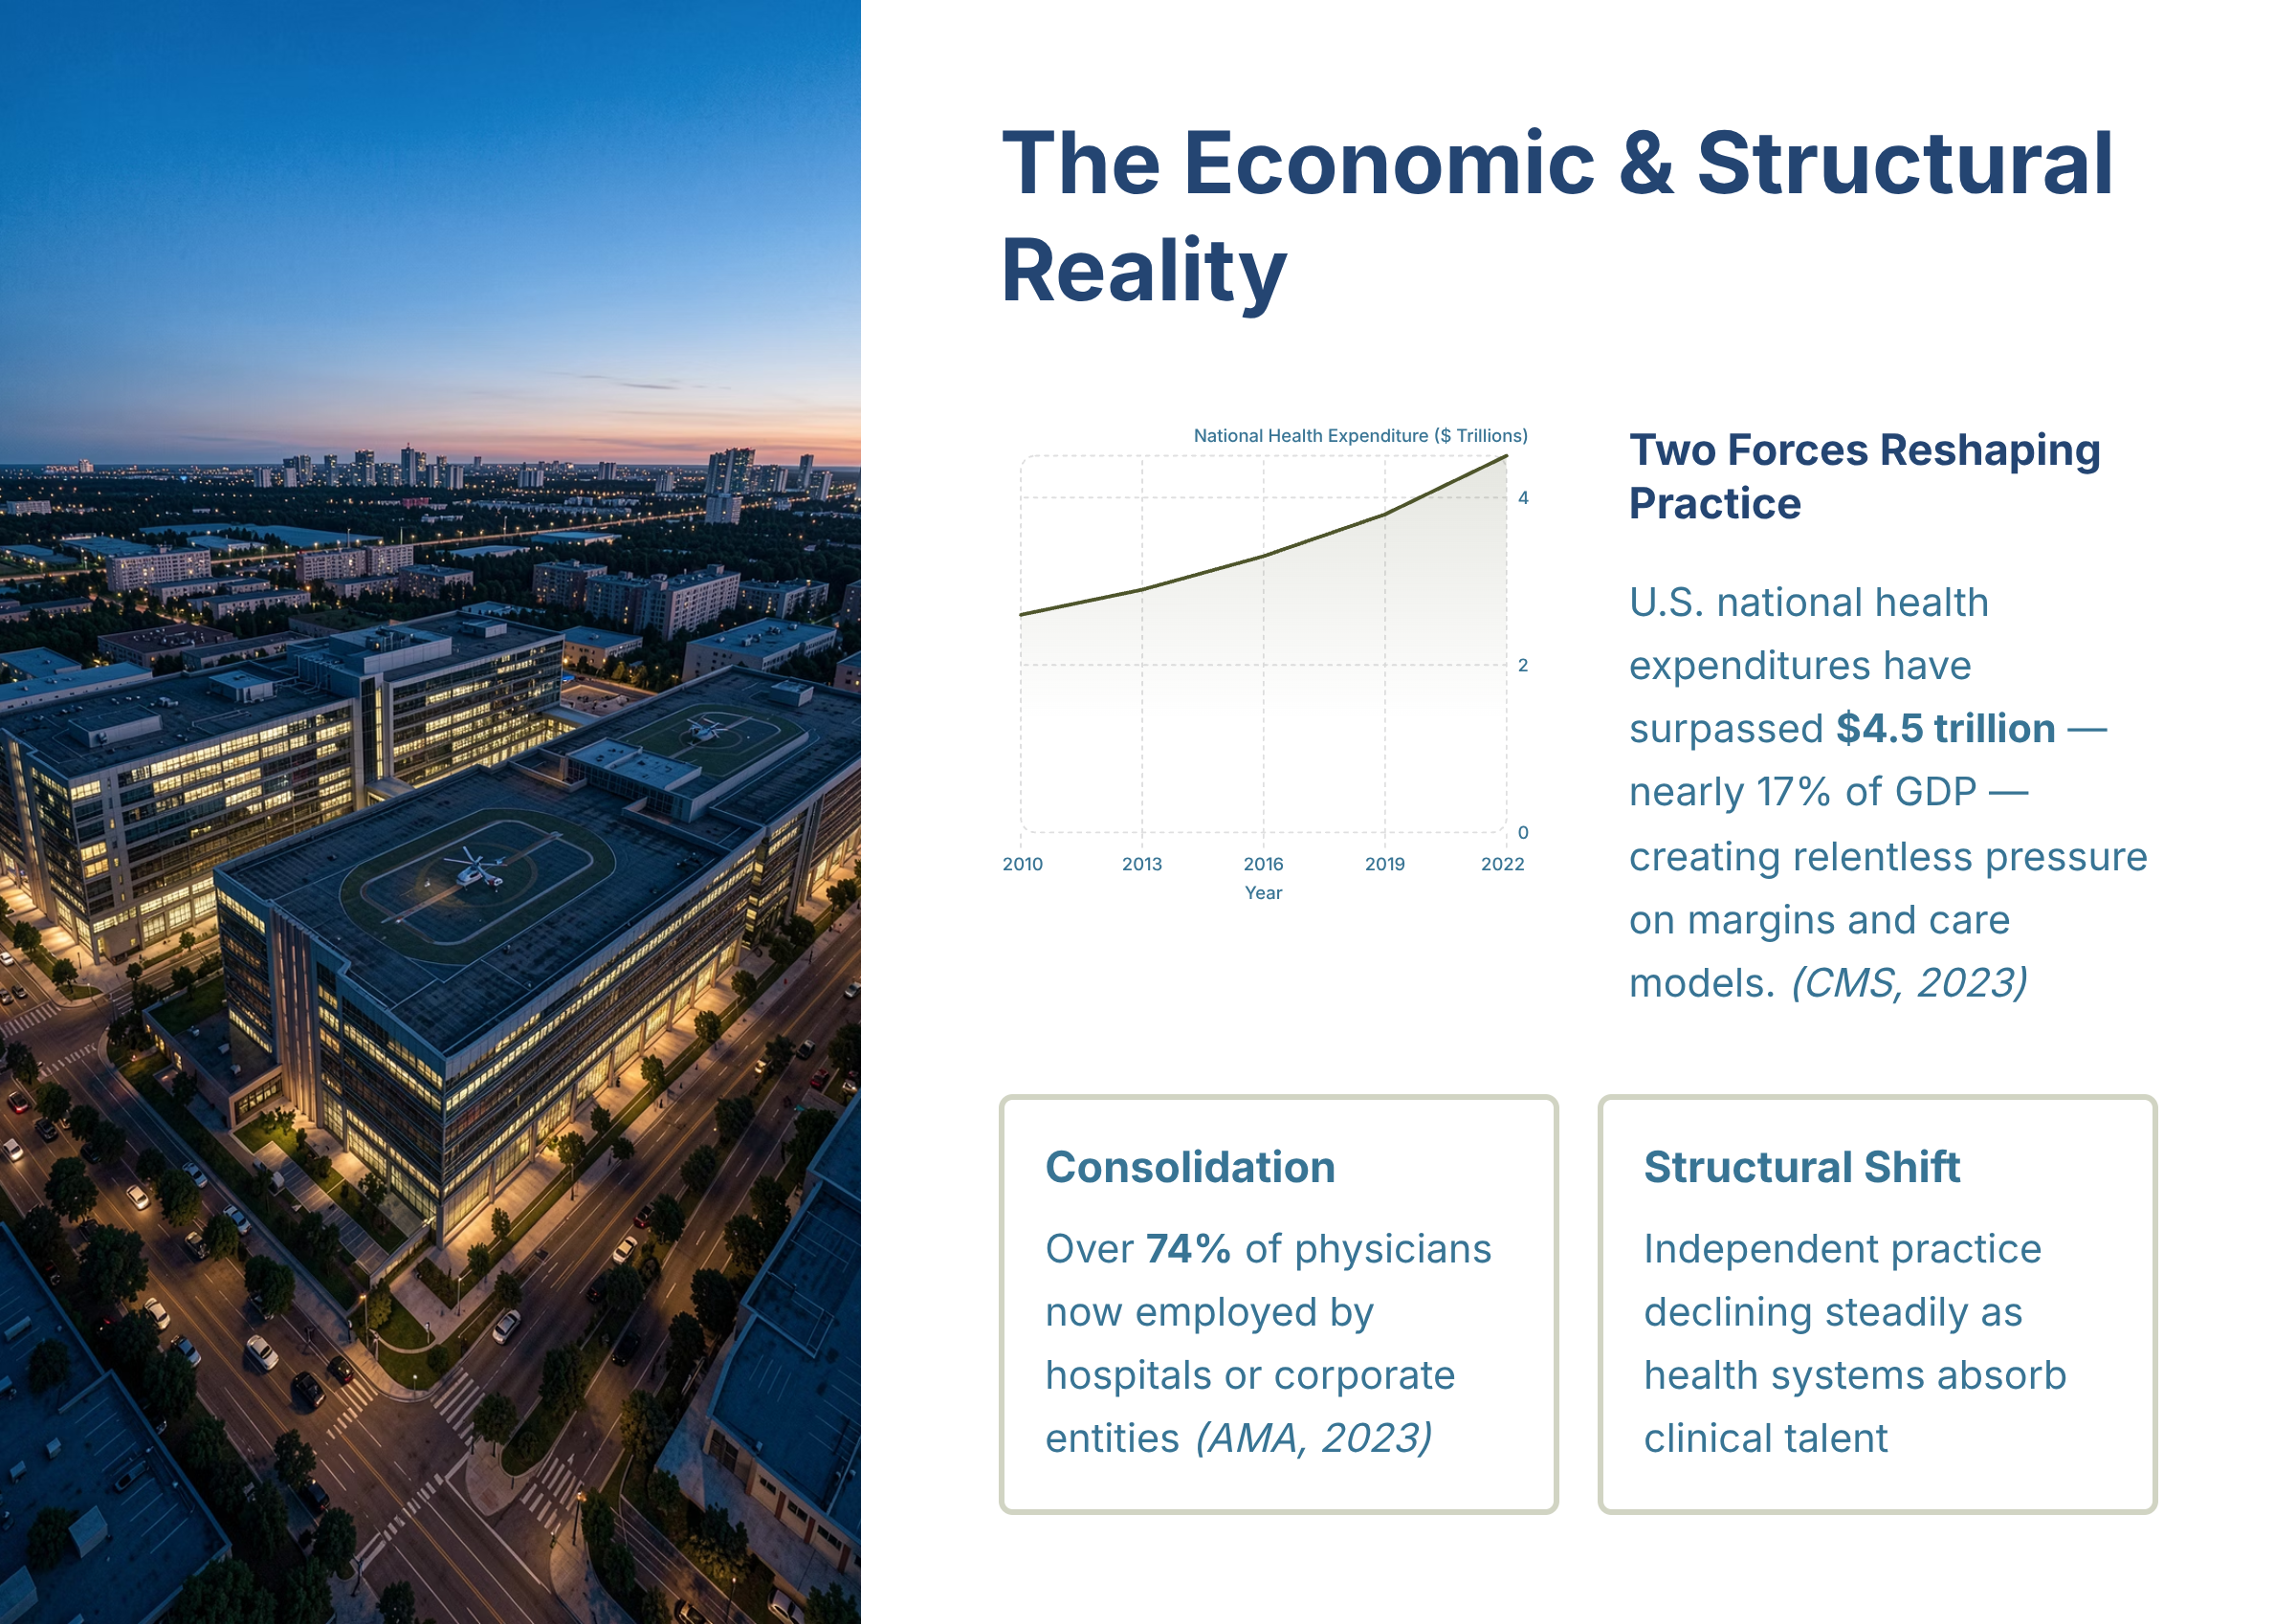
Figure — The Economic and Structural Reality (source_ref: src-slide-01)
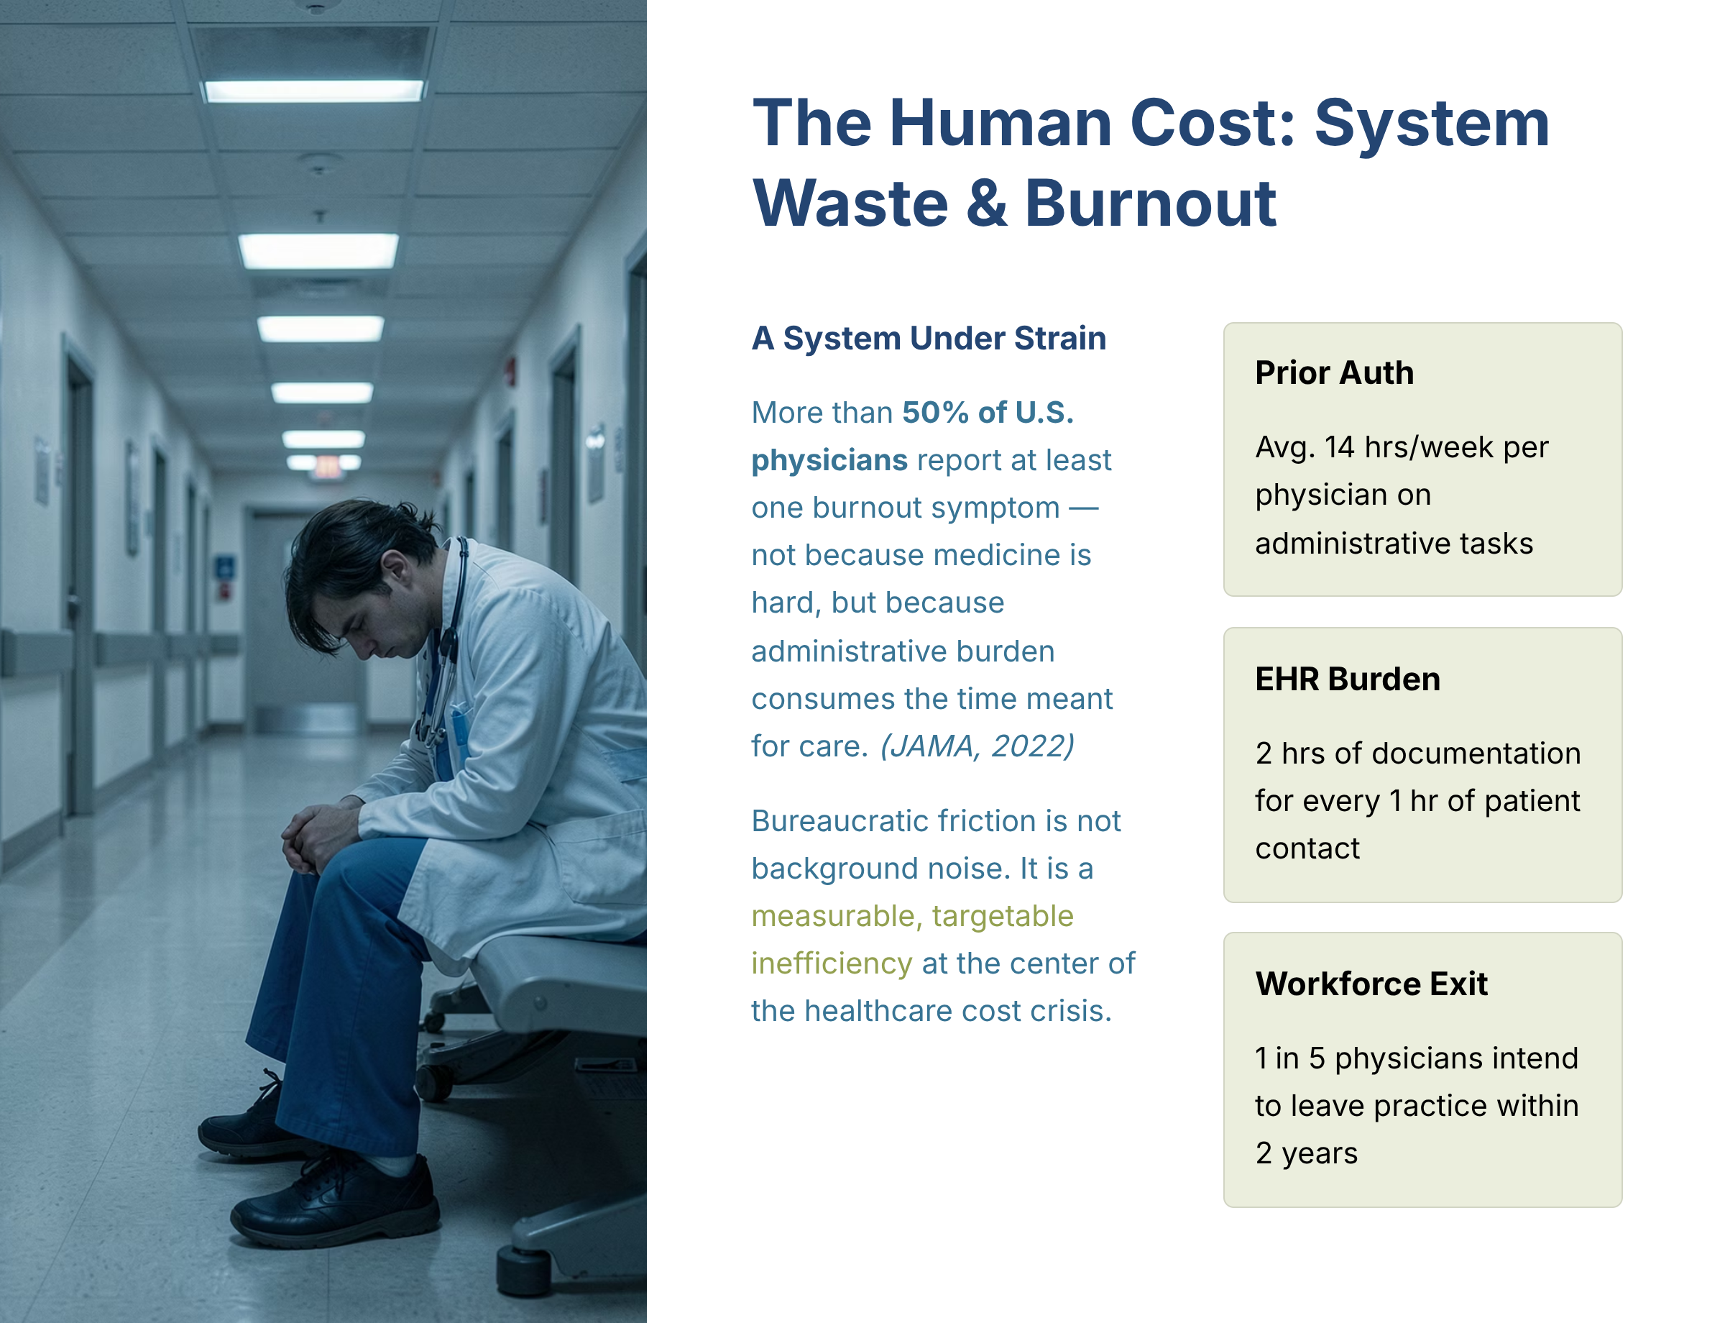
Figure — The Human Cost System Waste and Burnout (source_ref: src-slide-02)
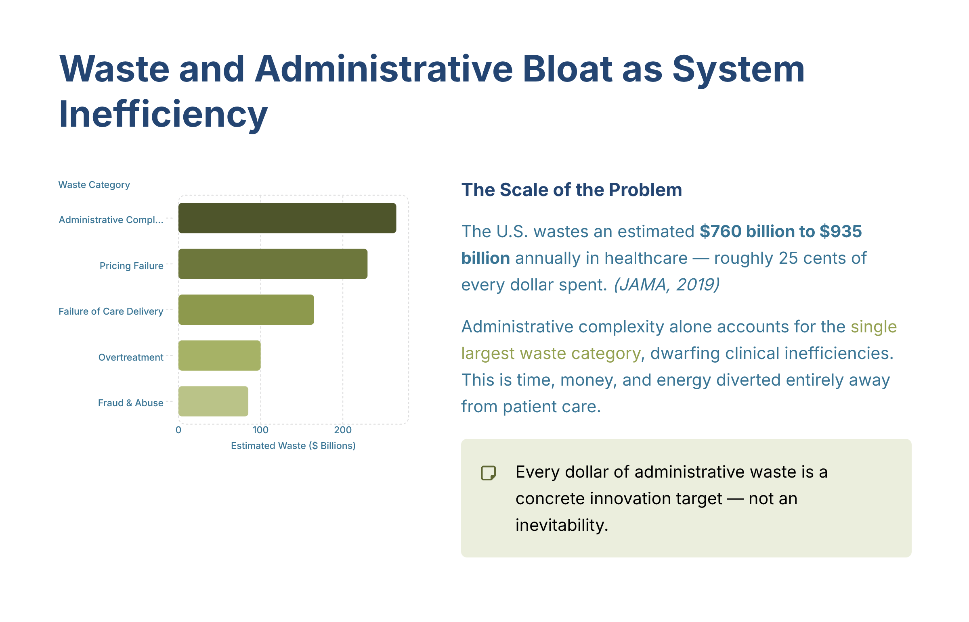
Figure — Waste and Administrative Bloat as System Inefficiency (source_ref: src-slide-03)
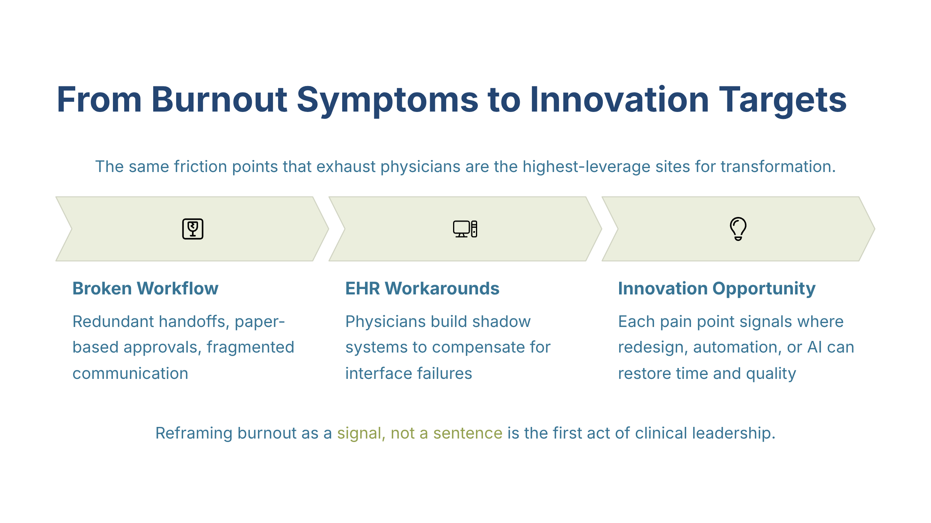
Figure — From Burnout Symptoms to Innovation Targets (source_ref: src-slide-04)
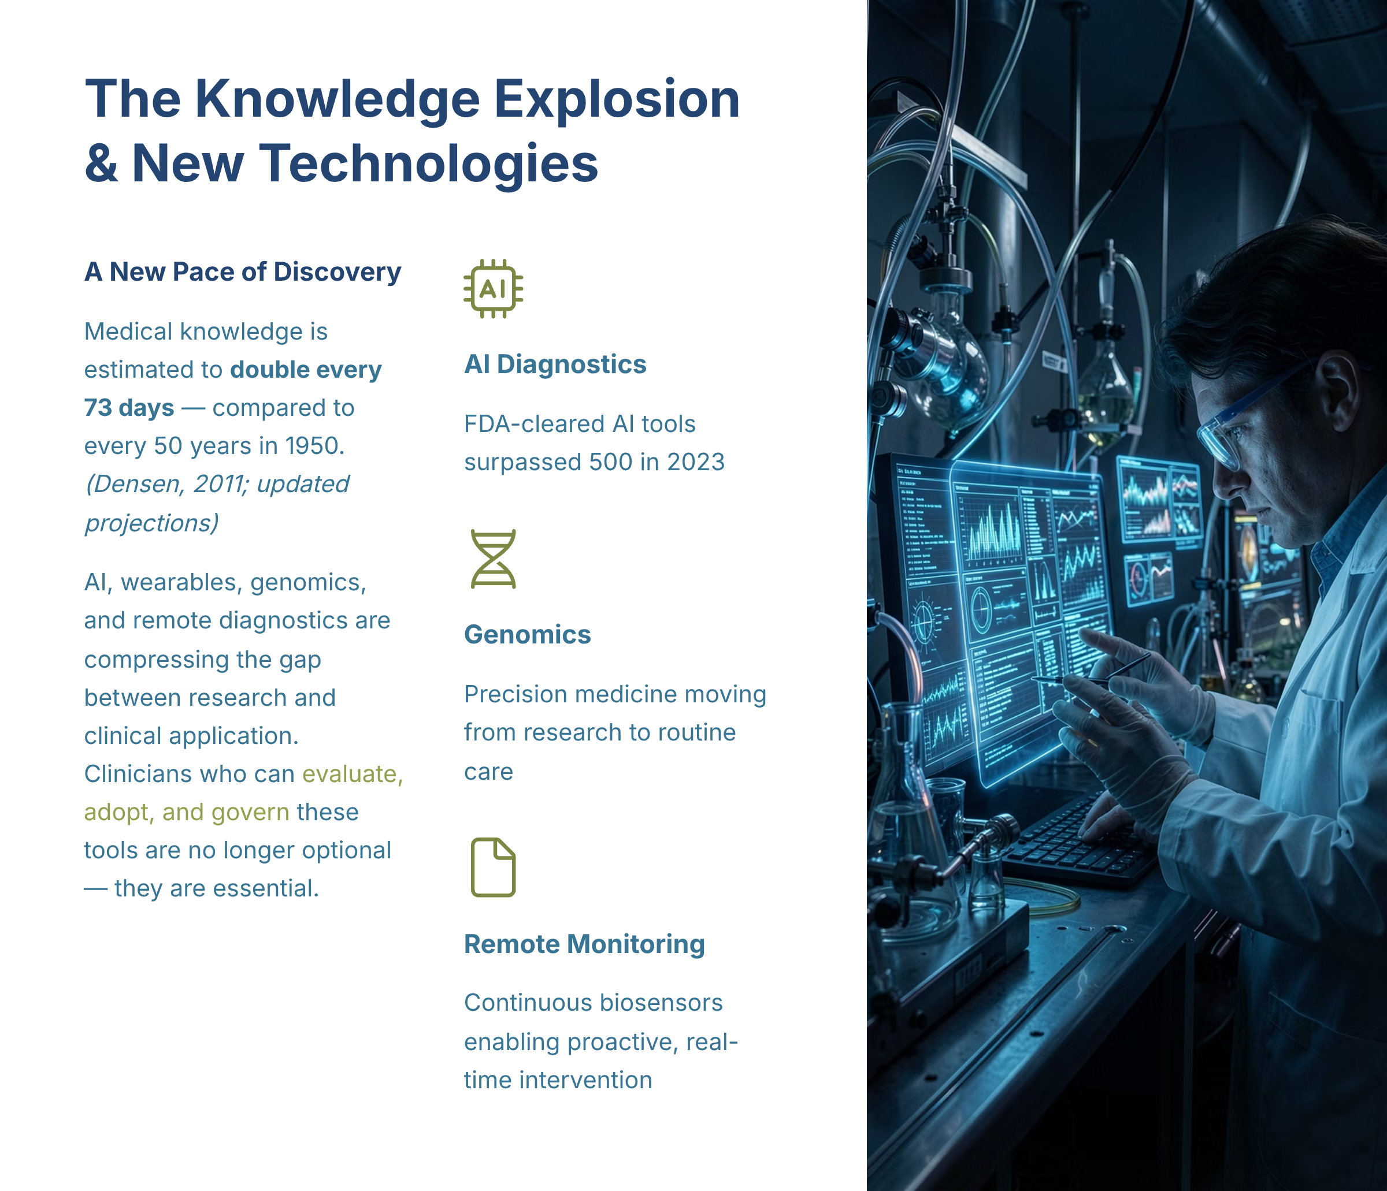
Figure — The Knowledge Explosion and New Technologies (source_ref: src-slide-05)
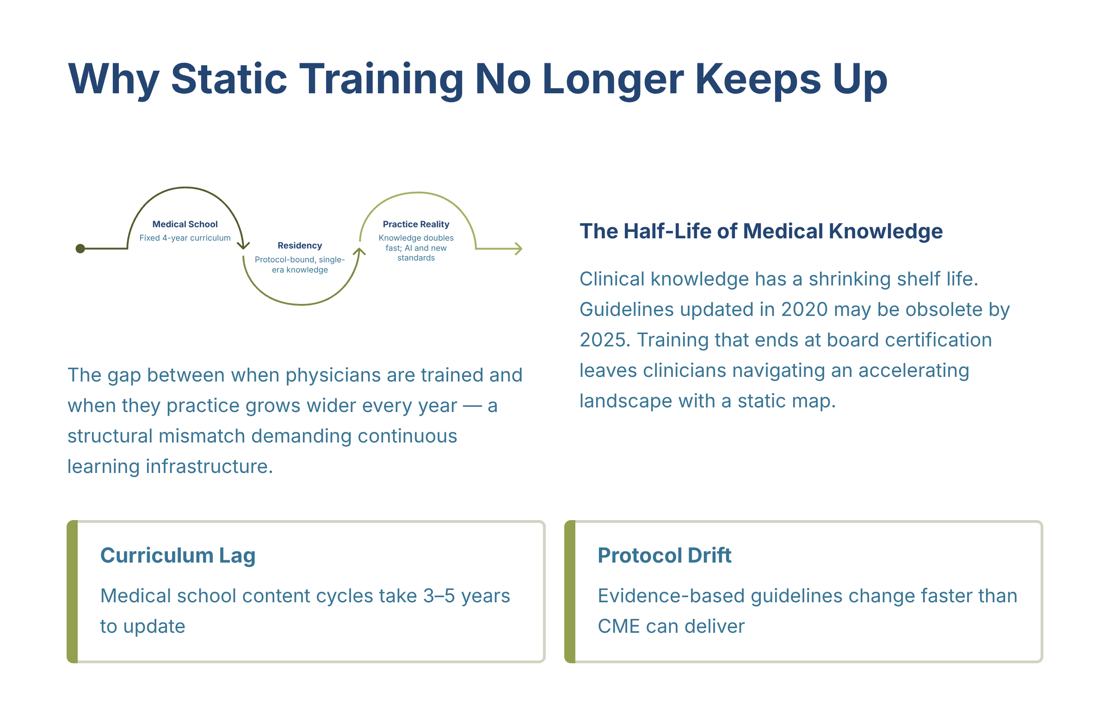
Figure — Why Static Training No Longer Keeps Up (source_ref: src-slide-06)
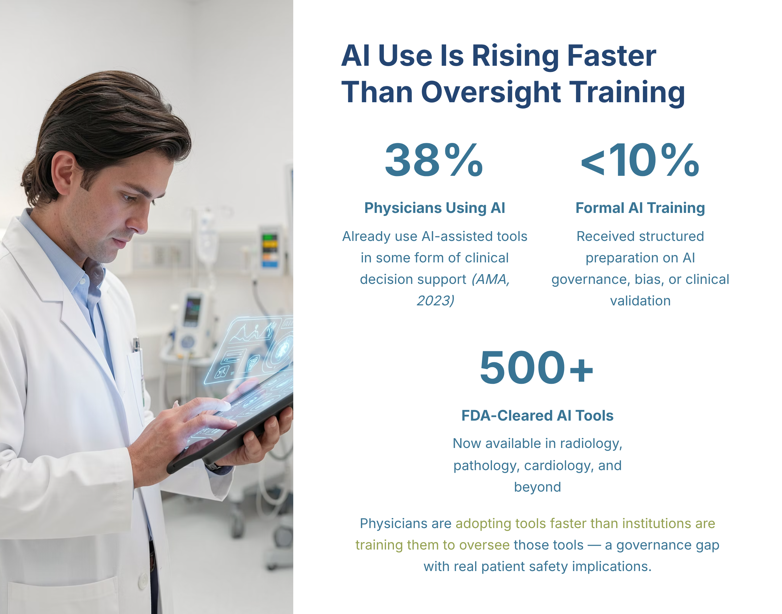
Figure — AI Use Is Rising Faster Than Oversight Training (source_ref: src-slide-07)
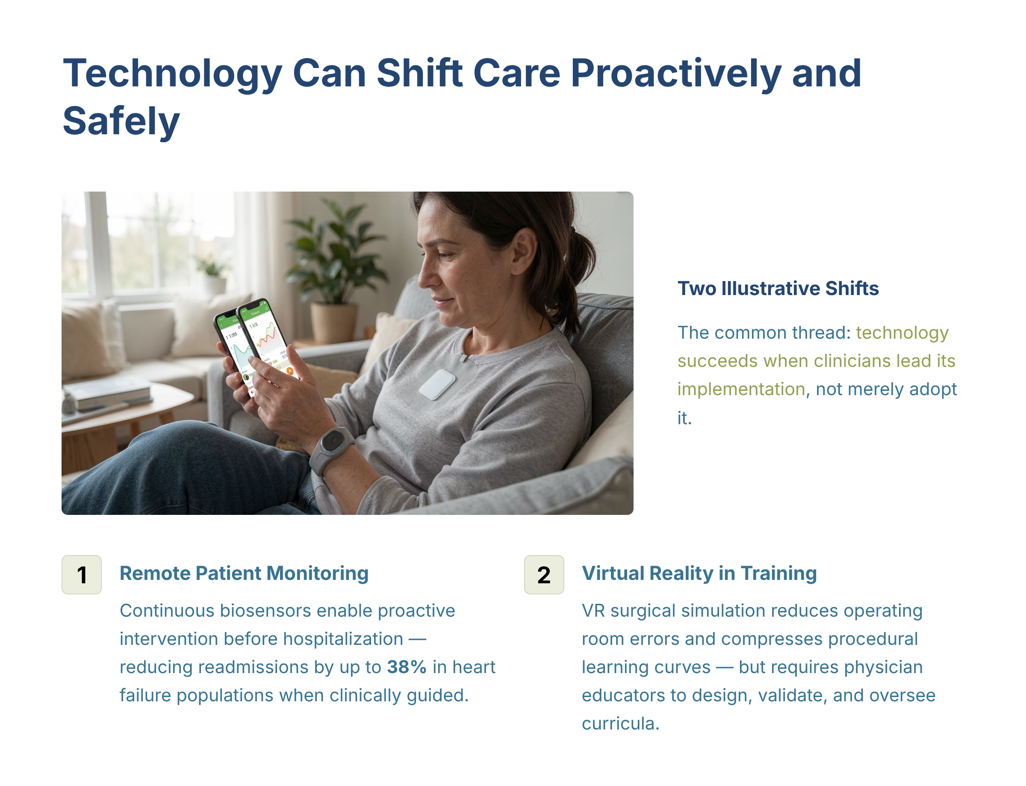
Figure — Technology Can Shift Care Proactively and Safely (source_ref: src-slide-08)
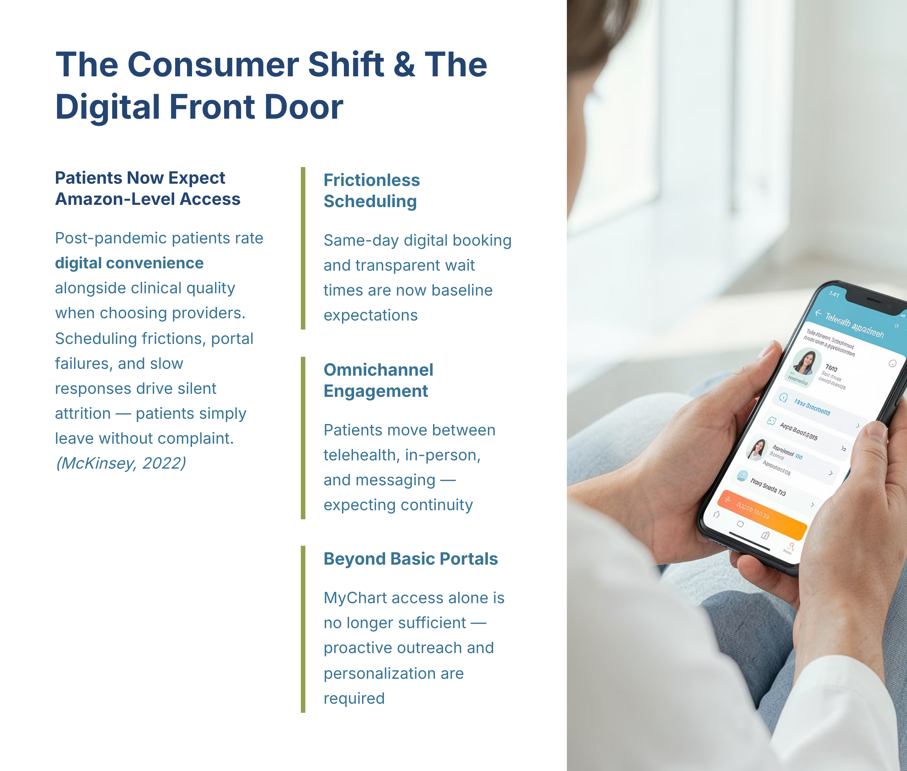
Figure — The Consumer Shift and The Digital Front Door (source_ref: src-slide-09)
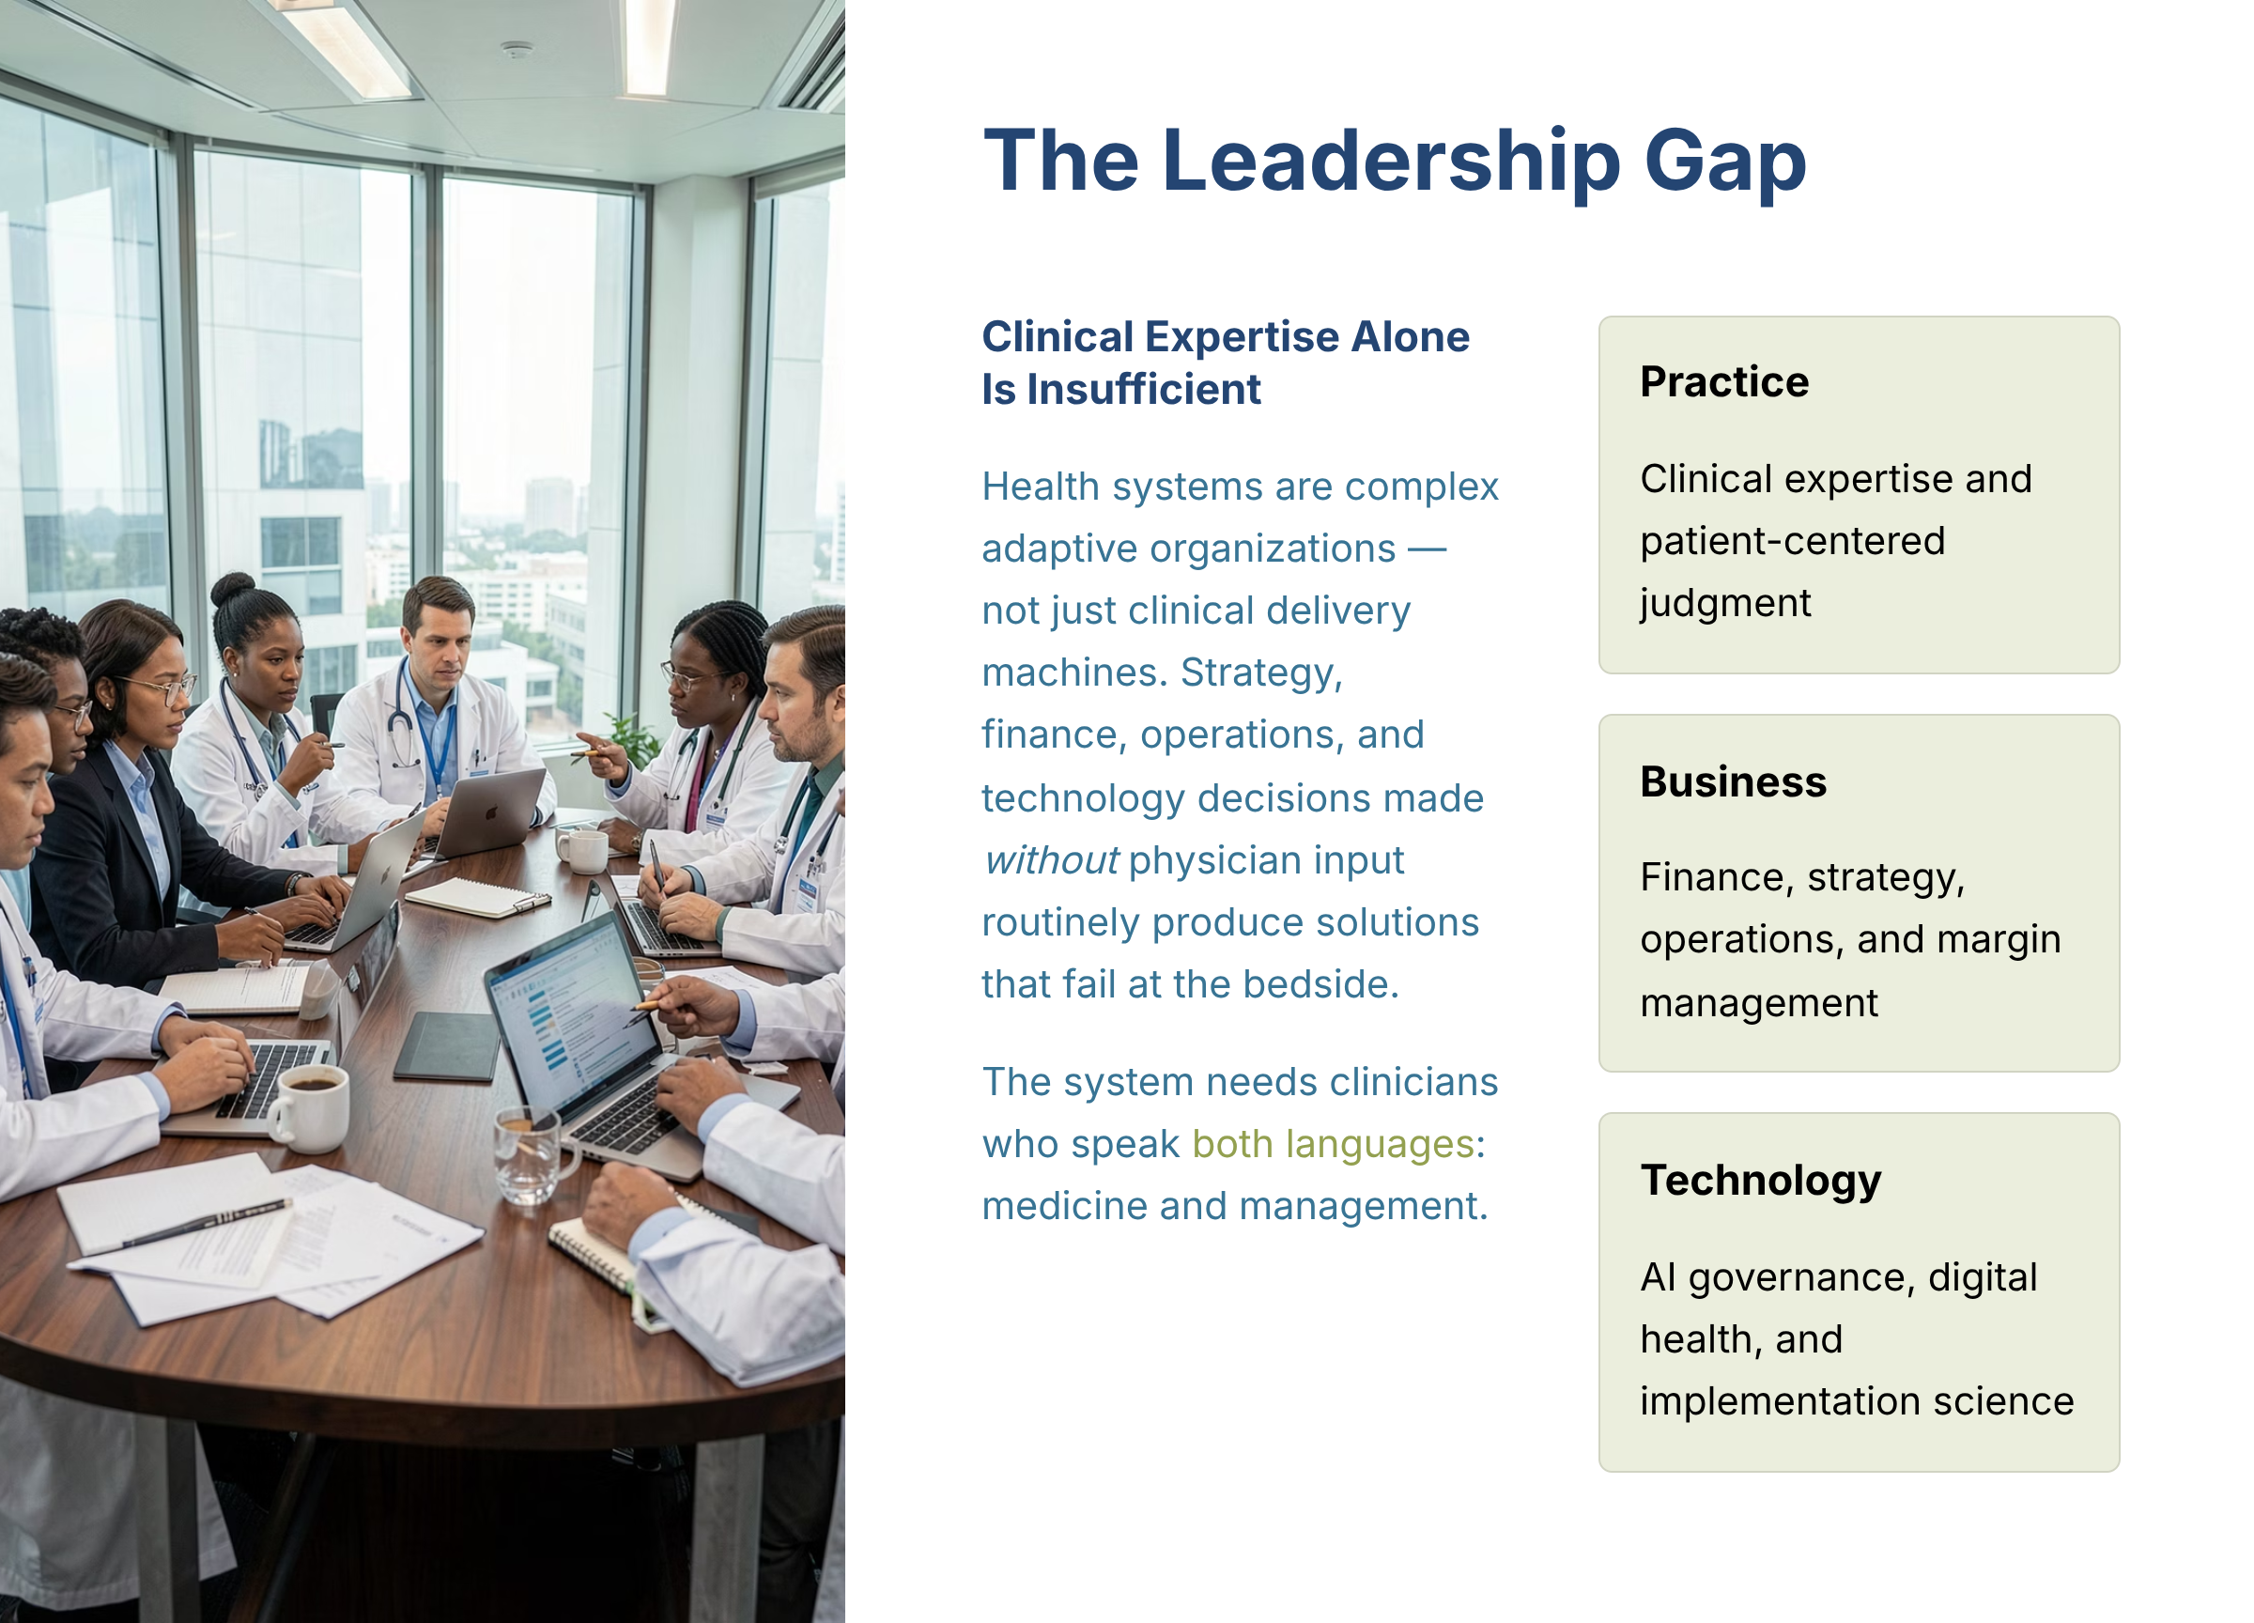
Figure — The Leadership Gap (source_ref: src-slide-10)
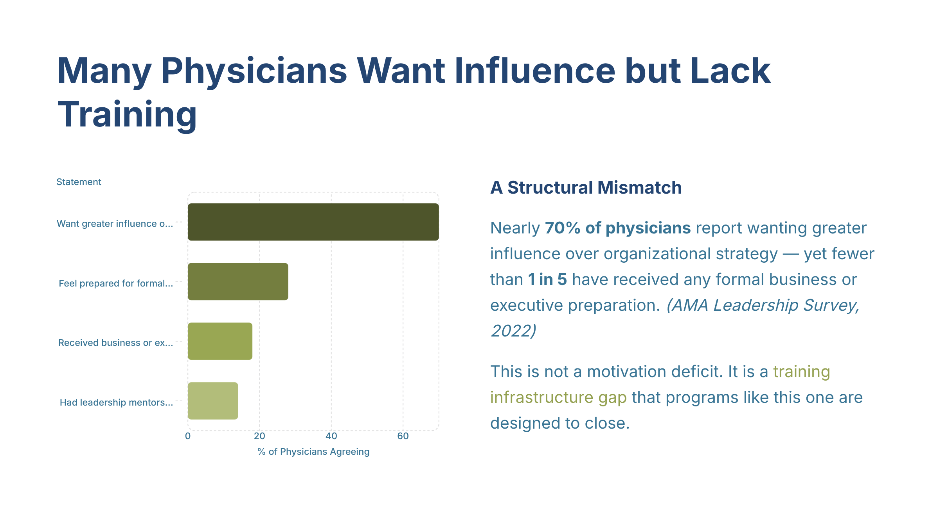
Figure — Many Physicians Want Influence but Lack Training (source_ref: src-slide-11)
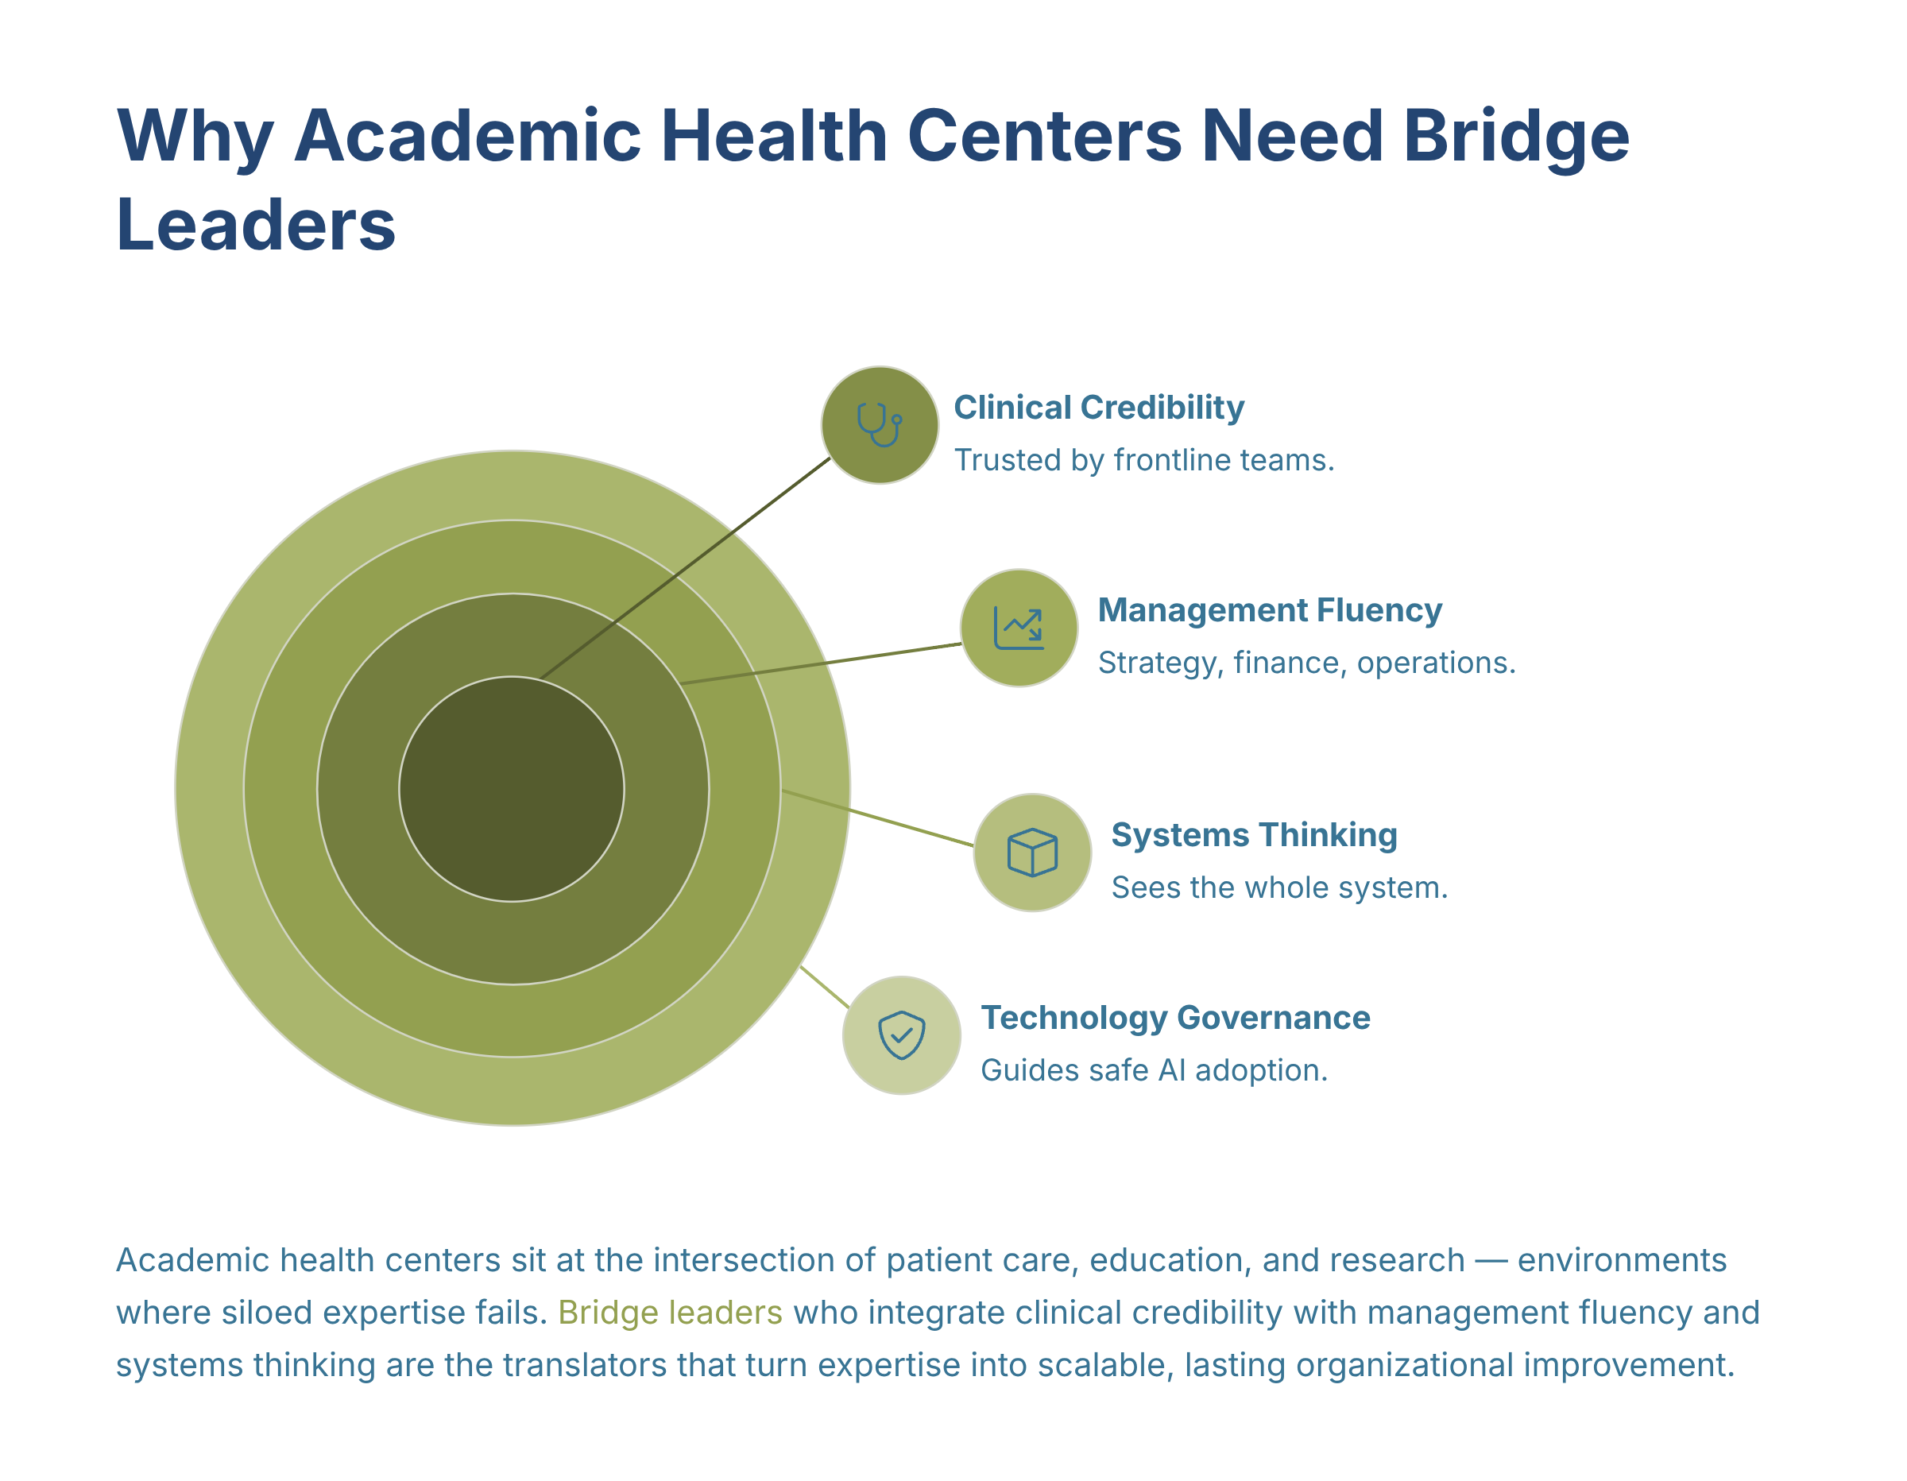
Figure — Why Academic Health Centers Need Bridge Leaders (source_ref: src-slide-12)
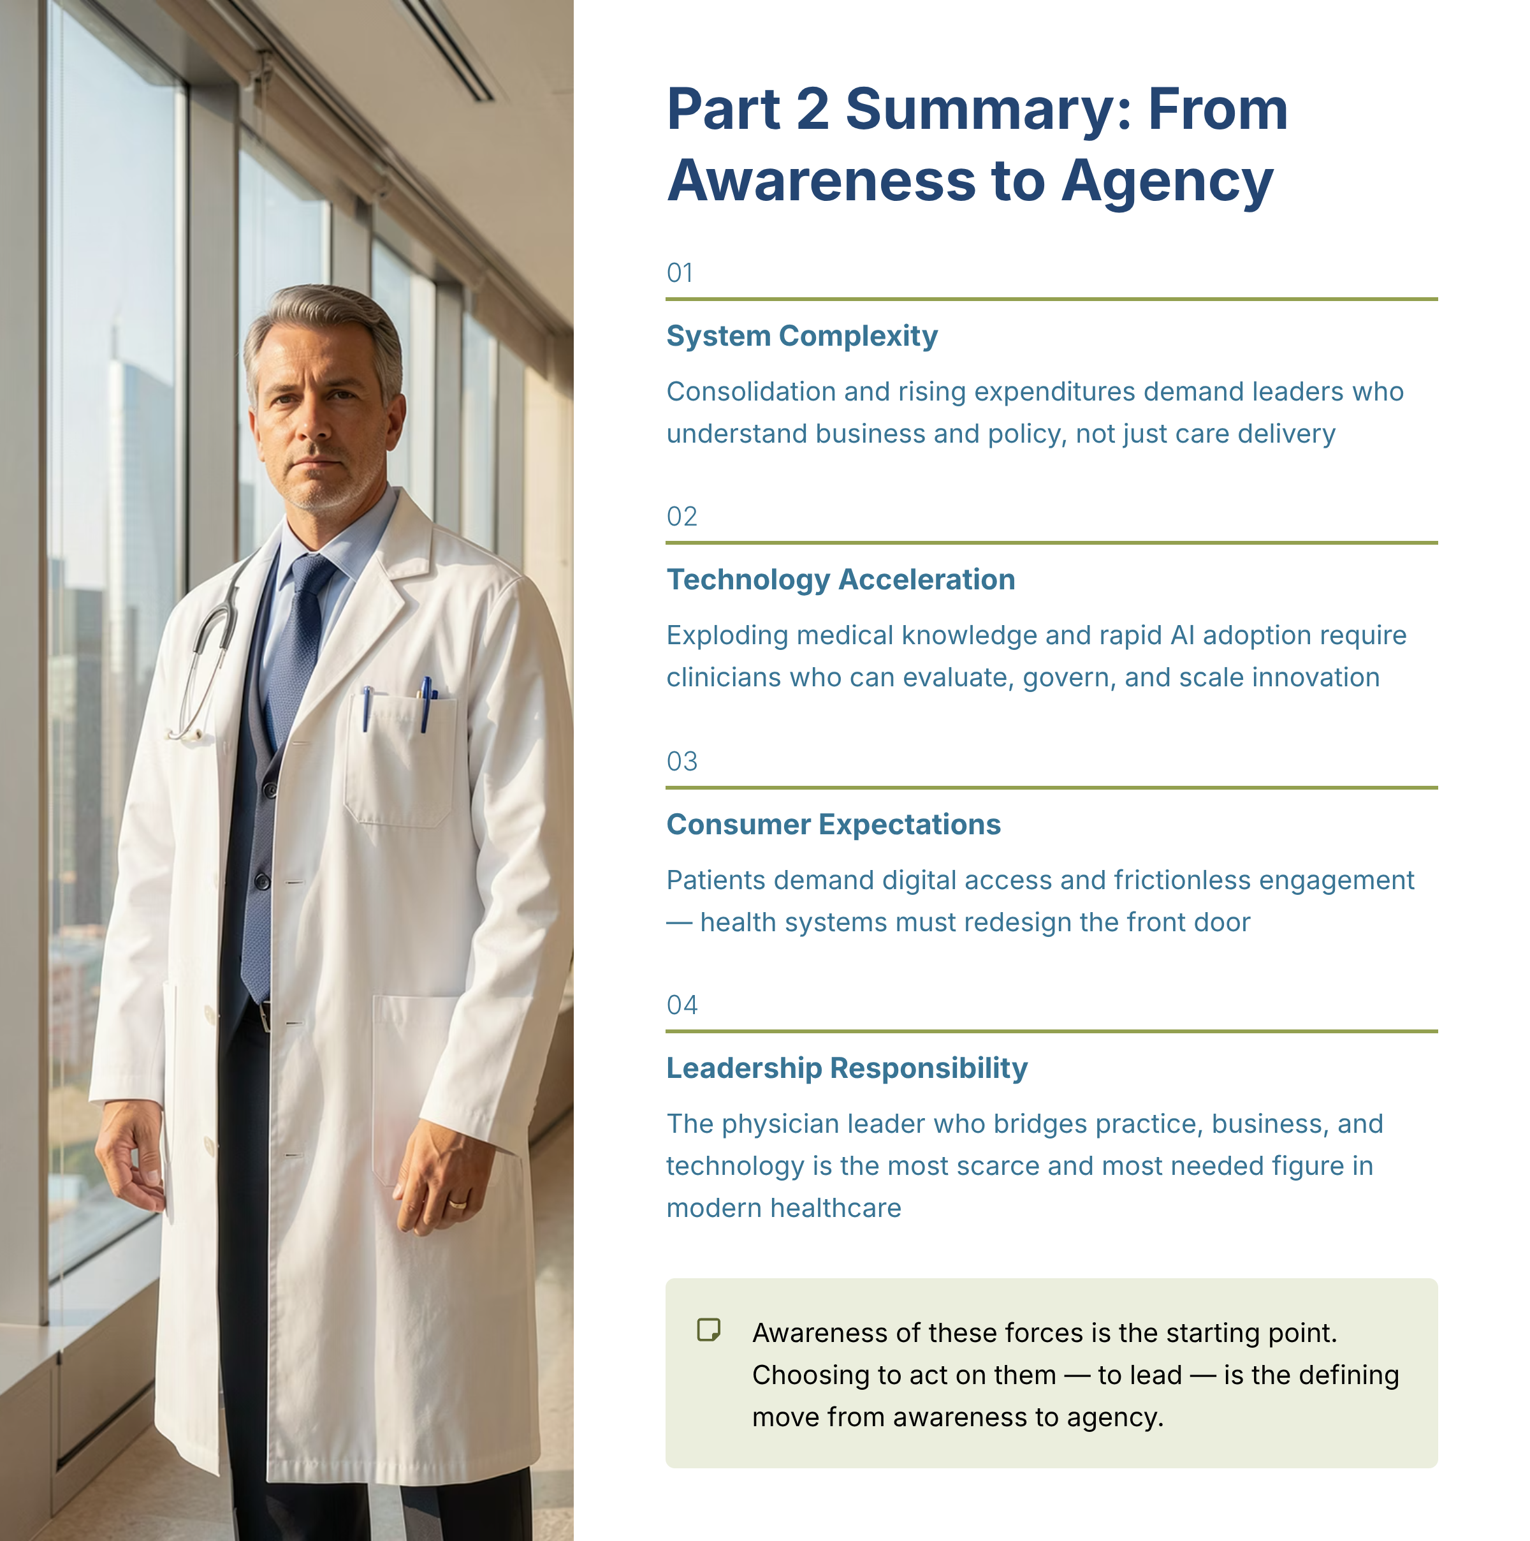
Figure — Part 2 Summary From Awareness to Agency (source_ref: src-slide-13)

Human Review Checkpoint
- [ ] Irene workbook review complete

