Workbook: this-lesson-reframes-physicians-as-natural-innovation-leaders-bridges-clinical-r

Overview
Unit ID: `u01`
Fulfills target: `u01@1`

This workbook is the read-in-depth companion to the narrated deck: it carries the transcript, the fuller narrative deferred off the glance-slides, the exercises, and the citations.

How to use this workbook with the deck: watch the glance-deck for the perception-tuned claim per card, then read here for the deferred depth, check the figures against their sources, work the self-check exercises, and follow the further reading into primary sources. The deck carries the *glance* channel; this workbook carries the *read* channel (dual-coding partners).

Learning Objectives
- **`u01`** — _understand_: (objective statement unresolved for `u01` — no enrichment overlay resolved this objective on this run) (served by section(s): `sec-u01`)
- **`u02`** — _understand_: (objective statement unresolved for `u02` — no enrichment overlay resolved this objective on this run) (served by section(s): `sec-u02`)
- **`u05`** — _understand_: (objective statement unresolved for `u05` — no enrichment overlay resolved this objective on this run) (served by section(s): `sec-u05`)
- **`u08`** — _understand_: (objective statement unresolved for `u08` — no enrichment overlay resolved this objective on this run) (served by section(s): `sec-u08`)
- **`u11`** — _understand_: (objective statement unresolved for `u11` — no enrichment overlay resolved this objective on this run) (served by section(s): `sec-u11`)
- **`u14`** — _understand_: (objective statement unresolved for `u14` — no enrichment overlay resolved this objective on this run) (served by section(s): `sec-u14`)

Transcript-narrative
<!-- segment:seg-01 -->
#### seg-01
<!-- REVOICE-REQUIRED: writer (Paige/Sophia) -> self-contained read-prose; Irene validates -->
> The main message is simple and empowering: the traits that make a great clinician are the same traits that drive innovation. You already practice profound empathy to understand pain, you use diagnostic rigor to find signal in noise, and you iterate when a plan needs to change. Aim that same empathy, analytical prowess, and comfort with ambiguity at operational and workflow problems, and you’re already leading innovation—without changing who you are.

<!-- segment:seg-02 -->
#### seg-02
<!-- REVOICE-REQUIRED: writer (Paige/Sophia) -> self-contained read-prose; Irene validates -->
> We just established that your clinical traits already fit innovation—now let’s map the workflow so it feels familiar too. First, history-taking is empathy—deeply understanding the human context. Then diagnostic synthesis defines the problem with precision. That produces options; treatment planning feeds a prototype you test and iterate on. You already run this loop many times a day—we’re simply swapping the patient for a broken workflow.

<!-- segment:seg-03 -->
#### seg-03
<!-- REVOICE-REQUIRED: writer (Paige/Sophia) -> self-contained read-prose; Irene validates -->
> First, empathize by listening for the patient’s lived experience in the history. Then, define by framing the problem precisely before acting. That handoff—from stories to a crisp problem statement—prevents premature solutions and anchors every downstream decision.

<!-- segment:seg-04 -->
#### seg-04
<!-- REVOICE-REQUIRED: writer (Paige/Sophia) -> self-contained read-prose; Irene validates -->
> First, generate multiple hypotheses—ideate through a differential. Then, select and test the best option—prototype through a treatment plan. Finally, observe outcomes, learn, and iterate at follow-up. That is everyday clinical practice, and it’s the same disciplined loop you’ll use to improve a clinic workflow.

<!-- segment:seg-05 -->
#### seg-05
<!-- REVOICE-REQUIRED: writer (Paige/Sophia) -> self-contained read-prose; Irene validates -->
> We’ve mapped your clinical method to innovation; now let’s decide where you’ll use it. On one side, entrepreneurship builds from scratch with full autonomy and risk. On the other side, intrapreneurship innovates within a system, navigating internal stakeholders and institutional constraints. For most physicians, the highest‑leverage arena is inside the institution.

<!-- segment:seg-06 -->
#### seg-06
<!-- REVOICE-REQUIRED: writer (Paige/Sophia) -> self-contained read-prose; Irene validates -->
> The main message: intrapreneurship means applying entrepreneurial principles inside an existing health system while navigating institutional realities. Work within existing structures, treat constraints as terrain, and bring an entrepreneurial mindset from the inside out. That’s how change sticks without collateral damage.

<!-- segment:seg-07 -->
#### seg-07
<!-- REVOICE-REQUIRED: writer (Paige/Sophia) -> self-contained read-prose; Irene validates -->
> Framework-level takeaway: intrapreneurship is harder because you are redesigning rooms inside a load‑bearing institution. The diagram underscores two rules of structure: some walls keep the building up, and every move affects existing systems, people, and processes. Your job is to architect change that honors those constraints.

<!-- segment:seg-08 -->
#### seg-08
<!-- REVOICE-REQUIRED: writer (Paige/Sophia) -> self-contained read-prose; Irene validates -->
> We’ve framed the arena and its constraints; now let’s calibrate what counts as progress. On one side, an idea is raw—unvetted and untested against reality. By contrast, an opportunity is vetted for organizational execution and therefore actionable. In this program, we’ll stop collecting ideas and start engineering opportunities.

<!-- segment:seg-09 -->
#### seg-09
<!-- REVOICE-REQUIRED: writer (Paige/Sophia) -> self-contained read-prose; Irene validates -->
> Here’s the pivot: a standalone idea is insufficient. Without organizational vetting, even brilliant concepts stall—there’s no alignment with institutional priorities, no pathway to resources or approval, and no evidence of fit, feasibility, or need. Energy without a runway goes nowhere.

<!-- segment:seg-10 -->
#### seg-10
<!-- REVOICE-REQUIRED: writer (Paige/Sophia) -> self-contained read-prose; Irene validates -->
> Use this diagram as a screening framework: pressure‑test every proposal for desirability, feasibility, and viability within your organization. The structure disciplines enthusiasm into evidence. Opportunities are engineered—test before you invest, then build what the results support.

<!-- segment:seg-11 -->
#### seg-11
<!-- REVOICE-REQUIRED: writer (Paige/Sophia) -> self-contained read-prose; Irene validates -->
> We’ve defined what qualifies as an opportunity; now we need a method to rebuild broken workflows. First principles gives it. First, deconstruct—strip the system to its raw elements. Then, identify truths—what is actually required? Finally, rebuild—reconstruct from the ground up. This is how you escape superficial fixes.

<!-- segment:seg-12 -->
#### seg-12
<!-- REVOICE-REQUIRED: writer (Paige/Sophia) -> self-contained read-prose; Irene validates -->
> The trap is reasoning by analogy: “We do it this way because that’s how it’s always been done.” That habit preserves the past and optimizes the wrong thing. Name the trap, then choose first principles instead.

<!-- segment:seg-13 -->
#### seg-13
<!-- REVOICE-REQUIRED: writer (Paige/Sophia) -> self-contained read-prose; Irene validates -->
> First, decompose the clunky workflow into raw truth blocks. Then, using the same materials, reconstruct only what is truly necessary. Finally, build back better—leaner and smarter. Same blocks, different design, far better performance.

<!-- segment:seg-14 -->
#### seg-14
<!-- REVOICE-REQUIRED: writer (Paige/Sophia) -> self-contained read-prose; Irene validates -->
> Three takeaways to carry forward. You already have the skills—clinical reasoning is design thinking. Your arena is intrapreneurship—drive change from within the institution. Your goal is to engineer opportunities—don’t collect ideas; vet and build them. To close this module, take your framed problem and join me in Module 2, where we define your leadership identity and name the saboteurs that could derail your work.

Depth-delta narrative
### Trait Overlap: Why Physicians Already Fit Innovation Work
Objective: `u01` (section `sec-u01`)
Depth deferred off the slide: Expanded explanation of each overlapping trait—empathy, curiosity, analytical prowess, resiliency, and comfort with ambiguity—and how each transfers from patient care to system improvement.
Deepen the identity reframe so learners internalize that innovation does not require becoming a different kind of professional.

### Clinical Workflow as Design Thinking
Objective: `u02` (section `sec-u02`)
Depth deferred off the slide: Stepwise prose walkthrough of the clinical method and design thinking parallels, including the exact pairings between history and empathize, diagnosis and define, treatment planning and prototype/test.
Convert a visual analogy into procedural confidence so learners can reuse the framework outside patient care.

### Choosing the Arena: Inside vs. Outside the Institution
Objective: `u05` (section `sec-u05`)
Depth deferred off the slide: Longer comparison of entrepreneurship and intrapreneurship, with emphasis on internal constraints, stakeholder alignment, and resource leverage inside health systems.
Help learners interpret innovation pathways strategically rather than assuming startup creation is the only meaningful route.

### From Zero-Value Idea to Actionable Opportunity
Objective: `u08` (section `sec-u08`)
Depth deferred off the slide: Detailed unpacking of feasibility, viability, and desirability as screening lenses for a proposed innovation inside a specific organization.
Move learners from casual brainstorming toward disciplined evaluation of execution readiness.

### First Principles Workbook: Deconstruct Before You Rebuild
Objective: `u11` (section `sec-u11`)
Depth deferred off the slide: A fuller explanation of reasoning by analogy versus first principles, plus a guided decomposition worksheet structure for breaking a workflow into fundamental truths.
Turn the conceptual method into a reusable redesign practice that can be applied to real institutional problems.

### Module Recap and Forward Link
Objective: `u14` (section `sec-u14`)
Depth deferred off the slide: A concise written recap tying together trait alignment, intrapreneurship, opportunity formation, and first-principles redesign before the leadership transition.
Consolidate memory traces across the lesson and prepare learners for the leadership-focused next module.

Transcript of Record
#### seg-01 (verbatim)
> The main message is simple and empowering: the traits that make a great clinician are the same traits that drive innovation. You already practice profound empathy to understand pain, you use diagnostic rigor to find signal in noise, and you iterate when a plan needs to change. Aim that same empathy, analytical prowess, and comfort with ambiguity at operational and workflow problems, and you’re already leading innovation—without changing who you are.

#### seg-02 (verbatim)
> We just established that your clinical traits already fit innovation—now let’s map the workflow so it feels familiar too. First, history-taking is empathy—deeply understanding the human context. Then diagnostic synthesis defines the problem with precision. That produces options; treatment planning feeds a prototype you test and iterate on. You already run this loop many times a day—we’re simply swapping the patient for a broken workflow.

#### seg-03 (verbatim)
> First, empathize by listening for the patient’s lived experience in the history. Then, define by framing the problem precisely before acting. That handoff—from stories to a crisp problem statement—prevents premature solutions and anchors every downstream decision.

#### seg-04 (verbatim)
> First, generate multiple hypotheses—ideate through a differential. Then, select and test the best option—prototype through a treatment plan. Finally, observe outcomes, learn, and iterate at follow-up. That is everyday clinical practice, and it’s the same disciplined loop you’ll use to improve a clinic workflow.

#### seg-05 (verbatim)
> We’ve mapped your clinical method to innovation; now let’s decide where you’ll use it. On one side, entrepreneurship builds from scratch with full autonomy and risk. On the other side, intrapreneurship innovates within a system, navigating internal stakeholders and institutional constraints. For most physicians, the highest‑leverage arena is inside the institution.

#### seg-06 (verbatim)
> The main message: intrapreneurship means applying entrepreneurial principles inside an existing health system while navigating institutional realities. Work within existing structures, treat constraints as terrain, and bring an entrepreneurial mindset from the inside out. That’s how change sticks without collateral damage.

#### seg-07 (verbatim)
> Framework-level takeaway: intrapreneurship is harder because you are redesigning rooms inside a load‑bearing institution. The diagram underscores two rules of structure: some walls keep the building up, and every move affects existing systems, people, and processes. Your job is to architect change that honors those constraints.

#### seg-08 (verbatim)
> We’ve framed the arena and its constraints; now let’s calibrate what counts as progress. On one side, an idea is raw—unvetted and untested against reality. By contrast, an opportunity is vetted for organizational execution and therefore actionable. In this program, we’ll stop collecting ideas and start engineering opportunities.

#### seg-09 (verbatim)
> Here’s the pivot: a standalone idea is insufficient. Without organizational vetting, even brilliant concepts stall—there’s no alignment with institutional priorities, no pathway to resources or approval, and no evidence of fit, feasibility, or need. Energy without a runway goes nowhere.

#### seg-10 (verbatim)
> Use this diagram as a screening framework: pressure‑test every proposal for desirability, feasibility, and viability within your organization. The structure disciplines enthusiasm into evidence. Opportunities are engineered—test before you invest, then build what the results support.

#### seg-11 (verbatim)
> We’ve defined what qualifies as an opportunity; now we need a method to rebuild broken workflows. First principles gives it. First, deconstruct—strip the system to its raw elements. Then, identify truths—what is actually required? Finally, rebuild—reconstruct from the ground up. This is how you escape superficial fixes.

#### seg-12 (verbatim)
> The trap is reasoning by analogy: “We do it this way because that’s how it’s always been done.” That habit preserves the past and optimizes the wrong thing. Name the trap, then choose first principles instead.

#### seg-13 (verbatim)
> First, decompose the clunky workflow into raw truth blocks. Then, using the same materials, reconstruct only what is truly necessary. Finally, build back better—leaner and smarter. Same blocks, different design, far better performance.

#### seg-14 (verbatim)
> Three takeaways to carry forward. You already have the skills—clinical reasoning is design thinking. Your arena is intrapreneurship—drive change from within the institution. Your goal is to engineer opportunities—don’t collect ideas; vet and build them. To close this module, take your framed problem and join me in Module 2, where we define your leadership identity and name the saboteurs that could derail your work.

Figures
<!-- segment:seg-01 -->
*Figure — Physicianship Innovation Leadership* (source_ref: `src-slide-01`)

<!-- segment:seg-02 -->
*Figure — The Bridge Diagnosis Design Thinking* (source_ref: `src-slide-02`)

<!-- segment:seg-03 -->
*Figure — Empathize and Define Through the Clinical Lens* (source_ref: `src-slide-03`)

<!-- segment:seg-04 -->
*Figure — Ideate and Prototype as Everyday Clinical Practice* (source_ref: `src-slide-04`)

<!-- segment:seg-05 -->
*Figure — Intrapreneurship vs Entrepreneurship* (source_ref: `src-slide-05`)

<!-- segment:seg-06 -->
*Figure — Define the Intrapreneurs Arena* (source_ref: `src-slide-06`)

<!-- segment:seg-07 -->
*Figure — The Intrapreneurs Maze* (source_ref: `src-slide-07`)

<!-- segment:seg-08 -->
*Figure — Idea vs Opportunity* (source_ref: `src-slide-08`)

<!-- segment:seg-09 -->
*Figure — Why an Idea Alone Has No Operational Value* (source_ref: `src-slide-09`)

<!-- segment:seg-10 -->
*Figure — Engineering Actionable Opportunities* (source_ref: `src-slide-10`)

<!-- segment:seg-11 -->
*Figure — First Principles Thinking The Deconstruction* (source_ref: `src-slide-11`)

<!-- segment:seg-12 -->
*Figure — The Status Quo Reasoning by Analogy* (source_ref: `src-slide-12`)

<!-- segment:seg-13 -->
*Figure — Break Down the Blocks Then Rebuild* (source_ref: `src-slide-13`)

<!-- segment:seg-14 -->
*Figure — Part 3 Summary and Transition* (source_ref: `src-slide-14`)

Exercises
### Exercise `ex-u01-1`
Bloom level: **understand**
Have learners explain in their own words how one clinical trait translates into innovation behavior.
Answer key (source_ref: `apply your existing clinical traits`)

### Exercise `ex-u02-1`
Bloom level: **apply**
Ask learners to map a familiar clinical task to the corresponding design thinking step.
Answer key (source_ref: `map it to your daily clinical workflow`)

### Exercise `ex-u05-1`
Bloom level: **analyze**
Have learners compare what changes when innovation happens inside an existing hospital versus outside it.
Answer key (source_ref: `within an existing organization`)

### Exercise `ex-u08-1`
Bloom level: **evaluate**
Ask learners to judge whether a sample proposal is still an idea or has become an opportunity based on the stated criteria.
Answer key (source_ref: `feasibility, viability, and desirability`)

### Exercise `ex-u11-1`
Bloom level: **create**
Prompt learners to redesign a broken workflow by first listing its raw constraints and truths before proposing a new build.
Answer key (source_ref: `build a new solution from scratch`)

Answer Key
### Answer — `ex-u01-1`
*(worked answer pending writer; grounded by the source_ref below — source_ref: `apply your existing clinical traits`)*
Answer key source_ref: `apply your existing clinical traits`

### Answer — `ex-u02-1`
*(worked answer pending writer; grounded by the source_ref below — source_ref: `map it to your daily clinical workflow`)*
Answer key source_ref: `map it to your daily clinical workflow`

### Answer — `ex-u05-1`
*(worked answer pending writer; grounded by the source_ref below — source_ref: `within an existing organization`)*
Answer key source_ref: `within an existing organization`

### Answer — `ex-u08-1`
*(worked answer pending writer; grounded by the source_ref below — source_ref: `feasibility, viability, and desirability`)*
Answer key source_ref: `feasibility, viability, and desirability`

### Answer — `ex-u11-1`
*(worked answer pending writer; grounded by the source_ref below — source_ref: `build a new solution from scratch`)*
Answer key source_ref: `build a new solution from scratch`

References
#### Segment source-ref trace
- `seg-01` -> source_ref `src-slide-01`
- `seg-02` -> source_ref `src-slide-02`
- `seg-03` -> source_ref `src-slide-03`
- `seg-04` -> source_ref `src-slide-04`
- `seg-05` -> source_ref `src-slide-05`
- `seg-06` -> source_ref `src-slide-06`
- `seg-07` -> source_ref `src-slide-07`
- `seg-08` -> source_ref `src-slide-08`
- `seg-09` -> source_ref `src-slide-09`
- `seg-10` -> source_ref `src-slide-10`
- `seg-11` -> source_ref `src-slide-11`
- `seg-12` -> source_ref `src-slide-12`
- `seg-13` -> source_ref `src-slide-13`
- `seg-14` -> source_ref `src-slide-14`

#### Cited references & further reading
- *(no corpus-native references supplied for this artifact)*

#### Live-research cited entries (DOI)
- Intrapreneurship and Trust. https://doi.org/10.5465/ambpp.2019.19399abstract (provider: scite, source_ref: `retrieval:scite:10.5465/ambpp.2019.19399abstract`, citation_id: `cite-001`)
- Enablers and barriers to implementing an interdisciplinary experiential learning program for university students in a Canadian rehabilitation centre. https://doi.org/10.3389/fresc.2024.1336559 (provider: scite, source_ref: `retrieval:scite:10.3389/fresc.2024.1336559`, citation_id: `cite-002`)
- Knowledge Markers: An AI-Agnostic Concept for the Design of Programming Courses. https://doi.org/10.48550/arxiv.2604.06331 (provider: scite, source_ref: `retrieval:scite:10.48550/arxiv.2604.06331`, citation_id: `cite-003`)
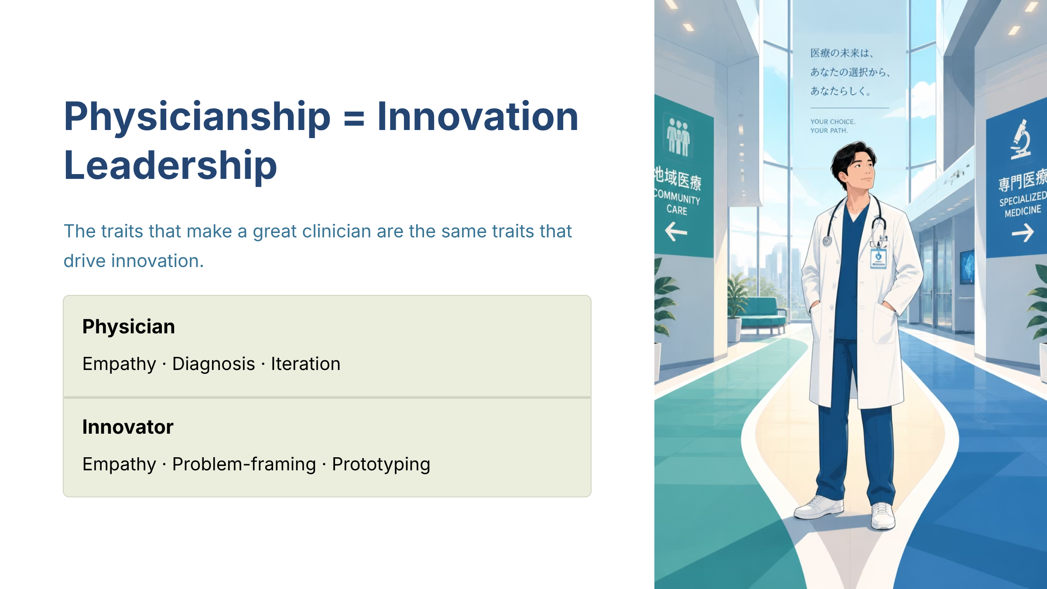
Figure — Physicianship Innovation Leadership (source_ref: src-slide-01)
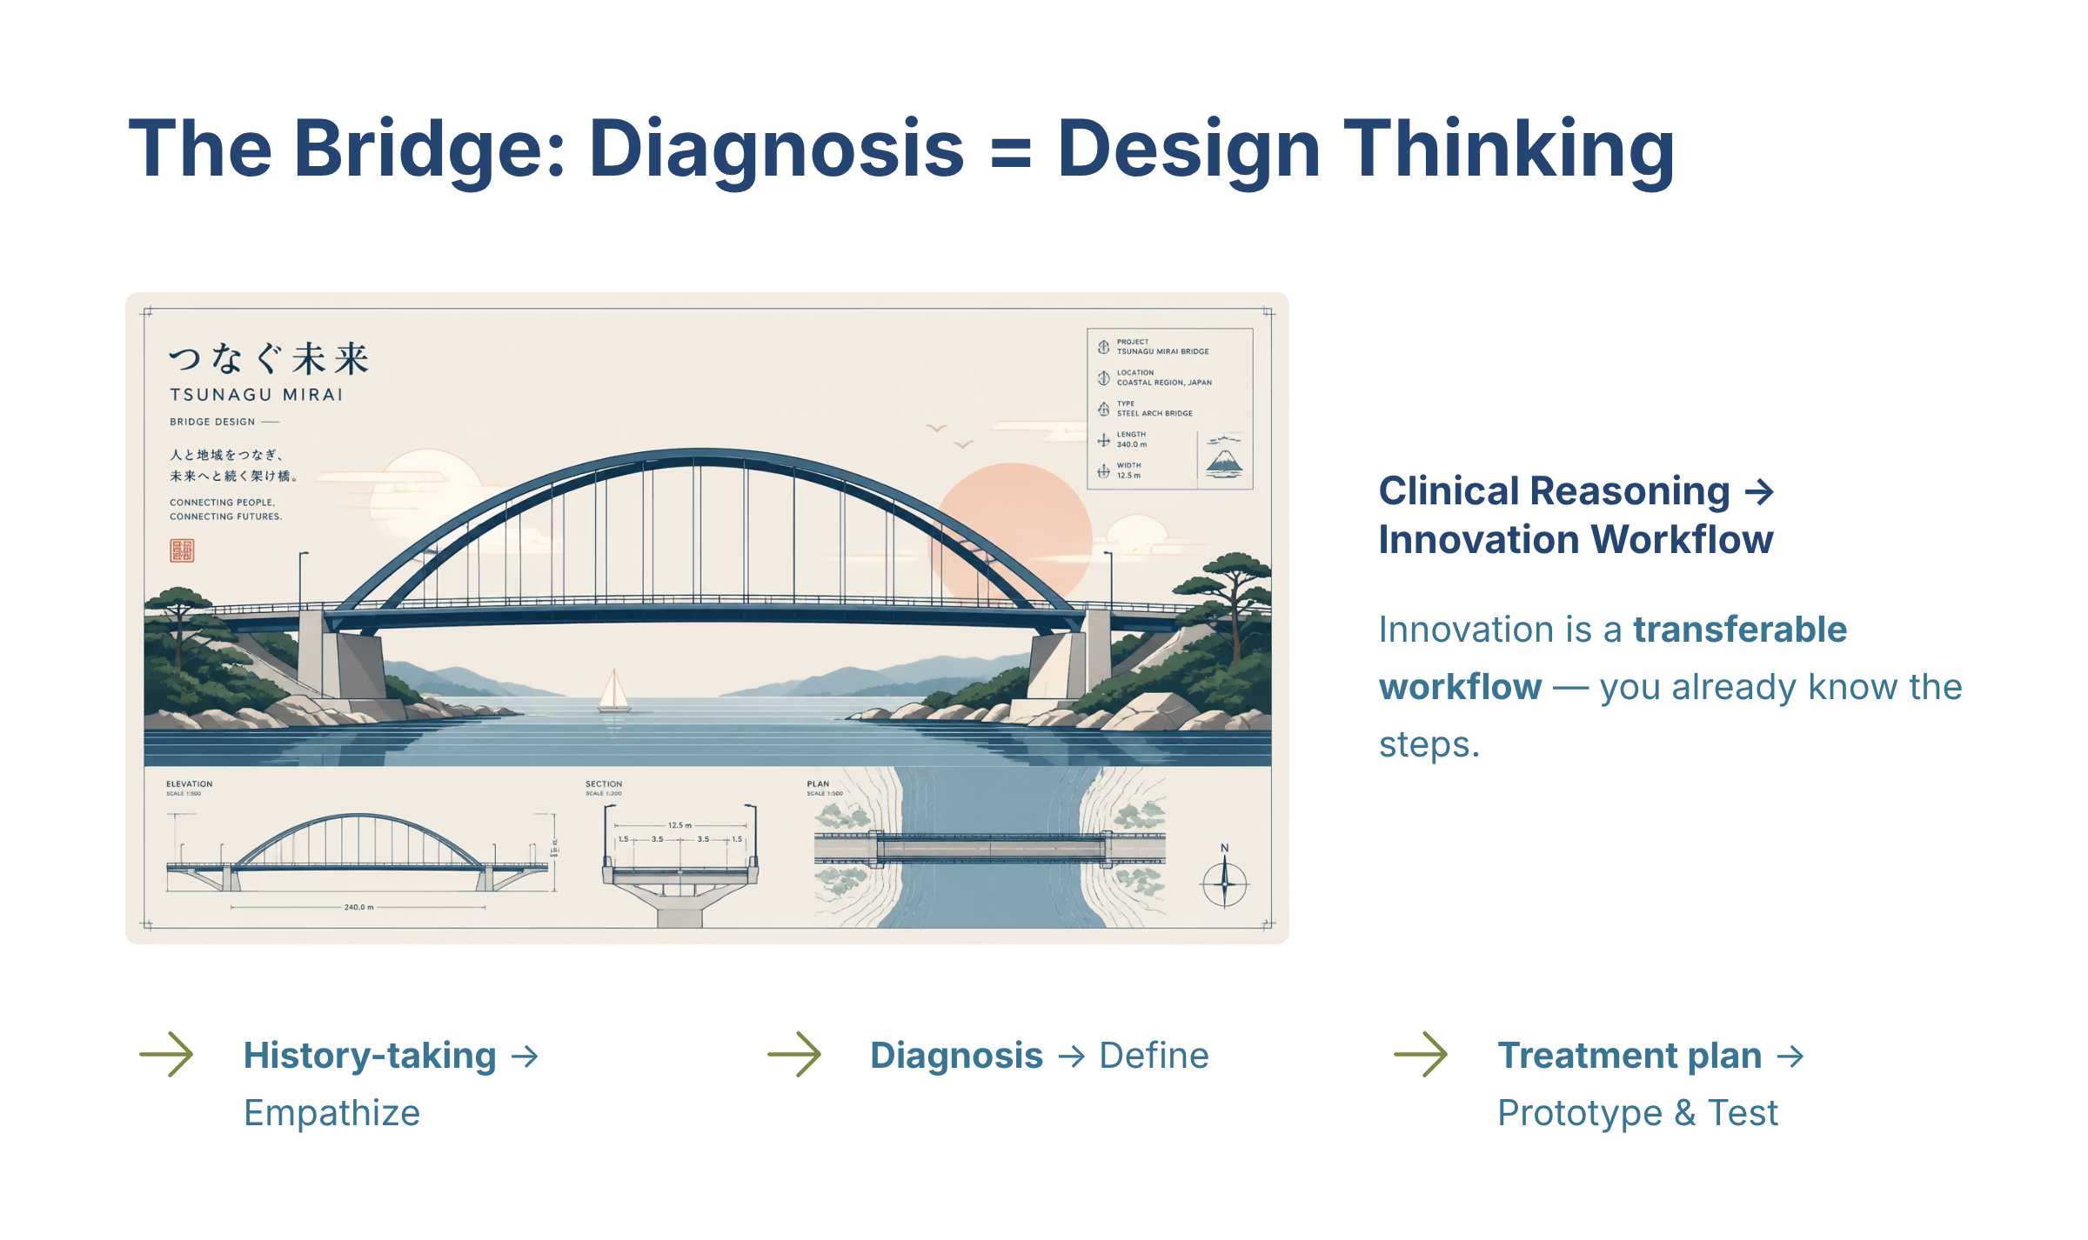
Figure — The Bridge Diagnosis Design Thinking (source_ref: src-slide-02)
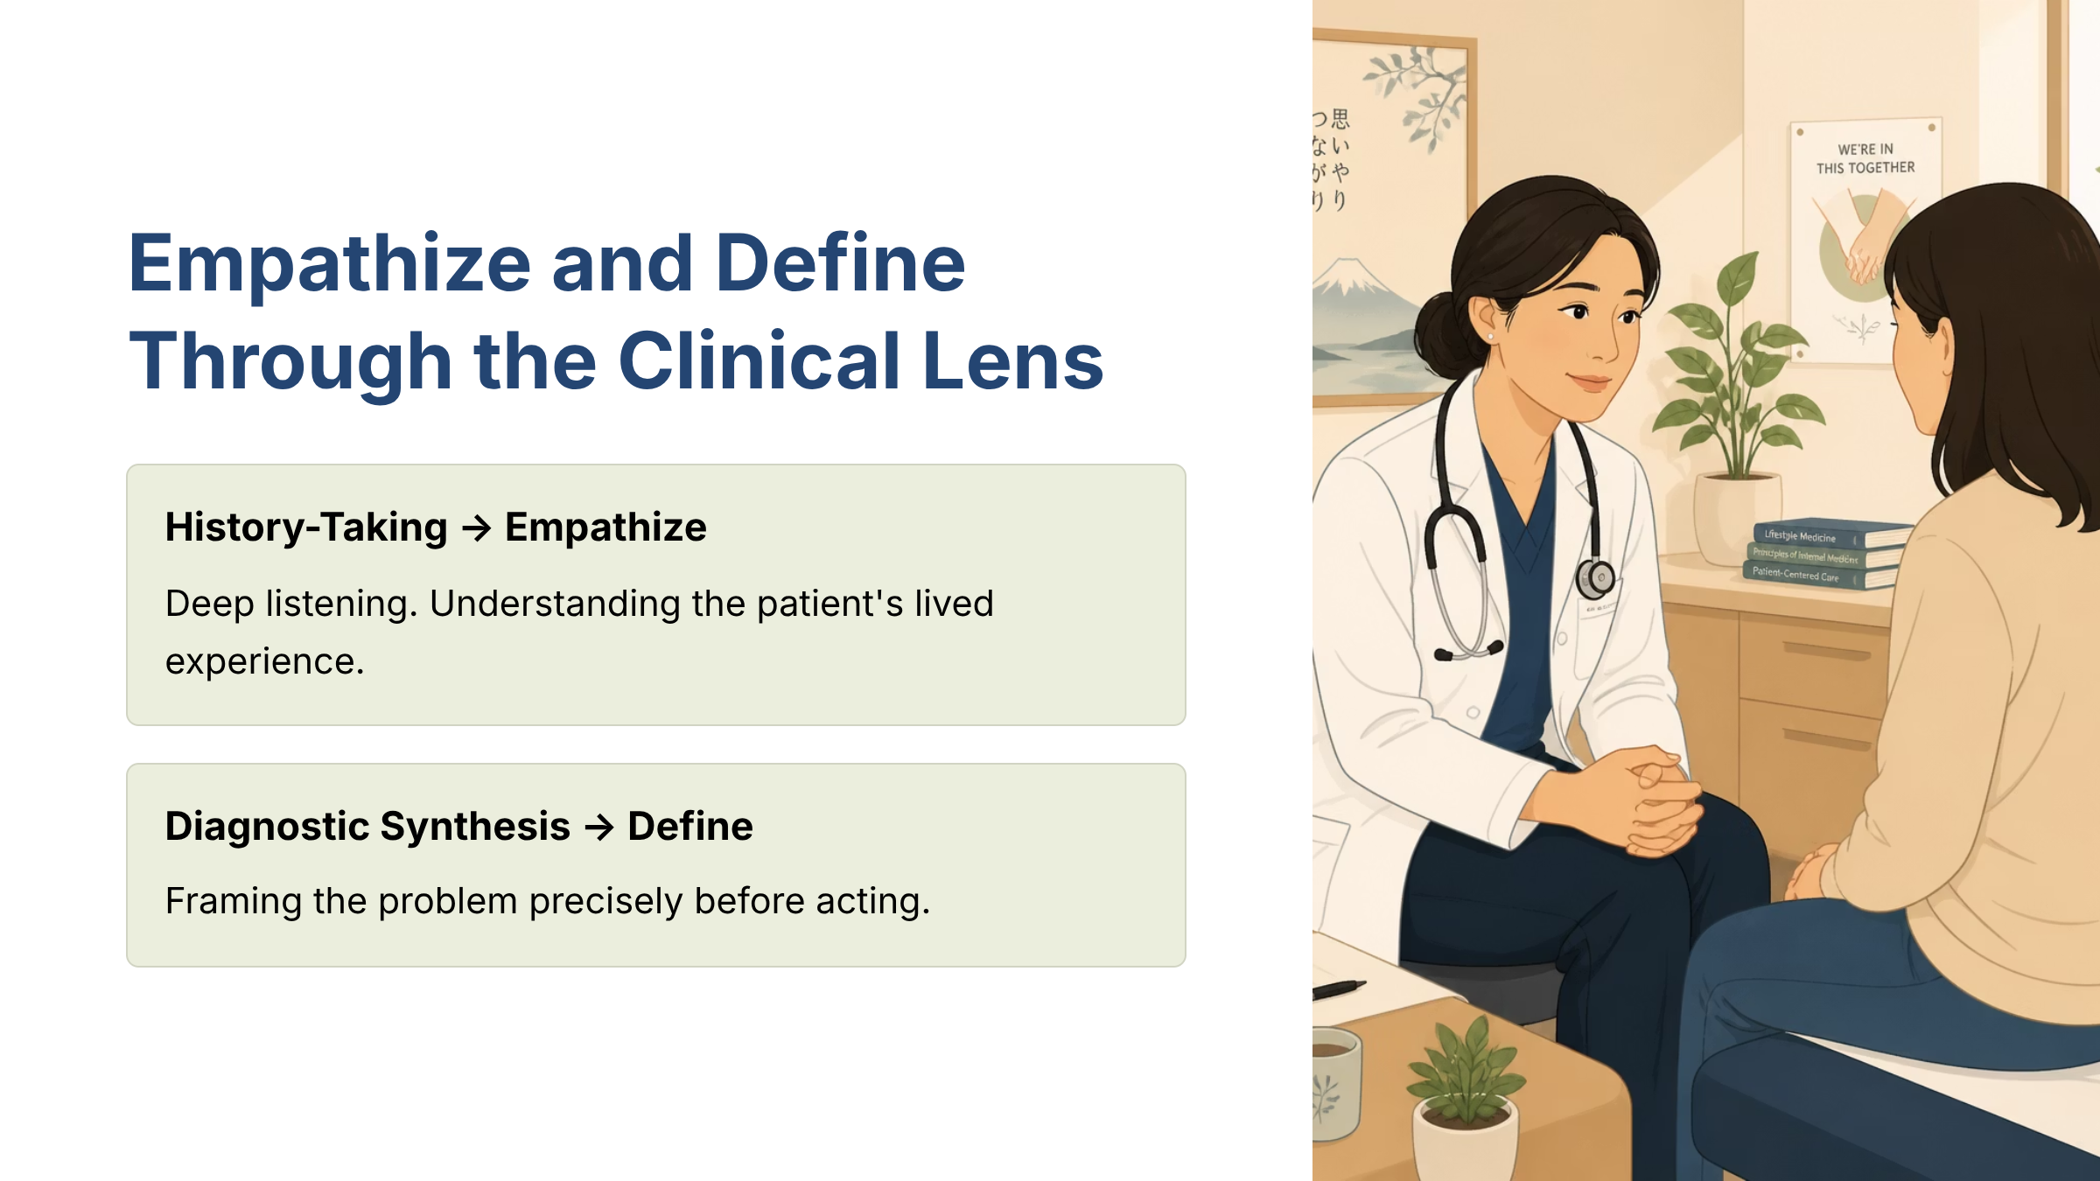
Figure — Empathize and Define Through the Clinical Lens (source_ref: src-slide-03)
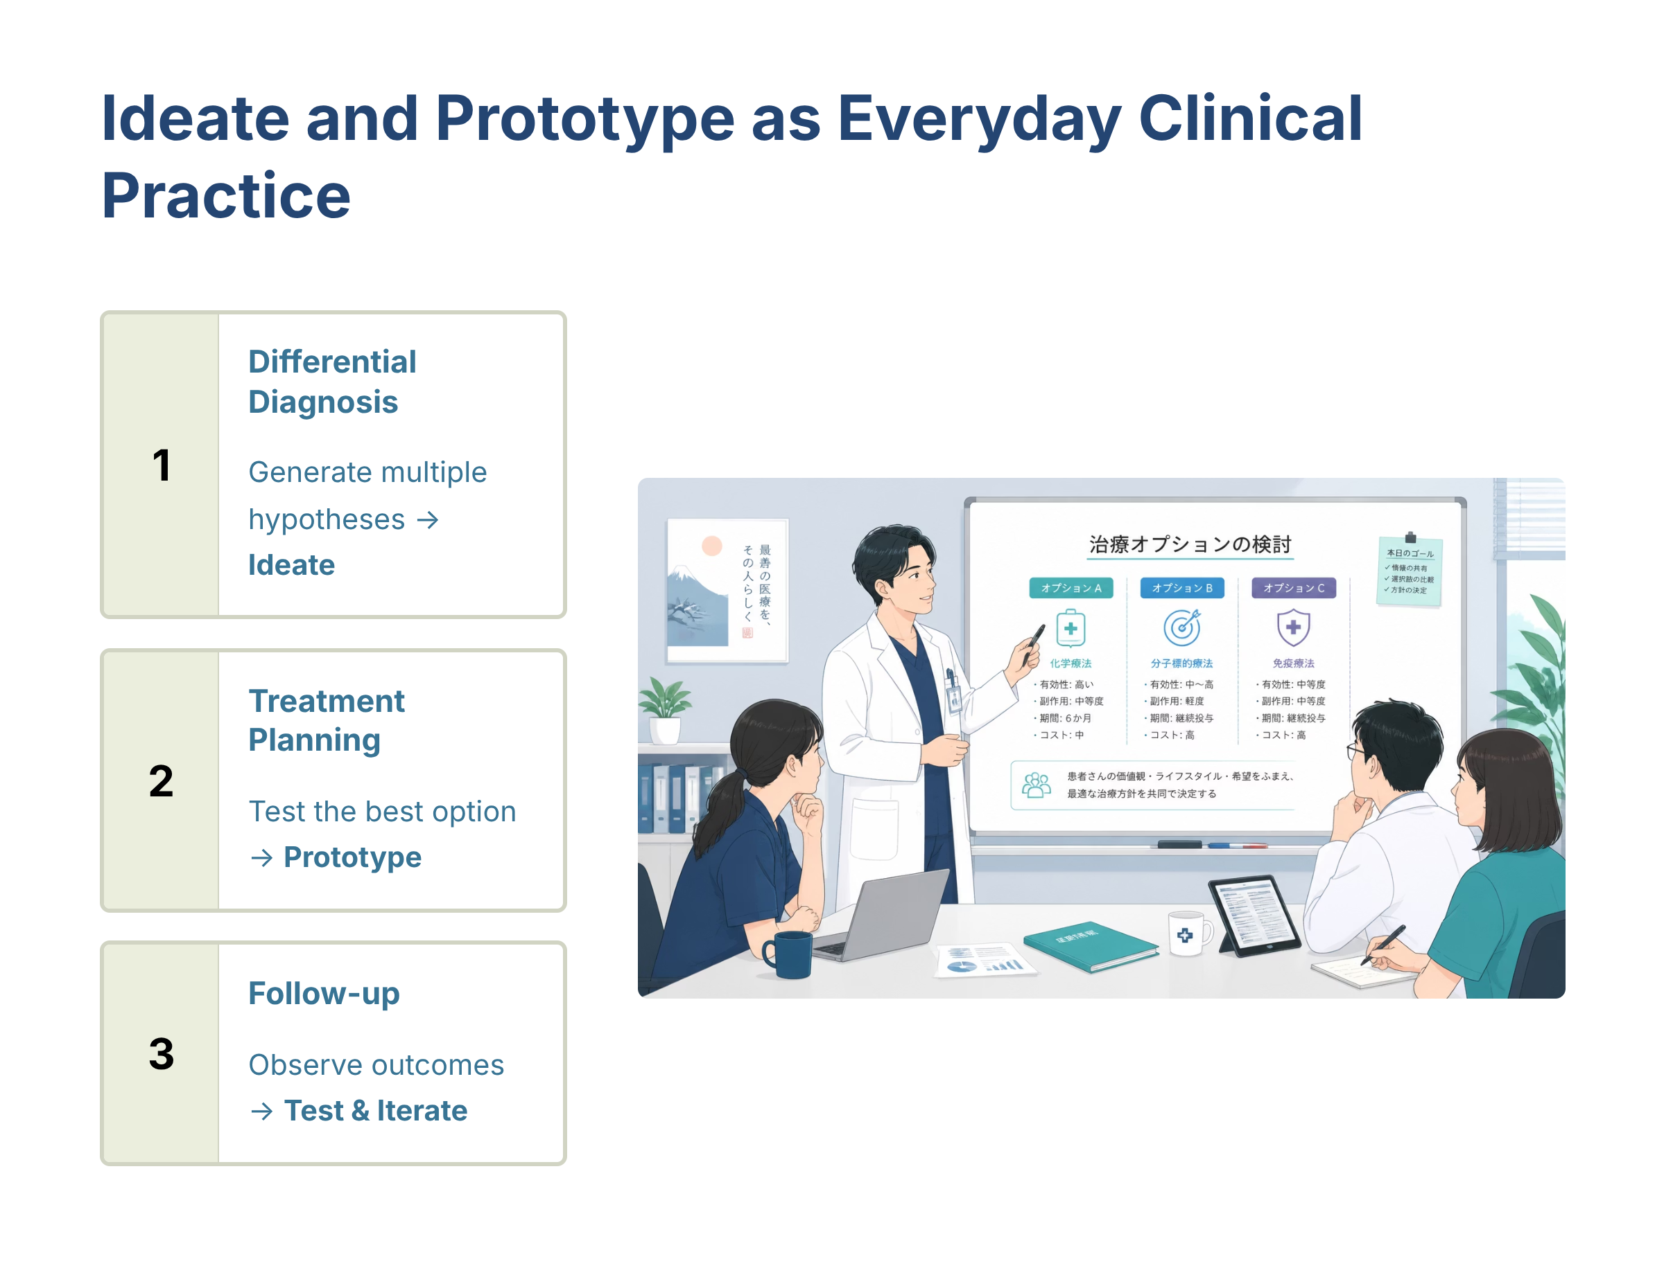
Figure — Ideate and Prototype as Everyday Clinical Practice (source_ref: src-slide-04)
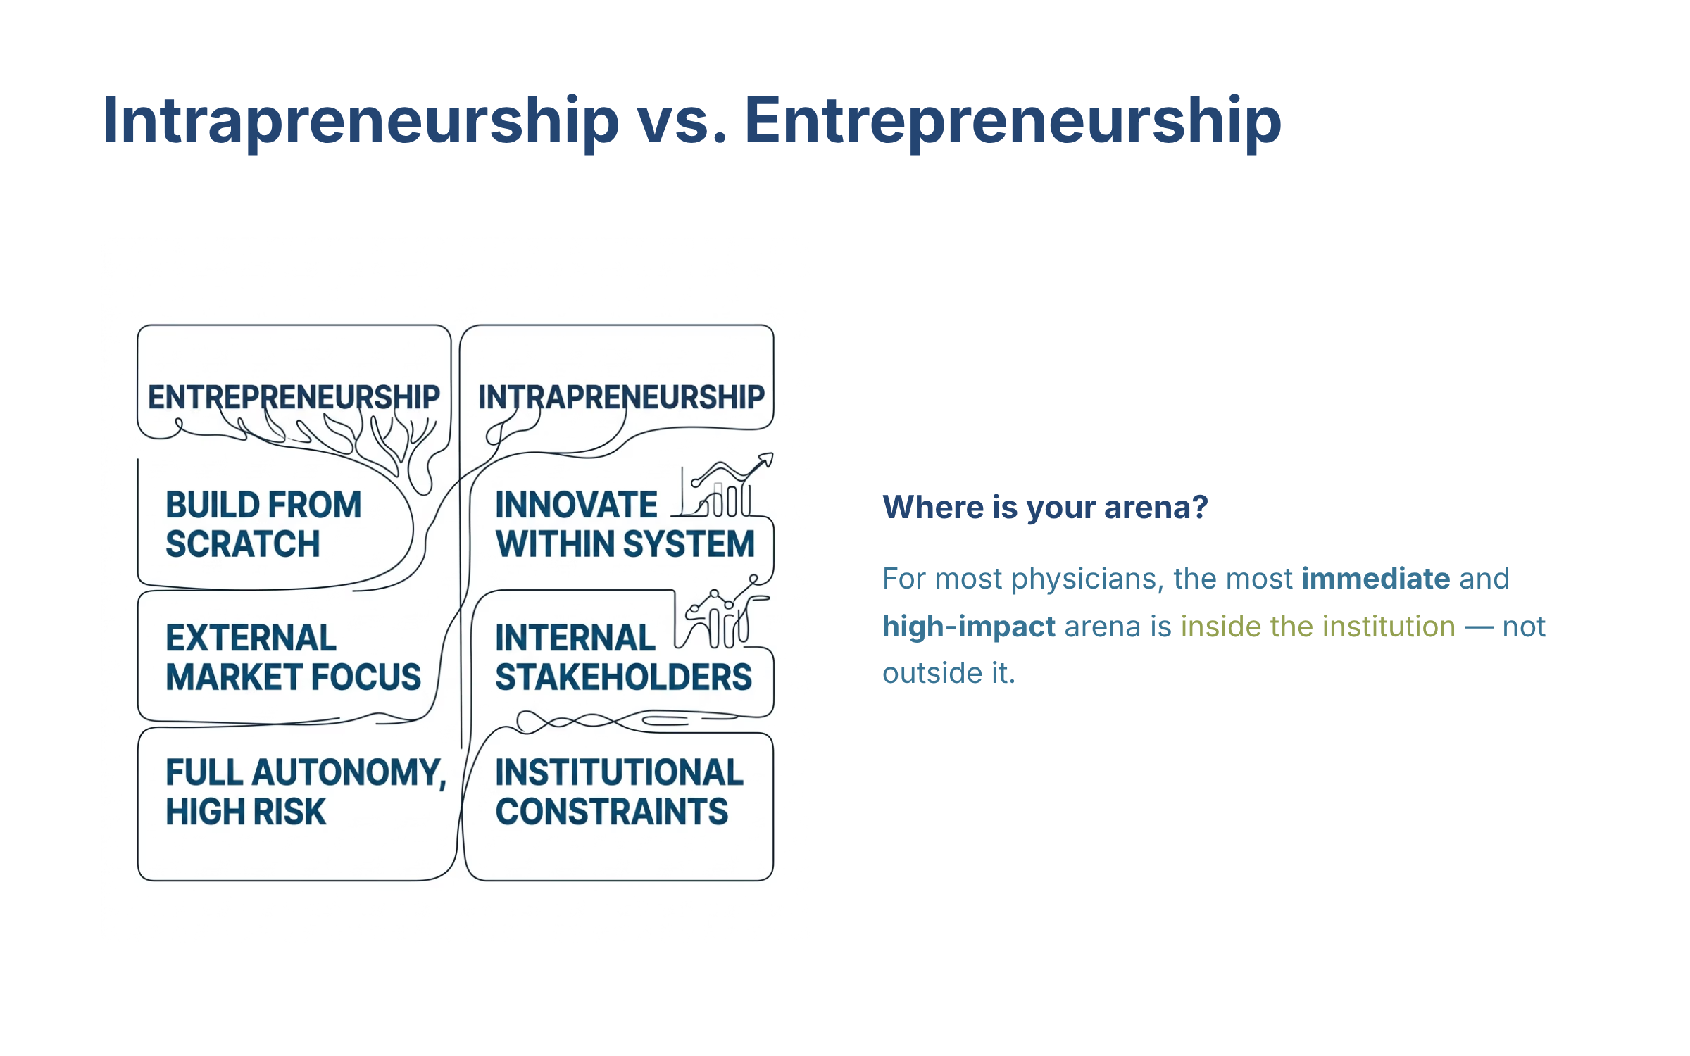
Figure — Intrapreneurship vs Entrepreneurship (source_ref: src-slide-05)
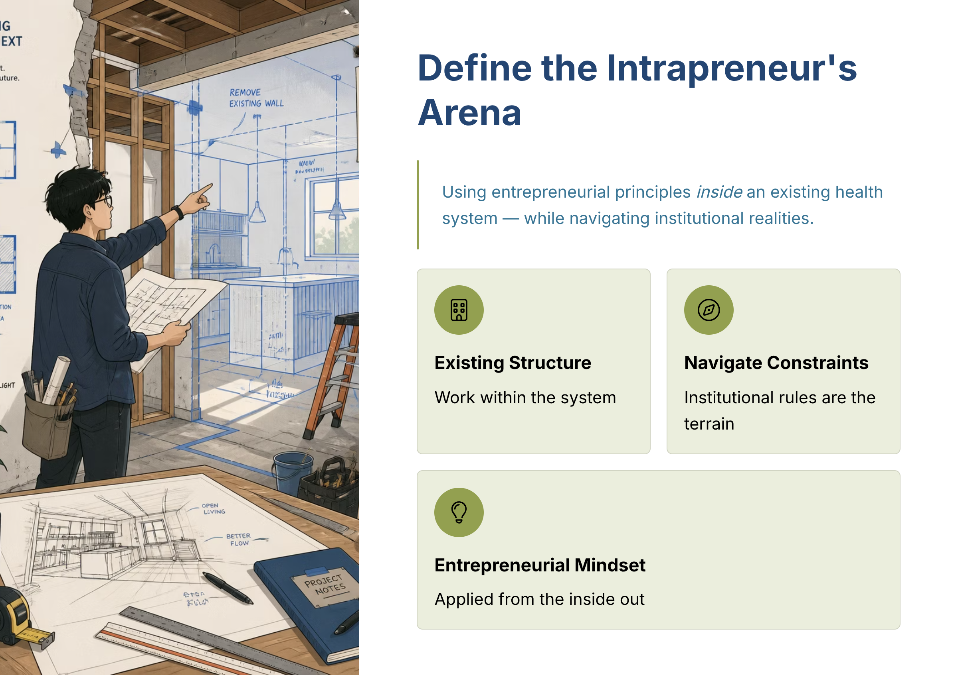
Figure — Define the Intrapreneurs Arena (source_ref: src-slide-06)
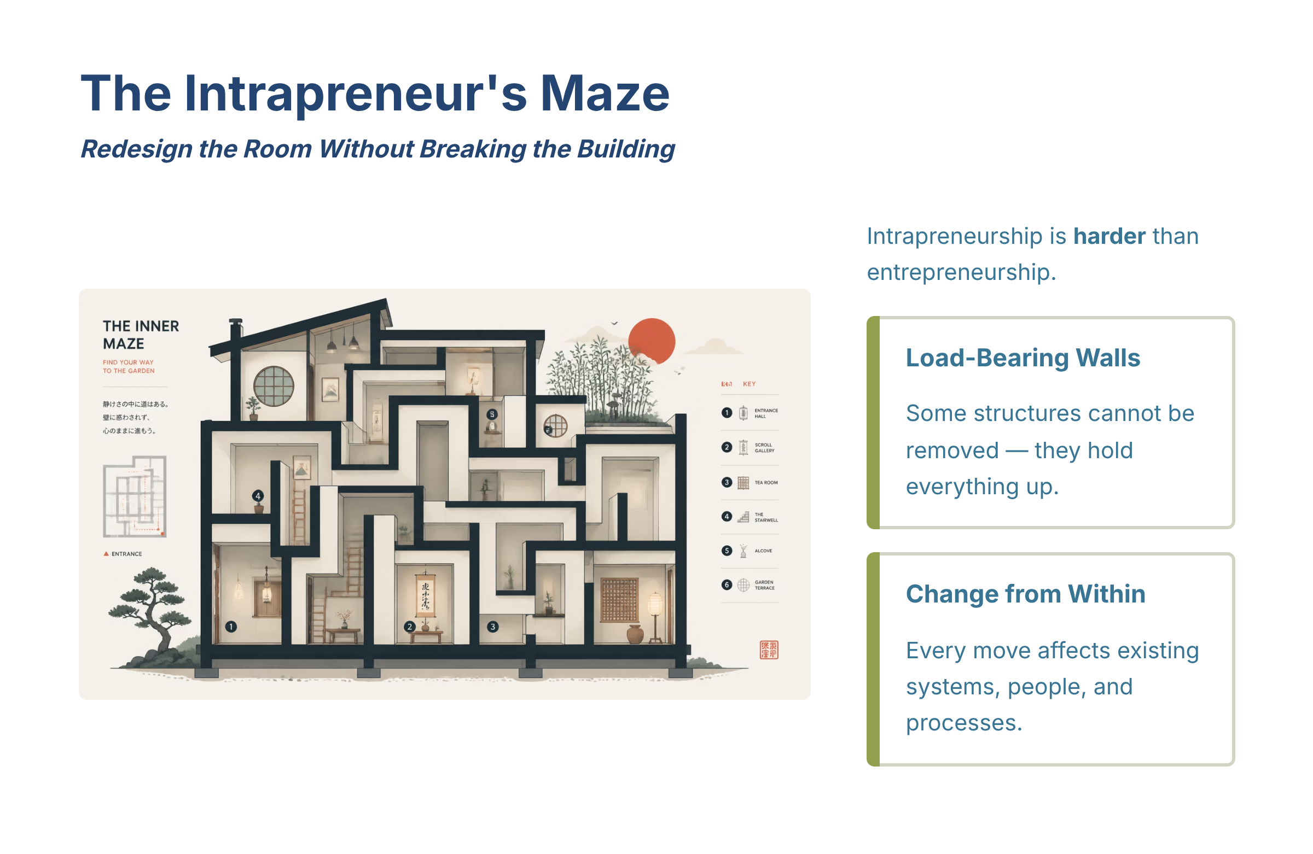
Figure — The Intrapreneurs Maze (source_ref: src-slide-07)
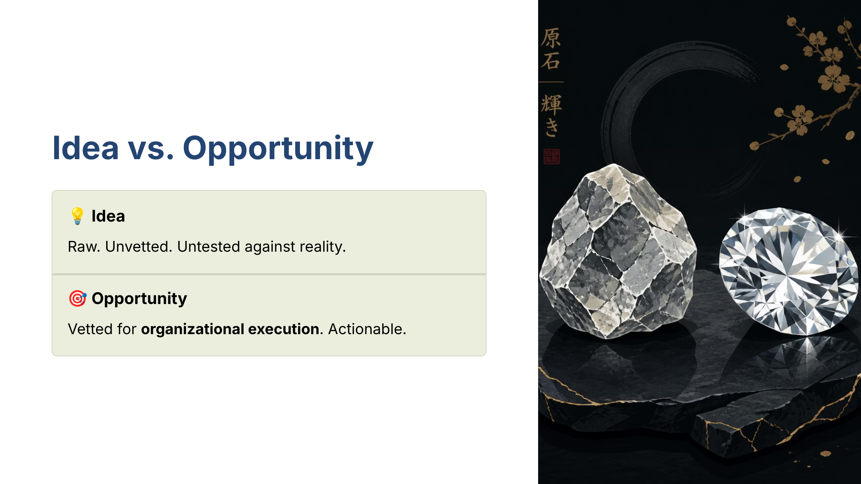
Figure — Idea vs Opportunity (source_ref: src-slide-08)
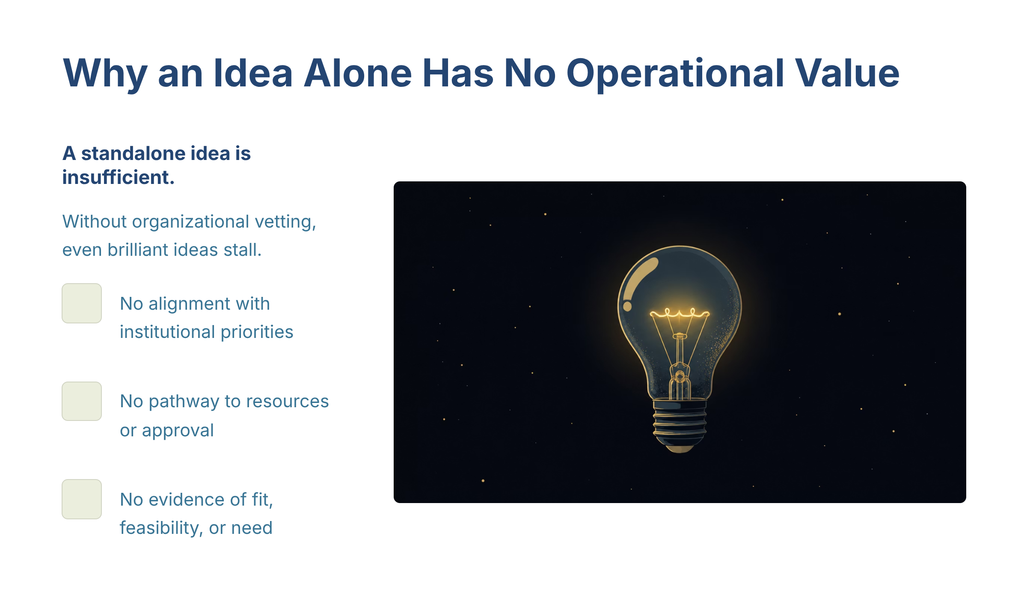
Figure — Why an Idea Alone Has No Operational Value (source_ref: src-slide-09)
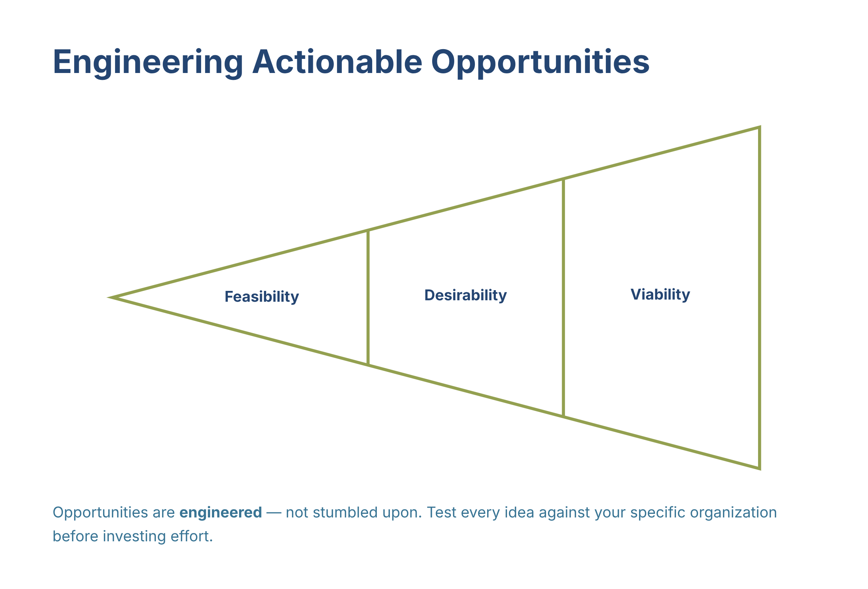
Figure — Engineering Actionable Opportunities (source_ref: src-slide-10)
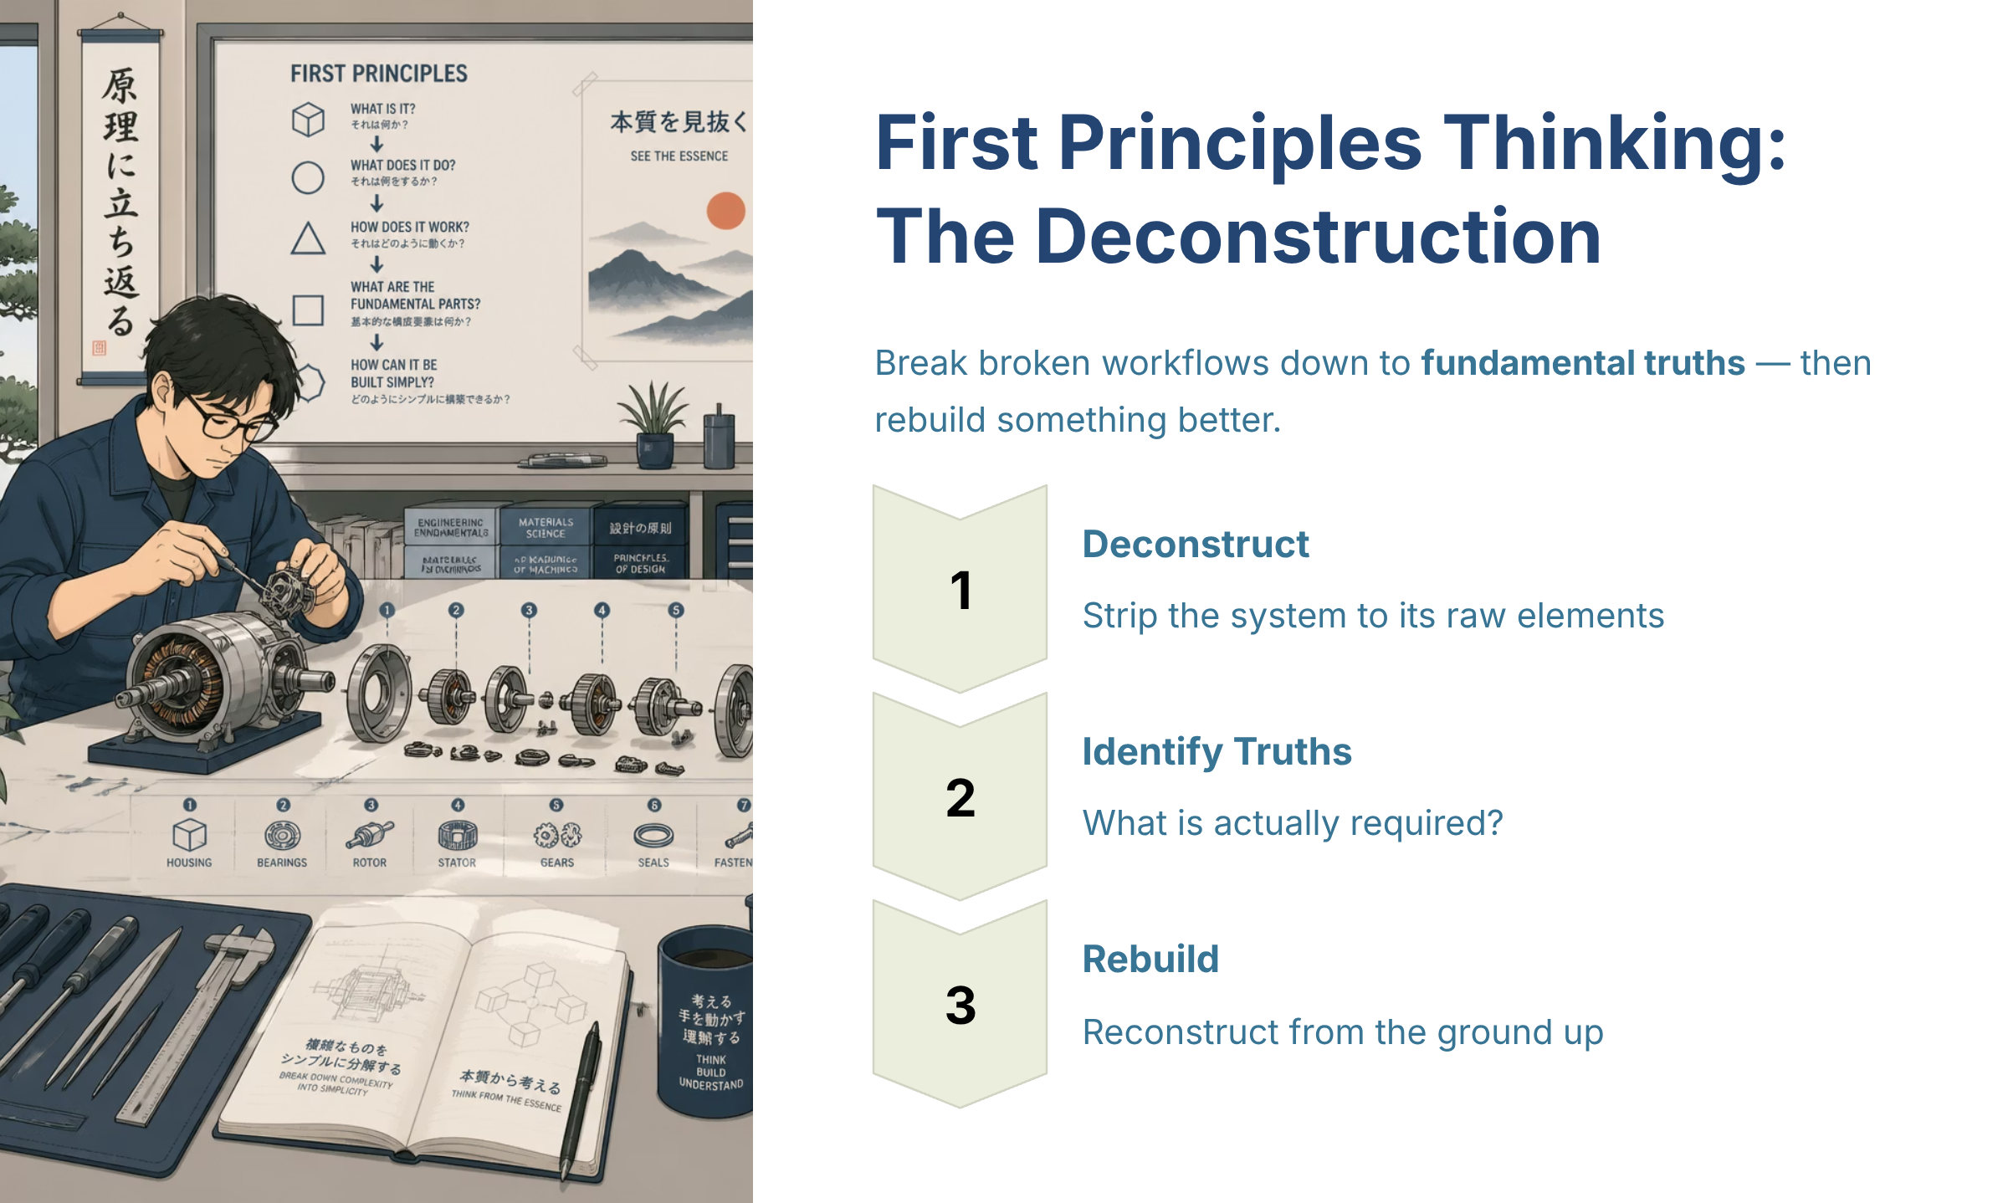
Figure — First Principles Thinking The Deconstruction (source_ref: src-slide-11)
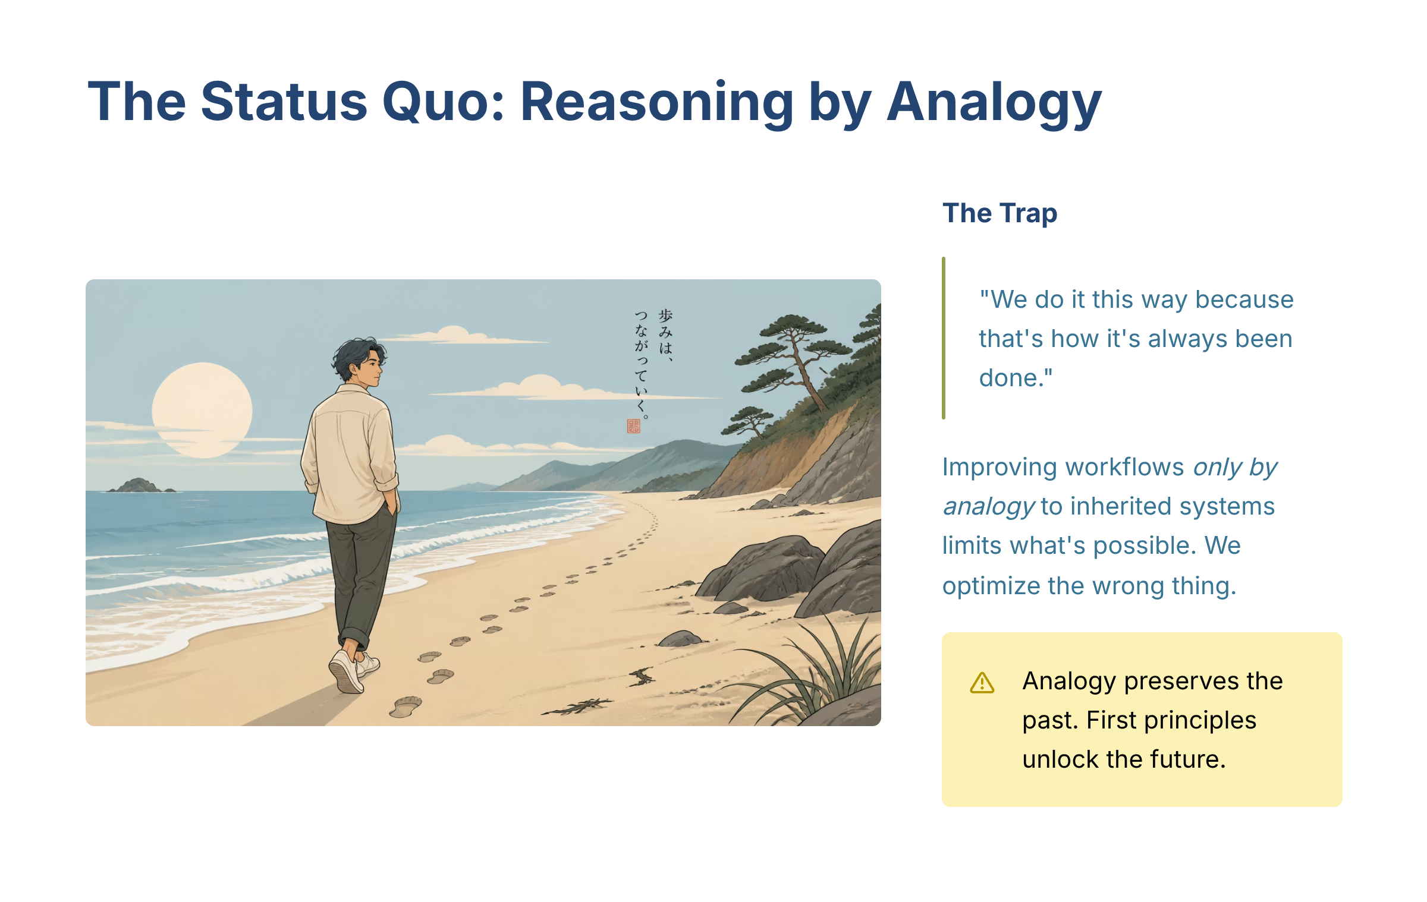
Figure — The Status Quo Reasoning by Analogy (source_ref: src-slide-12)
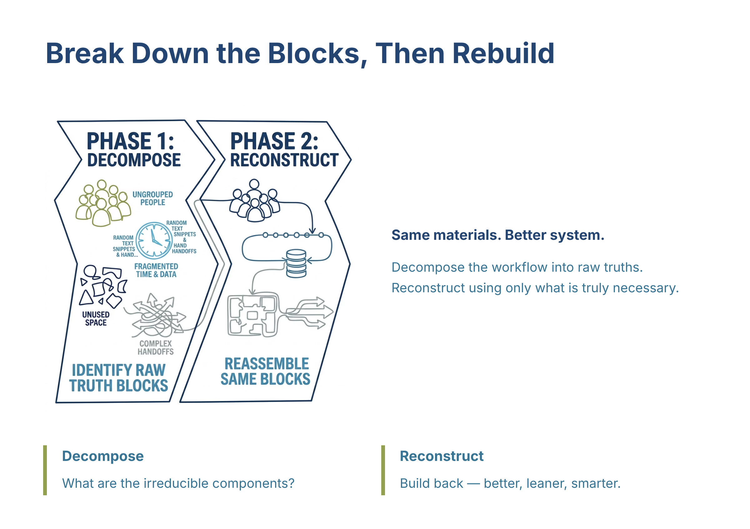
Figure — Break Down the Blocks Then Rebuild (source_ref: src-slide-13)
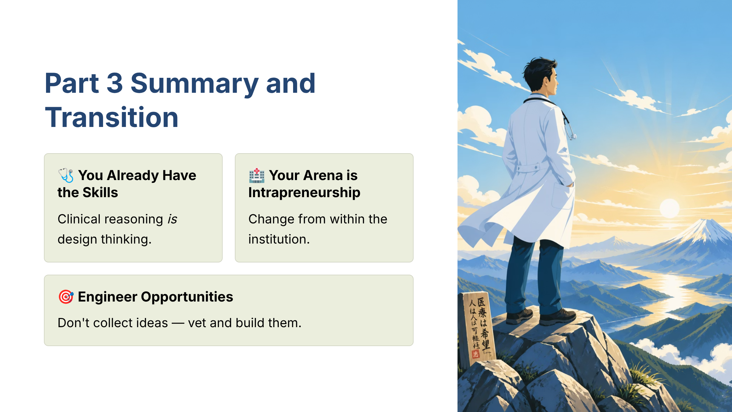
Figure — Part 3 Summary and Transition (source_ref: src-slide-14)

Human Review Checkpoint
- [ ] Irene workbook review complete

