NAME  Espinar, Jan Lislie E. |  | DATE  February 4, 2017 | SCORE
SCHEDULE  Saturday – 10:00 am - 1:00 pm | SCORE |  | SCORE

LABORATORY EXERCISES
RECURSION

OBJECTIVES:
- Understand recursion and its parts
- Use recursion to solve programming problems

PROCEDURE:
- Encode the C++ program below.
- Save as rec1.cpp,and rec2.cpp, respectively.
- Compile and run the program by pressing Ctrl + F9.
- For each syntax or logical error encountered in the given program, do the following:
- Correct the error
- Recompile the program
- Repeat step 4 until no errors are encountered in the program.
- Illustrate the output of the modified program.

Program No. 1

#include <iostream>
Output:

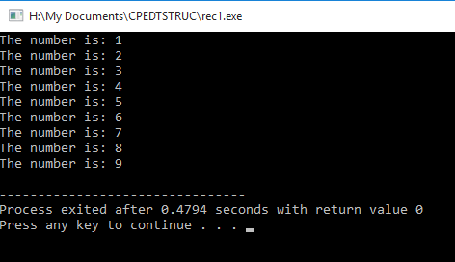

using namespace std;

void numberFunction(int i) {
cout << "The number is: " << i << endl;
i++;
if(i<10) {
numberFunction(i);
}
}

int main() {

int i = 1;
numberFunction(i);

return 0;
}

Program No. 2

#include <iostream>
using namespace std;

int factorial(int);

int main() {
int n;
cout<<"Enter a number to find factorial: ";
cin>>n;
cout<<"Factorial of "<<n<<" = "<<factorial(n);
return 0;
}
Output:

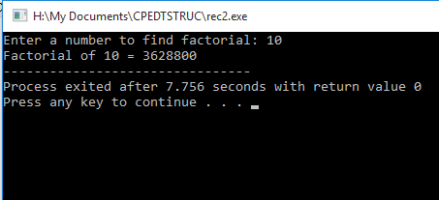

int factorial(int n) {
if (n>1) {
return n*factorial(n-1);
}
else {
return 1;
}
}

Supplementary Problem

- A recursive function that sums up the 10 integers in an array.

Program:

#include<iostream>
using namespace std;

int arraySum( int arry[], int n ) {
if (n < 0) {
return 0;
}
else{
return arry[n] + arraySum(arry, n-1);
}
}

int main()
{
int array[] = {2,1,3,6,5,4,7,9,10,8};
int sum;
sum = arraySum(array,9);
cout << "Sum of array: " << sum;
return 0;
}

Output:

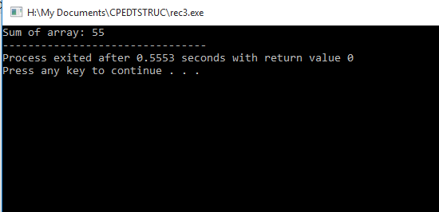

- A recursive function to produce the Fibonacci number for a given index in the series.
Use the function int fibonacci(int n)

Program:

#include<iostream>
using namespace std;

int fibonacci(int n){
if (n==0)
return 0;
else if (n==1)
return 1;
else return fibonacci (n-1) + fibonacci(n-2);
}

int main(){
int number;
cout << "Enter an integer: ";
cin >> number;
cout << "Fibonacci: " << fibonacci(number);
return 0;
}

Output:
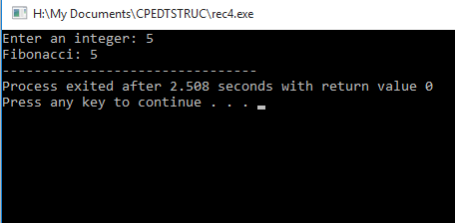

- A recursive function which raises its first parameter to the power of its second parameter.
Use the function int power(int number, int power)

Program:

#include <iostream>
using namespace std;

int power(int number, int exponent)
{
if (exponent == 1)
return number;
else
return number * power (number, exponent-1);
}

int main(){
int number, exponent, result;
cout << "Input num: ";
cin >> number;
cout << "Input exponent: ";
cin >> exponent;
cout << "Result: " << power(number, exponent);
return 0;
}

Output:
