Financial planning often involves making decisions on how to manage a company's resources:

- Capital budgeting: the process of determining whether real assets (tangible assets such as machinery, equipment or intangible assets such as patents and trademarks) are worth investing in or not)

- Capital Structuring: the decision on how to finance the company's investments, either by debt or equity

- Net Working Capital: the decision of how much short-term debt to have in comparison to current assets

Balance Sheet

- Financial snapshot of a firm's accounting value on a particular date

- Be concerned w/ liquidity, debt vs. equity, and value vs. cost

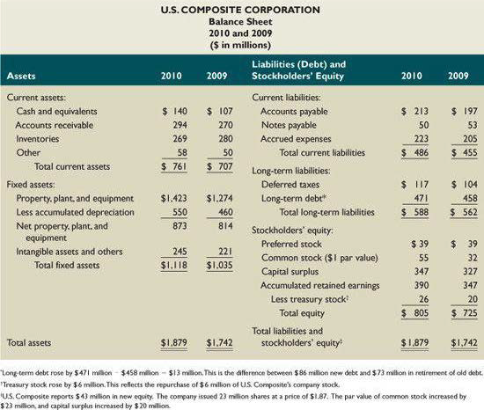

Income Statement

- Measures performance over a specific period (e.g. year)

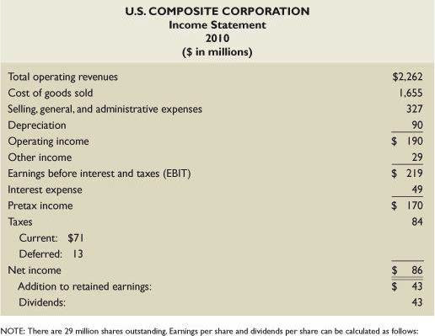

- Non-cash items: depreciation and deferred taxes (also amortization, which applies to intangible asset)

- Avg. Tax Rate = tax paid / taxable income

- Marginal Tax Rate = if we made one more dollar, the tax on that dollar would be x cents

- Firms can invest in fixed assets (capital spending) or in NWC (change in NWC)

Statement of Cash Flows

- Explains change in accounting cash and equivalents

- Cash Flow != NWC [increasing inventory requires cash, both are current assets, doesn't affect NWC, as incr. inventory is associated w/ decr. cash flow]

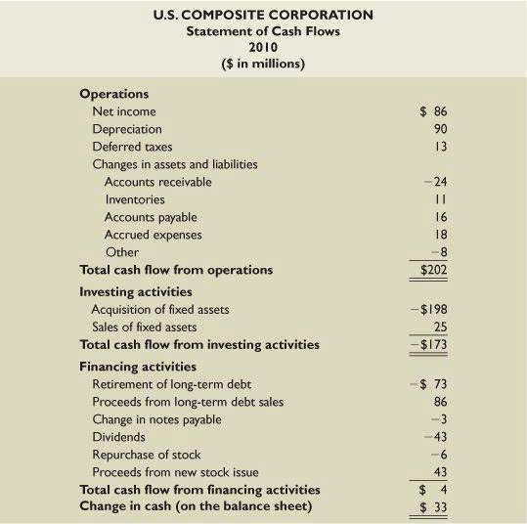

Ratio Analysis

- Short-term solvency (or liquidity): firm's ability to pay its bills over the short run w/o undue stress

- Long-term solvency (or leverage): firm's ability to meet long-term obligations (or its financial leverage)

- Asset management (or turnover measures, or utilization measures): attention to the efficiency that a firm uses its assets to generate sales

- Profitability: measure how efficiently the firm uses its assets and how efficiently the firm manages its operations

- Market value: how's this stock trading with other stocks in the broad index, and in its own industry

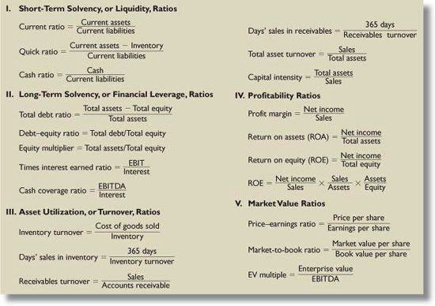

Du Pont Identity

- ROE = ROA \* Equity Multiplier

- ROE = ROA \* (1 + Debt-equity ratio)

- ROE = Profit Margin \* Total Asset Turnover \* Equity Multiplier

- ROE is affected by operating efficiency, asset use efficiency, and financial leverage (weakness in either of the first two will show up in diminished ROA, and lower ROE) (incr. debt, incr. interest expense, which reduces profit margins, which reduces ROE) (however, if company has no debt, then can incr. debt for higher EM)

Percentage of Sales Approach

Pro Forma Income Statement

- List all numbers as a percentage of sales

- Project sales value for the following year and match the rest of the income statement to the projection

Pro Forma Balance Sheet

- Identify spontaneous accounts and list them as percentage of sales (not notes payable, long-term debt, common stock)

- Project numbers that support growth in sales

- Calculate retained earnings

- Determine EFNs (identify plug variables to inject EFN) (e.g. short-term debt to balance NWC, and then remaining in long-term debt)

Other Ratios

Equity Multiplier = 1 + DE

EBIT = Sales – COGS - D

NI = (Pretax)(1 – Tax Rate)

Taxable Income = EBIT – I

Tax = (Taxable Income)(Tax Rate)

OCF = EBIT + D – T

FCF = OFC – Capital Expenditures

Capital Expenditures = Capital Spending – NWC

Net Capital Spending =

CF(A) = CF(C) + CF(S)

CF(A) = FCF

CF(B) = CF to creditors = Interest Paid – Net new borrowing = Interest Paid – (ending long-term debt – Beg. long-term debt)

CF(S) = CF to stockholders = Dividends – Net new equity raised = Dividends – (Stocks Sold – Stocks purchased)

Dividend Payout Ratio = Dividends / NI

Retention (or Plowback) Ratio = Addition to RE / NI = 1 – Payout Ratio

EFN = TA – (TL + TE)

EFN = (TA / Sales)(Sales) – (Spont. Liabilities / Sales) – (PM)(Proj. Sales)(1 – d)

d = dividends payout ratio, b = retention ratio

Addition to RE = TE (if no dividends payout, then equity account incr. by NI => NI = RE)

Common Size Inventory = Inventory / TA

Ratios Analysis (cont.)

- High current ratio, low quick ratio = high inventory

- High EM = lots of debt. Ok if OCF is high

- Inventory turnover ratio = goes down when COGS goes down or inventory piles up (both may be result of a recession)

- Low receivables turnover ratio = not able to collect cash from its customers

- Different revenue models = one-time payment or multiple

- Neither balance sheet nor income statement is directly linked to current stock price

- DE ratio = hi could mean company is more willing to get into debt to expand growth, low could mean company sells more, so equity goes up

- US businesses have higher DE than international as they have more access to capital and seem to be more risky

- Current stock price integrates past, current, and future info. about firm

- Proxy fight = group of investors using voting rights of other investors to change management's direction

- Stock buyback wouldn't lead to incr. in PM (lower TA, lower TE, lower shares outstanding, so ROE, ROA, and EPS go up)