Copy and Pasta SEO FIXES

As was done with the other files with SEO notes, meta descriptions and title tags are noted as to how they needed changes.

Home Page

Currently, it looks like this:

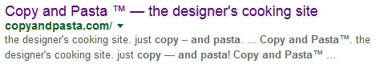

I like the title tag. Maybe the space between the TM could be removed. But overall, it looks great there. Even the meta tag is ok, but Google is a bit too liberal in competing the thought to where it becomes somewhat redundant, so I shortenend it to just what the website’s tagline is, essentially…

Suggested meta tag in the head:

<meta name="description" content="the designer's cooking site. just copy — and pasta!”>

For now, the recipes have NO meta descriptions. I have yet to make them. Google shows the search results for very few other recipes. But the Dill one shows under Pasta Shells.

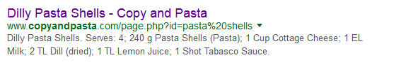

As you see, it lists the ingredients. Not good. Maybe until I can get around to making pretty, colorful descriptions, you can just add some sort of generic description for each recipe as a placeholder such as:

Content=”recipe for [recipename]”

For the Dill Pasta Shells page, for example, that format just listed would appear as:

Content=”recipe for Dilly Pasta Shells”

