**INNERWORKINGS ASSIGNMENT**

**ABOUT THE PROGRAM**

This program was made with ASP.NET MVC 5 (.NET Framework 4.6.1). Includes a database file to persist the data (*.mdf*).

**USER INSTRUCTIONS**

**Running the program**

There are two options to run the program:

1. Loading solution in Visual Studio and run project.
2. Deploy files on IIS.

For the first option, open it on Visual Studio 2017 and, once it is fully loaded, go to the menu *Debug > Start debugging* or just press F5.

For the second option, you will have to create a new application in IIS, pointing the source to the ‘Publish’ folder. For more info visit [this page](https://www.codeproject.com/Articles/28693/Deploying-ASP-NET-Websites-on-IIS#DeployonIIS7).

**Usage instructions**

In the Home view, you will see a form ready to entry the corresponding data:

* Items
  + Item type: is selected from a list
  + Amount: must be typed **using point as decimal separator**
* Has Extra Margin?: wheter the Job to process has it or not

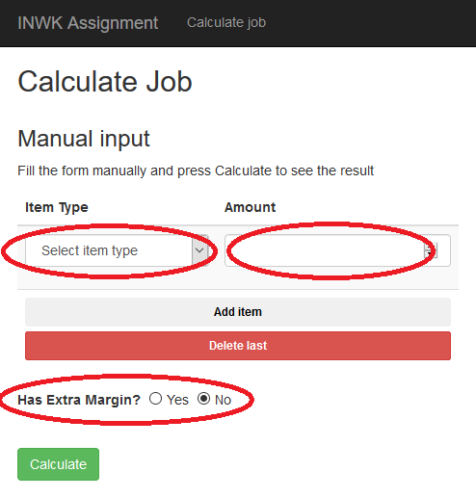

**Adding Items to calculate**

In the list of Items, there is always one item by default.

Note that you can add or delete as many items in the list as you need. This is possible with the buttons *Add item* and *Delete last*:

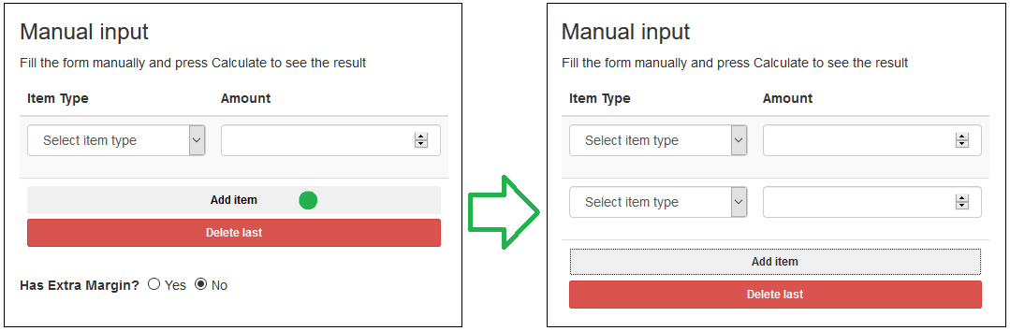

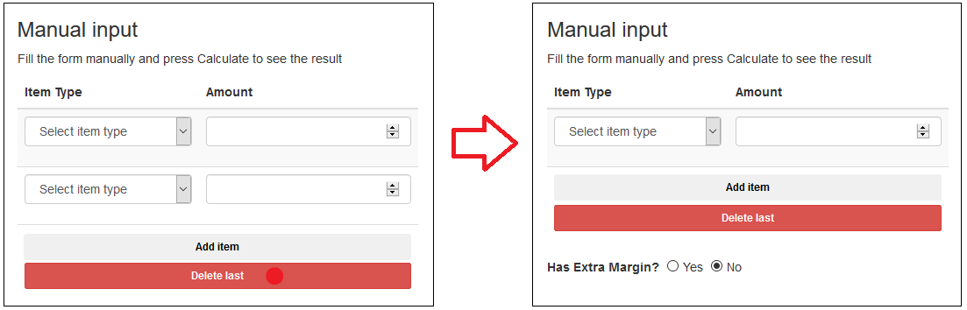

**Processing data and showing result**

When you filled all the fields you need, that means added the items to calculate and selected the “*Has Extra Margin?”* property, you must click on **Calculate** button to see the results:

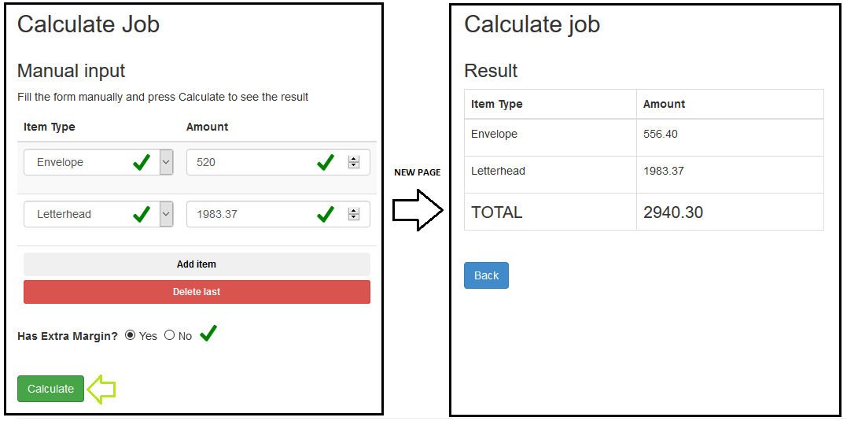

In the Result page, you can come back to the main page by pressing the “*Back*” button.

**CODE ASSIGNMENT**

*Below is a code assignment we would like the candidate to complete and return to us in no more than 24 hours.*

*1. Include this problem statement with the solution.*

*2. Use C# for the solution.*

*3. Send us the visual studio solution with instructions on how to run the program, and input data*

*4. This is a stage for the candidate to showcase his/her skills and strengths, so keep that in mind when coming up with the solution*

*PROBLEM STATEMENT*

*At InnerWorkings a "job" is a group of print items. For example,*

*a job can be a run of business cards, envelopes, and letterhead together.*

*Some items qualify as being sales tax free, whereas, by default, others*

*are not. Sales tax is 7%.*

*InnerWorkings also applies a margin, which is the percentage above printing*

*cost that is charged to the customer. For example, an item that costs $100*

*to print that has a margin of 11% will cost:*

*item: $100 -> $7 sales tax = $107*

*job: $100 -> $11 margin*

*total: $100 + $7 + $11 = $118*

*The base margin is 11% for all jobs this problem. Some jobs have an*

*"extra margin" of 5%. These jobs that are flagged as extra margin have*

*an additional 5% margin (16% total) applied.*

*The final cost is rounded to the nearest even cent. Individual items are*

*rounded to the nearest cent.*

*Write a program that calculates the total charge to a customer*

*for a job*

*(Bonus: Try to read the input from a file and output the invoice to a file).*

*The program should accept the inputs below and output the*

*total bill for the customer.*

*Job 1:*

*extra-margin*

*envelopes 520.00*

*letterhead 1983.37 exempt*

*should output:*

*envelopes: $556.40*

*letterhead: $1983.37*

*total: $2940.30*

*Job 2:*

*t-shirts 294.04*

*output:*

*t-shirts: $314.62*

*total: $346.96*

*Job 3:*

*extra-margin*

*frisbees 19385.38 exempt*

*yo-yos 1829 exempt*

*output:*

*frisbees: $19385.38*

*yo-yos: $1829.00*

*total: $24608.68*

*Thank You.*

**EXERCISE SELF SUMMARY**

