|  |
| --- |
| Unreserved studios |
| Sage Scrolls |
|  |
| Version 2.0  All work Copyright © 2015 by Unreserved Studios  All rights reserved. |
| **Joshua Fulmer** |
|  |

**Our Logo Here**

|  |
| --- |
| October 6, 2015 |

**Table of Contents**

1. **Game Overview..................................................................................4**
2. **Game Play Mechanics.........................................................................4**
3. **Camera...............................................................................................4**
4. **Controls...............................................................................................5**
5. **Interface..............................................................................................5**
6. **Menu and Screen Descriptions.............................................................8**
7. **Leveling................................................................................................8**
8. **Game Progression................................................................................9**
9. **Scoring................................................................................................10**
10. **Timing……………………………………………………………………………………………… 11**
11. **Combination List.................................................................................11**
12. **Technical…………………………………………………………………………………………..13**

**Version History**

Version 1.0: Joshua Fulmer 08/07/2011

Version 1.1: Joshua Fulmer 08/08/2011

Version 1.2: Joshua Fulmer 08/09/2011

Version 1.3: Joshua Fulmer 08/10/2011

Version 1.4: Joshua Fulmer 08/12/2011

Version 2.0: Joshua Fulmer 10/06/2015

1. **Game Overview**

Sage Scrolls is a puzzle/arcade game in which the player must combine elements starting with the four basic elements: Fire, Water, Wind, and Earth. The player combines elements to create higher compounds that are matched against the recipes shown on the scrolls.

1. **Game Play Mechanics**

Various inactive spell cards will appear with elements that need to be created and cast onto them. The player will have four elements to start out with; Fire, Water, Earth, and Wind. Combing these elements in different manners create new elements.

The work pads (4) are divided into sections, allowing the player to work with different combinations.

There is specified length of time to complete these tasks, as indicated by a constantly decreasing gauge on the screen. If a set of scrolls are not completed within the given time, the environment becomes unstable. Too many failures will result in a game over. Completing sets successfully and quickly, will contribute to the player’s final score.

1. **Camera**

This game will have a single 2D screen camera that will be static at all times, similar to traditional arcade and puzzle games.

1. **Controls**

The player will use the touch screen on their Android/iOS smart phone or tablet in order to drag the basic and combined elements onto the work pads, where they will remain until the player swipes the elements up towards the scrolls to submit an element.

Players will also have the ability to submit (cast) all elements on the work pads at once for efficiency, using a provided button. Another button can be used to remove all elements on the pads.

Note: perhaps a clear all button is not needed since cast all serves the same function for elements that don’t match the scrolls.

1. **Interface**

Note: Images are out of date, and need to be updated to reflect the mobile docs

See Below:

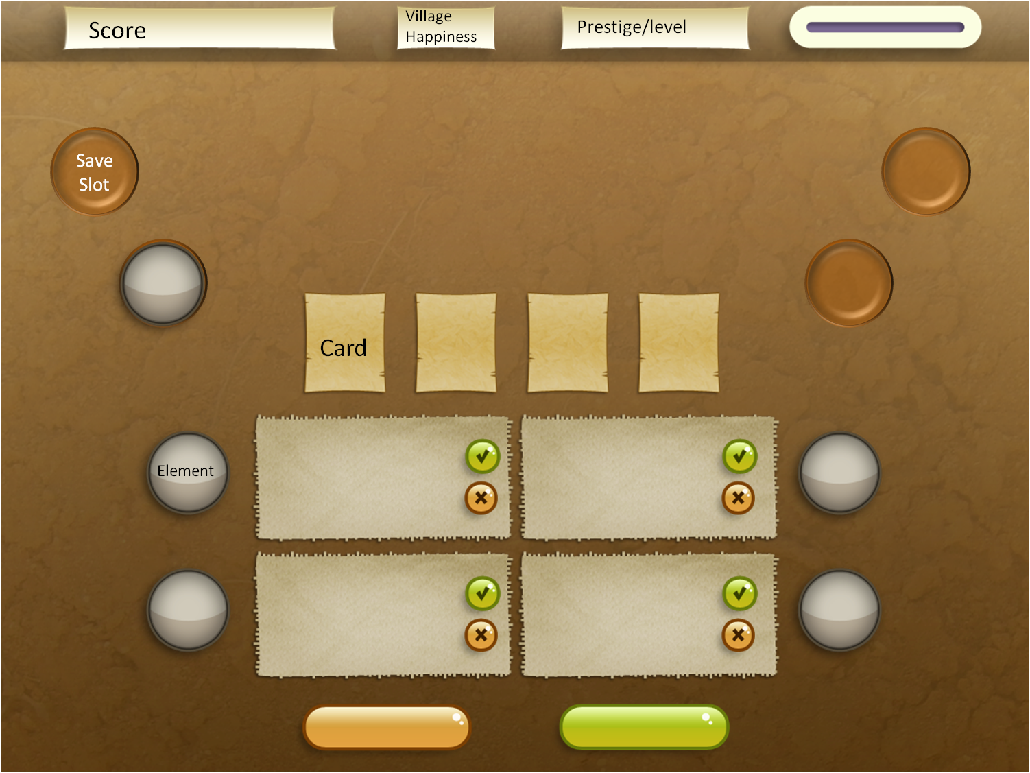

The work pads will be split up between four quadrants on the table, or sections where the player can create elements, as well as a 'cast all' button on the bottom. There will also be save slots on the table that are unlocked as the game progresses, and allow the player to save desired elements for continuous use in the future. (For example, if the player doesn't want to manually create 'life' elements in the future, he/she can save that element and it will act as another base element on the table.)

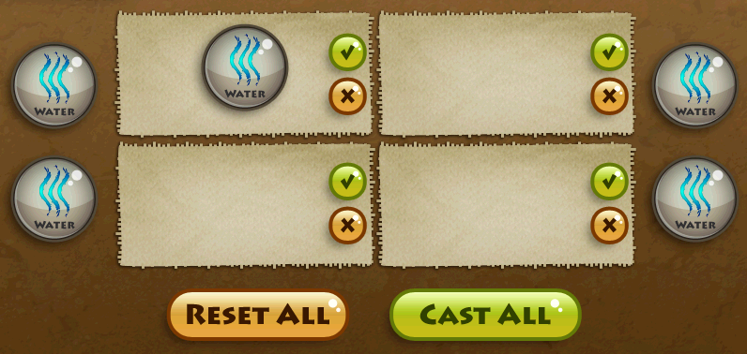

There will also be a point where scrolls are queued for certain tasks, and you must complete all queued scrolls in order to see the next row, below is an example:

Once all the available scrolls are completed, the set above will drop and become available for element casting:

1. **Menu and Screen Descriptions**

The game will have a main menu that will contain a ‘Play’ and 'Exit' option

* Play : Play the game
* Exit : Exit the program
* Note: may include a ‘Credits’ and ‘Instructions’ depending on time and screen availability

In game, when the game is paused, the player will see the following options:

* Continue: Return to the game.
* Exit to Main Menu: Return to the Menu screen.
* Exit: Exit the program.

1. **Leveling**

The game will become progressively more difficult as the game continues and your character progresses through the ‘Proficiency Levels’. As the player progresses, they will be able to cast more complicated elements, and will be required to do so. Half way through each level, except for the last two, tasks will be limited to one row of scrolls until halfway through the level. Below is an example of this system:

Note: Maybe we don’t want to limit the ability to create higher elements based on level, it might be confusing.

|  |  |  |  |
| --- | --- | --- | --- |
|  |  |  | Points to Next Level |
| **Lvl 1** | Player can cast tier 1 elements | Tasks require only single elements | 1000 |
| **Lvl 2** | Player can cast tier 2 elements | Tasks require T1 and T2 | 5000 |
| **Lvl 3** | Player can cast tier 2 elements | Tasks require T1 and T2 | 10000 |
| **Lvl 4** | Player can cast tier 3 elements | Tasks require T1, T2, and T3 | 25000 |
| **Lvl 5** | Player can cast tier 3 elements | Tasks require T2 and T3 | 50000 |
| **Lvl 6** | Player can cast Tier 4 elements | Tasks require T1,T2,T3, and T4 | 100000 |
| **Lvl 7** | Player can cast Tier 4 elements | Tasks require T2, T3, and T4 | 200000 |
| **Lvl 8** | Player can cast Tier 5 elements | Tasks require T2,T3,T4,T5 | 350000 |
| **Lvl 9** | Player can cast all elements | (Q)* T3 and above | 500000 |
| **Lvl 10** | Player can cast all elements | (Q)* T4 and above |  |

**\*: (Q)** implies that tasks involving card queues may be used throughout this level, for all other levels, queuing may begin only once the 'halfway' point between levels has been reached.

As the player levels, the save slots will become available as follows:

Level 3: Top Left Save Slot becomes available

Level 5: Top Right Save Slot becomes available

Level 7: Bottom Left Save Slot Becomes available

Level 9: Bottom Right Save Slot Becomes available

1. **Game Progression**

The player gains 'proficiency' levels based on the score, meaning that when the player reaches certain 'milestones', he/she will gain one level (refer to section VII).

Both success and efficiency affect how many points are earned for each row of scrolls. The proficiency level determines what scroll recipes will appear throughout the game.

1. **Scoring**

When a row of scrolls become available, a value is associated with each element scroll in the task. The player then has a set amount of time to complete the scrolls. The player must complete a full row in order to receive the points for those scrolls. If the entire task in completed, the player receives a bonus amount of points, equal to the entire task value multiplied by some percentage based on the time remaining

Please refer to the example below:

Note: images are out of date and may need to be updated

1. **Timing**

Note: This needs to be completely redesigned, unlikely balanced for new mobile design

|  |  |
| --- | --- |
| **Level 1** | **All Tasks 45** |
| **Level 2** | **All Tasks 45 Seconds + 10 Seconds Per Completed Row** |
| **Level 3** | **All Tasks 45 Seconds + 10 Seconds Per Completed Row** |
| **Level 4** | **All Tasks 45 Seconds + 10 Seconds Per Completed Row** |
| **Level 5** | **All Tasks 45 Seconds + 10 Seconds Per Completed Row** |
| **Level 6** | **All Tasks 45 Seconds + 15 Seconds Per Completed Row** |
| **Level 7** | **All Tasks 45 Seconds + 15 Seconds Per Completed Row** |
| **Level 8** | **All Tasks 45 Seconds + 15 Seconds Per Completed Row** |
| **Level 9** | **All Tasks 45 Seconds + 20 Seconds Per Completed Row** |

1. **Combination List**

**Element Philosophy:**

**Fire:** Destruction / Passion / Heat

**Wind:** Divine / Creation / Force

**Water:** Fluid / Healing / Pure / Cleansing

**Earth:** Unmoving / Solid / Strong

|  |  |
| --- | --- |
| **Combination** | **Elements** |
|  | **Tier 1** |
|  | **Fire** |
|  | **Water** |
|  | **Wind** |
|  | **Earth** |
|  |  |
|  | **Tier 2** |
| Fire + Fire | **Combustion** |
| Fire + Wind | **Atmosphere** |
| Fire + Water | **Steam** |
| Fire + Earth | **Coal** |
| Wind + Wind | **Cyclone** |
| Wind + Water | **Mist** |
| Wind + Earth | **Life** |
| Water + Water | **River** |
| Water + Earth | **Clay** |
| Earth + Earth | **Stone** |
|  |  |
|  | **Tier 3** |
| Fire + Stone | **Magma** |
| Life + Earth | **Creature** |
| Fire + Coal | **Energy** |
| Atmosphere + Stone | **Sand** |
| Combustion + Atmosphere | **Lightning** |
| Clay + Fire | **Brick** |
| Stone + Life | **Golem** |
| Life + Water | **Plant** |
| Water + Coal | **Oil** |
| Life + Fire | **Death** |
|  |  |
|  |  |
|  | **Tier 4** |
| Magma + Water | **Metal** |
| Energy + River | **Torrent** |
| Lightning + Sand | **Glass** |
| Energy + Coal | **Diamond** |
| Death + Creature | **Corpse** |
| Brick + Creature | **Shelter** |
| Water + Creature | **Fish** |
| Air + Creature | **Bird** |
| Earth + Creature | **Beast** |
|  |  |
|  |  |
|  | **Tier 5** |
| Bird + Fire | **Phoenix** |
| Creature + Metal | **Mechanism** |
| Energy + Lightning | **Electricity** |
| Corpse + Life | **Undead** |
| Corpse + Fire | **Ash** |
| Metal + Oil | **Machine** |
| Torrent + Cyclone | **Hurricane** |
|  |  |
|  |  |
|  | **Tier 6** |
| Life + Ash | **spirit** |
| Life + Machine | **Robot** |
| Metal + Mechanism | **Weapon** |
| Mechanism + Plant | **Wood** |
| Electricity + Metal | **Light** |

1. **Architecture**

TBA