Lab 07 ParticleSystems Animations and Instanced Rendering

**Fufillment**

* I finished all the objectives!!!!!!!

**Execution**

* I do not believe there should be any unexpected requirements for running

**Controls**

* Pressing the X key will close the application
* Pressing the P key will pause the application, pressing it again will un-pause the application
* Pressing numpad 0 will re-read the config file
* Pressing M, L, T or C will dump engine info to the console, this is pretty much exclusively used for debugging
* Pressing W will rotate BetterDargon to the left, S will rotate him to the right
* Pressing A will tilt BetterDargon forward, D backward
* Pressing Q will roll BetterDargon to the left, E to the right
* Holding space will move BetterDargon forward, in the direction he is facing, releasing will halt movement
* Right clicking and dragging the mouse will turn the camera around BetterDargon
* Scrolling in or out with the mouse wheel should zoom the camera accordingly, up to a minimum or maximum distance
* Pressing the 6 key will reset time, starting the plane waves and particle system over again
* Pressing 7 will toggle 2D instanced stuff in your face over the screen
* Pressing 8 will toggle between the instanced quad versions

**Screenshots**

* **Wavy plane**
  + **Hey look. It’s a plane. It waves. Its got phong lighting. See, the sides facing the light have diffuse plus specular. Woo boring. Next.**
  + 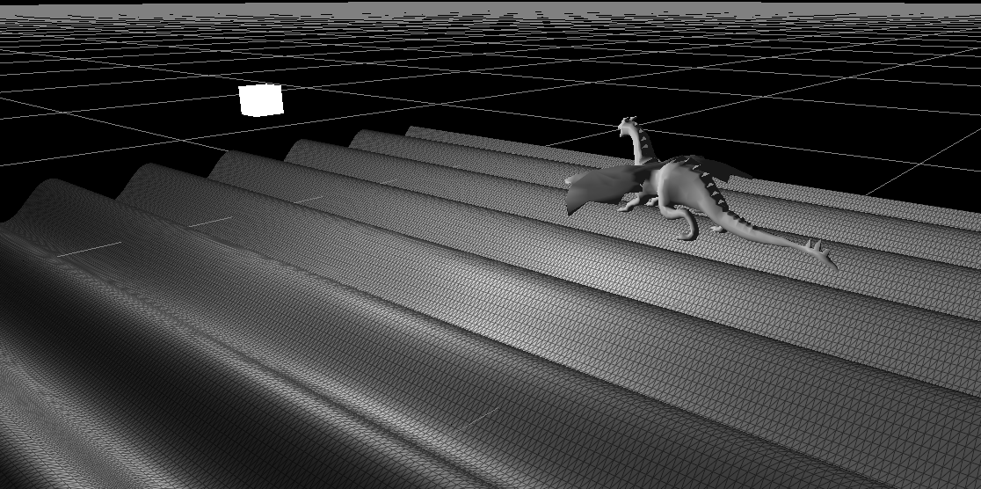
  + **Oh my gosh it’s the same plane from a different angle. Look I put my wireframe shader on it to demonstrate that my plane is actually a bunch of triangles generated in the CreateTessalatedPlane method**
  + 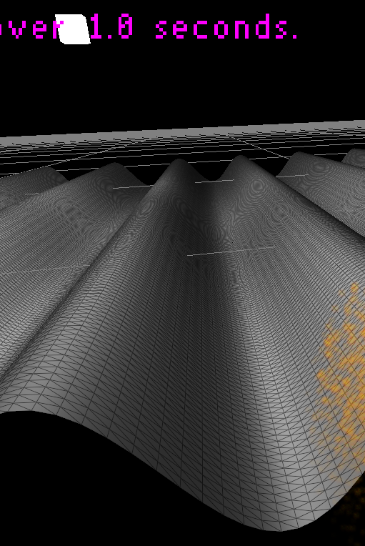
* **Particles**
  + **Finally. Some fire. Took you long enough. Eight weeks in a graphics course to get to fire. 😐**
  + 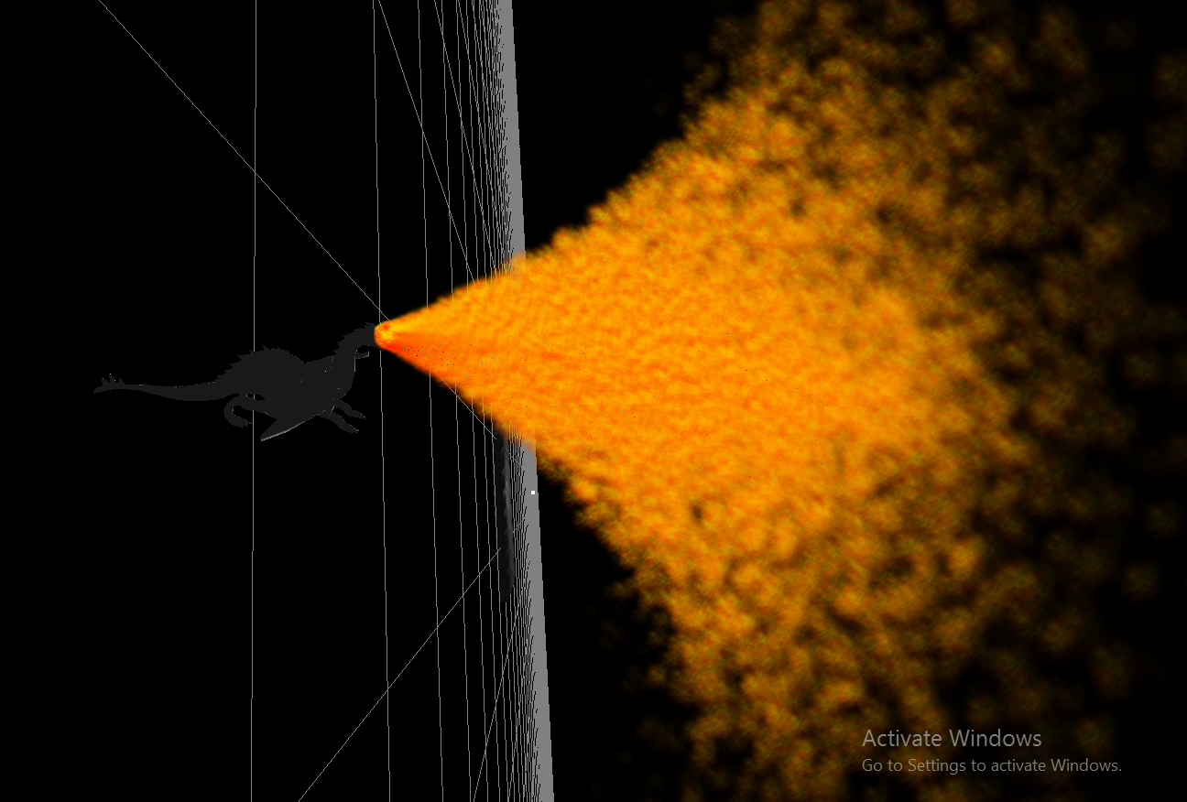
  + **This one shots that the fire follows my dragon and always comes from his mouth, also it shows the particles affected by gravity in world space, which was extra – maybe its enough extra to be given credit? Maybe not. Credit or not, its cool. My dragon breathes fire and I like it. Kinda the most fun part of this lab. Oh yeah, and the particles are billboards. You’re seeing about 25000 of them right now.**
  + 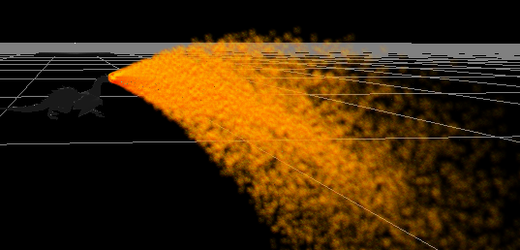
* **Instancing**
  + **Here is the basic instancing shown in the tutorial. It uses a buffer, I made a class for that. The data is sent through an attrib and used to offset the instances with no need for the id in the shader.**
  + 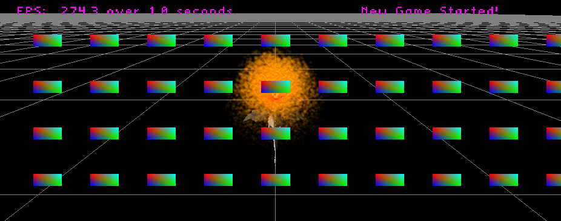
  + **This shows the first set of modifications you requested. The quads can be scaled via uniforms and are drawn with no need for an attrib/buffer because the id is used to calculate their positions along with the uniform number of rows and columns. The thing that makes this cool is that I can change those values dynamically at runtime (I would add a key for that but time constraints) and it would update the instances with no need to make a new buffer or anything.**
  + 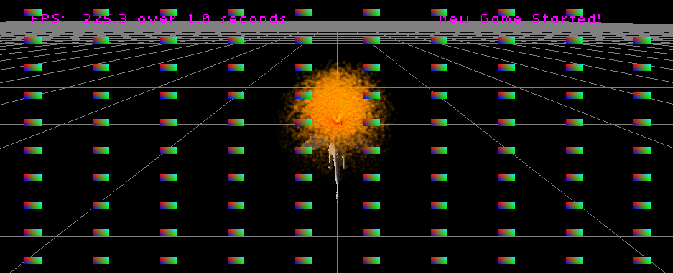
  + **This one shows the final part of the quad requirements shown in the lab doc. The quads are drawn with colors calculated based on the instance ids and some uniforms passed in. Again its cool because I have pointers to the values for uniform data and if I change the values at run time, it will be immediately reflected on the screen.**
  + 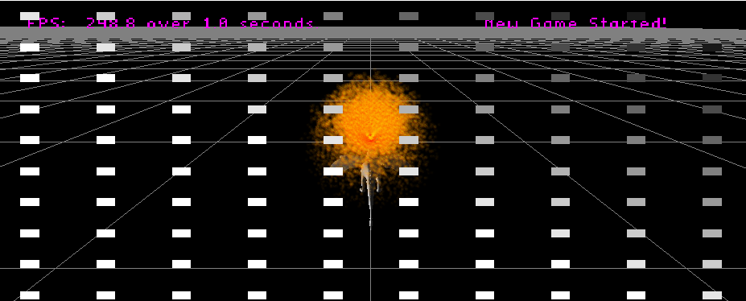
  + **BEHOLD, THE DARGON GALAXY**
  + 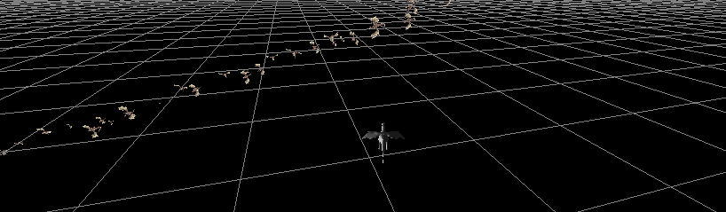
  + **EVEN MORE INSTANCED DARGONS!!!**
  + 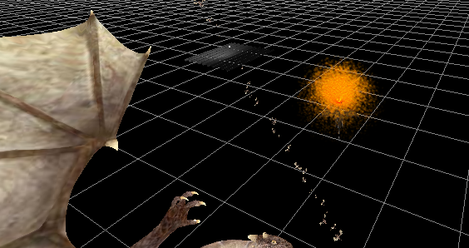

**Post-Mortem**

* WITHHELD DUE TO LAB DUE IN FIVE MINUTES