Lab 05 Geometry shaders

**Fufillment**

* I have met all the requirements for the lab, and even did some extra this time involving mouse input

**Execution**

* I do not believe there should be any unexpected requirements for running

**Controls**

* Pressing the X key will close the application
* Pressing the P key will pause the application, pressing it again will un-pause the application
* Pressing numpad 0 will re-read the config file
* Pressing M, L, T or C will dump engine info to the console, this is pretty much exclusively used for debugging
* Pressing W will rotate BetterDargon to the left, S will rotate him to the right
* Pressing A will tilt BetterDargon forward, D backward
* Pressing Q will roll BetterDargon to the left, E to the right
* Holding space will move BetterDargon forward, in the direction he is facing, releasing will halt movement
* Right clicking and dragging the mouse will turn the camera around BetterDargon
* Scrolling in or out with the mouse wheel should zoom the camera accordingly, up to a minimum or maximum distance
* Pressing j will increase the wireframe distance for dargon
  + It will be altered by less if k is held, and the direction will be negated if shift is held
    - So shift+j is backwards by a lot, j+k is forward by a little, shift+j+k is backward slow
* Pressing 1 will make the second teapot puffier
* Pressing 2 will make it less puffy and invert it (depending on how far you go)
* Pressing N will cycle through the normal hair modes

**Screenshots (NOTE: Humorous comments included deliberately in addition to normal descriptions to make this doc more enjoyable to read. ☺)**

* **Billboards**
  + This screenshot shows an overview of the billboard sector. Note that the bounding volumes are cubes of size n by n by n, and there are one hundred thousand billboarded fractal shaders of each color. This may seem like a boring screenshot, because its so distant the detail cannot be seen – however, it does show that the createpoints method works – the points are all contained within their respective bounding volume – it also shows that the bounding volumes are implemented.

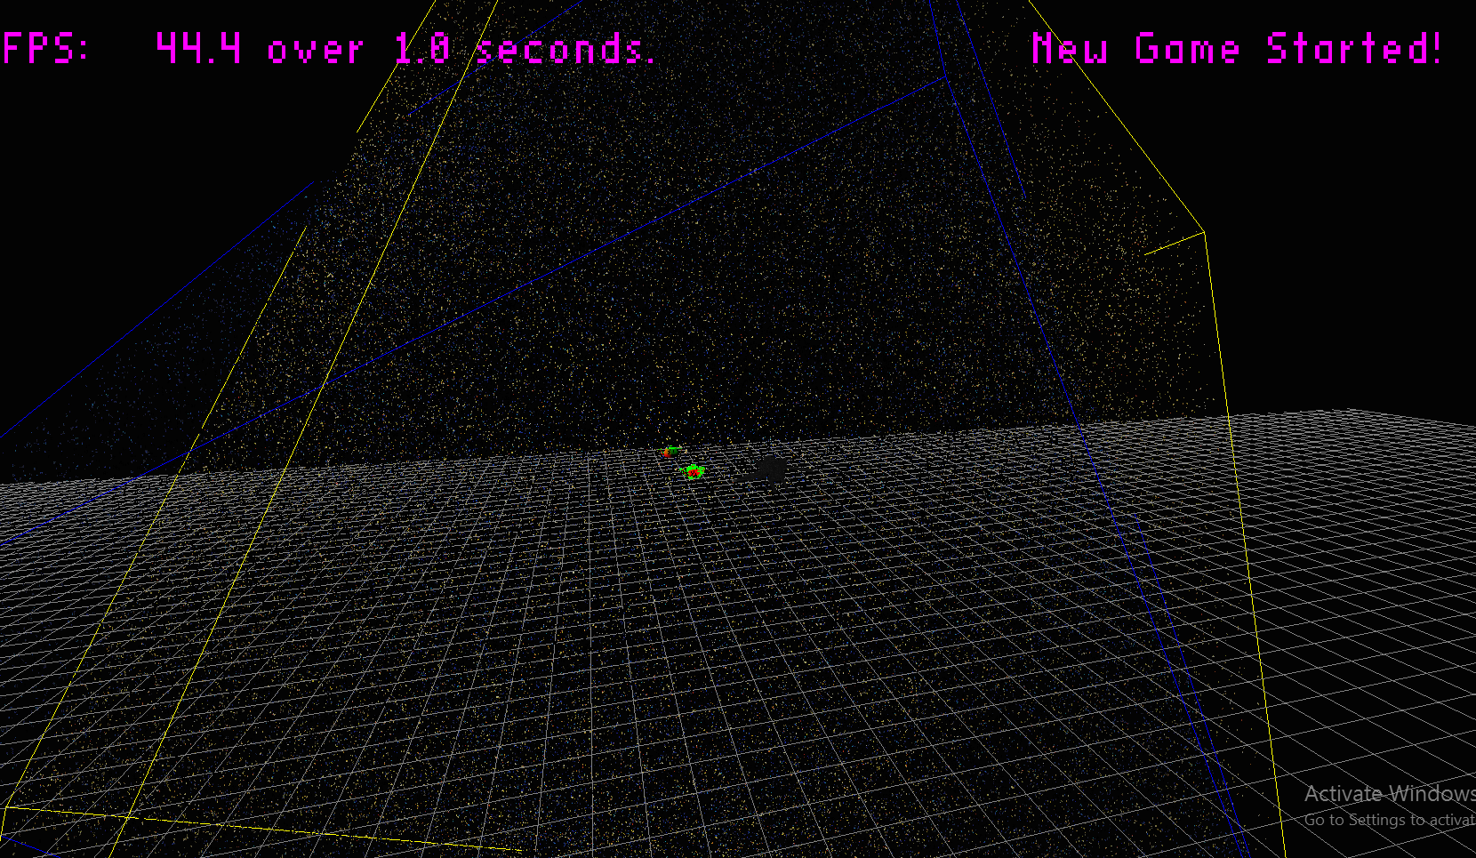

* + The next screenshot shows a close up of a billboarded fractal shader, which is very interesting and super cool looking. Note that it is discarding and does make use of a texture to choose its colors.

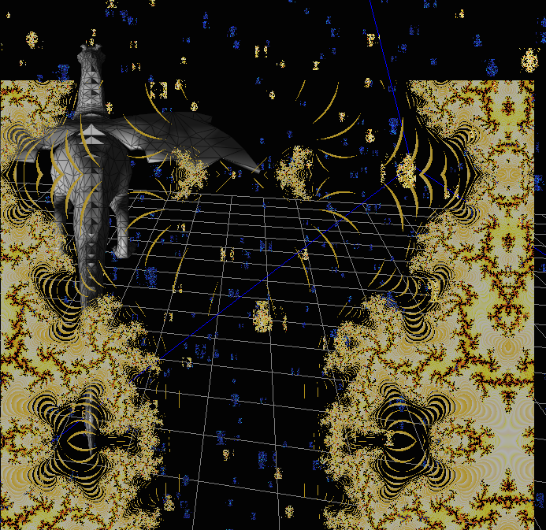

* + The next screenshot shows a fractal billboard facing the light source, as you can see it is well-lit

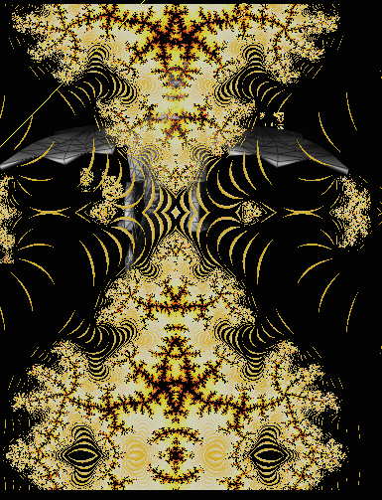

* + The next screenshot shows another fractal billboard, but this one is facing away from the light source. The contrast between the two screenshots shows that the billboards are being lit
  + 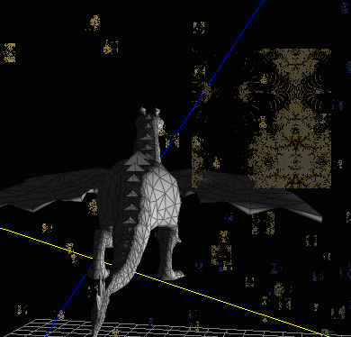
* **Wireframe screenshots**
  + Dargon is shown here with a nice, thin wireframe

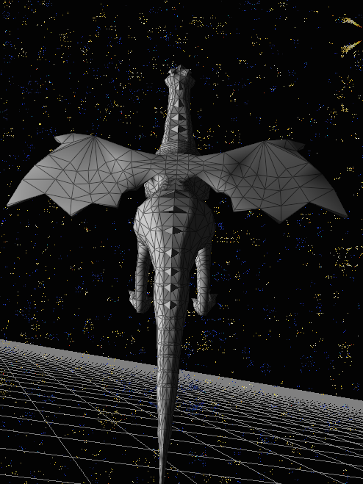.

* + 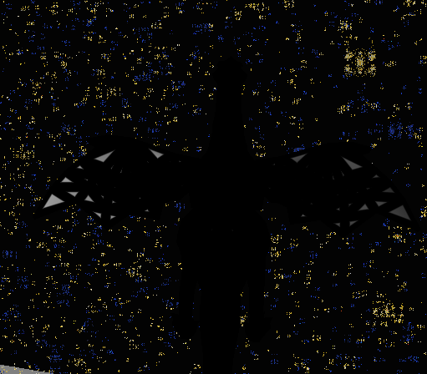The next screenshot shows Dargon with a very thick wireframe, notice how because he is so low-poly you can see some of the mesh underneath despite these huge lines.
  + …
  + Here you can see dargon with wireframes disabled, not drawn with a width of zero

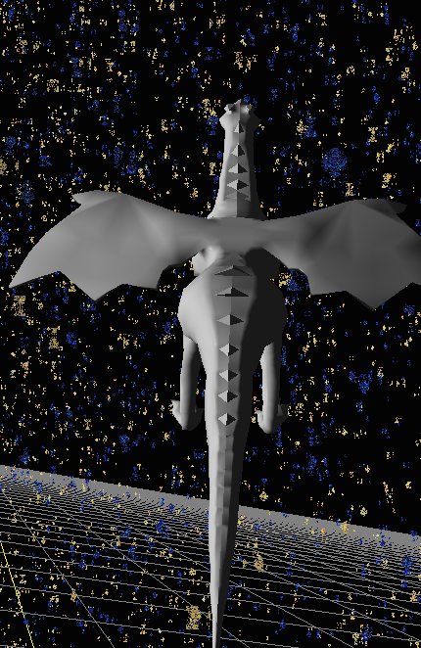

* **Normal Hair Screenshots**
  + Here you can see the teapot used to demonstrate normal hair with face normal hair disabled. Visible are the teapot lines (red) and the vertex normal hairs (green)

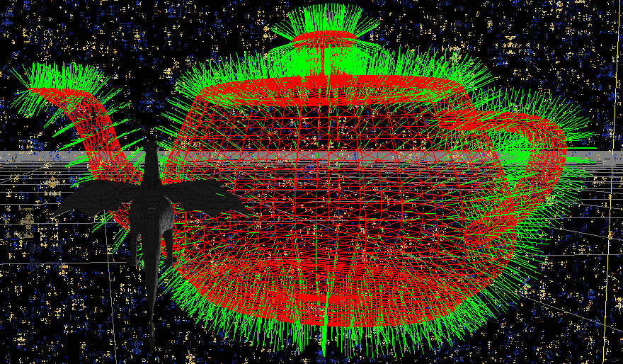

* + Here you can see the teapot with vertex and face normal disabled. Visible are the mesh lines (red)

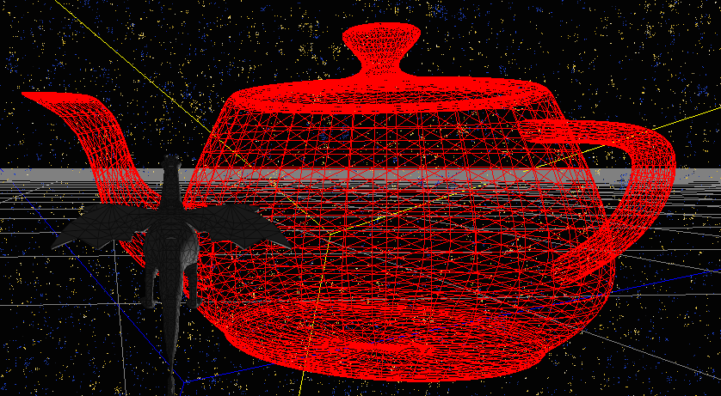

* + Here you can see the teapot with both vertex normal hairs (green) and face normal hairs (blue) as well as the mesh lines (red)

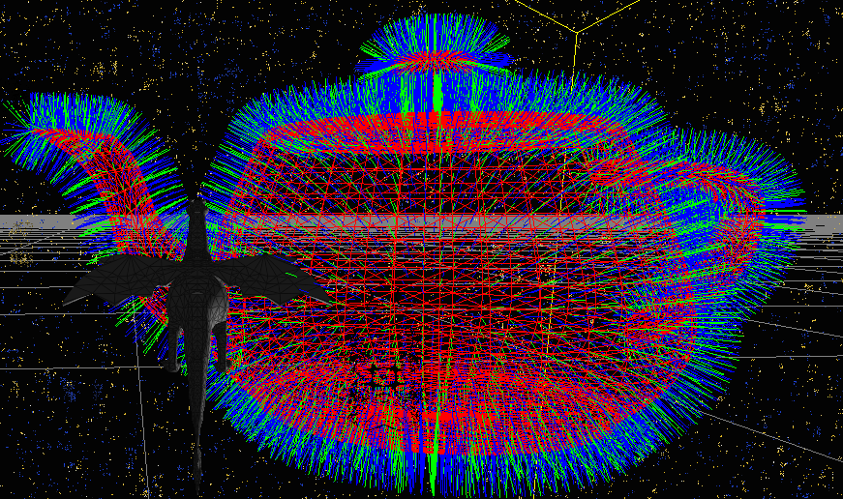

* + Finally, for completeness, included is the teapot with only face normal hairs (blue) and the teapot mesh lines (red)

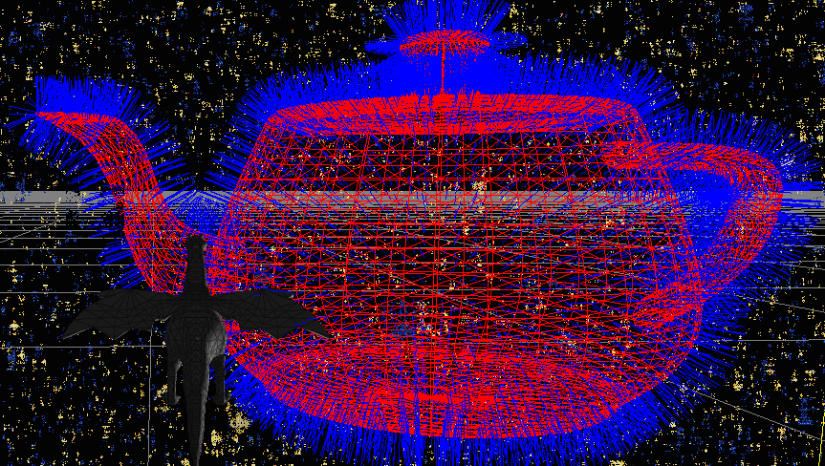

* **Something cool screenshots**
  + I made a teapot-puffer-upper for this – the first screenshot, however, is just for reference, You can see the base teapot here:

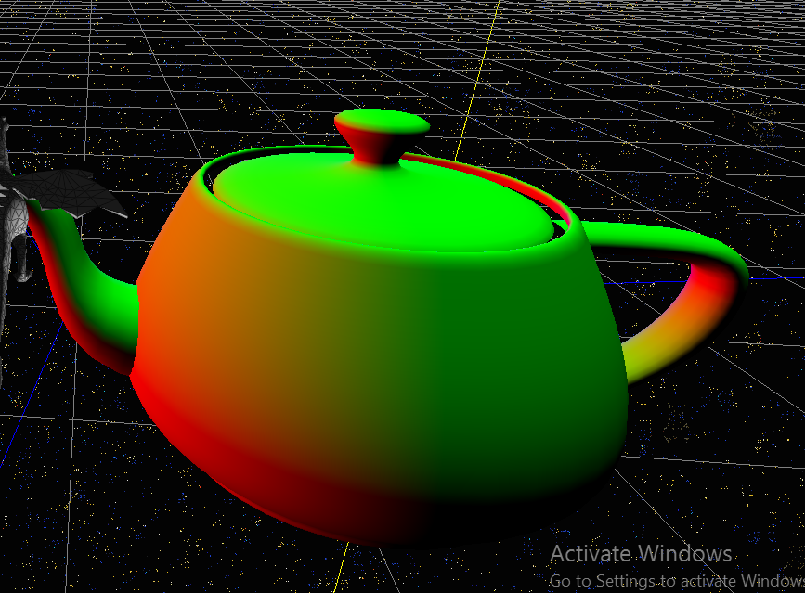

* + Now, you can see the teapot fattened up a little bit, through the application of math

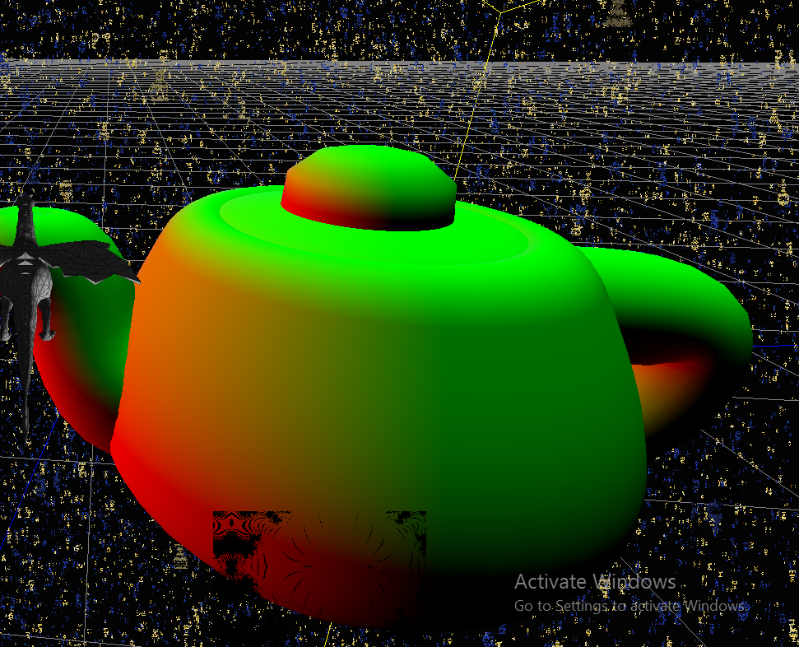

* + And here you can see it even more fattened, with the same amount of math

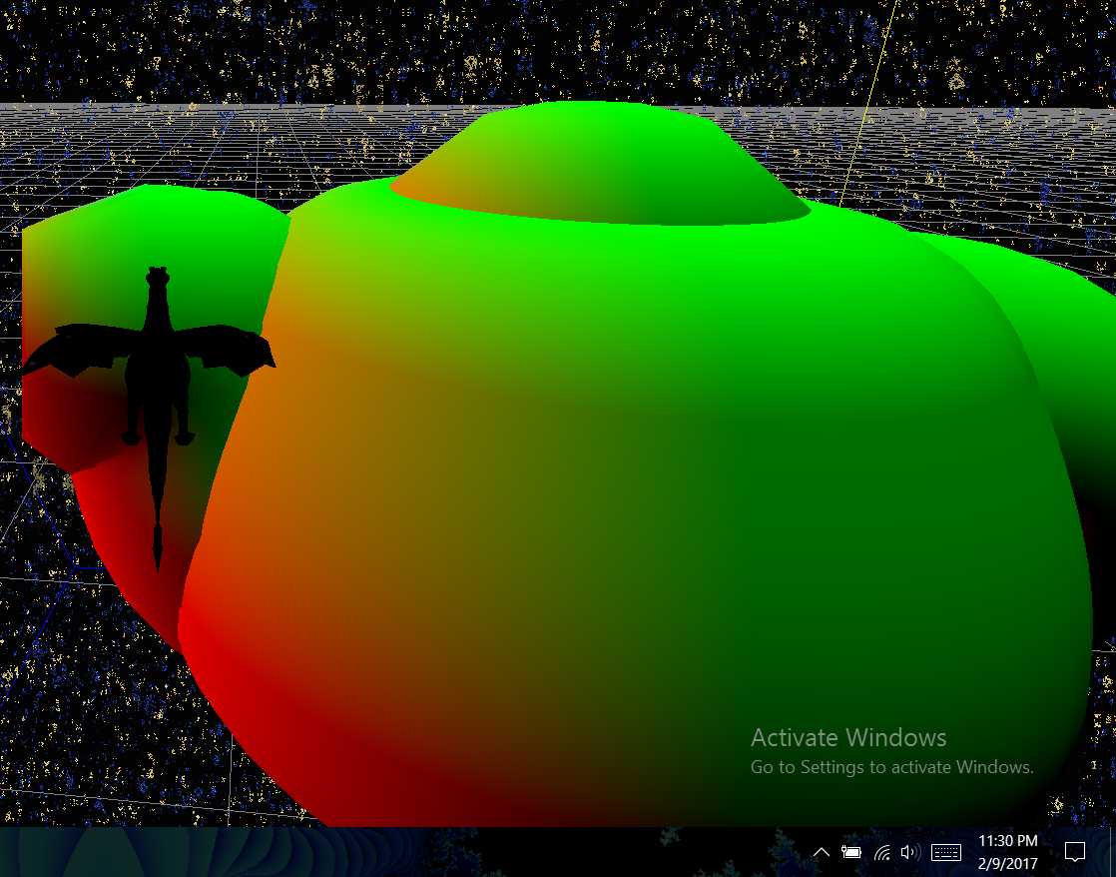

**Post-Mortem**

* My sincerest apologies, but this time there will be no post-mortem, because it is 11:30 and I need to obsessively test my code before I turn it in at the last second.
  + If you’re wondering, this week was exceptionally time-consuming in other classes for a variety of reasons, also I ran into a few issues with this lab that set me back a few days, but here it is, at the last second, barely on time.