Lab 07 ParticleSystems Animations and Instanced Rendering

**Fufillment**

* I got to everything except asteroids, which I may or may not do at a later time because I’m super burnt out…

**Execution**

* I do not believe there should be any unexpected requirements for running

**Controls**

* Pressing the X key will close the application
* Pressing the P key will pause the application, pressing it again will un-pause the application
* Pressing numpad 0 will re-read the config file
* Pressing M, L, T or C will dump engine info to the console, this is pretty much exclusively used for debugging
* Pressing W will rotate BetterDargon to the left, S will rotate him to the right
* Pressing A will tilt BetterDargon forward, D backward
* Pressing Q will roll BetterDargon to the left, E to the right
* Holding space will move BetterDargon forward, in the direction he is facing, releasing will halt movement
* Right clicking and dragging the mouse will turn the camera around BetterDargon
* Scrolling in or out with the mouse wheel should zoom the camera accordingly, up to a minimum or maximum distance
* Pressing the 6 key will reset time, starting the plane waves and particle system over again
* Pressing 7 will toggle 2D instanced stuff in your face over the screen
* Pressing 8 will toggle between the instanced quad versions

**Screenshots (NOTE: Humorous comments included deliberately in addition to normal descriptions to make this doc more enjoyable to read. ☺)**

* **Wavy plane**
  + **Hey look. It’s a plane. It waves. Its got phong lighting. See, the sides facing the light have diffuse plus specular. Woo boring. Next.**
  + 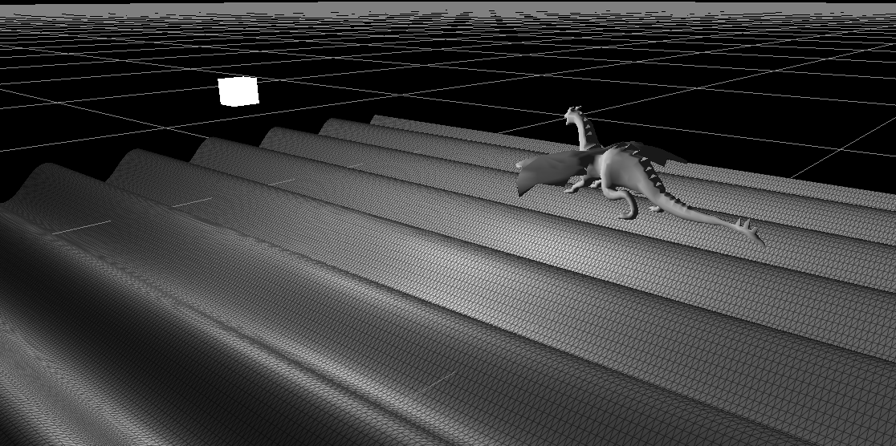
  + **Oh my gosh it’s the same plane from a different angle. Look I put my wireframe shader on it to demonstrate that my plane is actually a bunch of triangles generated in the CreateTessalatedPlane method**
  + 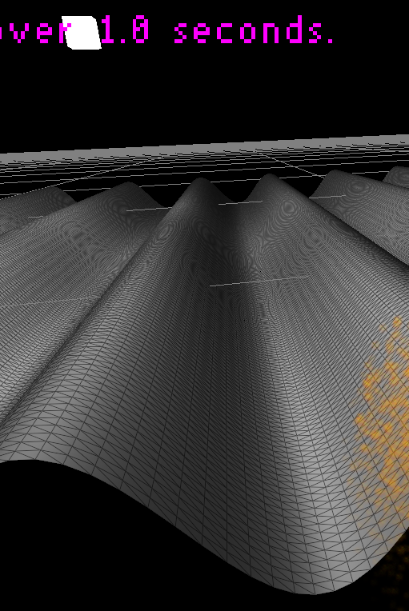
* **Particles**
  + **Finally. Some fire. Took you long enough. Eight weeks in a graphics course to get to fire. 😐**
  + 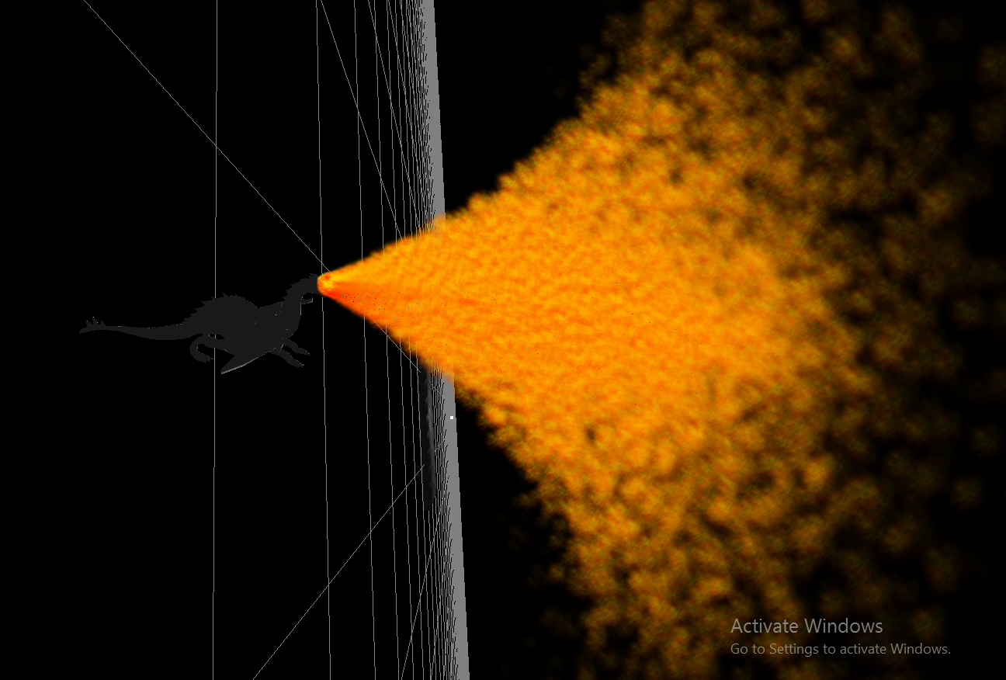
  + **This one shots that the fire follows my dragon and always comes from his mouth, also it shows the particles affected by gravity in world space, which was extra – maybe its enough extra to be given credit? Maybe not. Credit or not, its cool. My dragon breathes fire and I like it. Kinda the only fun part of this lab. Oh yeah, and the particles are billboards. You’re seeing about 25000 of them right now.**
  + 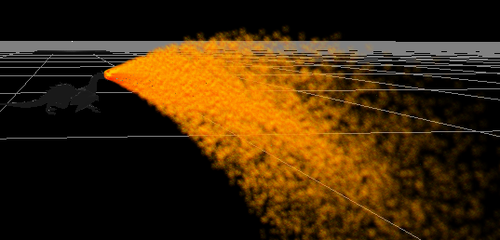
* **Instancing**
  + **Here is the basic instancing shown in the tutorial. It uses a buffer, I made a class for that. The data is sent through an attrib and used to offset the instances with no need for the id in the shader.**
  + 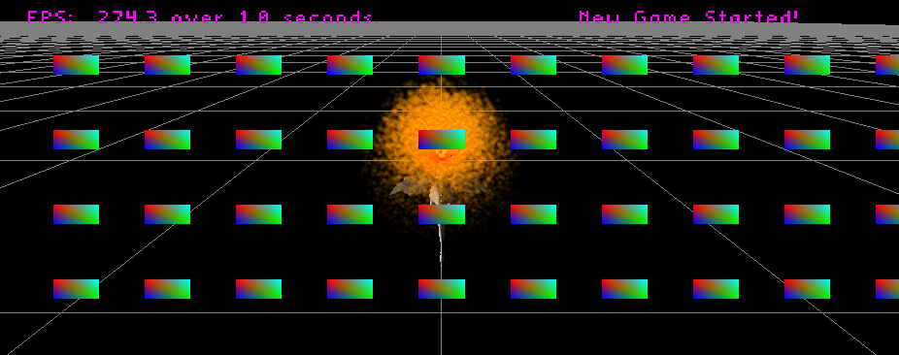
  + **This shows the first set of modifications you requested. The quads can be scaled via uniforms and are drawn with no need for an attrib/buffer because the id is used to calculate their positions along with the uniform number of rows and columns. The thing that makes this cool is that I can change those values dynamically at runtime (I would add a key for that but time constraint) and it would update the instances with no need to make a new buffer or anything.**
  + 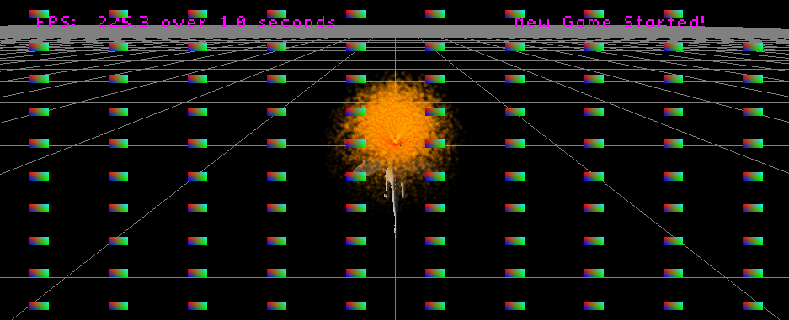
  + **This one shows the final part of the quad requirements shown in the lab doc. The quads are drawn with colors calculated based on the instance ids and some uniforms passed in. Again its cool because I have pointers to the values for uniform data and if I change the values at run time, it will be immediately reflected on the screen.**
  + 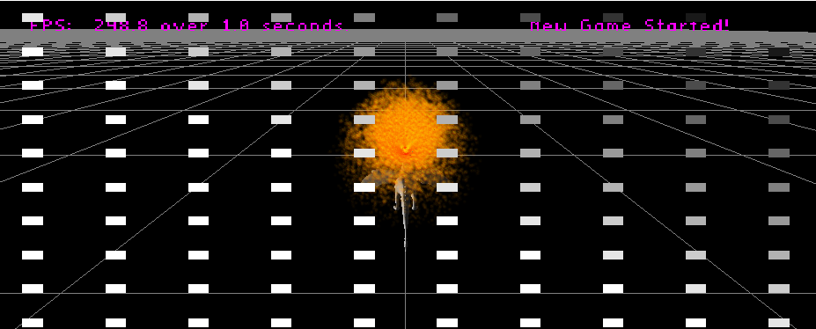
  + **I wanted to do the asteroids, I really did. I just don’t have the time to do it by the due date tonight. Sorry times the million asteroids I wanted to make.**

**Post-Mortem**

* I’m exhausted, not from this lab but from the sum of everything. I want sleep. I want break so I can just not touch a line of code for two weeks. This sprint was just too hard. For a minute I was surprised to hear other students telling me that they were going to not do parts of labs – then it hit me – I’m going to do the same. At some point, its’ just not worth the effort anymore. There. You’ve done it. I’ve finally hit my limits, and I could not be more upset or demotivated because I reminds me that I’m only so good. I hope you’re happy. I could not be more disappointed in myself or my engine than right now. Really. I’m giving up on my engine because it will never be good enough to do everything. I’ll just use Unity or whatever from now on. I also want to revoke my engine. It’s only caused failure in others and I can only just barely force it to work in the mode hideous ways ever because I know every line of code in it. Letting other students use it was a mistake from the beginning, because why make them be lost in a less capable engine when they can be lost in something better. People have been justified with every complaint they’ve made to me about my engine. I hope you can find a better one to share.