Lab08 Something Cool

**Fufillment**

* We did something cool
* Added Music/Sound Effects
* Screen Splitting
* Edge Detection
* Fractals (surprisingly)
* A basic game
* Models

**Execution**

* I do not believe there should be any unexpected requirements for running
* May require Visual Studio 2017 to run properly because Wesley’s computer derped some day and he figured he might as well install 2017

**Controls**

* Pressing the X key will close the application
* Pressing the P key will pause the application, pressing it again will un-pause the application
* Pressing numpad 0 will re-read the config file
* Pressing M, L, T or C will dump engine info to the console, this is pretty much exclusively used for debugging
* Pressing W will rotate BetterDargon to the left, S will rotate him to the right
* Pressing A will tilt BetterDargon forward, D backward
* Pressing Q will roll BetterDargon to the left, E to the right
* Holding space will move BetterDargon forward, in the direction he is facing, releasing will halt movement
* Right clicking and dragging the mouse will turn the camera around BetterDargon
* Scrolling in or out with the mouse wheel should zoom the camera accordingly, up to a minimum or maximum distance
* Left click on the right object to gain points, the wrong object to lose points.

**Screenshots**

* 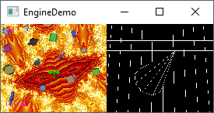
* **Shows small resolution, edge detection, screen splitting**
* 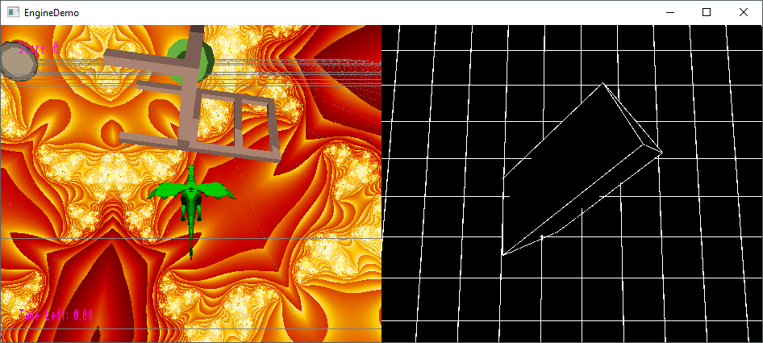
* **Shows different resolution, edge detection, screen splitting**
* 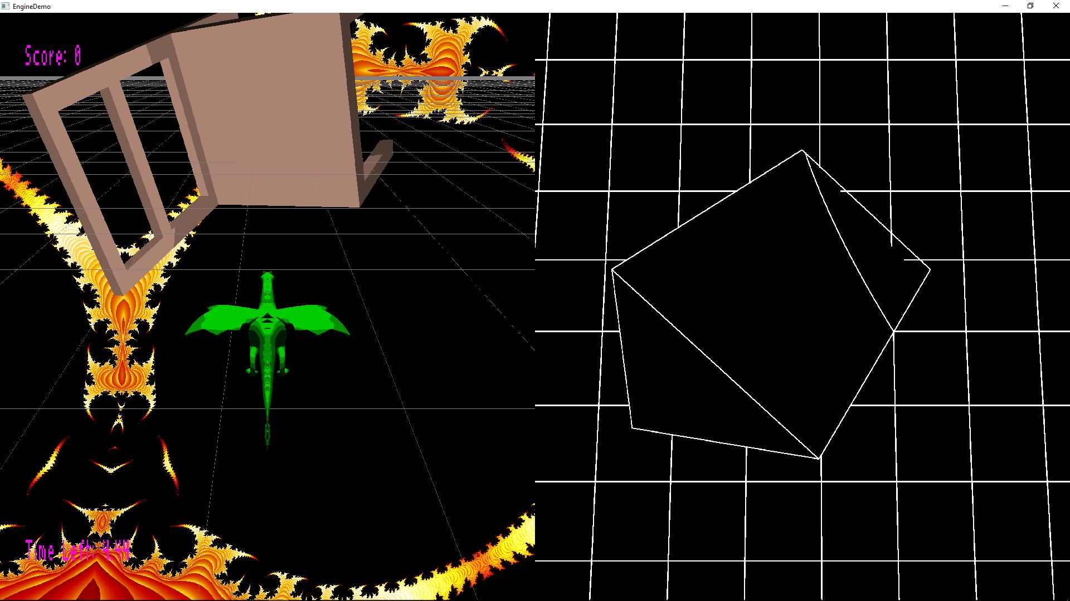
* **Shows edge detection and screen splitting working on yet another perspective**
* 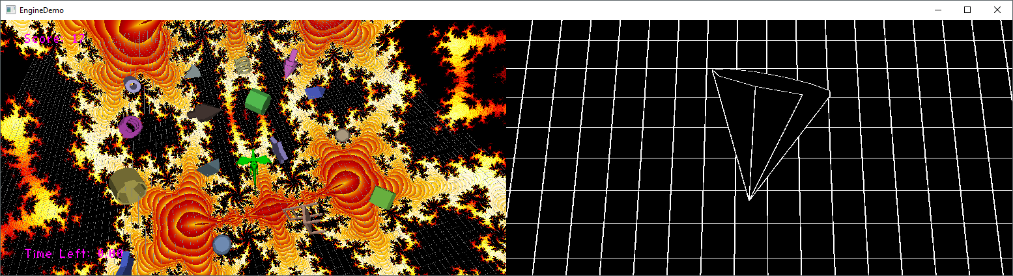
* **More evidence**
* 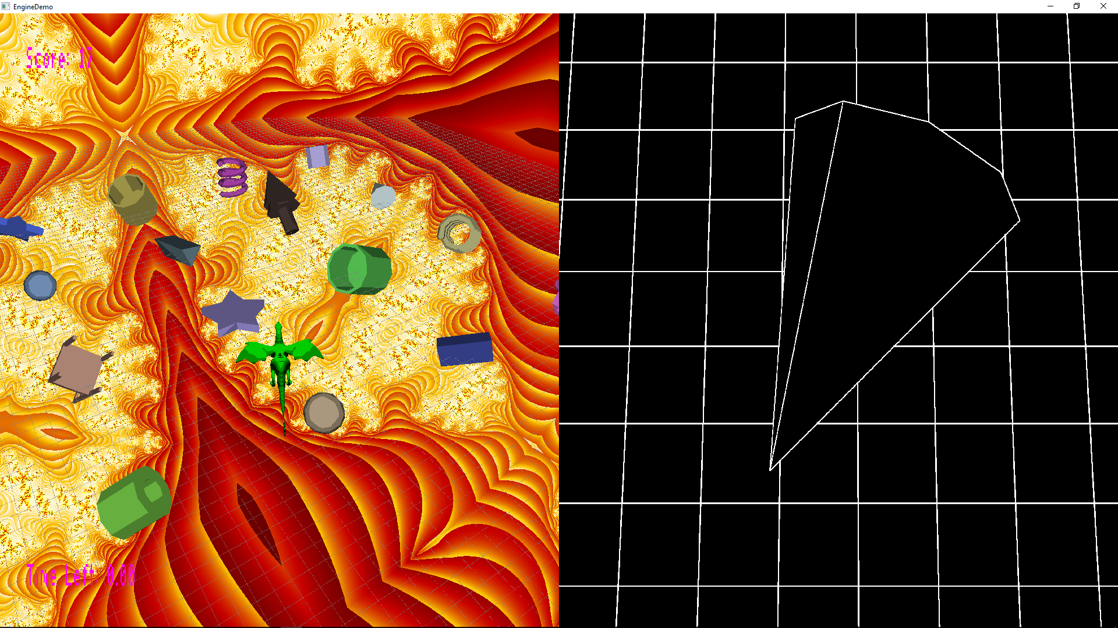
* **More evidence, plus you can see the score, showing our game.**
* **There is sound, but its not visible in the screenshots**

**Post-Mortem**

* We are ready for break