Lab 06 AStarPathing

**Fufillment**

* I finished all the objectives!
* I only did the required portions, not the recommended portions.

**Execution**

* I do not believe there should be any unexpected requirements for running
  + Actually, if you count setting the start-up project in visual studio to world editor or game (or back and forth) that could be a requirement

**Controls (Game)**

* Pressing the X key will close the application
* WASDQE Space – Same Dargon controls as the last multiple quarters…
  + W/S – Pitch
  + A/D – Yaw
  + Q/E – Roll
  + Space move forward relative to BetterDargon
  + Note controls are inverted while upside down
* 0-9 toggle layer visibility and intractability for spatial partitioning
  + U will make all layers visible
  + 2 toggle off node connections and nodes, and toggle on the hideout
  + 3 will toggle on nodes, and toggle off connections and the hideout
  + 4 will toggle on node connections, and toggle off nodes and the hideout
* K will spawn another Red Enemy Dargon if the cap of 100 has not yet been reached
  + One spawns every 10 seconds otherwise
* G will toggle the 3D spatial grid

**Screenshots**

* + **My version control history, as of about 5:33 pm – Two sittings – one to do set up, and another to code everything in**
  + 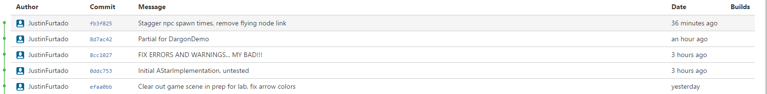
  + **Invasion of the BetterDargons! (100 spawned via spamming spawn key rather than waiting for timer)**
  + 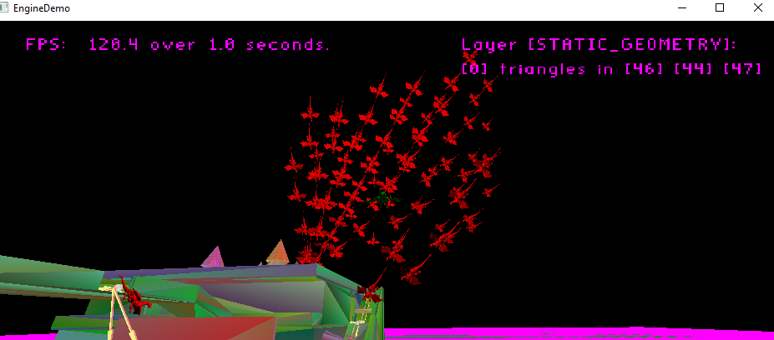
  + **A dargon using a one-way node (down only in this case)**
  + 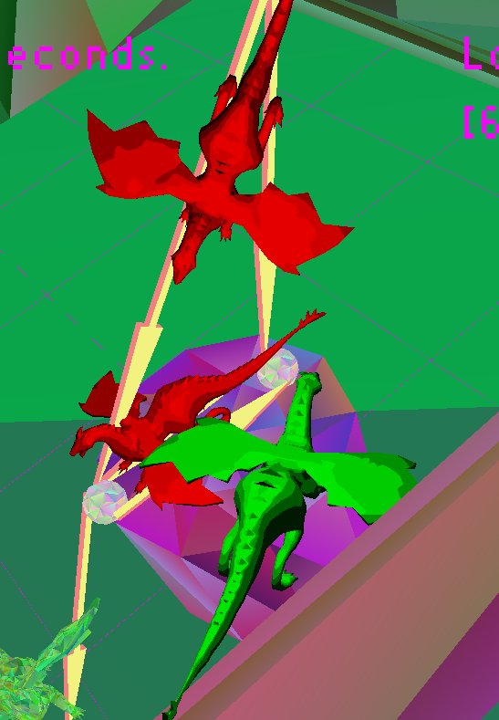
  + **Dargons that went all the way from one roof to the other**
  + 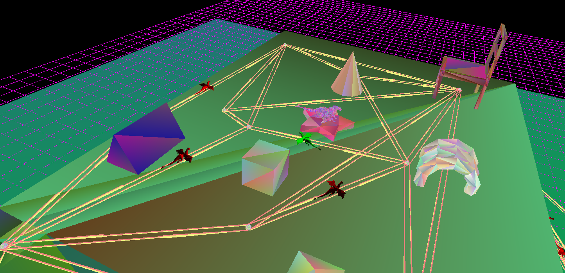
  + **Dargon staircase at rush hour**
  + 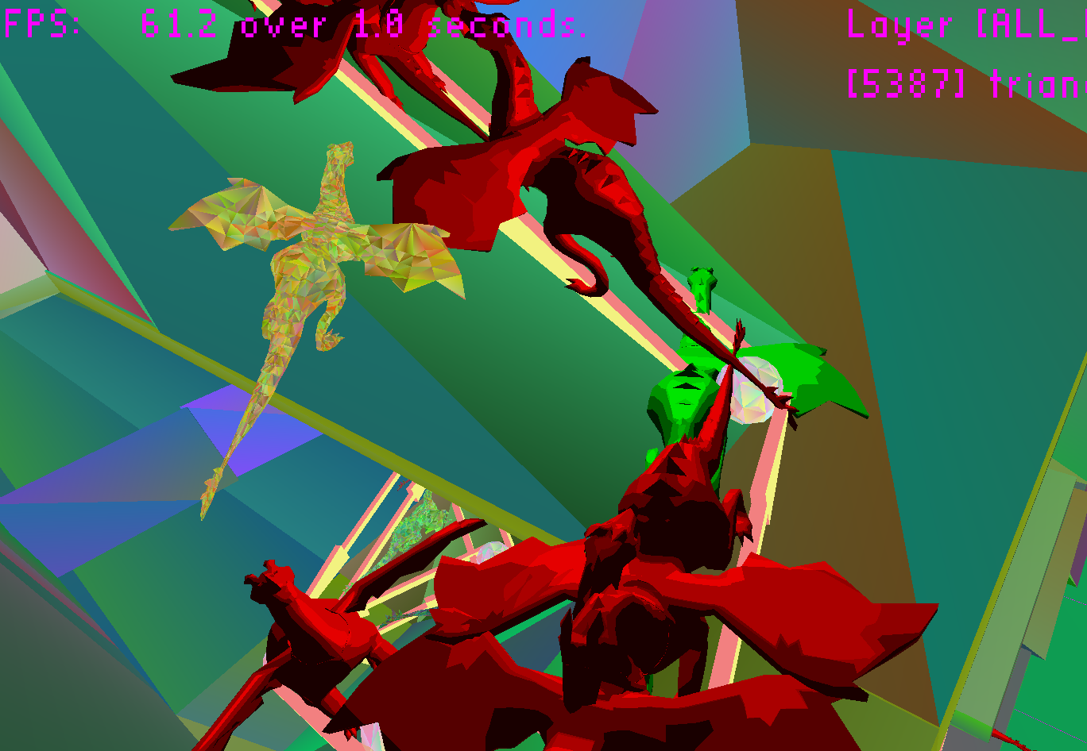
  + **Nodes and dargons**
  + 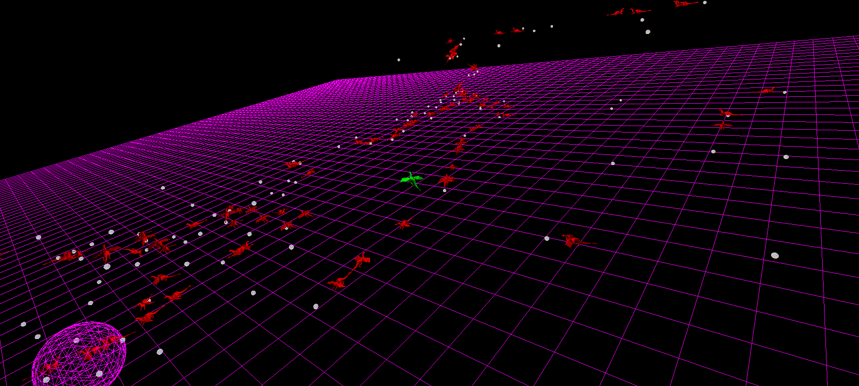
  + **Node connections and dargons**
  + 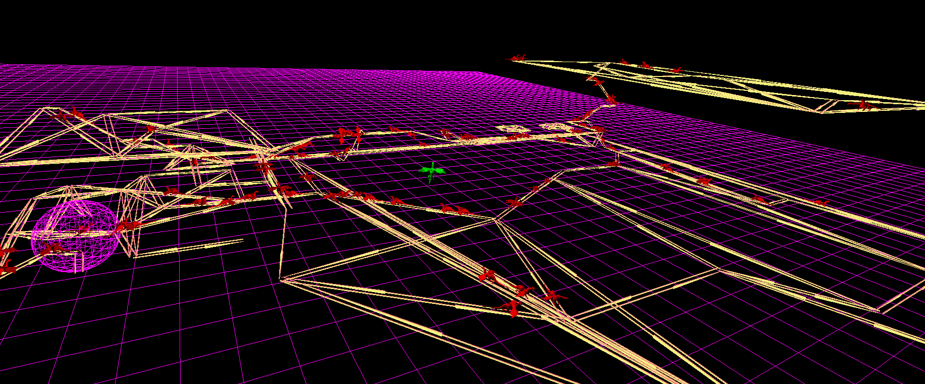
  + **Files are small! Even for my cool custom world!**
  + 

**Post-Mortem**

* **This lab was easier than other recent labs**
  + **4.5 hours, max**
    - **No major bugs (of course bugs, but all < 10 min fixes)**
* **I forgot to take a screenshot, but only 150 log files**
  + **I like to test my game a lot, okay!**
* **I can’t speak for the others, but I found it helpful to go over the algorithm in class before coding it**
  + **Yes, I had done A-Star before, but it was about two years ago and for a 2D grid-based game, which, although does not affect the pathfinding algorithm, does affect the way we find adjacent nodes and obtain distances**