SCRIBER Database Schema
  - Disaster Casualty Management System
22 October 2026 | For review
SCRIBER uses a relational data model centered on casualty_incidents. This report record connects a casualty to an incident and supports repeated assessments, transport, facility care, attachments and review history. The following diagrams and table descriptions explain the 32 entities declared in the project SQL.

Core entity relationship diagram
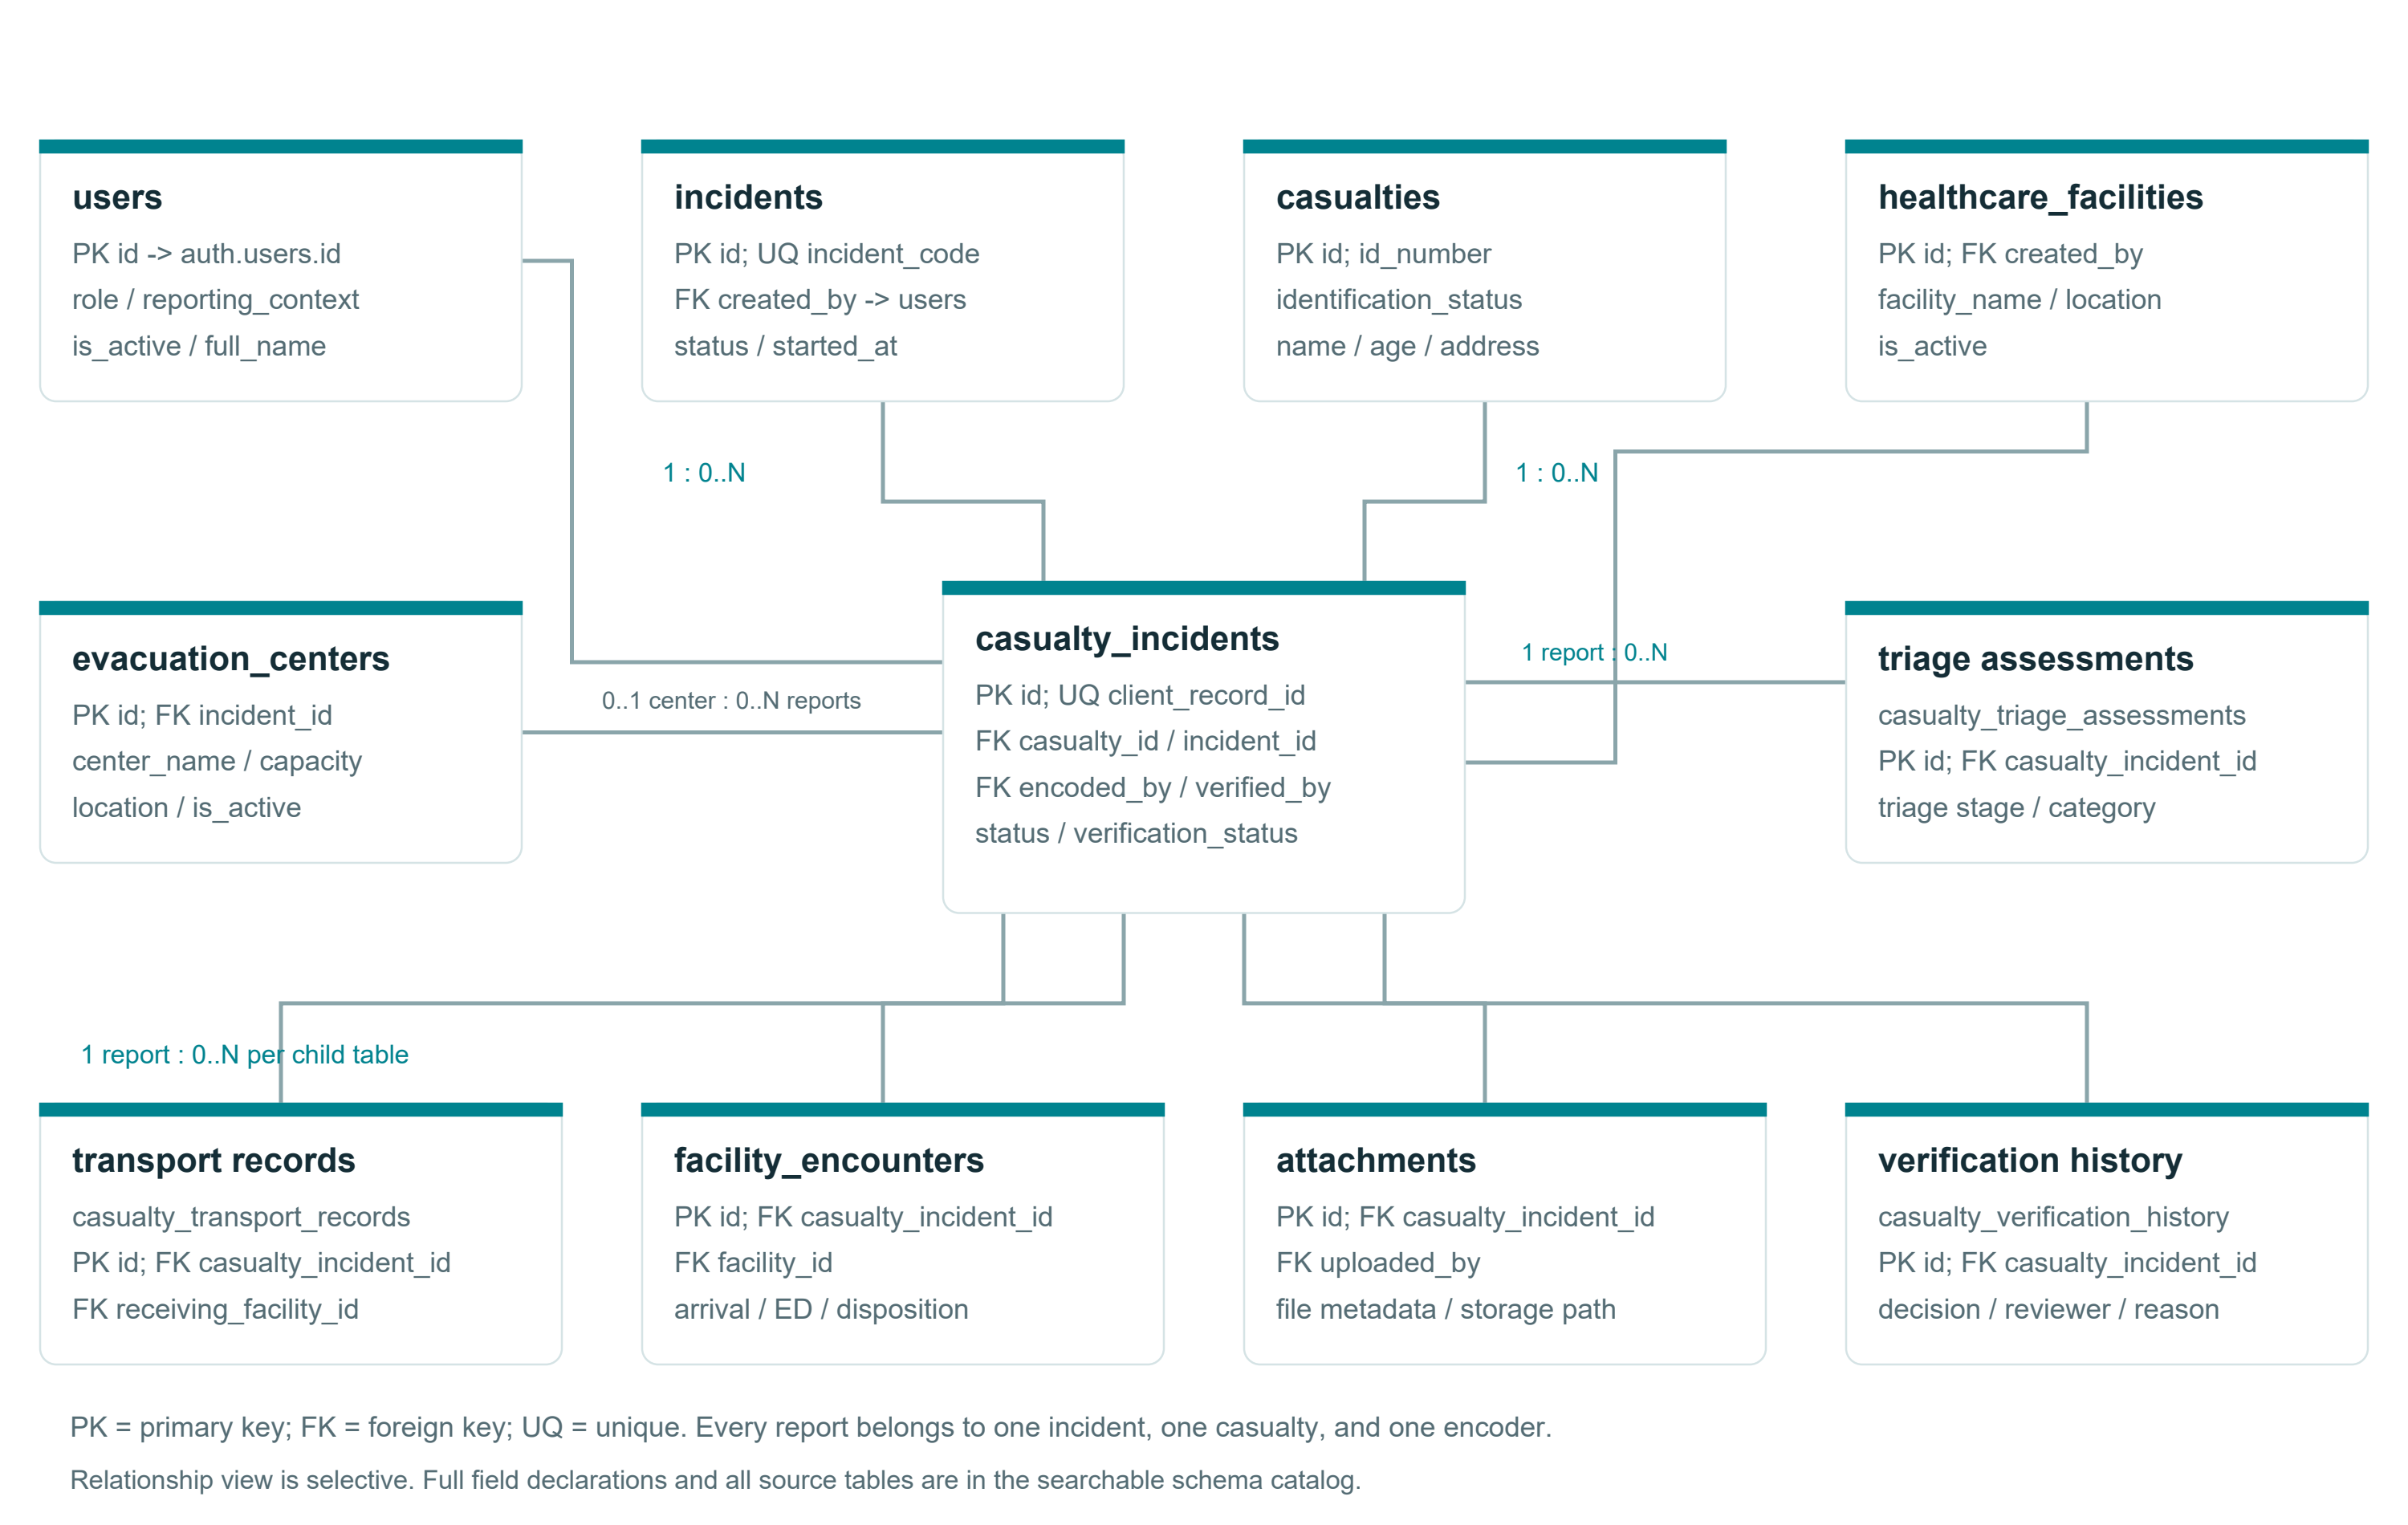
Figure 1 Core entities and selected foreign key relationships
One incident can contain many reports, and one casualty can be referenced by multiple incident reports. Each report has an encoder and can reference a receiving facility or evacuation center. Child records preserve the sequence of assessments and care events. PK identifies a primary key, FK a foreign key, and UQ a unique constraint.

Extended schema relationships
The extensions separate report-level care history from incident-level operational information. This keeps repeated clinical events distinct from staffing, resource and coordination observations.
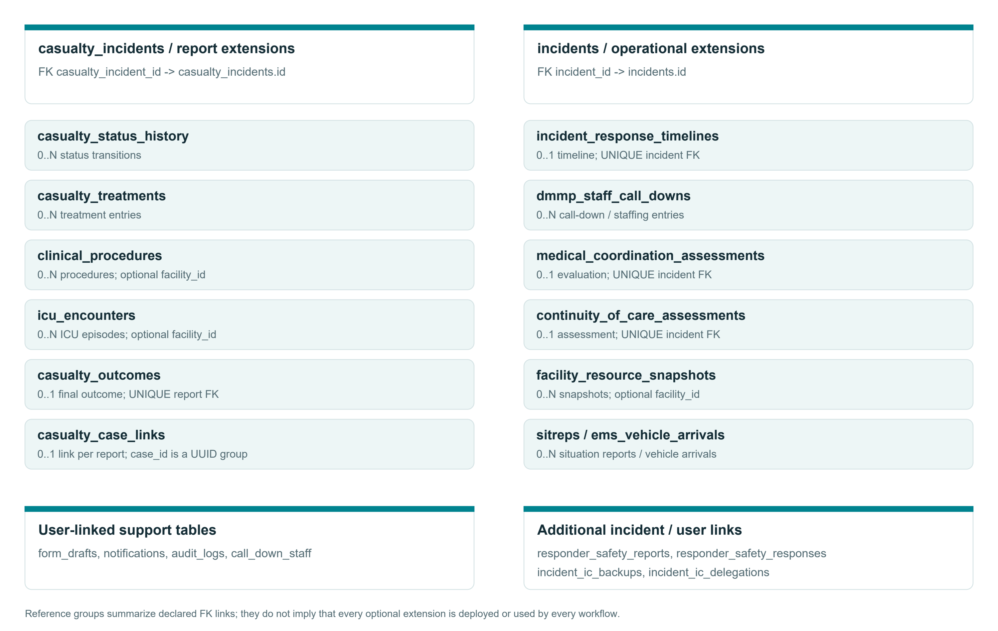
Figure 2 Report extensions and incident operational entities
casualty_outcomes and casualty_case_links declare at most one linked row per report in the reviewed definitions. Several incident assessment tables declare a unique incident link. User-linked support entities provide drafts, notifications, audit activity and staff information. The table descriptions on the following pages explain each entity individually.

Core and support table descriptions
Table | Description
users | Application profiles linked to authentication identities. Stores role, reporting context, active status and administrative ownership information.
incidents | Operational events with incident codes, location, status and ownership. Provides the scope for reports and response activities.
casualties | Person identity and identification details. A person is kept distinct from the reports that describe involvement in an incident.
casualty_incidents | Central report linking a casualty, incident and encoder. Includes a client record identifier, operational status and verification status.
healthcare_facilities | Directory of receiving facilities with location and contact details. Referenced by reports, transport and facility care records.
evacuation_centers | Incident-linked evacuation locations with capacity, contact and location information. Reports can optionally reference a center.
audit_logs | Administrative and operational action records associated with the actor and relevant entity information.
call_down_staff | Staff directory for response mobilization. Entries can link to application users and support call-down records.
form_drafts | User-owned in-progress forms stored as JSON payloads, with form type, title, status and timestamps.
notifications | User-targeted or broadcast messages with notification type, read status and optional related entity information.

Care and report history table descriptions
Table | Description
casualty_triage_assessments | Repeated triage assessments for an incident report, including assessment system, category and recording context.
casualty_transport_records | Movement and transport information for an incident report, with receiving facility and recorded transport details.
casualty_treatments | Treatment and stabilization information linked to an incident report.
facility_encounters | Arrival and emergency department encounter information, disposition and additional hospital care timestamps.
clinical_procedures | Procedure type and timing for an incident report, with an optional facility link.
icu_encounters | ICU admission, discharge and ventilation information for an incident report, with an optional facility link.
casualty_outcomes | Final outcome details for an incident report. Source declarations specify a unique report link.
casualty_case_links | Groups related role-specific reports using case_id. Source uniqueness covers a report link and the case and role pair.
casualty_status_history | Operational status transitions for an incident report, including the actor, reason and time where declared.
casualty_verification_history | Review decisions and verification changes associated with an incident report and reviewer.
attachments | Report-linked file metadata and storage path. The attachment object itself is held in object storage.

Incident operations table descriptions
Table | Description
incident_response_timelines | Incident response timestamps and timeline information. Source declarations specify a unique incident link.
dmmp_staff_call_downs | Mobilization and staffing records for an incident, including links to staff or users where declared.
ems_vehicle_arrivals | Emergency medical service vehicle arrival records for an incident.
medical_coordination_assessments | Incident-level evaluation of medical coordination. Source declarations specify a unique incident link.
continuity_of_care_assessments | Incident-level disruption and continuity assessment. Source declarations specify a unique incident link.
facility_resource_snapshots | Time-specific resource and capacity observations associated with an incident and an optional facility.
sitreps | Incident situation reports with reporting period, summary and preparation or approval information.
responder_safety_reports | Incident-linked responder safety reporting information.
responder_safety_responses | Responder-specific incident safety responses, role or function, arrival and protective equipment timestamps.
incident_ic_backups | Designated backup incident commanders and priority for an incident.
incident_ic_delegations | Temporary acting incident commander assignments, delegation and resumption details. Permanent incident ownership remains separate.

Identifiers and data integrity

Primary keys and foreign keys
UUID primary keys identify application records. Foreign keys connect reports to incidents, casualties and users, and connect child events to their parent report. Optional links require special attention: deleting a referenced record may cascade, be restricted or clear the reference depending on the specific constraint.

Client submission identity
The root schema declares casualty_incidents.client_record_id as unique and required. The creation workflow uses this identifier to recognize an already submitted client record. The database constraint and API behavior must work together when a device retries a submission.

Victim codes and linked cases
The later victim-code migration removes global uniqueness for casualties.id_number because codes may repeat across incidents. The API checks codes within an incident. casualty_case_links groups related reports through a UUID case_id; the reviewed SQL does not declare a separate cases table.

History and timestamps
Use status and verification histories to understand transitions instead of relying only on the latest value in the report. Assessment, transport and encounter timestamps support reconstruction of the care journey. Created and updated timestamps serve record maintenance purposes and should not substitute for event time.

Roles and authorization
Application roles have expanded beyond the original root enum. Role migrations, API guards and deployed database definitions need to agree. Table policies and backend scope checks jointly determine record visibility; administrative server access still requires explicit authorization logic.

Schema maintenance
The project contains overlapping CREATE TABLE and ALTER TABLE declarations. Reconcile the live column definitions, indexes, constraints, enum values and row policies before applying a new baseline or migration. The companion schema-review.sql contains read-only queries for this comparison.

Implementation references
UP-Manila-DB.sql; api/sql/*.sql; api/src/controllers/casualty.controller.ts. Exact table declarations and source filenames are retained in schema-catalog.json.

