SCRIBER System Architecture
  - Disaster Casualty Management System
22 October 2026 | For review
SCRIBER connects field and healthcare facility reporting with a web command dashboard through a shared backend. This document explains how the clients, API and Supabase services exchange data, and how local queuing supports reporting when a connection is unavailable.

System architecture diagram
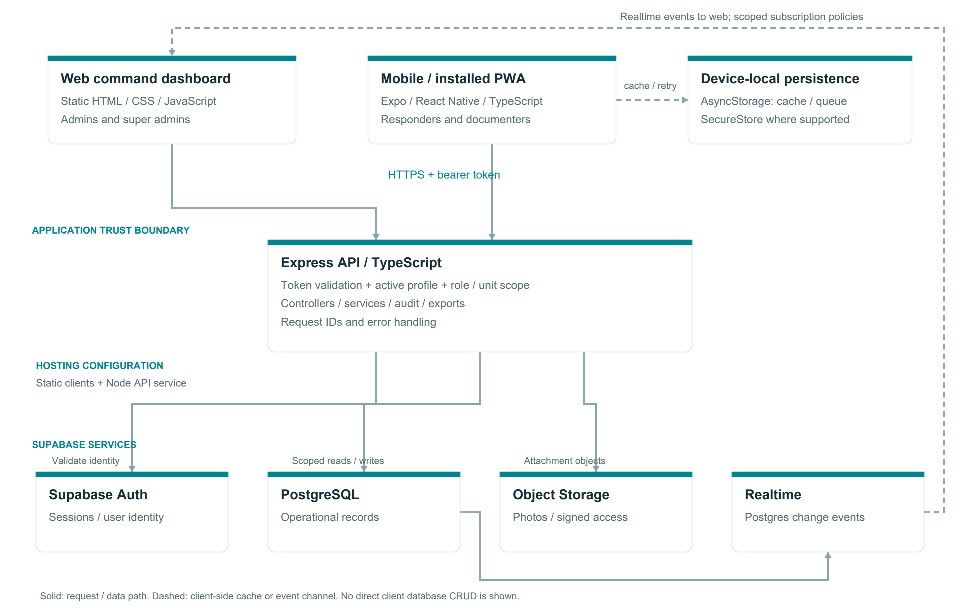
Figure 1 SCRIBER application components and communication paths
The web dashboard supports administration and review. The mobile app supports data capture and report tracking. Both send authenticated requests to the Express API, which coordinates operational records and attachments with Supabase. Dashed connections identify local persistence and event delivery.

System components and responsibilities
Component | Responsibility
Web dashboard | HTML, CSS and JavaScript interface for incident setup, account administration, casualty review, facilities, analytics and exports.
Mobile app and PWA | Expo and React Native interface for responders and documenters. Provides incident selection, role-aware entry, records, attachments and submission status.
Express API | TypeScript routes, controllers and services validate requests, apply authorization rules, manage records, generate exports and record audit activity.
Supabase Auth | Maintains authentication identity and sessions. API middleware validates bearer tokens and loads the active application profile.
PostgreSQL | Stores incidents, casualty identity, incident reports, operational events, clinical records, histories and administrative data.
Supabase Storage | Stores attachment objects. The API associates object metadata with reports and supplies attachment access to authorized clients.
Supabase Realtime | Delivers database change events to dashboard subscriptions so relevant views can refresh. Publication membership and row policies control availability and visibility.
Device persistence | AsyncStorage holds cached incident choices and queued submissions. Session storage depends on the platform, with SecureStore used where supported.

Deployment responsibilities
The repository separates the static dashboard, the Expo web export and the Node API service. The clients receive an API base URL; server configuration supplies the Supabase connection settings. Database, authentication, storage and realtime services share the operational backend. Hosting configuration is represented by netlify.toml and render.yaml.

Operational data flow

Authentication and access
The client obtains a session through the authentication workflow and sends the bearer token with API requests. Middleware checks the token and the active user profile. Role guards and controller scope checks determine which incident and casualty operations the caller can perform.

Online casualty submission
A responder selects an active incident and completes the appropriate report fields. The client submits the payload to the API. The creation workflow checks the client record identifier, writes the casualty and incident report data, and records related assessment or transport information where provided.

Offline submission and recovery
After incident options have been cached, a user can prepare a report without API connectivity. The local queue retains the payload, owner association, attachment data, attempt count and status. On retry, the client submits queued work and tracks failures or partially completed uploads. Queued work must remain visible until synchronization completes.

Verification and dashboard refresh
A submitted report becomes available to authorized reviewers. Review actions change verification status and retain review history. Dashboard subscriptions react to relevant database events, while refresh behavior depends on the configured publications, policies and view logic.

Attachments and traceability
Attachment objects and report metadata have separate storage responsibilities. An upload must be associated with the correct incident report. Audit and history records preserve significant actions so reviewers can understand changes over time.

Implementation references
api/src/app.ts; api/src/middleware/auth.ts; api/src/controllers/casualty.controller.ts; website/app.js; mobile/src/offline/casualtyQueue.ts; netlify.toml; render.yaml.

