SCRIBER Wireframes
  - Disaster Casualty Management System
22 October 2026 | For review
The SCRIBER interface separates command review from field reporting. The web dashboard organizes incidents and incoming reports, while the mobile app guides a responder through entry, review and submission. These wireframes show the layout and explain how users move between screens.

Web dashboard wireframe
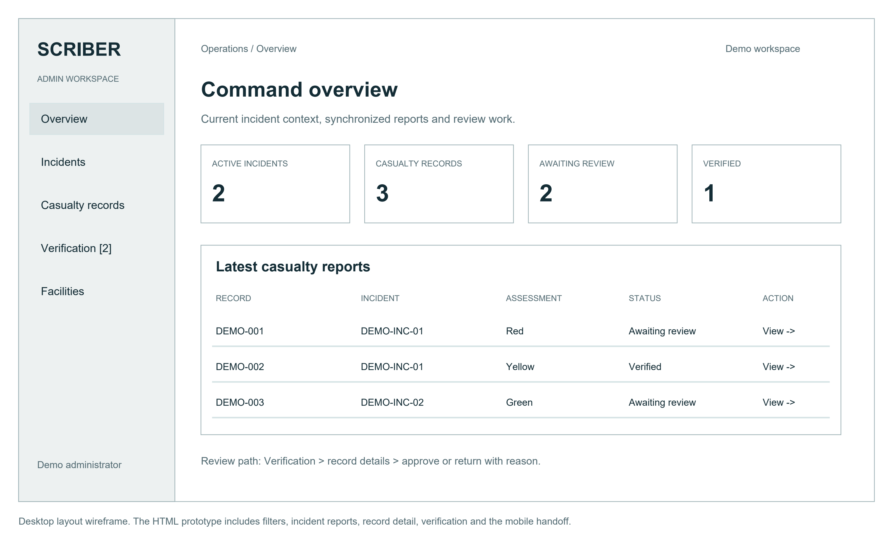
Figure 1 Desktop dashboard with navigation, summary metrics and casualty reports
The left navigation provides access to overview, incidents, casualty records, verification and facilities. Summary cards show incident and report counts. The report table presents the record identifier, incident, assessment label, verification state and a detail action. The verification count keeps pending review work visible.
A reviewer opens a submitted report to inspect its details and history. Approval changes its status to verified. Returning a report requires a correction reason so the reporting team can understand the requested change.

Mobile identity entry and submission review
Identity entry establishes the active incident and the casualty name or temporary unidentified label. Age is optional. The assessment step follows identity entry; the review screen then brings the entered information together before submission.
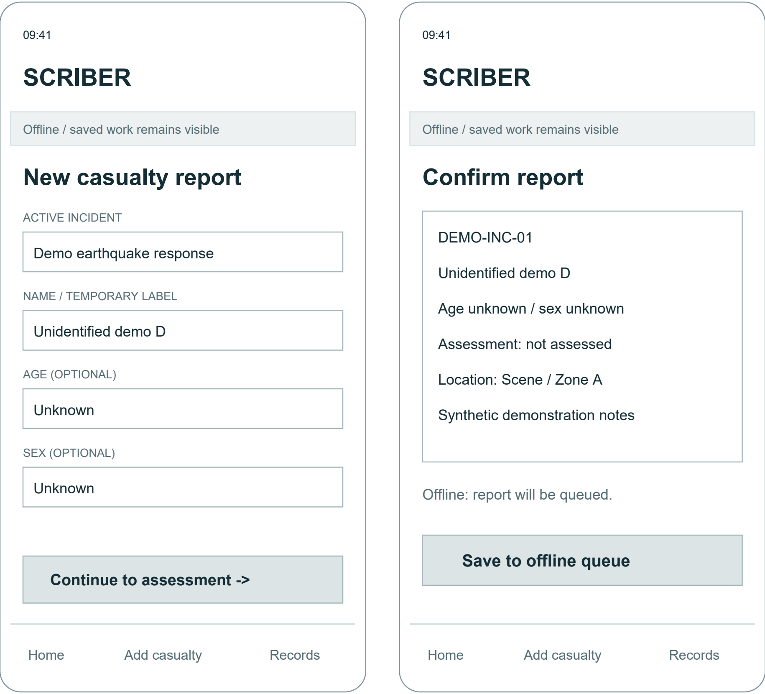
Figure 2 Mobile identity entry on the left and report review on the right
The identity screen groups a small number of fields above the continue action. The review screen repeats the incident, identity, assessment and location, and changes the primary action to match connectivity. Back navigation preserves draft values so the user can correct an earlier step.

Mobile records and offline queue
The Records screen distinguishes work still held on the device from reports already submitted for command review. The connection banner and textual status labels explain the next available action.
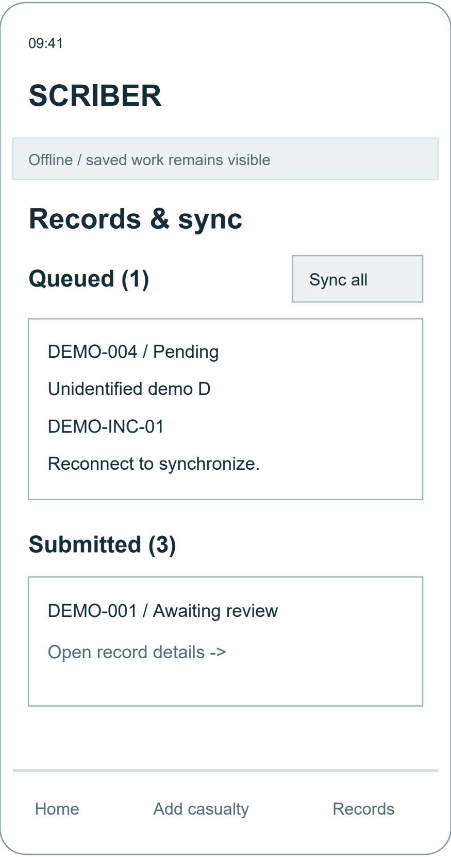
Figure 3 Pending report and submitted reports on the mobile Records screen
A report saved while offline remains pending in the local queue. After reconnecting, Sync all submits queued work and moves completed submissions into the shared register. A report must retain its client identity across retries to avoid duplicate creation. Failed or partially completed work needs a visible recovery action in the operational app.

Screen descriptions and interaction rules
Screen | Purpose and main actions
Web overview | Scan the current response context, synchronized report totals, assessment distribution and latest reports.
Web incidents | Select an incident and open its associated reports.
Web casualty records | Search by name or identifier and filter by incident or verification status. Open record details and history.
Web verification | Inspect submitted reports, approve a record or return it with a required correction reason.
Web facilities | Inspect the receiving facility directory and displayed capacity context.
Mobile home | See the current incident and queue summary, then begin a casualty report or open Records.
Mobile identity | Choose the incident and enter a name or temporary label, optional age and sex information.
Mobile assessment | Enter the assessment label, location and report notes before reviewing the report.
Mobile review | Confirm the entered details, return to edit, or submit to the server or local queue according to connectivity.
Mobile records | Track queued and submitted work, synchronize after reconnecting, and inspect review status and feedback.

Validation and accessibility
The demonstration requires an active incident and a name or unidentified label. An entered age must fall between 0 and 130. Status is expressed with text as well as color, and assessment colors are user-entered labels. Clear focus indicators, readable field labels and large mobile actions support navigation and touch input.

Implementation references
website/index.html; website/app.js; website/styles.css; mobile/src/app; mobile/src/offline/casualtyQueue.ts. The retained review prototype defines the illustrated interactions and uses demonstration records.

