SCRIBER Figure 2 Extended Schema Entity Relationship Diagram
Readable replacement for the report extensions and incident operational entities
The previous Figure 2 summary was too dense when inserted as one raster image. This replacement separates the logical design into four focused ERD figures. Each table-shaped node shows its primary key and important foreign keys, while connector labels show the relationship cardinality. The figures are intended to be read directly in the document at normal page size.

Figure 2A Casualty report core and care records
The casualty report is anchored by casualty_incidents. It joins a person identity to an incident and owns triage, transport, treatment and facility encounter records.
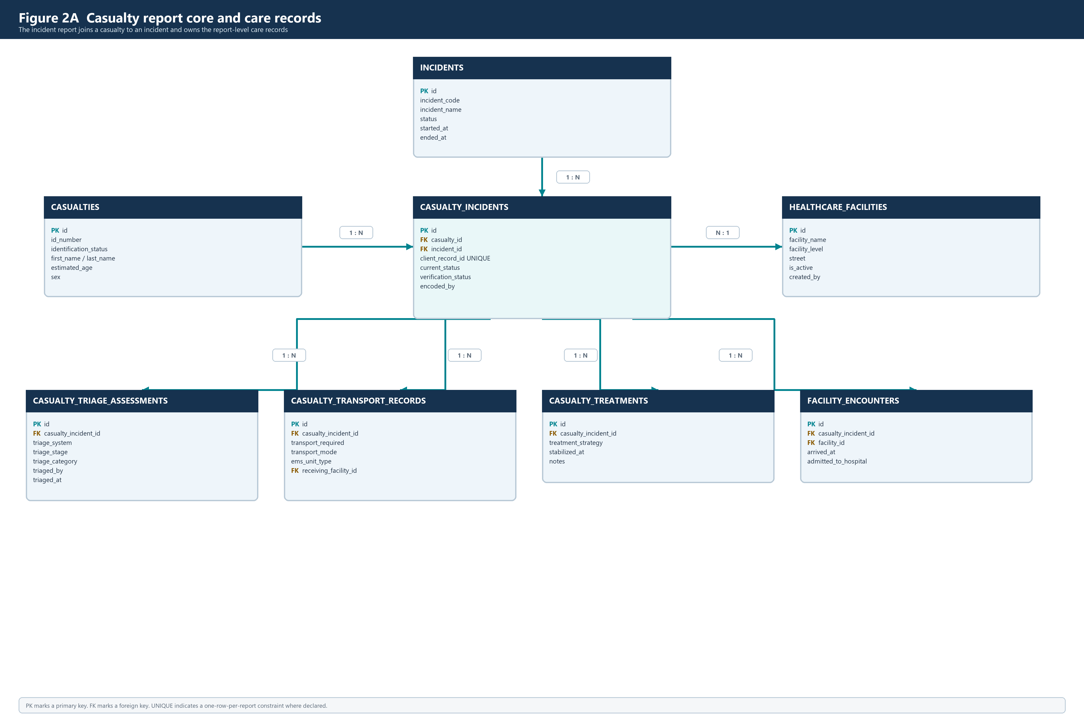
Figure 2A Casualty report core and care records entity relationship diagram

Figure 2B Report history and clinical extensions
These entities preserve report transitions, verification decisions, clinical procedures, ICU care, outcomes, case matching and stored attachments.
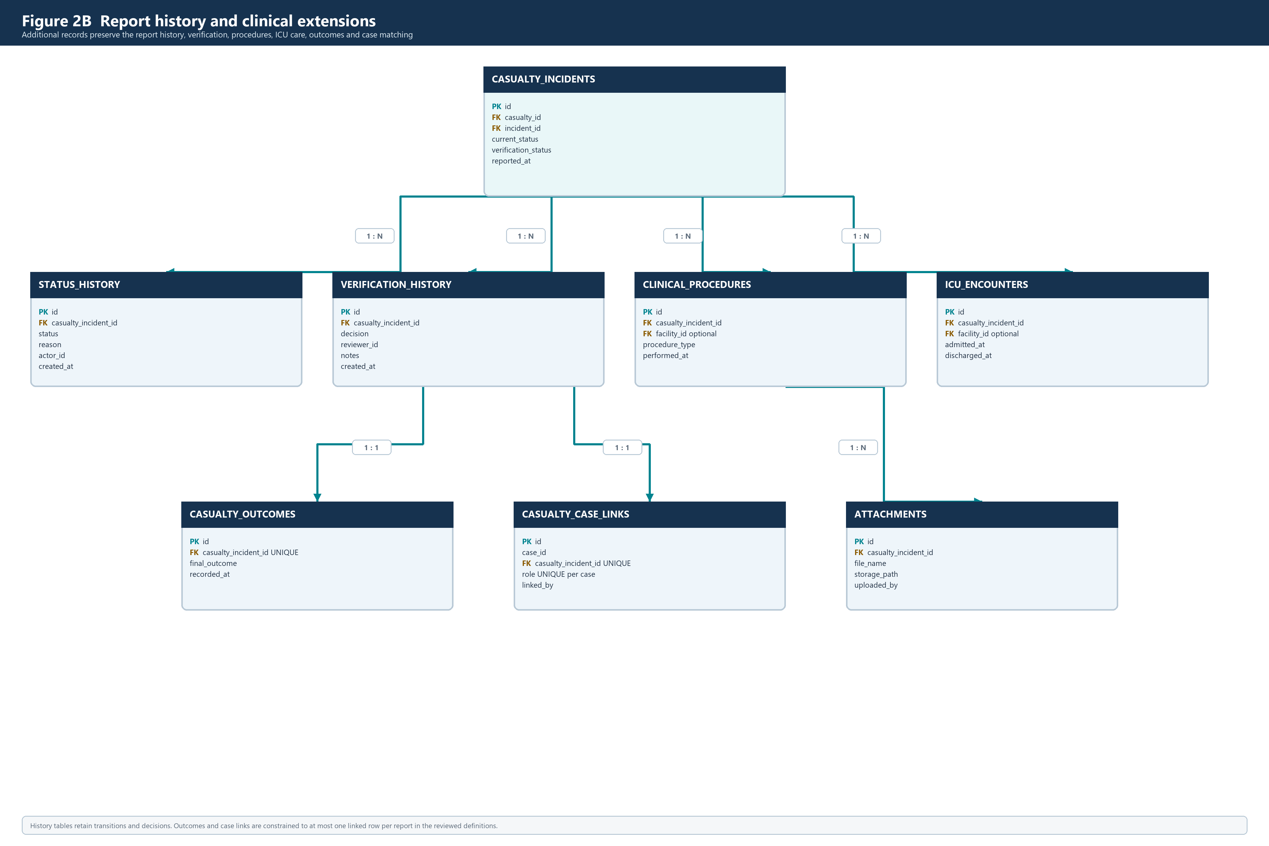
Figure 2B Report history and clinical extensions entity relationship diagram

Figure 2C Incident operations
These entities are scoped directly to incidents and support the response timeline, staffing, coordination, continuity, EMS, resources, SitReps and safety records.
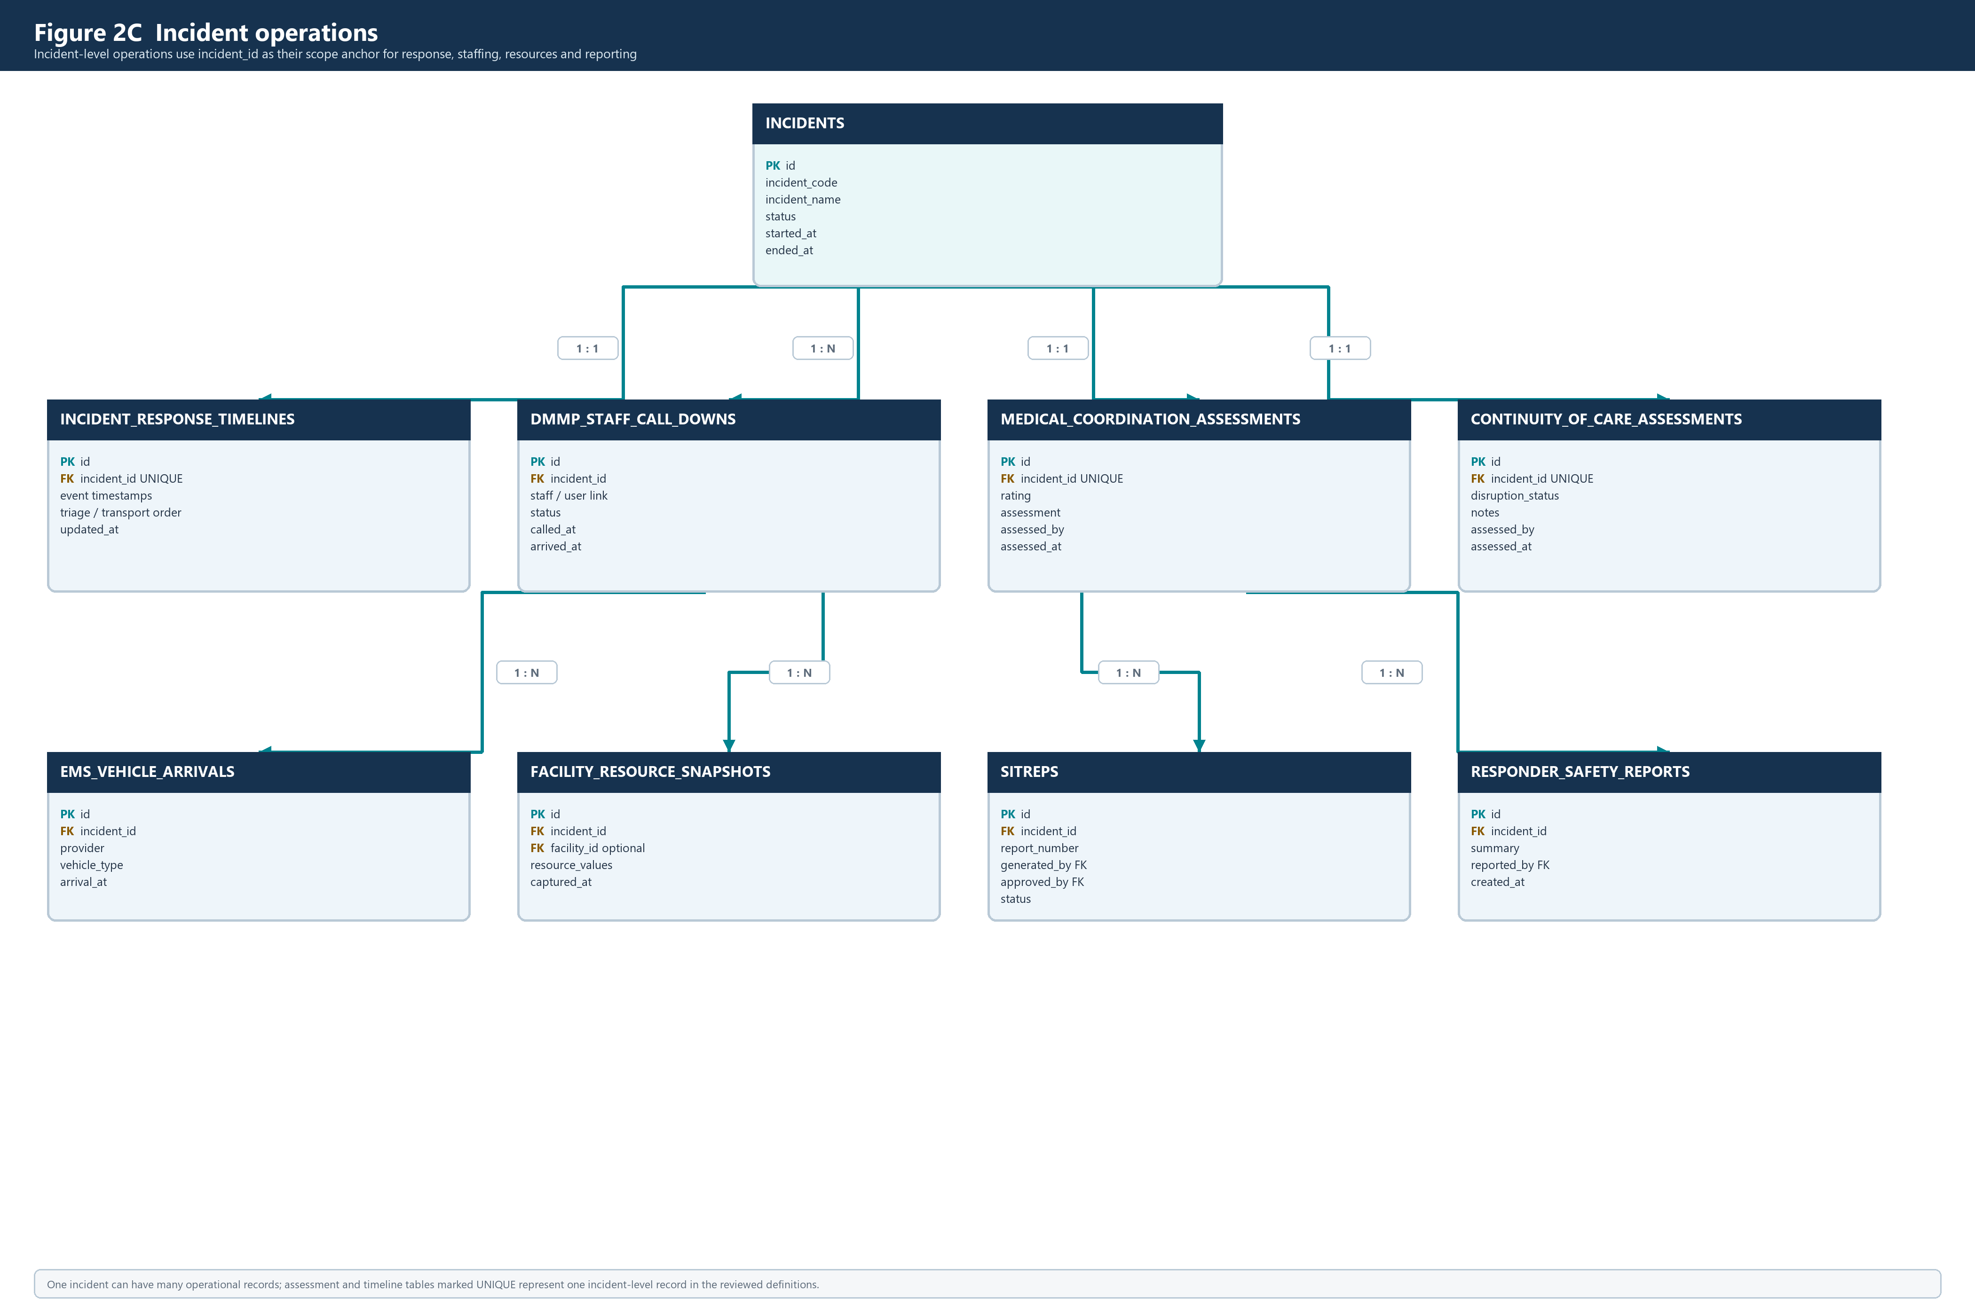
Figure 2C Incident operations entity relationship diagram

Figure 2D User linked support and control records
These entities connect users to drafts, notifications, audit activity and incident command continuity records.
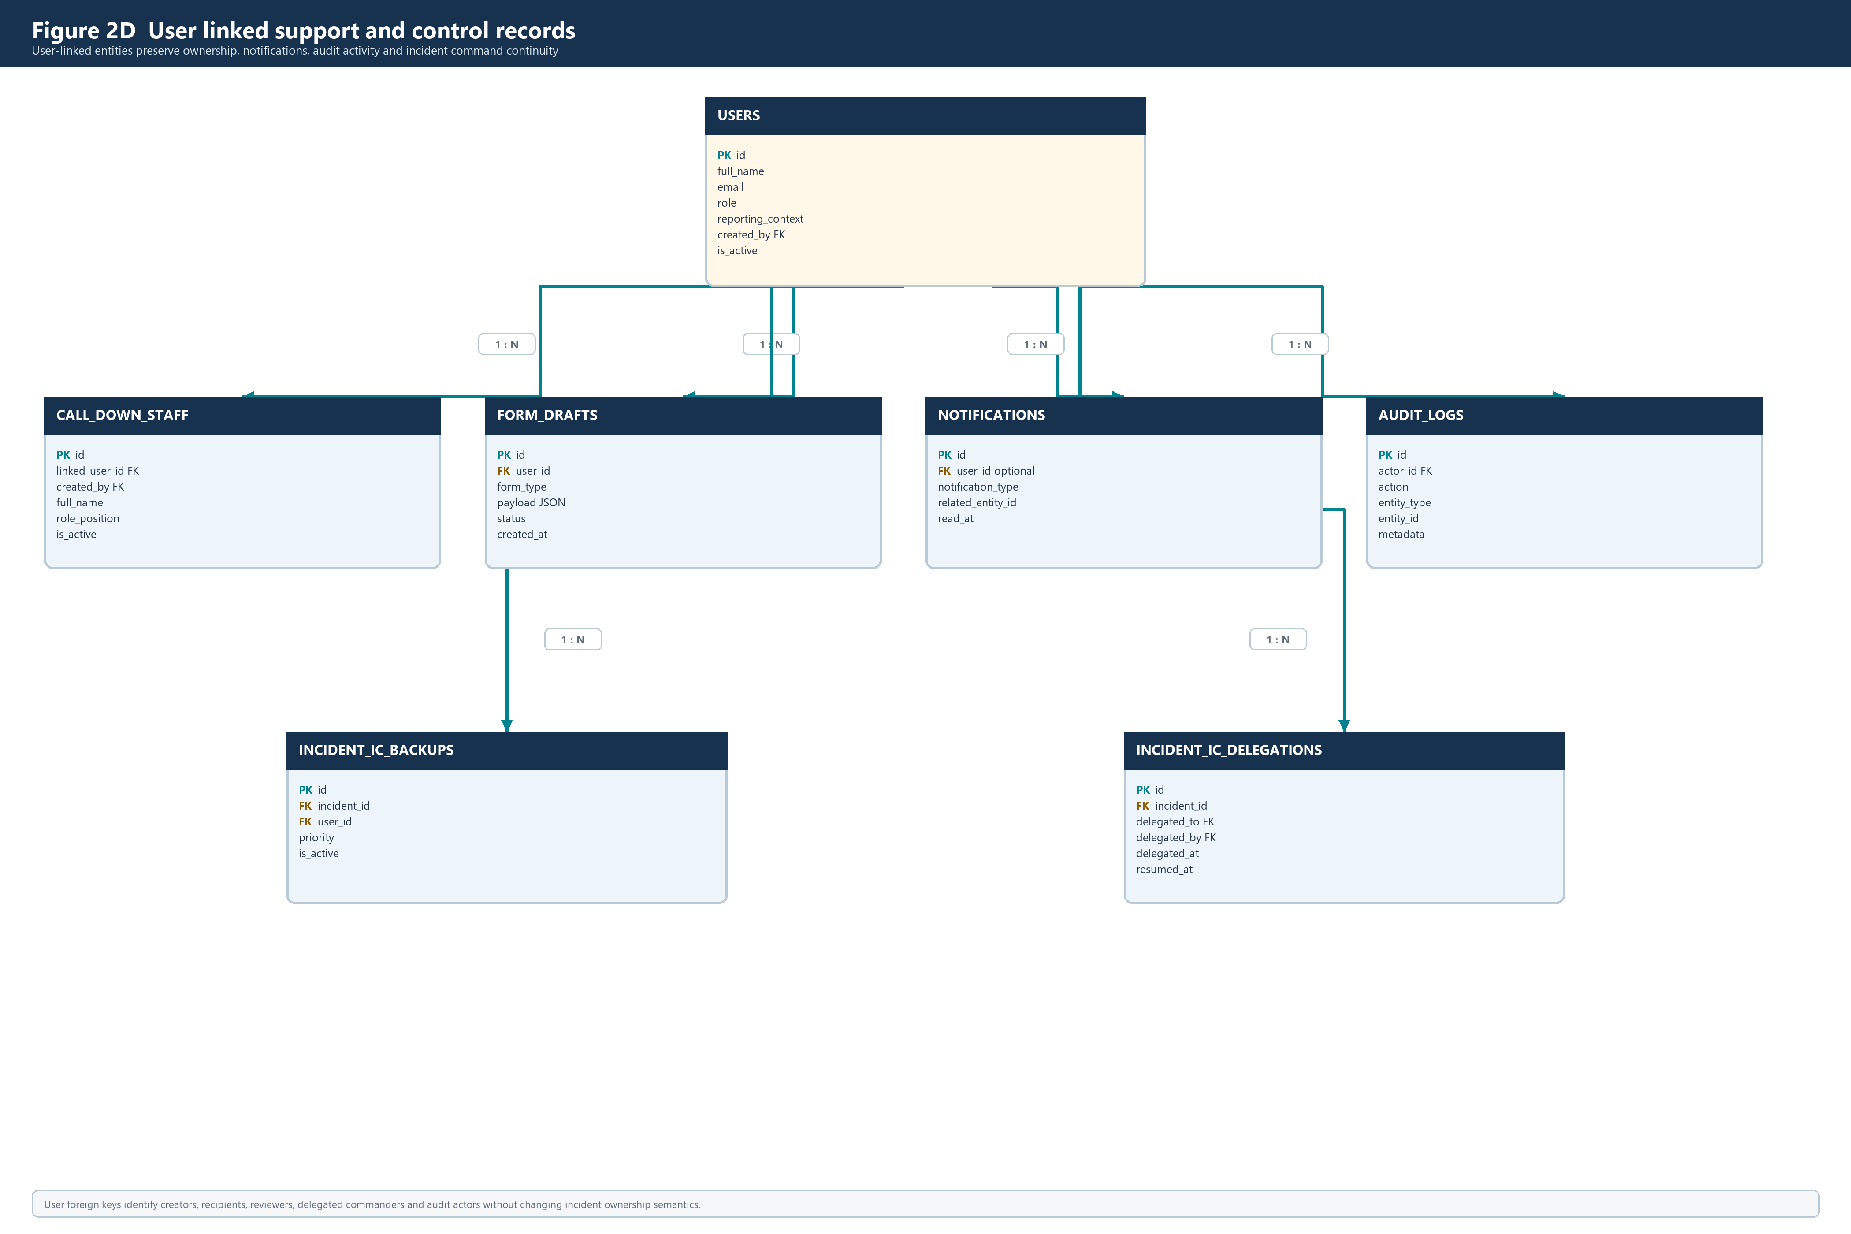
Figure 2D User linked support and control records entity relationship diagram

Relationship notes
Relationship | Design interpretation
incidents to casualty_incidents | One incident can contain many casualty reports; every report belongs to one incident.
casualties to casualty_incidents | A person identity remains separate from the incident-specific report describing that person.
casualty_incidents to report extensions | Triage, transport, treatment, encounters, procedures, ICU, history and evidence rows reference the report.
incidents to operational extensions | Timeline, staffing, coordination, continuity, EMS, resource, SitRep and safety rows reference the incident.
users to support and accountability | User foreign keys identify creators, recipients, delegates and audit actors.
unique links | The reviewed definitions declare one linked outcome and one case-link row per casualty report, and unique incident links for selected incident assessments.

Source and scope
The figures are based on the supplied Figure 2 relationship notes, the reviewed schema catalog, the project database ERD and the SQL migration definitions. They present the logical schema design and important relationships; the deployed database remains the authority for exact columns, policies, indexes and migration order.

