SCRIBER Overall Database Schema Design
Role-specific data relationships for Field Responder, AMP, MID, HCFD, Administrator, Super Admin, and Responsible Officer workflows
This document presents the database structure used by SCRIBER and separates the overall relationship model from the operational scope of each account role. The diagrams are intentionally simplified for readability: they show the tables and foreign-key relationships that define each workflow, while the accompanying tables identify the main records stored in each area.
Document item | Coverage
Overall schema | Core entities and supporting operational tables
Role figures | FR, AMP, MID, HCFD, Admin, Super Admin, and RO
Relationship notation | PK, FK, parent-child records, and scope boundaries
Access interpretation | Primary workflow ownership and visibility scope; not a replacement for API authorization rules

How to read the diagrams
- A box represents a database table or a closely related table group.
- An arrow shows the principal relationship used by the workflow. For example, an incident includes many casualty incident records.
- The user table is the application profile table linked to the authenticated account. created_by, encoded_by, recorded_by, reviewed_by, and similar columns point back to users.id.
- The role figures describe operational scope. They do not imply that a role can write every column in every table shown.

1 Overall schema
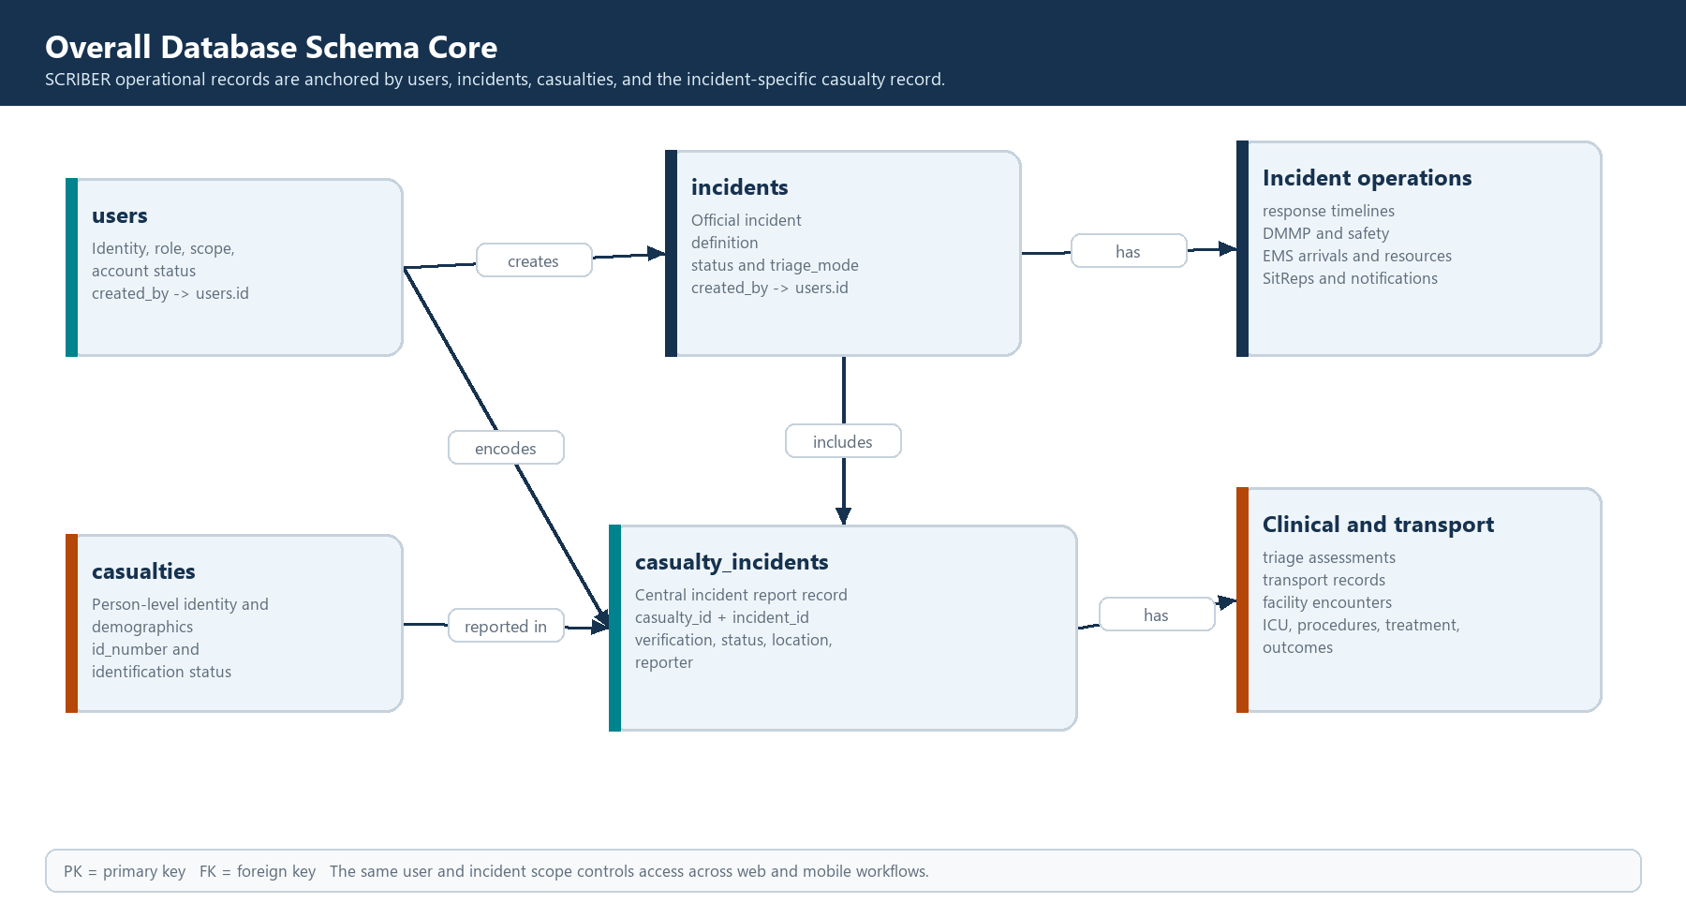
Figure 1. Core SCRIBER relationship model
The core design keeps person identity separate from the incident-specific report. casualties stores the person-level identity and demographic information, while casualty_incidents represents that person's report in a particular incident. This allows one person record to remain distinct from the operational history of each incident. incidents is the parent for incident-wide response operations, analytics inputs, and SitRep generation.
Core table | Purpose | Important relationships
users | Authenticated profile, role, account status, and creator hierarchy | Self-reference through created_by; referenced by most audit and author columns
incidents | Official incident, status, triage mode, and ownership | created_by -> users; parent of incident-wide and casualty records
casualties | Person identity and demographic master record | Referenced by casualty_incidents.casualty_id
casualty_incidents | Central report for one casualty inside one incident | incident_id and casualty_id; parent of triage, transport, facility, and history records

2 Supporting operational schema
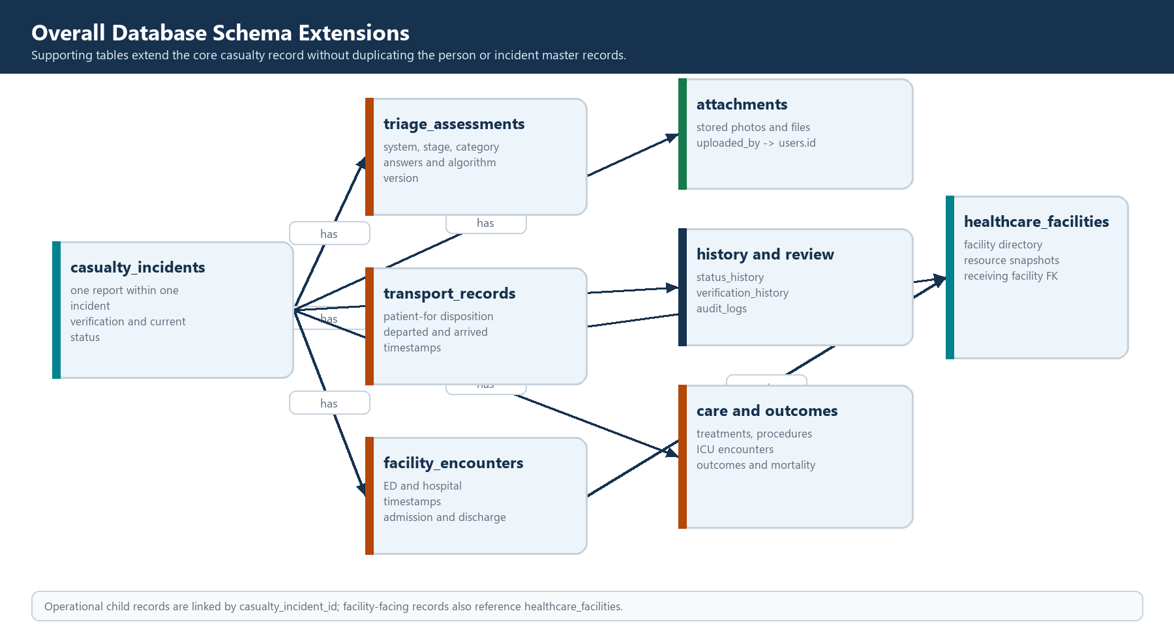
Figure 2. Supporting operational and clinical relationships
Supporting tables extend the central casualty incident record. Triage records preserve the decision system, stage, answers, and calculated category. Transport records preserve patient disposition and timestamps. Facility, ICU, procedure, treatment, and outcome records provide the downstream care history. Attachments and history tables preserve evidence, review status, and traceability without duplicating the core casualty or incident row.
Table group | Representative tables | Relationship anchor
Field and triage | casualty_triage_assessments, casualty_treatments | casualty_incident_id
Transport and facility | casualty_transport_records, facility_encounters, healthcare_facilities | casualty_incident_id and facility IDs
Clinical care | icu_encounters, clinical_procedures, casualty_outcomes | casualty_incident_id
Evidence and governance | attachments, casualty_status_history, casualty_verification_history, audit_logs | casualty_incident_id, user IDs, and entity IDs
Incident operations | incident_response_timelines, DMMP staff call-downs, responder safety, EMS arrivals, SitReps | incident_id

3 Field Responder
FR creates the initial field casualty record, completes the assigned triage workflow, records interventions, and attaches evidence when permitted.
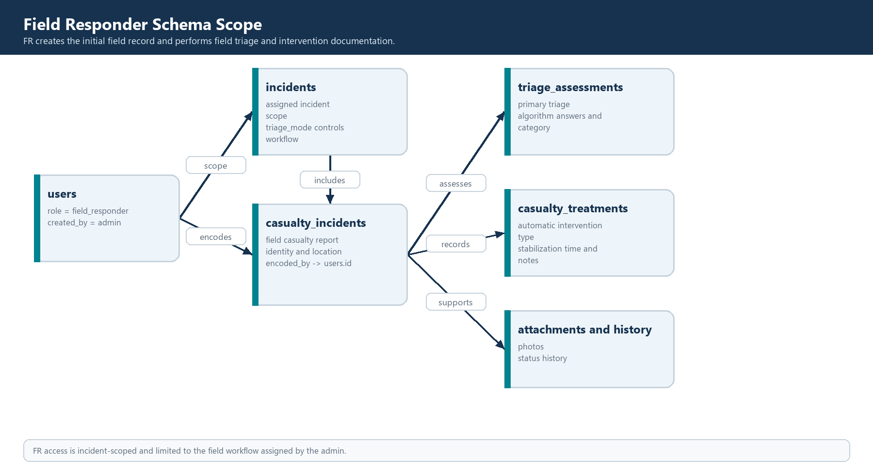
Figure 3. 3 Field Responder data scope
FR access is incident-scoped and limited to the field workflow assigned by the admin.
Primary table or group | Role-specific use
casualty_incidents | Primary workflow record or filtered supporting data for this role
casualty_triage_assessments | Primary workflow record or filtered supporting data for this role
casualty_treatments | Primary workflow record or filtered supporting data for this role
attachments | Primary workflow record or filtered supporting data for this role
casualty_status_history | Primary workflow record or filtered supporting data for this role

4 Advanced Medical Responder
AMP continues the incident casualty record with secondary assessment and transport or receiving-facility information.
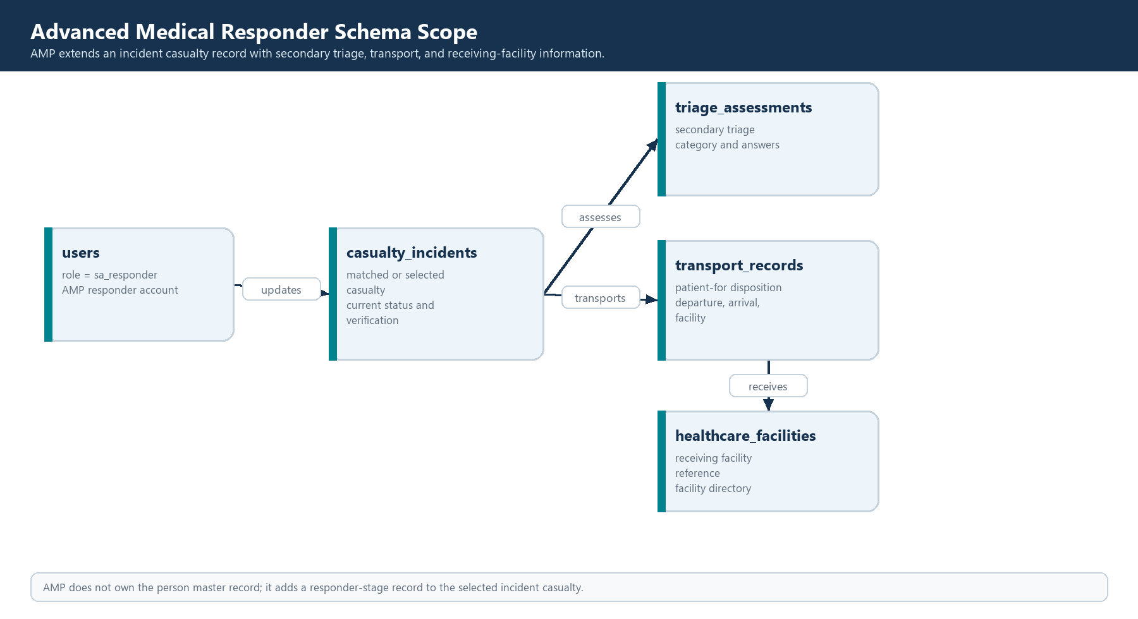
Figure 4. 4 Advanced Medical Responder data scope
AMP does not own the person master record; it adds a responder-stage record to the selected incident casualty.
Primary table or group | Role-specific use
casualty_incidents | Primary workflow record or filtered supporting data for this role
casualty_triage_assessments | Primary workflow record or filtered supporting data for this role
casualty_transport_records | Primary workflow record or filtered supporting data for this role
healthcare_facilities | Primary workflow record or filtered supporting data for this role

5 Minor Incident Documenter
MID receives a reduced incident-scoped mobile workflow while retaining the identifier fields needed to connect the report to the incident.
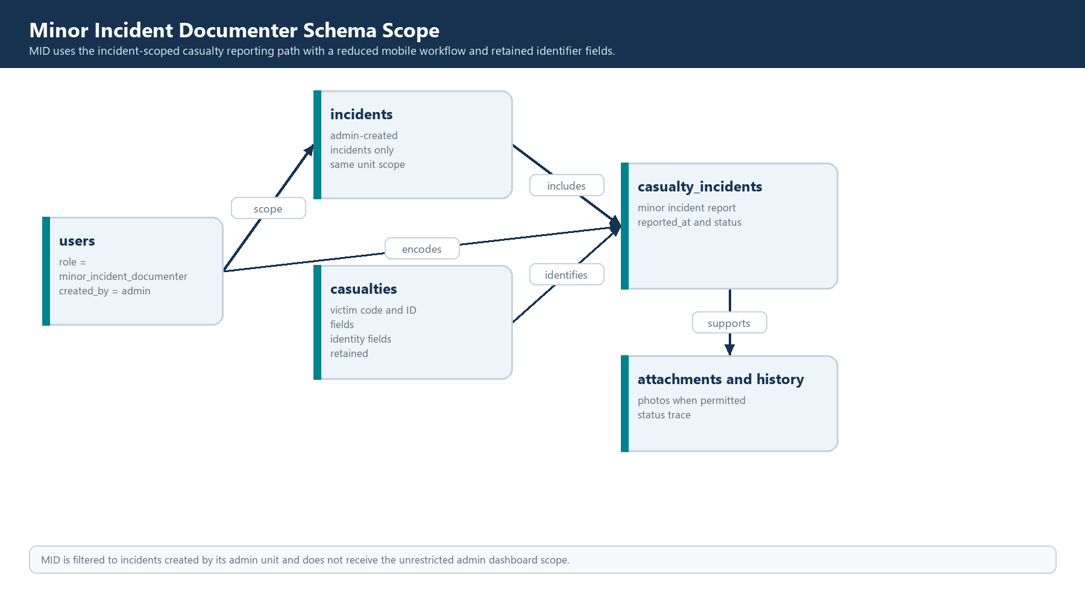
Figure 5. 5 Minor Incident Documenter data scope
MID is filtered to incidents created by its admin unit and does not receive the unrestricted admin dashboard scope.
Primary table or group | Role-specific use
users | Primary workflow record or filtered supporting data for this role
incidents | Primary workflow record or filtered supporting data for this role
casualties | Primary workflow record or filtered supporting data for this role
casualty_incidents | Primary workflow record or filtered supporting data for this role
attachments | Primary workflow record or filtered supporting data for this role
casualty_status_history | Primary workflow record or filtered supporting data for this role

6 Healthcare Facility Documenter
HCFD records the facility-side encounter and resource information without taking ownership of the transport workflow.
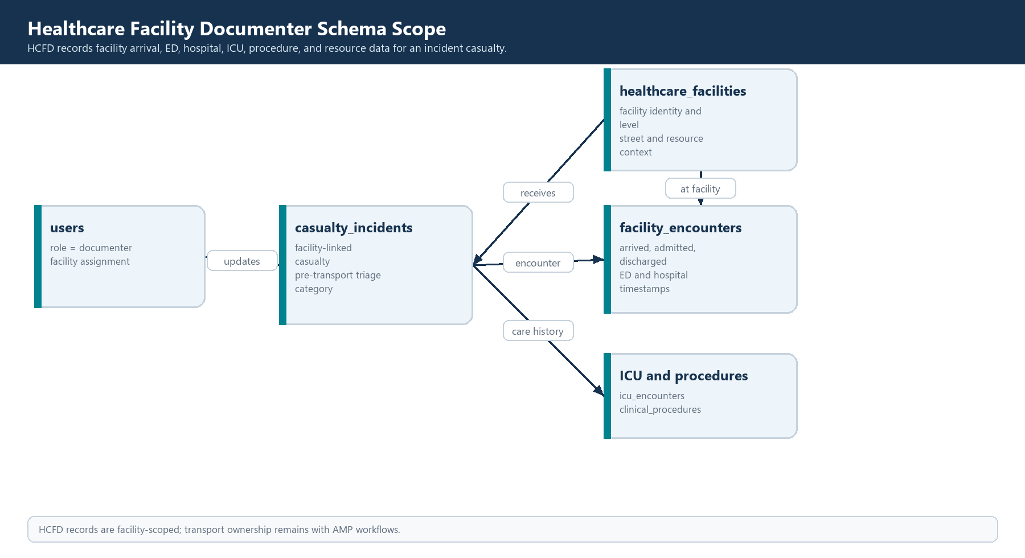
Figure 6. 6 Healthcare Facility Documenter data scope
HCFD records are facility-scoped; transport ownership remains with AMP workflows.
Primary table or group | Role-specific use
healthcare_facilities | Primary workflow record or filtered supporting data for this role
casualty_incidents | Primary workflow record or filtered supporting data for this role
facility_encounters | Primary workflow record or filtered supporting data for this role
icu_encounters | Primary workflow record or filtered supporting data for this role
clinical_procedures | Primary workflow record or filtered supporting data for this role
facility_resource_snapshots | Primary workflow record or filtered supporting data for this role

7 Administrator
Admin manages one operational unit, its official incidents, created mobile accounts, incident analytics, and final SitReps.
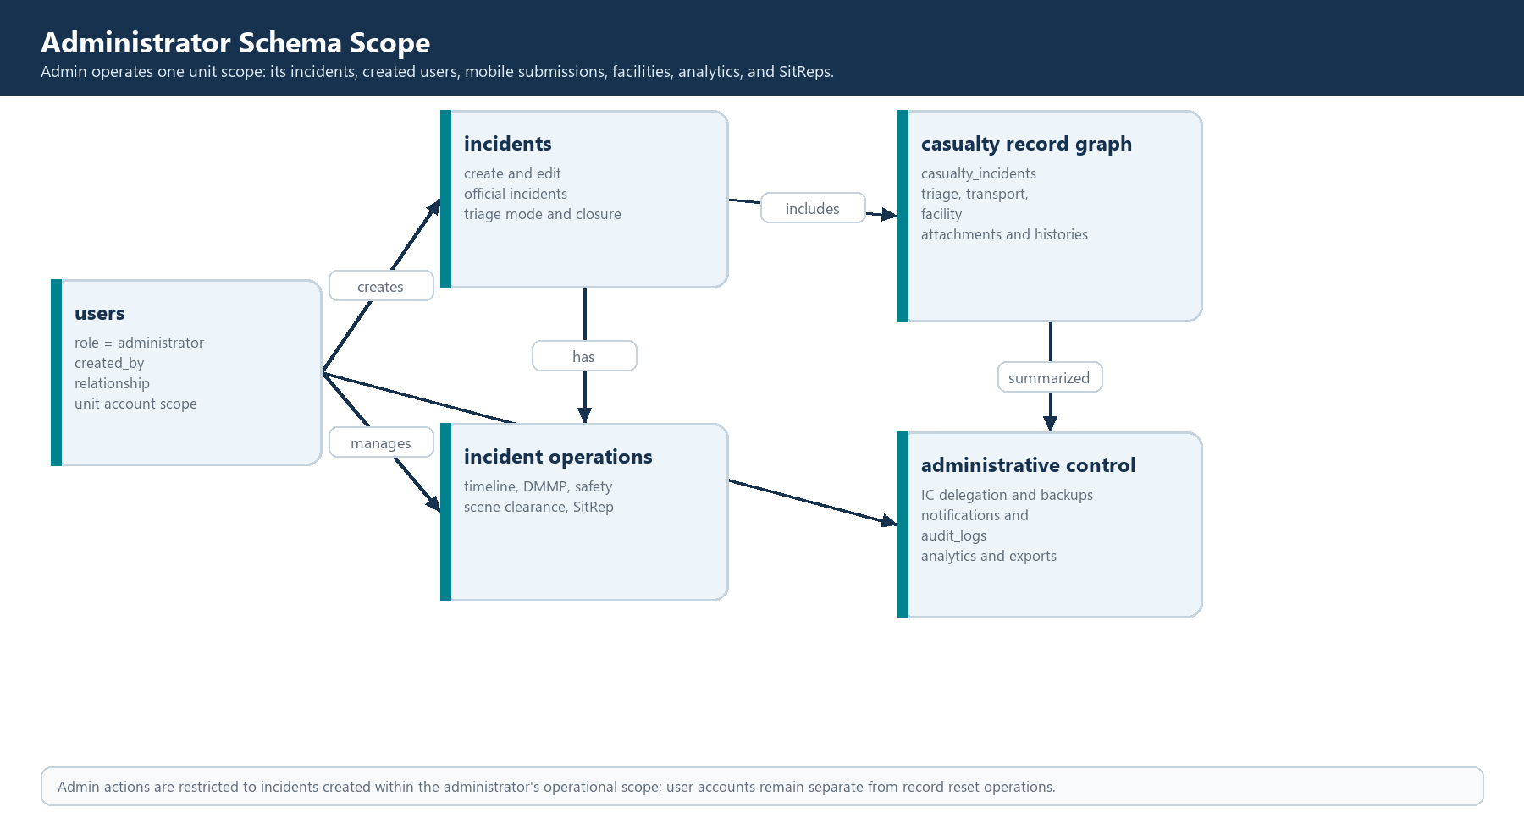
Figure 7. 7 Administrator data scope
Admin actions are restricted to incidents created within the administrator's operational scope; user accounts remain separate from record reset operations.
Primary table or group | Role-specific use
users | Primary workflow record or filtered supporting data for this role
incidents | Primary workflow record or filtered supporting data for this role
casualty_incidents | Primary workflow record or filtered supporting data for this role
incident_response_timelines | Primary workflow record or filtered supporting data for this role
sitreps | Primary workflow record or filtered supporting data for this role
incident_ic_delegations | Primary workflow record or filtered supporting data for this role
audit_logs | Primary workflow record or filtered supporting data for this role

8 Super Admin
Super Admin manages administrator accounts and has cross-unit visibility for system oversight and data governance.
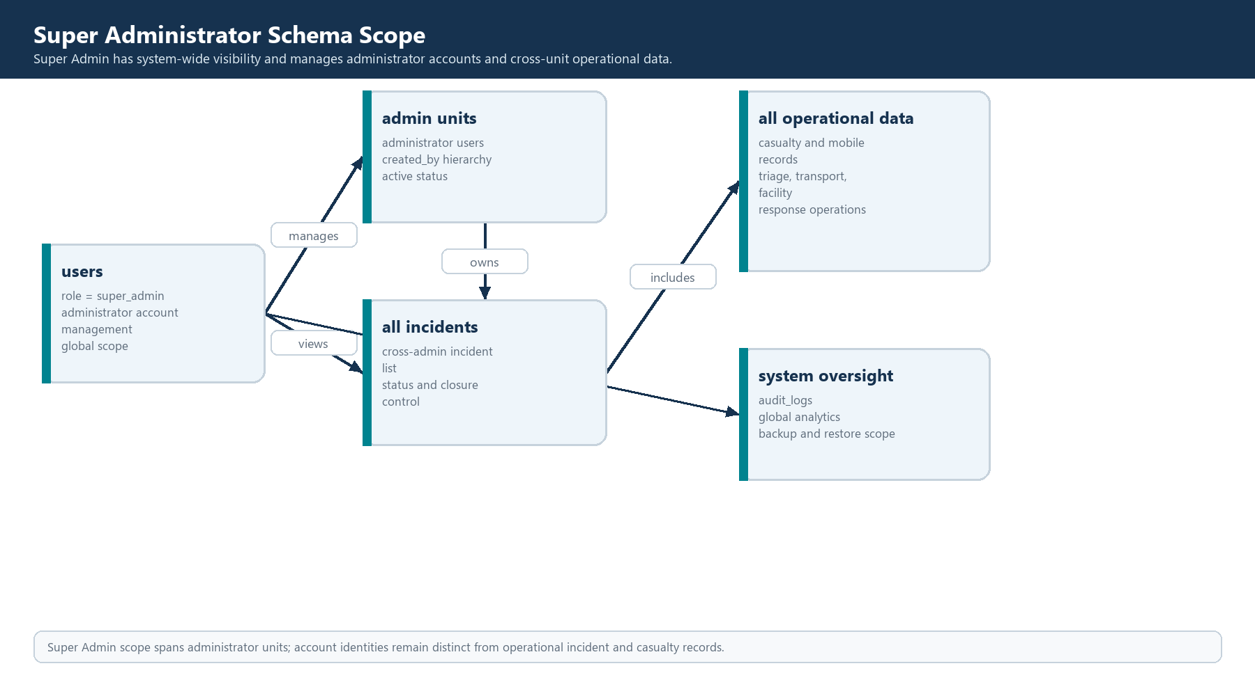
Figure 8. 8 Super Admin data scope
Super Admin scope spans administrator units; account identities remain distinct from operational incident and casualty records.
Primary table or group | Role-specific use
users | Primary workflow record or filtered supporting data for this role
incidents | Primary workflow record or filtered supporting data for this role
casualty_incidents | Primary workflow record or filtered supporting data for this role
audit_logs | Primary workflow record or filtered supporting data for this role
sitreps | Primary workflow record or filtered supporting data for this role
notifications | Primary workflow record or filtered supporting data for this role

9 Responsible Officer
RO provides web-based incident management and analytics access without incident delegation or mobile authoring.
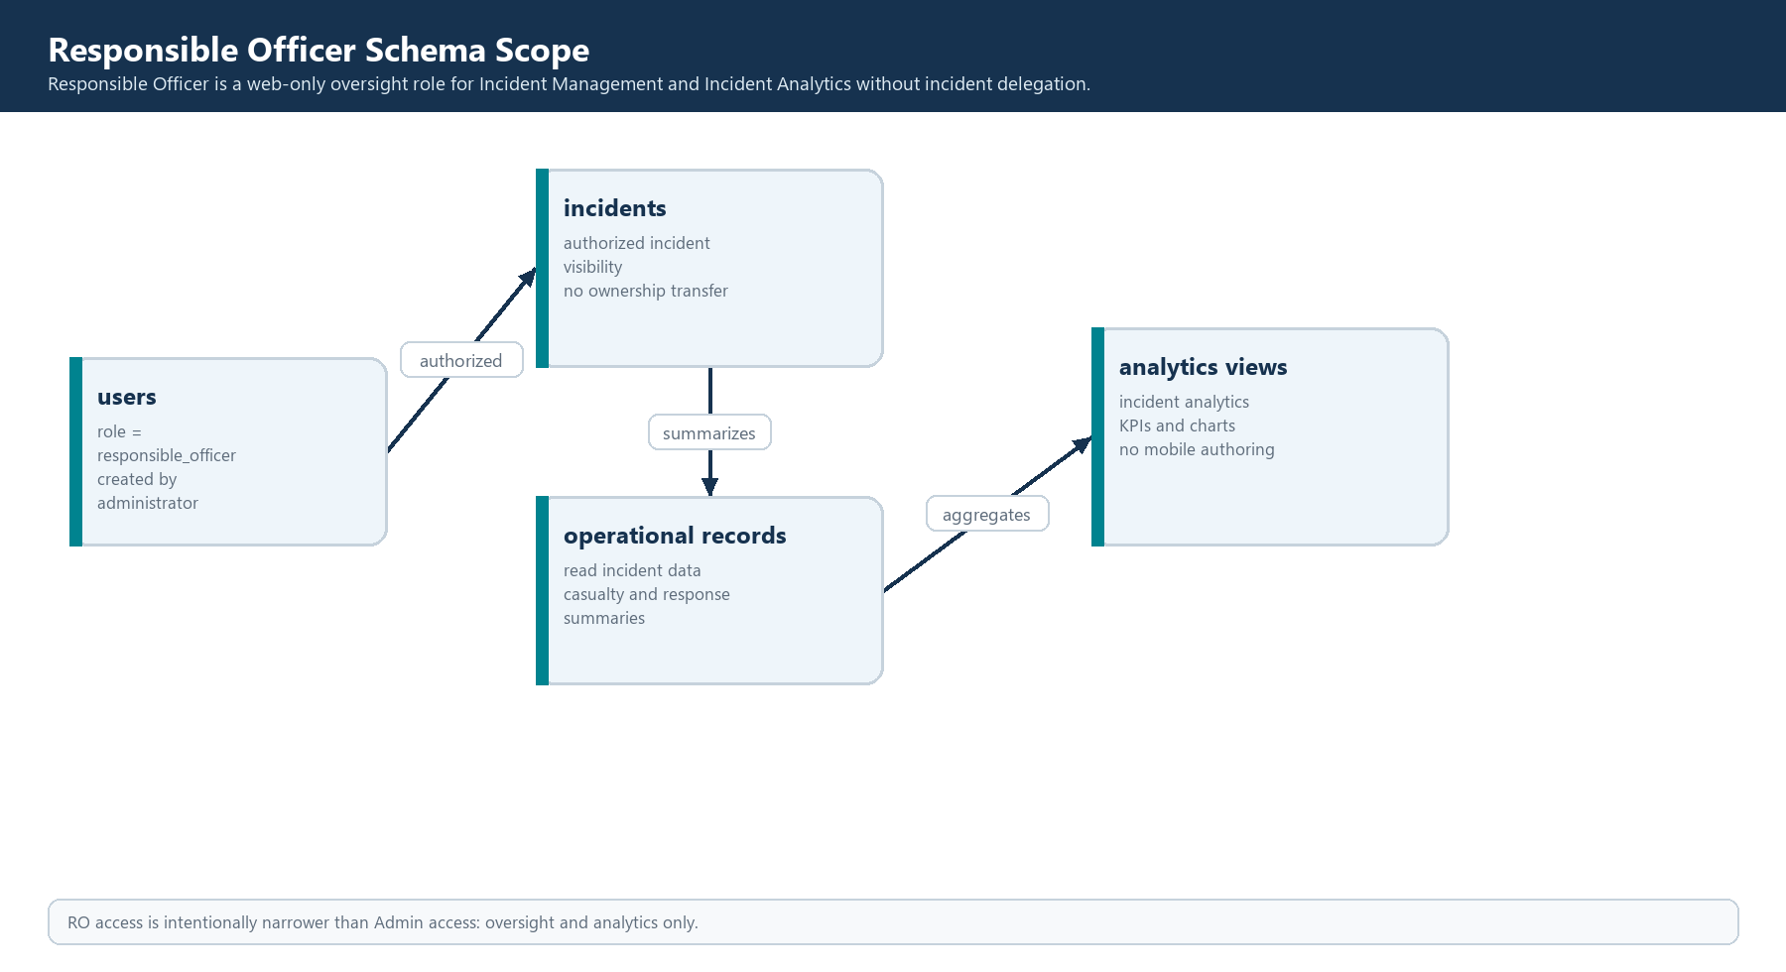
Figure 9. 9 Responsible Officer data scope
RO access is intentionally narrower than Admin access: oversight and analytics only.
Primary table or group | Role-specific use
users | Primary workflow record or filtered supporting data for this role
incidents | Primary workflow record or filtered supporting data for this role
casualty_incidents | Primary workflow record or filtered supporting data for this role
incident_response_timelines | Primary workflow record or filtered supporting data for this role

10 Role scope summary
The role figures show a shared relational model with different authorization boundaries. FR, AMP, MID, and HCFD accounts work against the incidents assigned to their administrator unit. Admin operates the unit and its official incidents. Super Admin operates across administrator units. RO is a controlled web oversight role rather than an incident owner.
Role | Primary interface | Main data responsibility | Scope
Field Responder | Mobile | Field casualty report, triage, intervention, attachments | Assigned incidents in admin unit
AMP | Mobile | Secondary triage, transport, receiving-facility data | Assigned incidents in admin unit
MID | Mobile | Reduced casualty documentation and identifiers | Admin-created incidents only
HCFD | Mobile | Facility encounter and hospital resource data | Assigned facility and incidents
Administrator | Web | Official incidents, users, analytics, SitReps, governance | Own administrator unit
Super Admin | Web | Account management, global oversight, backup and restore governance | All administrator units
Responsible Officer | Web | Incident management and analytics review | Authorized incident visibility

11 Implementation notes
- The diagrams use the current table names and role names represented in the SCRIBER API and database design files.
- The central foreign-key relationship for mobile casualty work is casualty_incidents.id. Role-specific records should attach to that row rather than creating separate casualty master records.
- Incident-wide records use incident_id. This includes response timelines, DMMP and staff call-downs, responder safety, EMS arrivals, facility resource snapshots, and SitReps.
- Account and role scope is enforced by the application authorization layer in addition to the relational links shown here.
- The diagrams are designed as documentation figures and should be updated when a migration adds or changes a table, foreign key, enum, or role scope.

