1. What did I do this week?
   1. Did the weekly reading and took notes.
   2. I was traveling, so unable to meet with my team, but I did do the team assignment on my own.

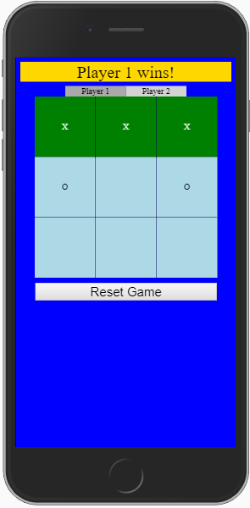

* 1. Updated my portfolio with this week’s work
  2. Updated intex.html page to add links for future weeks. Added scroll bar (this looks terrible on internet browser but looks great on my iPhone 6+)

1. What am I going to do next?
   1. Do the weekly reading
   2. Continue collecting ideas for small projects I can do to practice what I am learning
2. What are my blockers?
   1. Unable to attend office hours due to conflict with other classes
   2. Had to travel out of town this week. Lost one entire day traveling