```r  
library(tidyverse)

## -- Attaching packages --------------------------------------- tidyverse 1.3.0 --

## v ggplot2 3.3.3 v purrr 0.3.4  
## v tibble 3.0.5 v dplyr 1.0.3  
## v tidyr 1.1.2 v stringr 1.4.0  
## v readr 1.4.0 v forcats 0.5.0

## -- Conflicts ------------------------------------------ tidyverse_conflicts() --  
## x dplyr::filter() masks stats::filter()  
## x dplyr::lag() masks stats::lag()

diamonddata <-ggplot2::diamonds

10 columns and 53,940 rows

ggplot(data = diamonds, aes(x=carat, y=price)) +  
 geom_point()

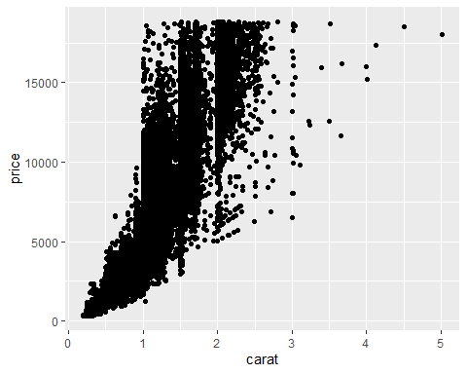

As carat size increases there are fewer diamonds. At the start of the scatterplot there are so many diamonds that in some spots it is solid black, but as the size increases there are fewer and fewer diamonds.

ggplot(data = diamonds, aes(x=carat, y=price, color = cut)) +  
 geom_point()

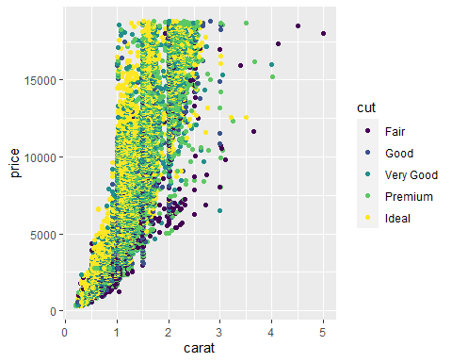

The diamonds that are up to 2.5 carats are primarily made up of lower quality cuts but still range in price from relatively inexpensive to very expensive. As the diamonds get larger there are fewer of them but they are better quality cuts.

ggplot(data = diamonds, aes(x=carat, y=price, color = cut)) +  
 geom_point() +  
 facet_grid(color~.)

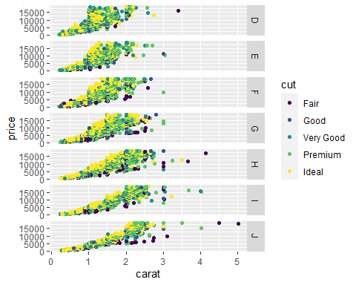

There is a higher number of D, E, and F diamonds just over one carat. As the color decreases in quality there are fewer diamonds but there are larger ones.

inventory <- read_csv("InventoryData.csv")

##   
## -- Column specification --------------------------------------------------------  
## cols(  
## `Item SKU` = col_character(),  
## Store = col_character(),  
## Supplier = col_character(),  
## `Cost per Unit ($)` = col_double(),  
## `On Hand` = col_double(),  
## `Annual Demand` = col_double()  
## )

inventoryA <- filter(inventory, Supplier == "A")

inventoryA =mutate(inventoryA, OnHandRatio =`On Hand`/`Annual Demand`)

It created the On Hand Ratio column from the On Hand divided by the Annual Demand.

From my previous class I had the most trouble with plotting graphs.  
—