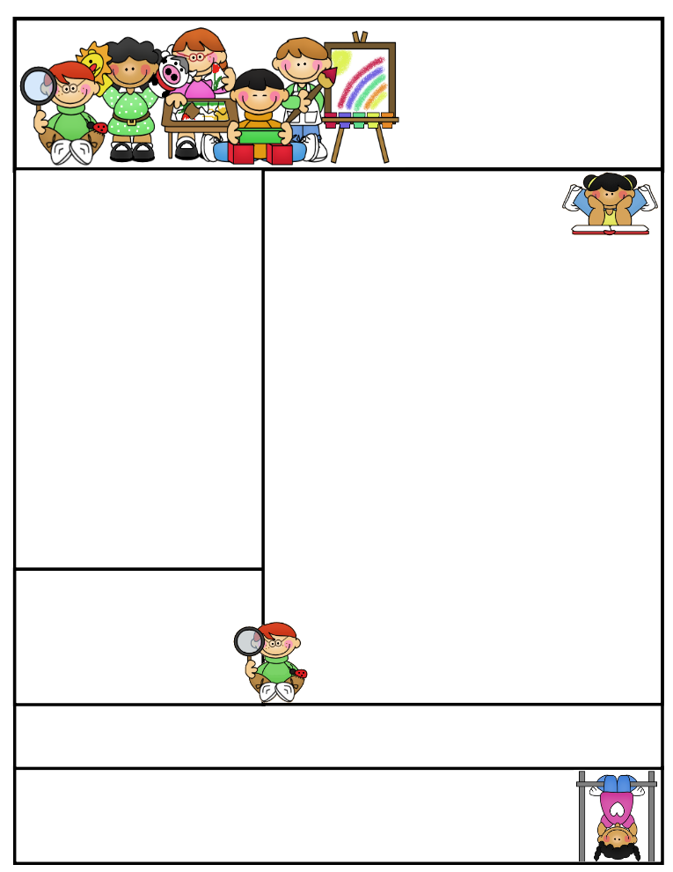

**Math Goal:** Using numbers in addition and subtraction as we learn more about place value. **Reading Goal:** Use spelling words in our reading and writing as we improve writing with proper sentence structure.

Classroom News  
In our classroom this  
month we are working on Pumpkin Science building our math skills and finding locations using compass directions. You will also find a spelling list in your students’ backpack each week to practice.

Classroom “Motto”  
 “WE ARE A T.E.A.M”

By working cooperatively in a positive learning environment, our **CLASS MISSION** is to:

**Teach** and learn together, **Encourage** each other to grow and develop new skills, **Achieve** all our goals and **Motivate** ourselves to always reach for success.

Important Dates

**October 16-19th**

Red Ribbon and Spirit Week

**October 20th**

No School- Professional Development

**October 23rd-27th**

Fall Break

**October 31th**

Halloween

Mrs. Henke’s  
Newsletter:

October   
2017

Mrs. Jessica Henke Email address: [JHenke@theleadschool.com](mailto:JHenke@theleadschool.com)   
The Lead School   
School: (636) 447-5100

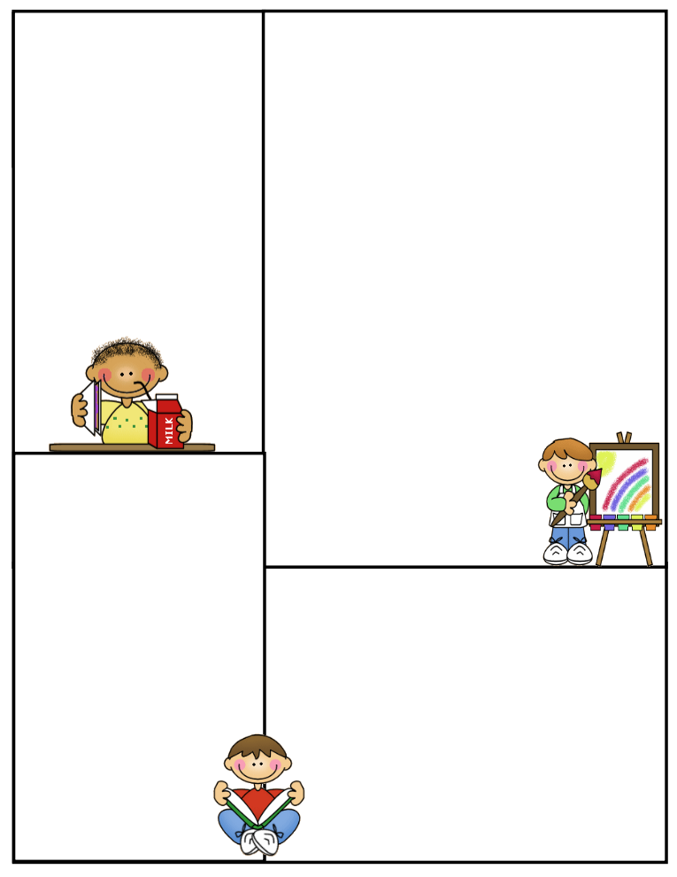

Other Information Here

Our classroom goal this quarter is to use active listening skills to follow directions.

**September 30th**

Picture Day

What We’re Learning

Reading: Treasures Unit 1 with Listening Comprehension and Fluency

Math: Cross-curriculum Pumpkin Science; counting seeds, 10 frames, estimation, and math games

Writing: Pumpkin Spelling and Treasures Unit 1 Writing activities

Science: Pumpkin Science; inquiry skills and floating experiments

Social Studies: Compass Directions, Communities, and “What is Geography?”