PRIVATE HACKATHON DEMONSTRATION

TryOnReady
  - Judge and Small-Business Use-Case Guide
One continuous, easy-to-evaluate journey from boutique application to a secure virtual try-on result.
The complete story
Elena Rivera submits Luna & Thread, adds a synthetic garment, an administrator approves it, and a guest customer consents and selects a synthetic photo. The secure ASP.NET server calls the configured provider and returns the result. The API key never reaches the browser or GitHub.

Prepared: July 26, 2026
Architecture: ASP.NET Core 10 + Next.js/TypeScript + EF Core 10 + PostgreSQL
Demo boutique: Luna & Thread (fictional)
Retailer persona: Elena Rivera (fictional)

Start here: roles and access
The retailer and administrator sign in. The guest customer does not need an account for this lean MVP.
Role | Username | Password | Purpose
Retailer | retailer@tryonready.demo | RetailerDemo!2026 | Apply, add garments, view totals
Administrator | admin@tryonready.demo | AdminDemo!2026 | Approve boutique and garment
Guest | None | None | Consent, upload, view result

Local URL
Start the TryOnReady.Api https profile in Visual Studio, then open https://localhost:7090/. The HTTP profile is http://localhost:5090/.

The 1-3 minute judge path
- Retailer signs in and submits Luna & Thread.
- Retailer uploads the Moonlight Blazer and passes image readiness.
- Administrator signs in and approves the boutique and garment.
- Guest selects the approved garment, consents, and uploads Marisol Lopez's synthetic photo.
- The server creates and tracks the provider task; the guest sees the result.
- A repeated click is stopped as a duplicate; the dashboard shows aggregate totals.
Never enter the YouCam key in the browser
The provider key is a server-side secret. It is intentionally absent from this guide and every repository file.

Retailer journey: Elena Rivera

1. Submit Luna & Thread
- Open Judge Sign In and choose Retailer.
- Enter the retailer credentials exactly as shown.
- Keep the prepared Luna & Thread and Elena Rivera values.
- Check the image-rights statement.
- Select Submit application and confirm Application submitted.

2. Add the Moonlight Blazer
- Continue to Product Readiness.
- Keep product number SYN-BLZ-001 and category Top.
- Choose samples/synthetic/garments/moonlight-blazer.png.
- Confirm the image reads 1254 x 1254 pixels.
- Select Save garment and check image.
- Confirm the product is waiting for administrator approval.
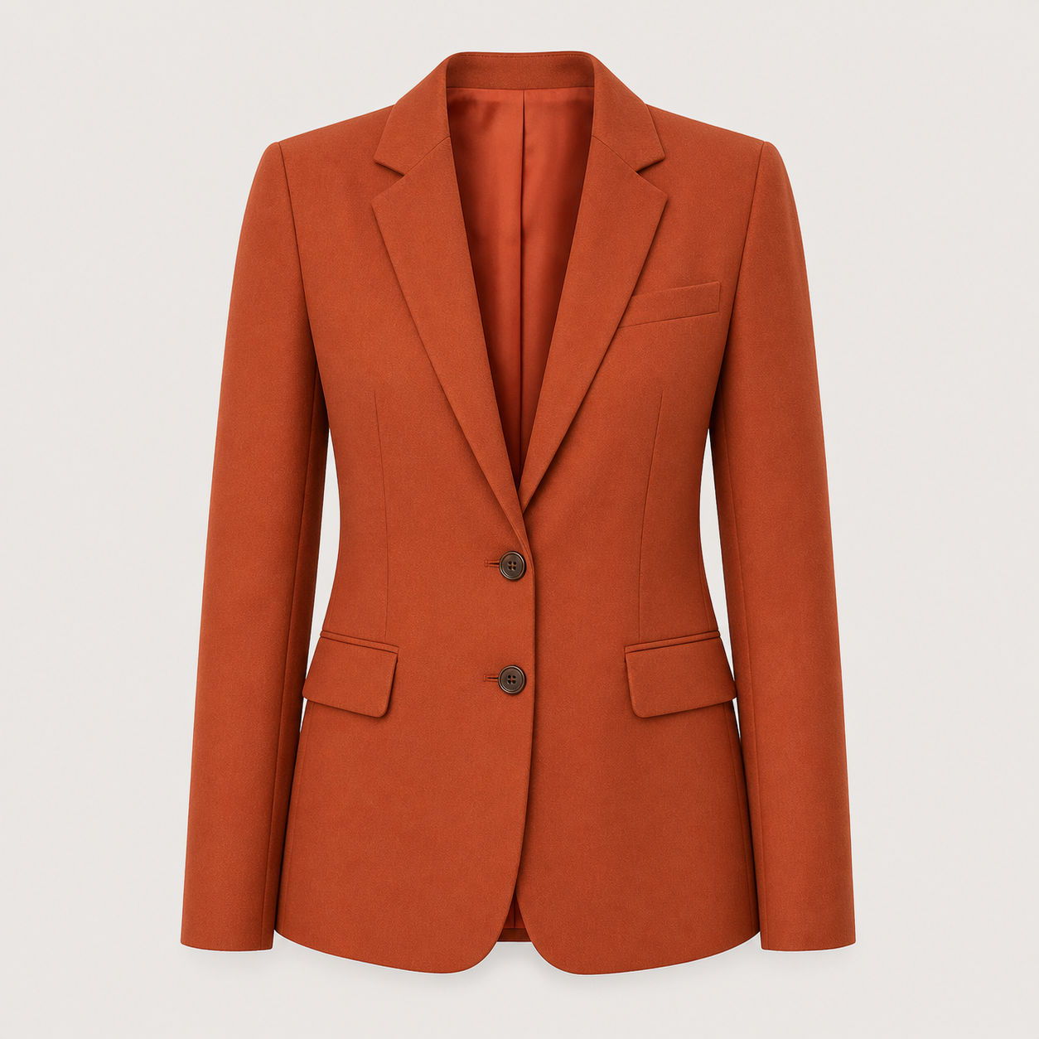
Moonlight Blazer | SYN-BLZ-001 | Top | Terracotta | USD 89

Administrator and guest journey

3. Human approval
- Return to Judge Sign In and choose Administrator.
- Enter the administrator credentials exactly as shown.
- Approve Luna & Thread.
- Inspect the Moonlight Blazer image and catalog facts.
- Approve the product.
- Continue to Consumer Try-On.

4. Guest customer try-on
- Confirm Moonlight Blazer is selected.
- Confirm the page says API key in browser: Never.
- Choose Marisol Lopez's synthetic customer image.
- Check the consent statement.
- Select Generate virtual try-on once.
- Wait for Succeeded and confirm the generated result appears.
- Submit the unchanged request again and confirm Duplicate request prevented.
- Open the results dashboard and confirm aggregate totals.
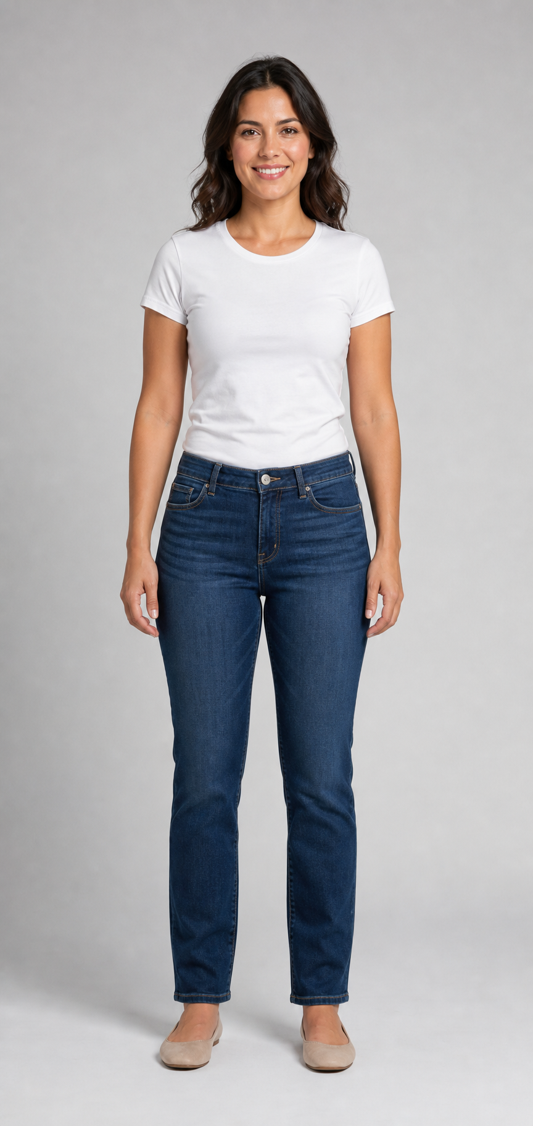
Marisol Lopez — fictional adult synthetic customer source, 864 x 1821

Fictional customer alternatives
Both people are fictional adults created specifically for this demo. They are not real customers. Use only these authorized files for the controlled live validation.

Marisol Lopez

customers/marisol-lopez-source.png | 864 x 1821 | full-body source

Danielle Smith
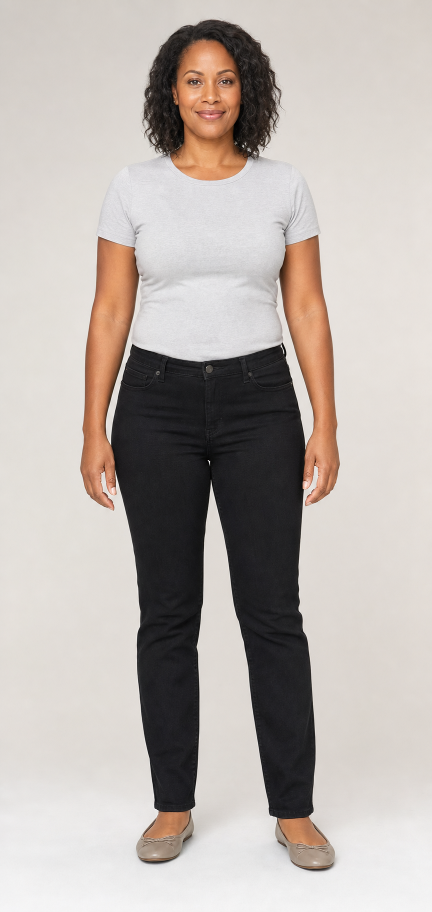
customers/danielle-smith-source.png | 864 x 1821 | full-body source

Moonlight Blazer

Authorized synthetic garment input. File: moonlight-blazer.png
- Product number: SYN-BLZ-001
- Category: Top
- Brand: Luna & Thread
- Color: Terracotta
- Material: Cotton-blend suiting
- Sizes: XS-XL
- Demo price: USD 89.00
- Image: 1254 x 1254; 1,788,350 bytes
- SHA-256: 8f02878034877b38cc1e9f8372bfd145819e6ffff74f5e295709e3af8f5fd907
Upload-ready
The complete garment is visible on a neutral background with no model, hanger, logo, text, or third-party brand.

Harbor Sage Blouse
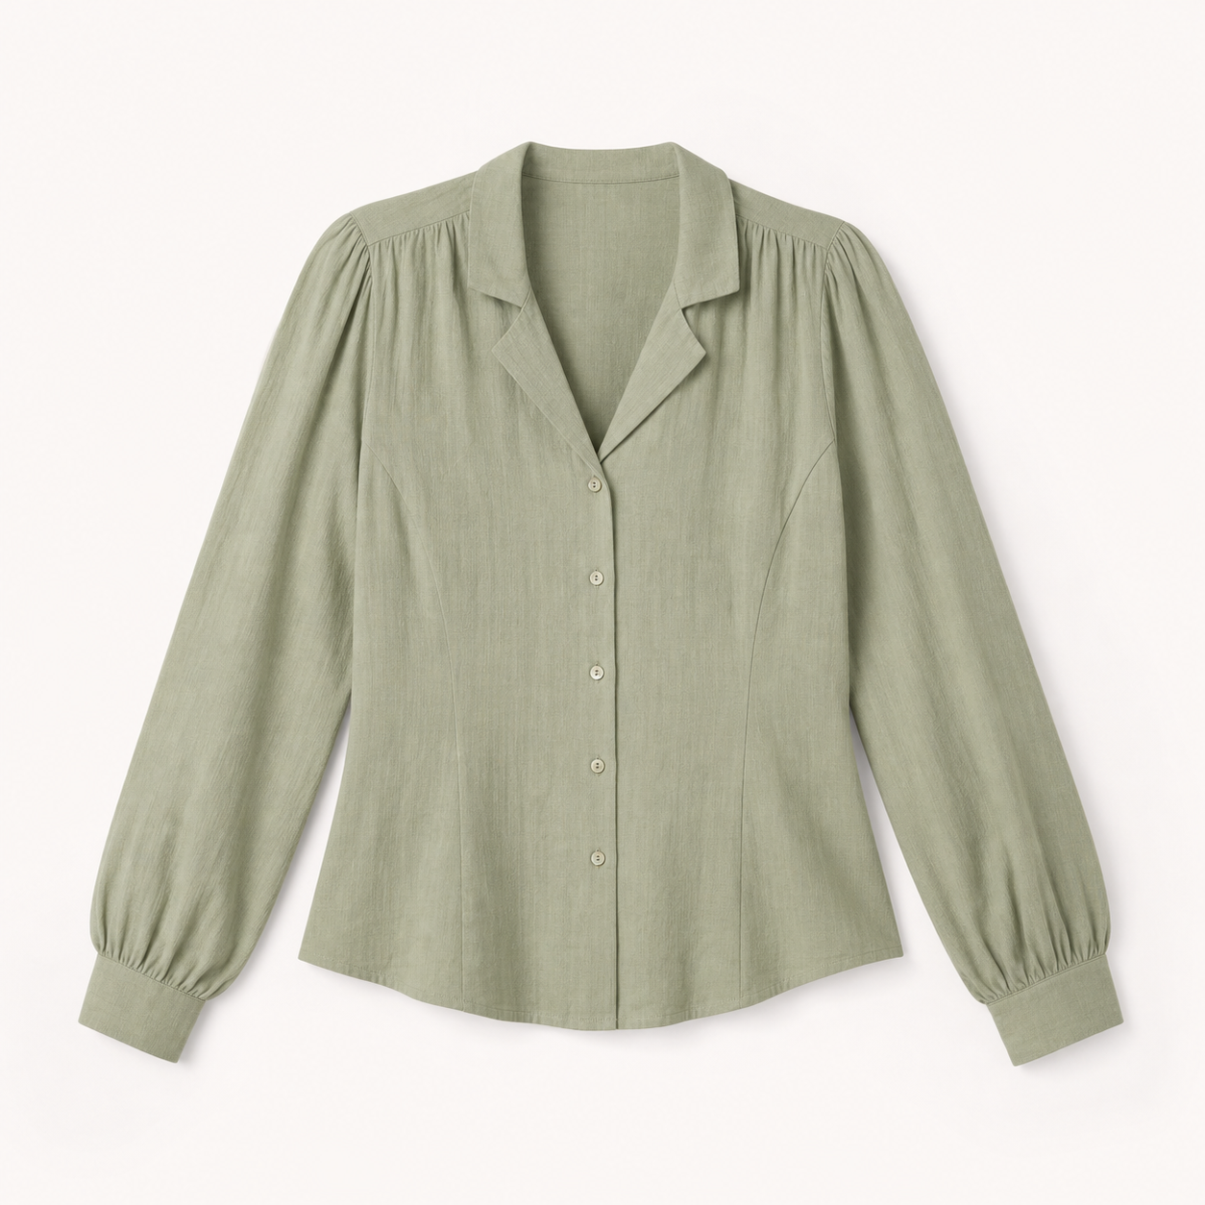
Authorized synthetic garment input. File: harbor-sage-blouse.png
- Product number: SYN-TOP-002
- Category: Top
- Brand: Luna & Thread
- Color: Sage
- Material: Cotton-linen blend
- Sizes: XS-XXL
- Demo price: USD 64.00
- Image: 1254 x 1254; 1,608,884 bytes
- SHA-256: 8fd8adb4386ec064f9f8f621469aa685410abe7c7b7da62bb9e9fa25030a5bdc
Upload-ready
The complete garment is visible on a neutral background with no model, hanger, logo, text, or third-party brand.

Midnight Wrap Dress
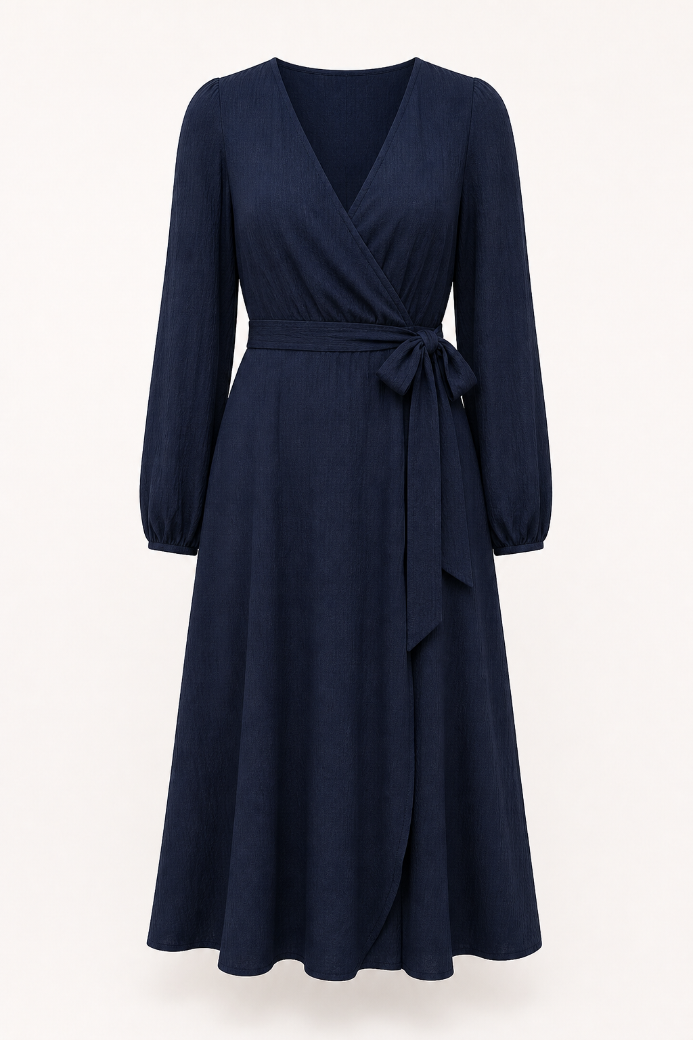
Authorized synthetic garment input. File: midnight-wrap-dress.png
- Product number: SYN-DRS-003
- Category: Full-body outfit
- Brand: Luna & Thread
- Color: Deep navy
- Material: Woven rayon blend
- Sizes: XS-XL
- Demo price: USD 118.00
- Image: 1024 x 1536; 2,131,211 bytes
- SHA-256: 4173e3974e3423db5c508c864cb0ac854a0d6d49d007af481070c58f9b6cf16e
Upload-ready
The complete garment is visible on a neutral background with no model, hanger, logo, text, or third-party brand.

Verification evidence
These results were recorded on July 26, 2026 using provider simulation for the automated journey. Simulation proves application behavior without spending a YouCam unit.
Check | Result
Release build | 0 warnings / 0 errors
.NET unit tests | 2 passed
.NET integration tests | 8 passed
Frontend lint and TypeScript | Passed
Playwright desktop journey | Passed
Playwright mobile smoke | Passed
PostgreSQL-backed journey | Passed
Duplicate-request protection | Passed
API key exposed to browser | False
Isolated PostgreSQL | Healthy

YouCam account ready
The YouCam account balance screenshot confirms 1,040 bonus units. A controlled live call must use the same authorized assets, be submitted once, and be recorded in docs/IMPLEMENTATION-LOG.md.

Security and privacy facts
- The YouCam API key is stored only in server-side secrets.
- No API key, redemption code, or signed upload URL is committed to GitHub.
- Consumer images are private and outside the public web root.
- The retailer sees totals and outcomes, not customer photographs.
- TryOnReady PostgreSQL is isolated on local port 55432.
- The existing Duevara and CarPermit PostgreSQL container is never changed.

Fast troubleshooting and scope

If a step does not work
- Applications will not load: sign in as Retailer again.
- Admin queues will not load: sign in as Administrator.
- No guest garment appears: approve both the boutique and product.
- Image rejected: use an unchanged repository synthetic file.
- Processing does not finish: check the API server log for provider status.
- Live provider disabled: complete simulation first, then follow docs/YOUCAM-SETUP.md.

Lean MVP boundary
The retailer pays for the service and offers virtual try-on to guests as a courtesy and convenience. A later phase may let a customer create an optional account, save favorite garments, signal purchase interest, and return to prior choices. Customer accounts, retailer subscriptions, checkout, and marketing automation are intentionally outside the hackathon MVP.
Source of truth
For exact hashes and provenance, see samples/synthetic/ASSET-METADATA.md. For retention rules, see docs/DATA-RETENTION.md. For the provider secret and controlled live test, see docs/YOUCAM-SETUP.md.

