**ESE 124: Homework Week 3**

1. Write a C program that computes ln (x) using the following Taylor series: DONE: do second and third way

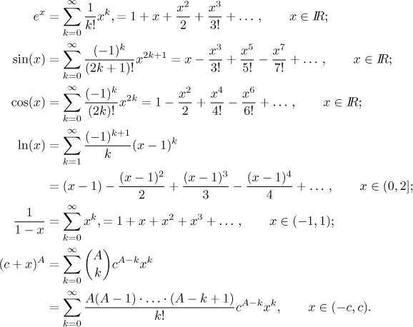

Implement the program using for loop, while loop, and do while (similar to the in-class exercises).

* Follow cosine program for (-1)^k+1.

1. Write a C program that finds the greatest common divider of two integer numbers. DONE

* Find factors from last hw, run through array for largest number and return.

1. Write a program in C to convert a binary number into a decimal number without using array, function and while loop. Example: The Binary Number : 1010101 ; The equivalent Decimal Number : 85

* Probably mod and exponent of 2

1. Write a C program that checks if a character is a vowel or a consonant. DONE

* Make an array of vowels and check if input is there, If not then consonant.