**ESE 124: Homework Week 10**

Scanning integer require an &.

1. Write a C program that uses a Finite State Machine (FSM) to identify the number of occurrences of the string “tete” in a word. The program should count overlapping occurrences. For example: there is one occurrence of “tete” in the word “metete”, however there are two occurrences in the word “metetete”.

Int teCount = -1;

Add to it after you find te.

First take the words in from file and separate them

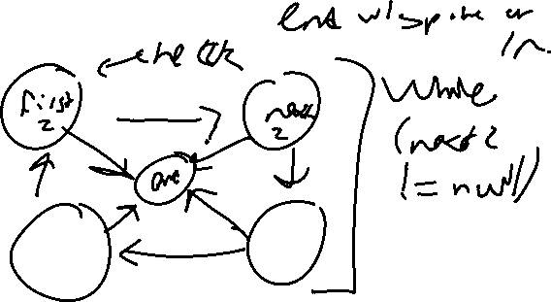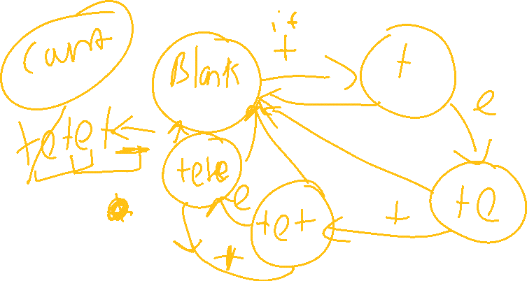

Transition Table :

|  |  |  |  |
| --- | --- | --- | --- |
| States inputs | T | E | EVERYONE ELSE |
| b  for blank | t | b | b |
| T | b | Te | b |
| Te | tet | b | b |
| Tet | b | tete | b |
| tete | tet | b | b |

Output Table:

|  |  |  |  |
| --- | --- | --- | --- |
| State input | T | E | EVERYONE |
| B | 0 | 0 | 0 |
| T | 0 | 0 | 0 |
| Te | 0 | 0 | 0 |
| tet | 0 | 1 | 0 |
| tete | 0 | 0 | 0 |

1. Write a C program that uses a Finite State Machine (FSM) to produce the behavior of an electronic lock: inputs are integer values 0 and 1. There is a start signal that rings the program to an initial state. The lock is unlocked for the input combination “0 1 0 1 1”, otherwise the lock remains locked.

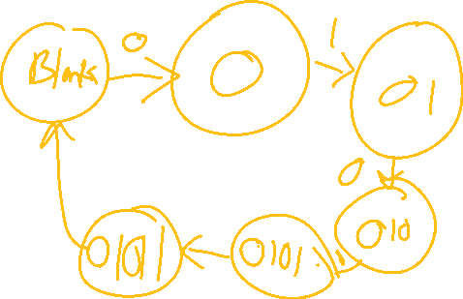

Transition Table:

|  |  |  |
| --- | --- | --- |
| State input | 0 | 1 |
| B | 0 | b |
| 0 | B | 01 |
| 01 | 010 | B |
| 010 | B | 0101 |
| 0101 | B | 01011 |

Conversation Table:

|  |  |  |
| --- | --- | --- |
| State input | 0 | 1 |
| B | 0 | 0 |
| 0 | 0 | 0 |
| 01 | 0 | 0 |
| 010 | 0 | 0 |
| 0101 | 0 | 1 |

1. Write a C function that computes the first thirty terms of the Fibonacci series. Store the computed terms in an array. Build another function that displays the array. The definition of the Fibonacci series is as follows: F[0] = 0; F[1] = 1; F[i] = F[i-2] + F[i-1], F[2] = 1+0 =1, F[3] = 1+1 = 2

Use recursion. Double check the function below

Public int fib(int userInt)

{

If(userInt == 0)

{

Return userInt;

}

Else

{

Return fib(userInt -1) + fib(userInt-2);

}

}

Run for each number and store in another array and print. Ez pz.

1. Write a C function that returns the average value of the values of a bi-dimensional array. Read the array values from an input file. The main function displays the average value.

Take in the array values and put into a 2 dimensional array; go by row and account for all values, the sum and the number; find the average and print.

1. Write a program to read text to end-of-file, and print a count of word lengths, i.e. the total number of words of length 1 which occurred, the number of length 2, and so on. Define a word to be a sequence of alphabetic characters. You should allow for word lengths up to 25 letters.

Typical output should be like this:

length 1 : 10 occurrences

length 2 : 19 occurrences

length 3 : 127 occurrences

length 4 : 0 occurrences

length 5 : 18 occurrences

count how many words have certain lengths: ex:

