Jessica Libman

INFO 474

Assignment 3

Write-Up

1. **Describe the data domain and storyboard interactive visualization techniques you will use.**  
   Start either by choosing a data domain or choosing the interactive visualization techniques you will implement. Think about why the domain and the techniques are a good match for one another. Then write a description of data domain and the interactive visualization application you will build. The description should include a storyboard of the interface/displays you will create. Be sure to explain the features of your application. Most importantly you should explain why the interaction techniques you will implement will be effective in the context of your data domain. The goal of this exercise is to think through the various concerns that go into the software implementation. This is why it is important that you perform this task **first**, before actually building the software.
2. **Implement your design.**  
   Use the programming language and toolkit of your choice to implement your design (though we strongly recommend using Javascript and D3). You may wish to spend some time looking into the various toolkits that are available. I have listed some of them at the end of this document. You are free to use any publicly available language and toolkit. However, I would like you to submit a final executable program that I can execute on my own on either a Mac OS X, or a Windows machine. If this is a problem for you, please talk to me right away.
3. **Produce a final writeup.**  
   Your final submission should include:
   * The description with storyboards from part 1.
   * A brief description of your final interactive visualization application.
   * An explanation of changes between the storyboard and the final implementation.
   * The bundled source code for your application, uploaded as a webpage or file (either a .zip or .tar.gz archive). Please ensure that the software submitted is in working order. If any special instructions are needed for building or running your software, please provide them.
   * For submissions by groups of two, please also include a breakdown of how the work was split among the group members.
   * Finally, please include a commentary on the development process, including answers to the following questions: Roughly how much time did you spend developing your application? What aspects took the most time?

**Part I**

The dataset that I chose included data about the precipitation in Seattle from 1948-2017. I will be implementing an interactive visualization using D3 and Javascript. I will make a scatter plot that displays one data point per day in the dataset, graphed by date and compared to precipitation level. The data domain and visualization application is appropriate because it expressively displays the dataset by showing the amount of precipitation each day, and not showing any extra data that is not coming directly from the dataset. The initial storyboard is displayed below.

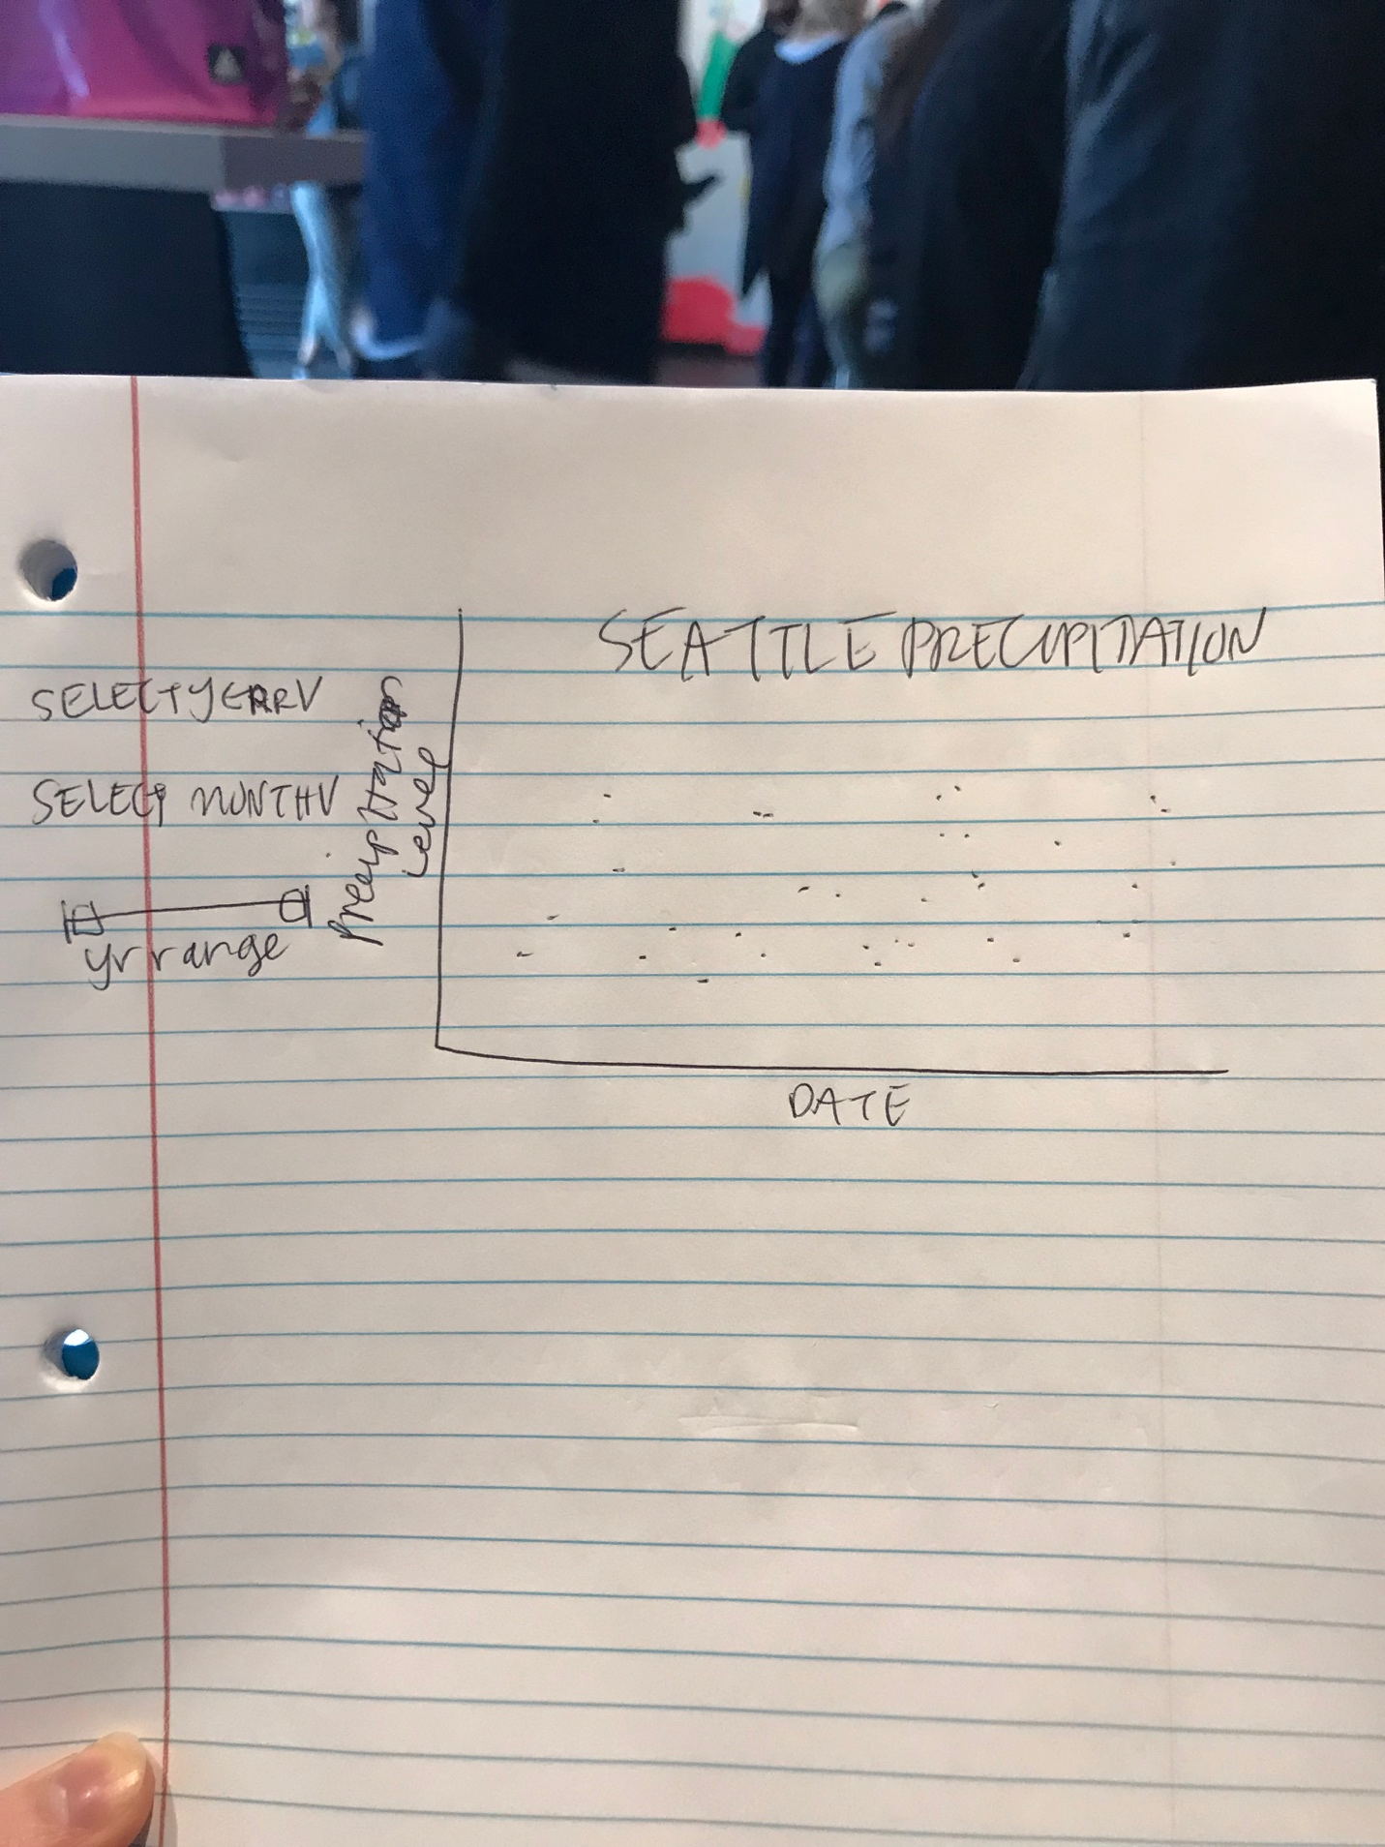

The storyboard includes the graph that maps date and precipitation level. It also has two dropdown menus where the user can select a specific year or month that they’d like to view. Lastly, it displays a sliding range so the user can adjust the range of years that is being displayed.

**Description of final interactive visualization application**

The final interactive visualization application includes two drop down menus and one range slider that allows the user to specify the months and years that they would like to be displayed depicting the year and months of precipitation in Seattle.

Explanation of changes between storyboard and final implementation

**Instructions to run software**

`http-server`

Final commentary on development process (How much time did you spend developing your application? What aspects took the most time?)