CoLab
Deliverable One
CS 3300
Group Seven
Liem, Johannes
Luongo, Matt
Martin, Chris
Overman, Pamela
February 26, 2008

Contents
Contents 2
1 Product Overview 1
1.1 Product Overview 1
1.2 Deliverables 1
1.3 Definitions 1
2 Delivery Description 2
2.1 colab.client 3
Classes 3
2.2 colab.client.gui 3
Classes 3
2.3 colab.common.channel 3
Classes 3
2.4 colab.common.exception 3
Classes 4
2.5 colab.common.remote.exception 4
Classes 4
2.6 Package: colab.common.identity 4
2.7 Package: colab.common.naming 4
Classes 4
2.8 Package: colab.common.remote.client 5
Classes 5
2.9 Package: colab.common.remote.server 5
Classes 5
2.10 Package: colab.common.util 5
Classes 5
2.11 Package: colab.server 5
Classes 5
3 System Design 6
4 Detailed Design 7
5 Data Design 8
6 Interface Specifications 9
6.1 Client-server Interface 9
7 Demo Plan 10
7.1 Demo Overview 10
7.2 CoLab Server 10
7.3 CoLab Client 10
8 Test Plan 11
8.1 Test Plan Overview 11
8.2 Test Classes 11
8.2.1 colab.common.identity 11
8.2.2 colab.common.util 11
8.2.3 colab.server 11
9 Requirements Specification 12
9.1 Requirements Overview 12
9.2 Updated Delivery Plan 12
9.2.1 Delivery 1: February 26 12
9.2.2 Delivery 2: March 21 12
9.2.3 Delivery 3: April 21 12
9.3 Current Status of Features 13
9.3.1 Basic Framework 13
User Accounts 13
Communities 13
9.3.2 Chat Channel Protocol 13
Functionality 13
View 13
Export 13
9.3.3 Document Channel Protocol 14
Editing 14
View 14
Revision History 14
Exporting 15
10 Architectural Model 16
10.1 Trust Boundaries 16
10.2 Server 17
10.2.1 User Management 18
10.2.2 Content Management 18
10.2.3 Networking 20
10.2.4 Behavior 21
10.3 Client 22
10.3.1 Networking 23
10.3.2 Behavior 23
11 Validation 24
11.1 TA Review Session 24
Participants 24
Goal 24
Criteria for Validity 24
11.2 Mutual Peer Group Meeting 24
Participants 24
Goal 24
Criteria for validity 24
12 Delivery Plan 25
12.1 25

Product Overview

Product Overview
CoLab is a network-enabled utility for communication, brainstorming, and collaborative document authoring. It is centered around a basic chat-room style environment, and is enhanced with inclusion of several tools to facilitate idea sharing within small groups. These tools include a collaborative document editor and whiteboard drawing tool.
Users create and join communities which are hosted on a single server. All of a community's related data is stored on a server for this application, including revisions of documents, saved drawings, and chat logs.
Within a community interface, users can open multiple editors in new channels and co-author documents simultaneously. For example, several people may be working on a diagram in the drawing tool while discussing it in a text chat.

Deliverables
The final product consists of two independent applications: a server and a client. Deliverables will consist of the full source code and scripts to build both the server and client applications.

Definitions
This application introduces several terms to cover collaborative groups and functions. A community represents a group of people (users) and a project on which they are collaborating, such as a university class or a company project group.
Users with the permission to control membership in the community and access to channels are called moderators. In a classroom setting, moderator status would be limited to instructors and teaching assistants (TAs). In a flat group with no distinct authority, all users may be moderators.
Each document or collaborative entity is referred to as a channel. A channel represents content being edited, and the workspace in which the group is dealing with it. A protected channel can only be modified by community moderators. Each channel is of a particular typed called a channel protocol which specifies the type of data represented by the channel and the way in which that data is displayed and manipulated by users. Examples of channel protocols are chat, document, and whiteboard.

Delivery Description

System Design
The Java code is segmented into three main packages
- The client application
- The server application
- A common package which contains classes used by both applications and specifies interfaces for communication between the client and server

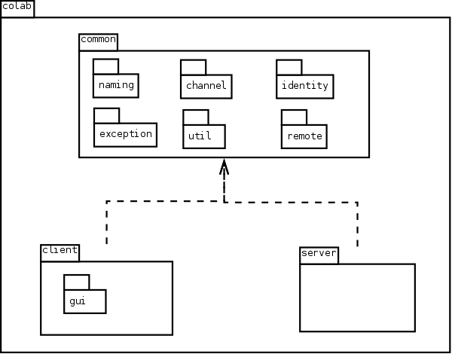

colab.client
Purpose of package: Lays the domain for the functions of the application and contains the middle layer between the GUI and the server

Classes
- ClientChannel
- ClientChatChannel
- ColabClient

colab.client.gui
Purpose of package: Contains all of the UI components. The components use an event-driven system for updating

Classes
- ChannelPanel
- ChatPanel
- ChooseCommunityPanel
- ColabClientGUI
- FixedSizePanel
- LoginPanel

colab.common.channel
Purpose of package: Holds classes pertaining to Channel and its functions and features

Classes
- Channel
- ChannelData
- ChannelDescriptor
- ChannelType
- ChatChanelData
- ChatDataCollection

colab.common.exception
Purpose of package: Holds all the exceptions pertaining to network

Classes
- ConnectionDroppedException
- NetworkException
- UnableToConnectException

colab.common.remote.exception
Purpose of package: Contains exceptions that will be thrown over remote invocations

Classes
- AuthenticationException
- ChannelDoesNotExistException
- CommunityDoesNotExistException
- IncorrectPasswordException
- UserDoesNotExistException

Package: colab.common.identity
Purpose of package: Contains classes for Identifiers
- Classes
- Identifiable
- Identifier
- IdentitySet
- LockIdentifier
- StringIdentifier

Package: colab.common.naming
Purpose of package: Groups all the wrapper and name rules classes.

Classes
- ChannelName
- ColabNameRules
- CommunityName
- InvalidCommunityNameException
- InvalidNameException
- InvalidUserNameException
- UserName

Package: colab.common.remote.client
Purpose of package: Provides remote interfaces for remote client objects

Classes
- ChannelInterface
- ColabClientInterface

Package: colab.common.remote.server
Purpose of package: Provides remote interfaces for remote server objects

Classes
- ColabServerInterface
- ConnectionInterface

Package: colab.common.util
Purpose of Package: Contains utility classes

Classes
- FileUtils
- StringUtils

Package: colab.server
Purpose of package: Contains server objects

Classes
- ChannelManager
- ColabServer
- Community
- Connection
- Password
- ServerChanel
- ServerChatChannel
- User
- UserManager

Detailed Design

Data Design
CoLab uses a class hierarchy where a Channel object represents the concept of a CoLab channel--for example, a chatroom, a document editor, or a whiteboard. Therefore, each Channel object is self-contained and holds all data necessary to re-create the exact state of that channel at a given moment. The CoLab framework also contains a Community class, representing a CoLab community with a list of channels and users who are authorized to view the data. The CoLab framework contains two structuring classes responsible for holding this channel and community information--ChannelManager and UserManager. ChannelManager stores information about Channels, and UserManager holds information about all communities and their users.

In D1, the CoLab server does not support any data persistence. However, later deliverables will include the ability to save and retrieve data for channels and communitites. Data storage will probably be implemented using XML files so that the data can be edited easily outside of the CoLab application.

Interface Specifications

Client-server Interface
Colab's client-server communication is supported entirely by distributed objects using Remote Method Invocation (RMI).
The server application binds a single instance of ColabServer to the server's RMI registry. This uses a port which can be specified by a parameter when launching the server. This uses a port which can be specified by a parameter when launching the server.
The client application remotely invokes the ColabServer.connect(), which returns a ConnectionInterface object. The ConnectionInterface will be used for all further requests to the server. The server’s implementing Connection class keeps track of the state of the connection and knows which user has logged into it.

Demo Plan

Demo Overview
D1 will consist of two executable deliverables, the CoLab server and the CoLab client. In addition to the functionality described below that will be displayed during the demo, the deliverables for D1 will also include the channel and community framework used by our client and server. However, the framework has no component that can be demonstrated independently from the server and client.

CoLab Server
The CoLab server creates a new server using our custom-built application framework, populates it with some test data and waits for incoming connections. The server is designed to run from a terminal/console so while there is no GUI, the server will print a message when it has finished initializing successfully. The server will run forever until the client chooses to terminate it using Ctrl+C on the console.

CoLab Client
The CoLab client application presents a GUI to the user prompting for a server IP, username and password. The user logs in using an existing username/password pair (for D1, this is part of the test data pre-populated by the server). The client program connects to the CoLab server using RMI and authenticates whether the username/password combination is correct. If the user is authenticated successfully, the client displays a list of communities of which the user is a member (pre-populated by server) as well as a button to join a community. The user selects a community from the drop-down list and clicks the button to select and join that community. When the button is clicked, the CoLab client presents a new GUI representing a chatroom lobby, where the user has a window with chat messages and an input box. By typing text in the input box and clicking a button to send, the user's text is sent to the server, then relayed to all CoLab clients connected to this community's lobby.

Test Plan

Test Plan Overview
The test plan will cover unit testing and integration testing through a combination of whitebox and blackbox techniques. Whitebox methods will be used to ensure the tests have complete statement coverage of the code, and blackbox methods will be used to check that the tests produce the correct values. Both unit tests and integration tests will be conducted by all developers.

JUnit will be used to faciliate the running of unit test cases. Unit test cases will be written for functionality that can be tested in such a manner, but some components depend heavily on others and must be checked using integration testing. In addition, the front-end GUI cannot be easily tested using unit tests and will be verified through integrated usability tests by the developers.

System integration will be checked in two ways. First, test cases will be written which rely on a variety of components and will require correct values from each separate component in order to pass. Second, developers will manually verify that the application is working by running the GUI and looking for reasonable values at each step.

Test Classes

colab.common.identity
Classes: IdentitySetTester
Purpose of package: Tests the identity objects

colab.common.util
Classes: StringUtilsTester
Purpose of package: Tests the utility objects

colab.server
Classes: ChannelManagerTester, PasswordTester, TestLaunch, UserTester
Purpose of package: Tests the objects that require coordination with the server

Requirements Specification

Requirements Overview
The D2 plan had the following original goals:
- Document channel protocol is functional
- User can create and use a document channel
- User can create user accounts and communities
- User can create channels, join multiple channels concurrently
- Moderators can modify community preferences (adding passwords, changing blacklist, etc.)
Most of the original D2 plans are still valid. D1 focused on establishing the back-end framework and getting working network connections. Because most of the framework has been written and is working correctly, extending the code will be efficient in D2. However, the D2 plans must be modified to add data storage to the application. D2 will add mechanisms for storing data to disk and retrieving it later. Adding data storage will require significant consumption of developer resources, so the moderators feature will be removed from the D2 plan.

Updated Delivery Plan

Delivery 1: February 26
- Client can enter user name and password and login
- Server can authenticate incoming clients
- Chat channel protocol is functional
- Client automatically opens a single chat channel upon login
- GUI available for client login, lobby chat

Delivery 2: March 21
- Document channel protocol is functional
- User can create and use a document channel
- User can create user accounts and communities
- User can create channels, join multiple channels concurrently
- Server can save and retrieve data from disk

Delivery 3: April 21
- Whiteboard channel protocol is functional
- User can create and use a whiteboard channel
- Moderators can modify community preferences (adding passwords, changing blacklist, etc.)
- All functionality implemented

Current Status of Features
Following is the original description of system features from the original requirements document and a description of what features will be implemented in future deliverables.

Basic Framework

User Accounts
Currently, a user can log in using a pre-existing username and password and the server authenticates whether the pair is correct.
For D2, the user will be able to create new accounts.

Communities
Currently, every channel exists within a community. A community member can see every channel in the community, and the data is hidden from non-members.
Once a user authenticates with the server, he may then sign in to any community in which he has membership. An instance of the client application can participate in at most one community at a time.
A user can join a new community by choosing it from a list of communities of which he is already a member.
For D2, the user will be able to create new communities and join communities by providing the community password.

Chat Channel Protocol

Functionality
Each user must be users to post messages to the channel. When a message is posted, it becomes immediately visible to all other users participating in the channel.
Each message includes a timestamp, and all messages are seen chronologically.

View
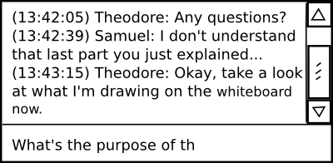Basic layout of a chat channel, with scrolling content panel and input field
The view looks like a typical chat system. Most of the screen space is used to display the list of messages which have been posted; older messages can be viewed by scrolling upwards in this panel. A single-line text entry mechanism below that display is used to post new messages.

Export
The entire history of a chat channel can be exported as a plain text file. This has not been implemented in D1 but will be available in D2.

Document Channel Protocol
A document contains textual data. It supports plain text only. This will be implemented in D2.

Editing
Documents are divided into newline-delimited entities called paragraphs. At most one user can modify a paragraph at one time.
When a user begins editing a paragraph, his client acquires a lock on that paragraph to prevent editing conflicts. All other clients in the channel are alerted to this lock and cannot edit the paragraph while that user is still typing. Once the user stops typing and several seconds pass, his client sends the updated paragraph text to the server, and the paragraph lock is freed. All clients see the changes, and anyone can now make their own changes to the text.
A paragraph can be designated as a header. Headers come in several levels to enable hierarchically organized documents. Since designating a paragraph as a header or changing its level does not create edit conflicts, it can occur regardless of any locks held on the paragraph.
All editing functionality will be implemented in D2.

View
The entire view for a document channel consists of a scrolling panel which displays the document text.
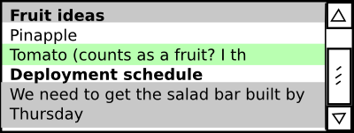Basic layout of a document channel, with the user editing the line highlighed in green (paragraph 3) while two other people are editing the lines highlighted in gray
A lock held by another user is designated by a discolored background on the paragraph. Similarly, another color signifies a lock held by one's own client.
The lock mechanisms will be implemented in D2.

Revision History
A user can switch his view into revision history mode, which provides a navigation mechanism for selecting prior revisions of the document and viewing them in an uneditable panel.
A button allows the user to revert to a given revision. This updates the current contents of the channel to an old state, and puts the view back into editing mode. All locks are removed, and all participants in the channel see the change immediately.
The revision history will be implemented in D2.

Exporting
The entire contents of the document can be exported as an html file. From the revision history view, the contents of any revision can also be exported in the same manner.
Exporting features will be implemented in D2.

Architectural Model
The application is based on an event-driven control scheme; the purpose of the application is so closely coupled to user interaction that any other scheme would be cumbersome. Each user edit of a channel will raise an event, and trigger a mechanism to keep all users' documents concurrent.
The issues of channel concurrency and the large set of shared data required suggest a repository-based architecture. The application is aimed at small user groups. A typically sized community, in the proposed academic setting, might be thirty users, and there should rarely be need of more than twenty active communities, disregarding occasional small communities used for personal meetings and one-on-one tutoring. Because the application is based on a repository, and because of the project's scale, the application is built around a two-tier client/server architecture.

Trust Boundaries
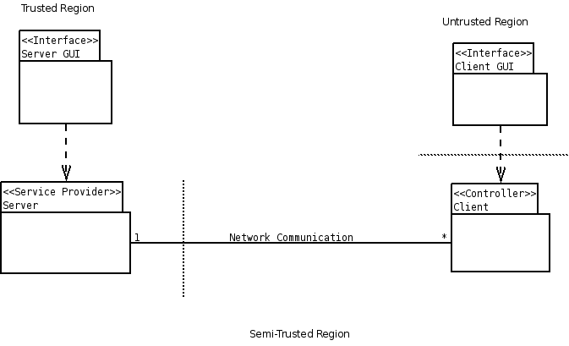
The trust boundaries in a two-tier architecture as this are rarely difficult to distinguish. Usually, the innards of a server are considered trusted, and anything outside of these bounds is considered untrusted; however, the security requirements of this application are not nearly so stringent. For this reason, we define a semi-trusted region where the untrusted region would usually lie, excluding the client-side user interface. Since most users will be using the application over a local network, this is not an unreasonable distinction.

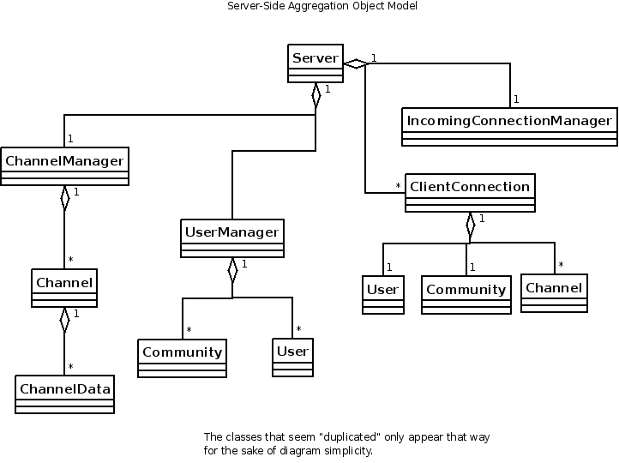
Server

CoLab uses a dedicated server application that handles all of the networking necessary for document concurrency, without any direct peer-to-peer communication. The server is also responsible for all persistent data storage, including metadata on communities and users, as well as any logs and files produced by the application. This central role in the application lends itself toward two general server functions: user/community and content management. The one all-pervasive facilitator for these functions is the network.
The function of content management is taken by the ChannelManager class, and user and community management is handled through the UserManager class. Network abstraction is provided by IncomingConnectionManager and ClientConnection. IncomingConnectionManager listens for connection requests, and wraps newly-opened connections in a ClientConnection object. The ClientConnection object acts as the client/server interface. It interprets and carries out client commands through the use of UserManager, ChannelManager, User, Community, and Channel.

User Management
The User class represents a user, complete with user name and hashed password. The Community class is a structural element, consisting of User members, at least one designated User moderator, and intra-community preferences, including a community password.
The UserManager class holds all Community and User objects registered with the server. It has two functions, both mutually obvious and mutually important. It is responsible for the persistent storage of the User/Community hierarchy. It also managers creation and authentication of users and communities.

Content Management
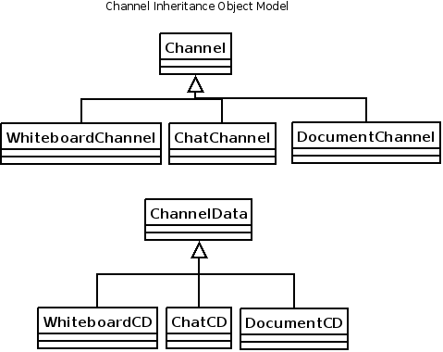

Data is represented congruently on both the client- and server-side. The Channel abstraction - objects built of individual revisions, acting as communication media - is a flexible solution to similarity of storage between the client and server, easing the difficulty of intercommunication. Channel, and its constituent, ChannelData, are each subclassed to allow different channel protocols, corresponding to the typed of tools available to an end users.
A benefit gained from using the Channel abstraction is that Channel objects - potentially text documents, images, et cetera - will have simple, uniform methods to serialize and save the data they represent. On the server side, whenever a ChannelData object is added to a Channel, an event is fired to save the change to a storage backend. On the client side, the same event will trigger the revision being applied to the visual client model.
ChannelManager manages both Channel objects as they are used in a session, and Channel objects as they are viewed as files on the server side. Although the ChannelManager will listen for Channel events, it will not involve itself in file I/O. Its responsibilities consist of merely providing create/join functionality for channels in a community, and managing the file structure to which those channels will commit their own changes.

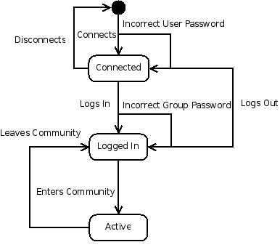
Networking
The server accepts and maintains a socket connection for each client, wrapped in a ClientConnection object. These objects have three important states, and an initial disconnected state.

The three significant states are represented by the creation of a ClientConnection object, a reference to a valid User object, and a reference to a valid Community. The Active state can be further subdivided into additional transitions, as shown on the diagram below, where the final state is either the Logged In, Connected, or Disconnected state shown in the diagram above.
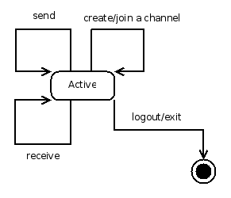
The ClientConnection objects completely encapsulate the sending and receiving of network data from data storage by only communicating with User, Community, and most importantly, Channel, and by interacting only with UserManager and ChannelManager to request those objects.

Behavior
Together, these functions comprise the server solution.

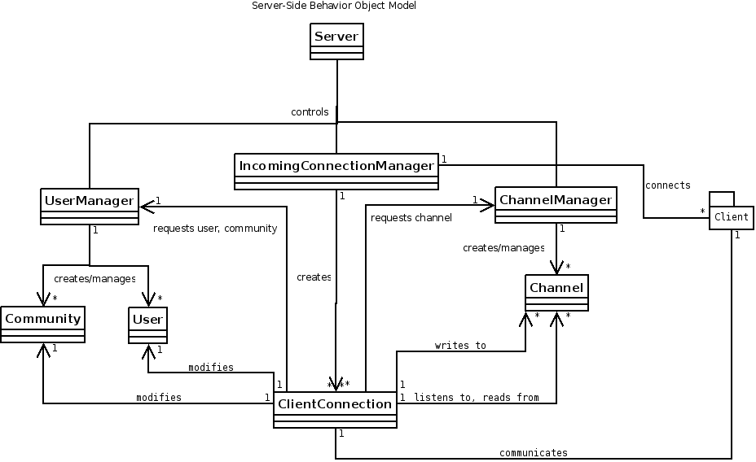
IncomingConnectionManager accepts new connections and wraps them in ClientConnection objects. ClientConnection objects request authentication from UserManager, request channel references from ChannelManager, modify their own User and Community objects, and write to and receive data from Channel objects. ClientConnection objects respond to data they receive from client side and send the client changes in a Channel. UserManager supplies User objects when given the proper password, creates and supplies new Users when given a unique user name, and handles persistent storage of User and Community objects. UserManager also supplies Community objects when given a valid User, or password. ChannelManager supplies a Channel when given a valid channel name and Community, or creates a channel when given a valid and unique channel name, User, and Community. ChannelManager also listens to changes in Channel objects, and responds by logging them in their proper files.

Client
CoLab's simpler client-side solution has two basic responsibilities: keeping channel concurrency over the network, and informing the user when a channel changes.
The user will be informed of channel alterations in a similar fashion with which the server keeps up with them, except instead of listeners that update the server back-end, the listeners will fire events in the Client class for display by the GUI.
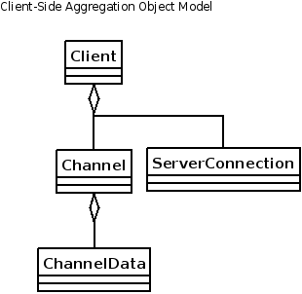

Networking
All client-side network activity is accomplished through the ServerConnection object. A client has exactly one ServerConnection which is responsible for sending updates to the server whenever a client-side Channel object is revised, and for updating a client-side Channel whenever the server notifies that its Channel counterpart has changed. The networking function of the client is minimal, which makes sense, given the two-tier architecture.

Behavior
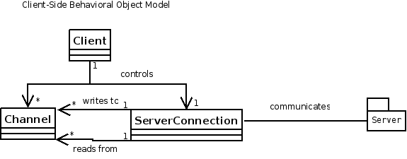

Validation
CoLab will be validated through two usage scenarios of the application using the think-aloud method.

TA Review Session

Participants
10 students, 1-2 TAs (moderators)

Goal
Use CoLab to hold a review session online that is comparable to one held in a physical classroom.

Criteria for Validity
Students must be able to ask a question at any time.
Students should be able to read answers to previously asked questions from TAs.
TAs should be able to draw diagrams as needed to illustrate concepts.
Software should be fast and responsive, providing updates in a real-time manner that is similar to the experience of a classroom environment.

Mutual Peer Group Meeting

Participants
4 students (all moderators)

Goal
Collaboratively write a review of the software user experience

Criteria for validity
Students must be able to communicate easily with one another.
Students should be able to simultaneously discuss what they are doing while doing it.
Editing conflicts should be minimal.
Software should be fast and responsive, and updates should be as close to real-time as possible.

Delivery Plan

