Architecture and Rationale

Architecture

The overall architecture is based around a central server at the corporate intranet level that hosts the main inventory system. The kiosks then communicate with the central server over the intranet to pull information for their particular store. The kiosks use a Java Swing-based application to interface with users, either through a touchscreen or mouse/keyboard.

We will be using the model-view-controller system to implement the kiosk software, along with an inventory server and map/update server using a simple request model.

>kiosk

[ controller ] :collects input and notifies the model/view
| \
| [ view ] :displays the data from the model to the screen
| /
[ model ] :processes input and updates; manages connection/queries to the server
|
~
|
|
[ server(s) ] :integrated with existing inventory system, handles queries for info; stores the store maps
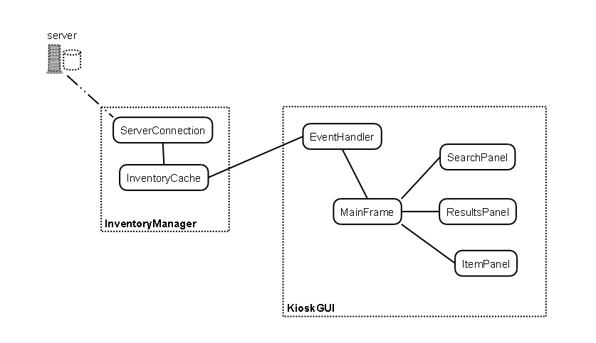
Class diagram and architecture

In this diagram, KioskGUI and related helper classes represent the view and InventoryManager represents the controller and model. KioskGUI gets input from the user and sends search queries to the InventoryManager component. InventoryManager connects to the cache and database to look up data.

When the user conducts a search, the KioskGUI dispatches the event to the EventHandler class. EventHandler passes searches to the InventoryManager. InventoryManager is responsible for checking the cache for data and, if necessary, connecting to the database on a central server (maintained by the store). InventoryManager then returns search results back to EventHandler and back to the KioskGUI, then the results are displayed to the user.

Rationale

One decision we faced was where to store product location information and store map information. This data could be stored either locally, on a server in each store, or centrally. Since companies already have inventory tracking systems, we decided to simply integrate our system with the central servers. Since information regarding products and stores already exists, we could simply add fields for location and a store map. Additionally, the existing setup in most retail stores is to deploy very lightweight hardware to minimize costs. Implementing a per-store self-contained system would be more costly and less effective.

Another decision we faced in planning our project was whether or not to use a web-based user interface. A web-based UI would have made client updates much easier, as the client would be stored in the main server. Additionally, it would have allowed to company to make the product map and inventory available on their company website. However, the kiosk interface would have to be altered anyway to be usable over the internet. Since most of the information used by the kiosk is stored on the company’s main servers, it would be nearly as easy to simply develop a web interface as well as an application-based interface. Ultimately we decided to go with an application based interface. This will allow us to use a touch screen kiosk, eliminating the need for a mouse or keyboard. However, if a company did not want to spend extra money for touch screens, a keyboard and mouse could be used just as easily.

A model-view-controller architecture for the kiosk software was chosen over other possibilities because of the high effectiveness and ease of implementation/extension – the straightforwardness of MVC also helps maintain the simplicity needed for the interface to be accessible to non-technical users. The one-to-many server-client relationship between the central inventory system and the kiosks was chosen over distributed or other sophisticated setups for simplicity - the kiosks only need to pull relatively small updates from the server, negating the need for a high throughput or complicated system.

We had to decide early on how we wanted to handle connections between clients and the central server. We considered maintaining a persistent connection. It would have saved us the overhead of creating a new connection for each query, and the client could have monitored the connection status, in case the connection was lost. However, in a full scale deployment there could be thousands of clients connected at any time. The would be a huge load on the server, so instead we opted to open a new connection each time we need to query. That way, the server only has to handle the connections for current queries. The client has code to handle queries if the server is down, but as soon as the server comes back up, the client will immediately be able to receive results from it again.

Data

Because our product is designed to connect to a store’s existing inventory database, our software does not require much data of its own. For the prototype we will design a simple database to mimic the basics of a store’s actual database. Below is a representation of the data our program will require, most of which we assume is already being kept by the store.

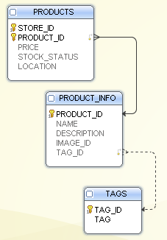

The PRODUCTS table contains information about the products and details at each store. Information here may vary for each product depending on the store (for example, nails might cost more in certain stores). This table contains the product’s price, the stocking status (in stock or out of stock) and the location.

The PRODUCT_INFO table contains information about each product that is common no matter where the product is located, such as the name and description. It also contains the image id (for looking up thumbnail images).

The TAGS table contains a list of tags associated with each product, used for searching and categorizing.

Integrating with an existing inventory system is not easy, but the additional data tracking required for the kiosks is very small. One other requirement is a corporate intranet level service to store and serve maps of the stores and kiosk client updates.

Detailed Design

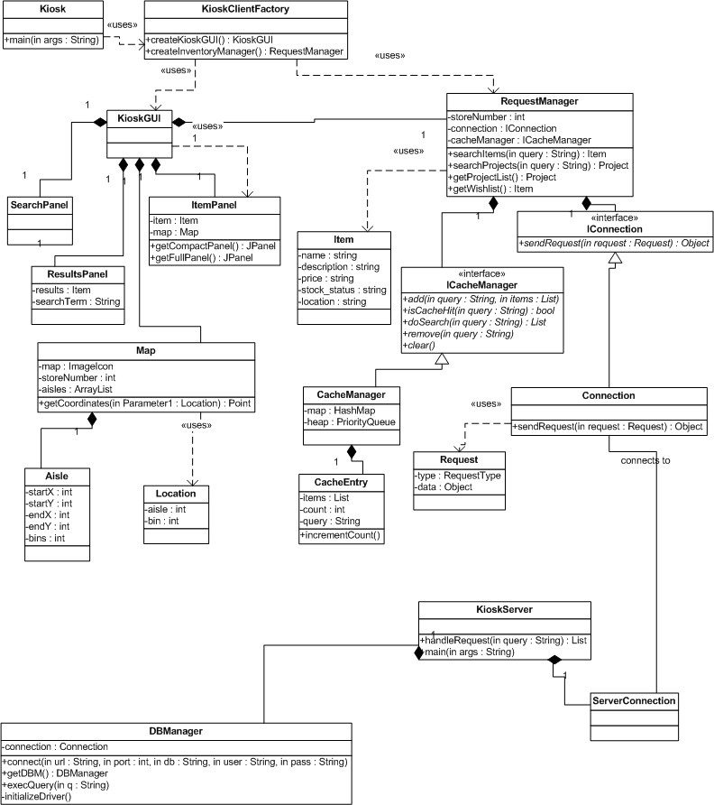

Class level UML
This is the current architecture that supports our most basic features. As part of our entrepreneurial project, we are running user surveys to determine what features to add next and will update the UML accordingly.
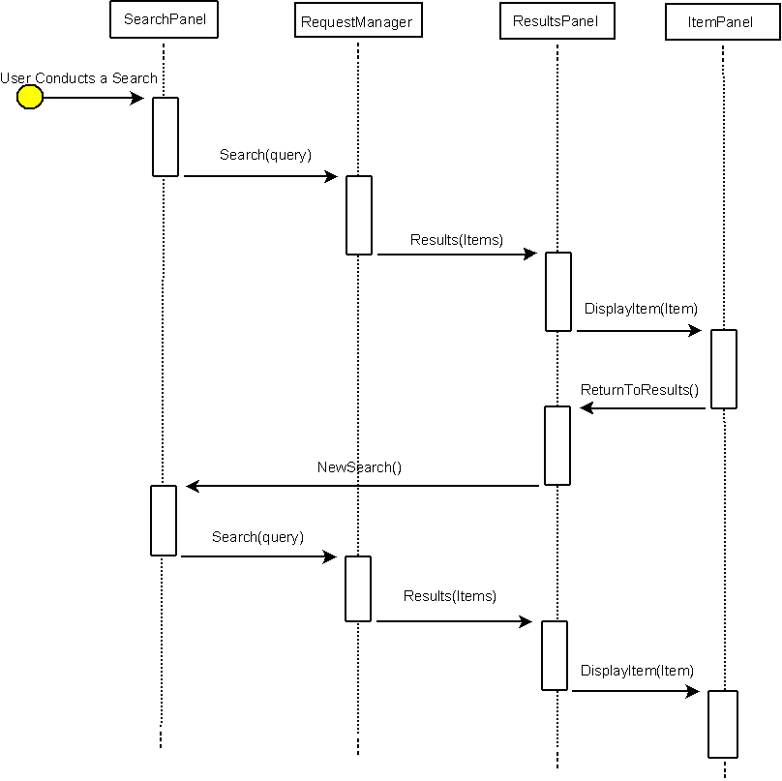UML Sequence diagram
This shows a user searching for an item. The user then chooses from the results and that item is then displayed with a map of its location. The user then decides to look for something else on the results page but the item isn’t there, so they then try a different search and repeat the above process.
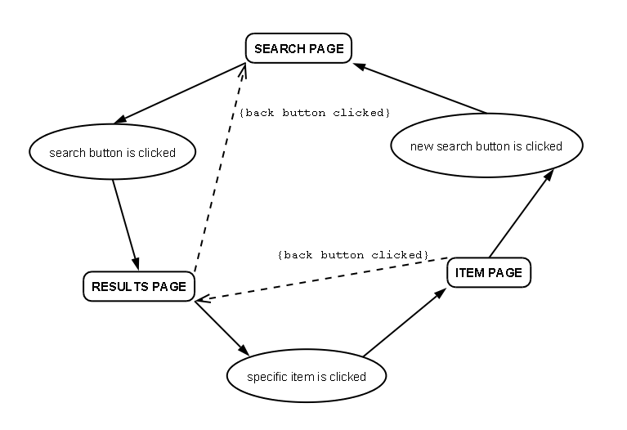
For our primary feature, searching for items, the user passes between three main components: the search page, the results page, and the item page. The user starts on the search page, enters a term and tells the application to search (such as by clicking a button). The application performs the search lookup (described in the Architecture portion of this document) and displays results on the results page. From there, the user can select a specific item to be taken to the item page which has product details, or the user can return to the search page. On the item page, the user can return to the results page or can begin a new search.

GUI

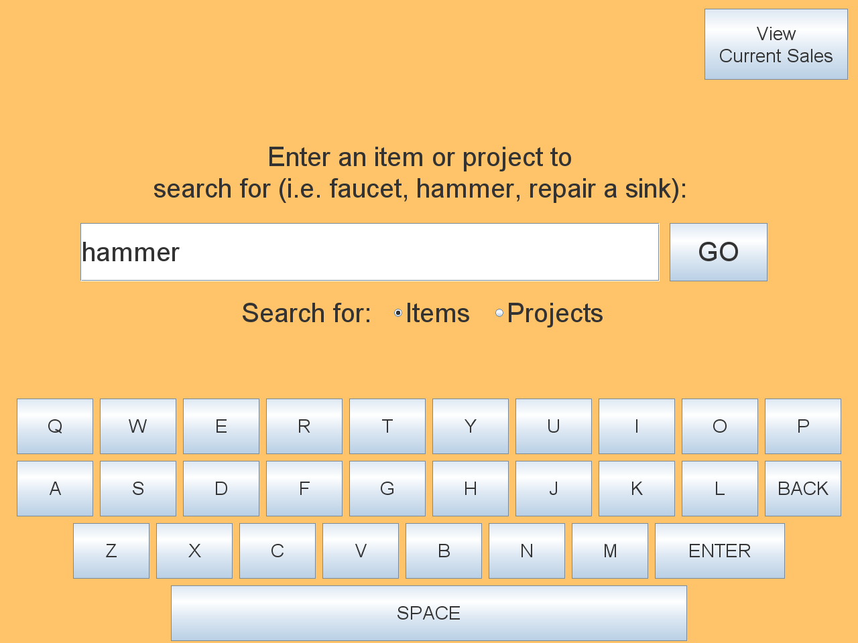

The search page.

This is the main page that appears when the user first begins using the application. Because this interface is intended to be used with a touch-screen kiosk, the on-screen keyboard has large buttons for letters that are spaced apart.

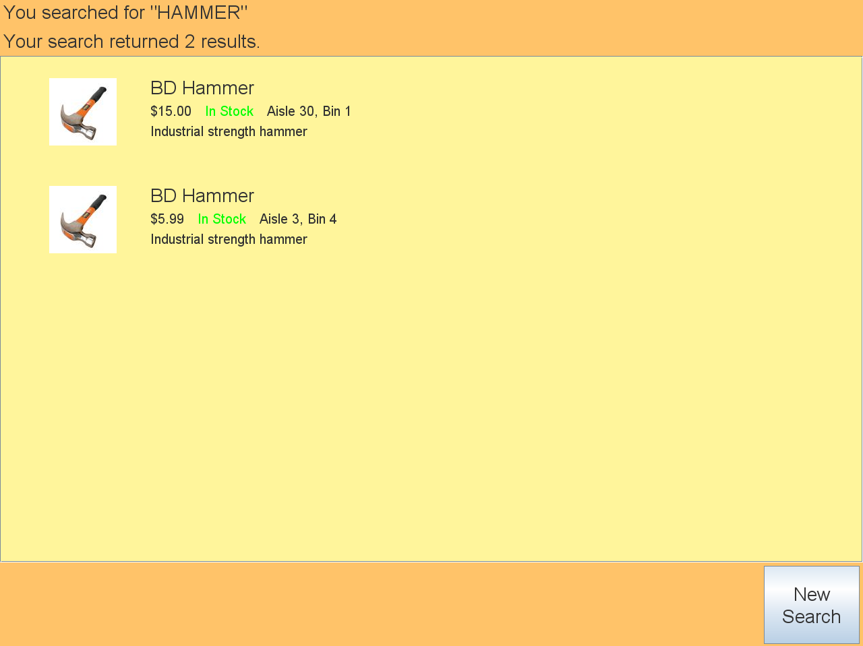

Screenshot of search results screen.

This page appears after the user has searched for a term. From this page, the user can see the item’s name, brief description, price, stock status (in stock or out of stock) and the aisle and bin number. If the user is able to find the numbered aisle, he/she can stop using the software at this point as the item has already been pinpointed.

This screen also shows related items (hammer and nail gun with a search of “nails”).
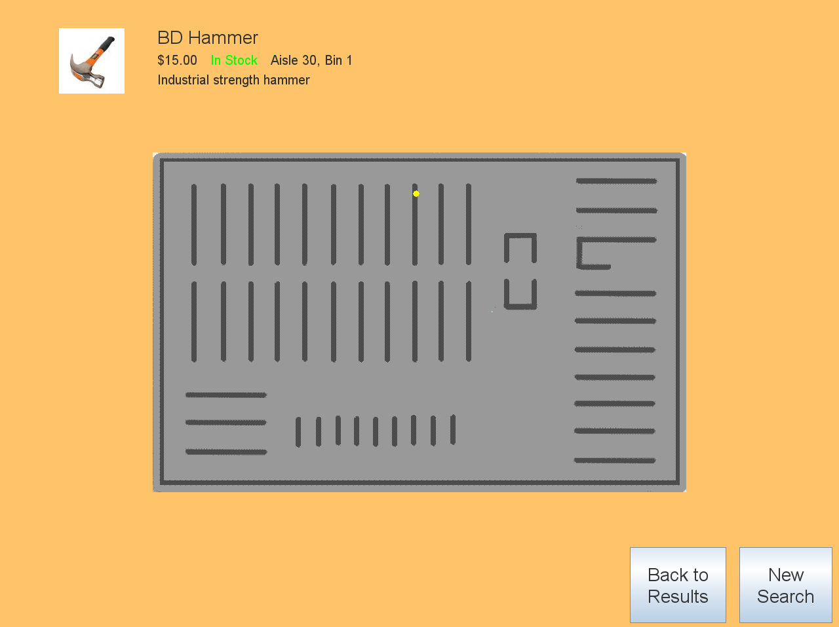

Product details page mockup.

This page is the detailed product page which appears after the user selects a result from the results page. The product’s full name is given as well as any associated information, and a map is shown with both the user’s current location and the item’s location plotted.

Validation

Because our project is an entrepreneurial project, we do not have a single customer giving us requirements so instead we brainstorm ideas, then conduct user surveys to find out which features are most popular. As such, we do not yet have a set list of concrete requirements to check for validation.

Here is a walkthrough using our own self-generated requirements:

Requirement: performance—software must deliver results quickly (no more than 5 seconds between page loads)
Result: design uses a cache to minimize database access. Result is that the software takes less than five seconds to load a page.

Requirement: reliability—software must not affect store’s current database
Result: design is strictly read-only with the store’s inventory, so there is no chance of corrupting an existing database.

Requirement: efficiency—software must not require large amounts of disk space or RAM
Result: cache has a limit to prevent from getting too large; small overhead of disk space for program. Most disk usage comes from thumbnail images, so small images are used.

Requirement: software must be accessible through both a touch-screen interface and by using a mouse.
Result: search page has large buttons so it can be used on a touch-screen.

Requirement: software must not have complicated navigation and must present results as quickly as possible
Result: search page has only a simple search bar and keyboard; results page show aisle/bin numbers so customer gets important information immediately. Selecting a result shows more details and a map.

Requirement: software must be easy to use and understand
Result: each page has only a single obvious function. The search page includes a tagline “What are you searching for?” The search results page lacks a label to indicate the user can click for more details; this is an aspect currently under consideration as a result of the review.

We are also preparing surveys for alternate UI views to validate our UI design, but we are trying to complete surveys about application features first.

